Gitwangak Land Use Plan (LUP)

for all

Gitwangak Traditional Territory
within the
Kispiox, Kalum, and Bulkley Forest Districts

In co-operation with the Gitwangak Hereditary Chiefs and the Gitwangak Treaty Society



Prepared for: The Gitwangak Hereditary Chiefs
Prepared by: Philpot Forestry Services (1977) Ltd., Terrace, B.C.
Date: April 20, 2015

Table of Contents
ACKNOWLEDGEMENTS iii
GITWANGAK MENTAL, EMOTIONAL, AND PHYSICAL HEALTH ix
LIST OF TABLES xi
LIST OF APPENDICES xi
LIST OF ACRONYMS USED IN THE PLAN xii
1.0 INTRODUCTION 1
2.0 GITWANGAK CONNECTION TO CULTURAL RESOURCES, AND GITWANGAK RELATIVE CULTURAL VALUE OF THE RESOURCES 5
3.0 SUSTAINABLE MANAGEMENT 7
4.0 TERMS OF REFERENCE 8
5.0 METHODOLOGY OF PLAN PREPARATION 10
5.1 Development of Resource Management Zones, Objectives, and Strategies 10
6.0 THE PLANNING AREA 15
7.0 GUIDING PRINCIPLES FOR THE DEVELOPMENT OF OBJECTIVES AND STRATEGIES FOR MANAGEMENT OF GITWANGAK CULTURAL RESOURCES 18
8.0 CULTURAL AND ARCHAEOLOGICAL TERMINOLOGY 20
9.0 MANAGEMENT DIRECTION: OBJECTIVES AND STRATEGIES 28
9.1 Consultation Policy 29
9.2 Gitwangak Traditional Use Areas And Sites 37
9.2.A Gitwangak Ancestral Human Remains 48
9.3 Gitwangak Traditional Uses 57
9.4 Culturally Modified Trees (Cmts) 61
9.5 Gitwangak lax’yip (traditional territories) 66
9.6 Cedar 67

9.7 Gitwangak Interests and Vision For Future Gitwangak Use Of Territories 71
9.8 Water Quality and Hydrology 78
9.9 Fisheries 115
9.10 Wildlife 120
A. GENERAL WILDLIFE MANAGEMENT: ALL WILDLIFE 124
B. IDENTIFIED WILDLIFE MANAGEMENT STRATEGY (2004) SPECIES 136
B-1 GRIZZLY BEAR 136
B-2 UNGULATE WINTER RANGE: MOOSE, MULE DEER, AND MOUNTAIN GOATS 148
B-3 FISHER 168
B-4 WOLVERINE 170
B-5 NORTHERN GOSHAWK 172
B-6 Coastal Tailed Frog 181
9.11 Botanical Forest Products 184
9.12 Timber 195
9.13 Biodiversity 219
9.14 Cumulative Effects Of Multiple Industries 271
10.0 PLAN IMPLEMENTATION, MONITORING, AND AMENDMENT 275
10.1 Implementation Plan 275
10.2 Monitoring 276
10.3 Amendments And Land Use Plan Review 277
BIBLIOGRAPHY: LIST OF REFERENCES CITED AND CONSULTED 282

ACKNOWLEDGEMENTS

We wish to acknowledge and thank the Gitwangak Simgiget (Hereditary Chiefs), Sigidimnak (Matriachs), Kuubawilsasxw (Wing Chiefs), Galdim Algyax (Spokespersons) and Wilp members of the Gitwangak Lax Skiik, Gitwangak Lax Gibuu, and Gitwangak Ganeda:
Sakxum Higookxw (Vernon Smith), Simadeeks (Calvin Hyzims), D’welasxw (Anna Marchildon), Skayan (Anita Smith), Gilawo’o (Peter Turley), Nagalyee (Alvin Hyzims), Axtii Naa Hap (Robert Morrison), Liksgiigyetwinwit, (Erling Magnussen), Dinimget (Art Mathews), Axtii Hix (Sam Derrick), Xbii Lax Haa (Ivan Mathews), Wii Hlawts (James Tait), Axti Mihlxw (Barry Shanoss), Baxhildastaat (Geraldine Shanoss), Xbiisoont (Chasity Shanoss), Hlengwax (Lance Williams), Lelt (Lloyd Ryan), Haluus (Billy Morrison), Aliest (Linda Williams), Axgawt (Debbie Bright), Luu Dax Hitxw (Fred Johnson), Gibuu’m An Dok (Philip Clifton), Luutgisxw (Alva Denomme), and Gaxgabaxs (Lawrence Watson)
for their tireless contribution of traditional knowledge, knowledge of their territories, and their dedicated participation to the development of our Gitwangak Landscape Unit Plan.
We would like to acknowledge and thank the Gitanyow Huwilp Society who made available and provided permission to utilize their:
- Cranberry and Nass South Landscape Unit Plan
- Cultural Heritage Resource Management Policy
These documents are a valuable source of reference regarding the content and structure of our Gitwangak Landscape Unit Plan.
We would also wish to acknowledge the Gitseguekla Watershed Table who made available and provided permission to utilize their Gitseguecla Landscape Unit Plan.
We would like to extend a very special thank you to Dinimget (Art Mathews), Hlengwax (Lance Williams), Lelt (Lloyd Ryan), Gitdaootsip Ansa Hun Commercial Fishery, Gitwangak Education Society and the Gitxsan Treaty Society for your assistance in contributing valuable resources to make our GLUP possible.
The Gitwangak Landscape Unit Plan is dedicated in loving memory of Axtii Mihlxw (Charlie Mathews) and Axgawt (Norma Bright).
Toyaks’m Nissim.
FOREWORD
We, the Gitwangak, belong to the Gitxsan First Nation. We are located in northwestern British Columbia and have occupied our Lax’yip (Traditional Territories) since time immemorial. Archeological records indicate occupation for ten thousand years.

The Gitwangak Huwilp consists of historic wilps (houses). Gitwangak wilp, by p’deek (clan) and laxyip (territory) are:

Territory Reference # | Ganada (Frog) P’deek |  |  | Territory Reference # | Gitgaast (Fireweed) P’deek
 | Laxyip (Territory) |  | Wilp (House Group) |  | Laxyip (Territory) |  | Wilp (House Group)
10 | Anxmaiy Litsxw |  | Gaxsgabaxs | 21 | Hihl Guuhl Sganist |  | Haxbagwotxw
11 | Luu Andilgan |  | Gaxsgabaxs | 94 | Tsim An Makhl |  | Yal
30 | Luum An Tsim Din |  | Haakxw
31 | Xsan Skeeks |  | Haakxw
32 | Xsa Andilgan |  | Haluus
33 | Xsuwii Lax Loobit |  | Haluus
39 | Xsi Lax Tselasgwit |  | Lelt
40 | Xsu Gwin Aaxwit |  | Lelt
41 | Xsi Galdii Ess |  | Luulak
78 | Gwi Tsoo |  | Wii Hlengwax
79 | Haahl Daakt Sganist |  | Wii Hlengwax
80 | Xsi Anx Tamilyit |  | Wii Hlengwax
81 | Xsugwin Biiyoosxwit |  | Wii Hlengwax
99 | Xsa Andilgan |  | Wii Hlengwax
 | Lax Skiik (Eagle) P’deek |  |  |  | Lax Gibuu (Wolf) P’deek
 | Laxyip (Territory) | Wilp (House Group) |  |  | Laxyip (Territory) | Wilp (House Group)
60 | Gwax Tseelixit | Sakxum Higookxw |  | 67 | Tsihl Gwellii | Tenimget
61 | Lax Behlit | Sakxum Higookxw |  | 68 | Xsa Gwingoohl | Tenimget
62 | Sigagit | Sakxum Higookxw
63 | Xsi Gallii Gadsit | Sakxum Higookxw
64 | Mii Sxu Gwin Gaat | Sakxum Higookxw
65 | Xsu Gwin Yookhl | Sakxum Higookxw

The greater Gitwangak Territory boundary is agreed to by all Gitwangak Huwilp. We, at times, dispute, discuss, and agree to adjustments to our internal Lax’yip boundaries. We conduct all discussions and evaluations, and come to all agreements regarding our Lax’yip boundaries within the Feast Hall, witnessed by Huwilp chiefs and members, according to our Gitxsan Ayookxw (laws). All decisions are made with mutual agreement and consent of the affected wilps.

The Gitwangak Traditional Territory is bisected by the Skeena River, and is bounded by Xsi Amhl Loop (Burdick Creek) to the northeast, the watershed of Xsi Galdii Ess (Little Oliver Creek), Luu Mil Xsugwin Gaat (Fiddler Creek), and Xsi Mihl’Etxwit (Douglas Creek) to the south, and watersheds of Gisax Itt (Cedar River) and Xsi Gwi Tsoo (Kiteen River) to the west and north. The Seven Sisters mountain range is located in the southeast part of the Territory. The Seven Sisters Provincial Park and Protected Area represent 14% of the Territory area. The total area of our Territory is approximately 270,000 hectares in size (Gitwangak Watershed Atlas).

The connection of the Wilp to its Lax’yip is integral to the Wilp and its members. Therefore, the ownership and authority of Wilp Lax’yip cannot be severed and must be utilized, managed, and inherited in accordance with Gitxsan Ayookxw (laws).

Gitwangak values and interests are directly and inextricably connected to and reliant upon the sustained presence and quality of our ecological resources. Sustaining the land is central to sustaining Gitwangak culture and providing for our economies.

Using the land for economic purposes is an inescapable component of Gitwangak aboriginal rights, as affirmed by the Delgamukw court action and re-affirmed by the Tsilcot’n decision.

We manage our Territories for the use of current generations and hold the land in trust for the benefit and sustainability of future generations. Traditional Gitwangak resource management is based on a holistic perspective that plans ahead for the flow of life from Mother Earth for the wellbeing of seven future Gitwangak generations.

Table 1 illustrates the linkages and hierarchies of the land, the natural resources of the land, and the Gitwangak cultural resources that evolved from the Gitwangak relationship to the their lands.

Gitwangak Huwilp members utilized all the land on our Territories from valley bottom to alpine tundra, including swamps, streams, and lakes, to conduct our traditional uses of hunting, fishing, trapping, food and medicinal plant gathering, and spiritual worship, to provide for our sustenance and cultural customs. Historically, the Territories have been the “breadbasket” and have supplied the necessities of life for culture, sustenance, and medicinal requirements of Huwilp members.

A diversity of ecosystems and forest conditions, including aquatic systems (streams, springs, swamps, and lakes), areas of mature and old forest, areas of young forest and new growth, and dense forest and clearings were required to produce the variety of plants, animals, birds, and fish that were harvested and utilized.

Protection and maintenance of the diversity and productivity of the ecosystems of our Territory is essential to Gitwangak Huwilp members:

- to uphold Gitxsan law for protection and inheritance of our lands
- to maintain our practical and economic connections to our land
- to provide medicines, foods, and cultural resources for the subsistence and well-being of our people.

The land (Gitwangak Territory) is integral to the heritage and culture of the Gitwangak; heritage and culture was formed by the land and resources of the land, and cannot be considered separate from the land. The overall Gitwangak Territory is of primary importance to Gitwangak; specific sites are focal points of importance but are secondary in importance to the full Gitwangak Territory.

Sacred areas and sites exist throughout each House Territory from which Gitwangak Huwilp members draw spiritual strength.

In the past several decades, development activities such as timber harvesting and logging road and highway construction have damaged or destroyed many Gitwangak cultural resources, from cabins, smokehouses, and grave sites to trapping areas, wildlife habitats, and medicinal and food plant sites. The development and resource extraction has been initiated with inadequate knowledge and concern for Gitwangak traditional use and cultural resources. There has been no respect for Gitwangak resources and little accommodation of our interests.

Currently, there is continuing timber harvesting and strong interest from industrial companies for mining, gas, and oil exploration and development. Additionally, tourism, recreational, and agriculture/grazing lease development are increasing. The potential is high for continued negative impacts to Gitwangak cultural resources and the ability for Gitwangak to use our Territories for our own benefit in a manner which is culturally appropriate to Gitwangak. Protection and preservation of Gitwangak cultural resources is essential to maintaining the identity, integrity, and well-being of Gitwangak Huwilp members.

The continued existence of cultural sites in an undamaged condition is of importance to Gitwangak Huwilp members

- to maintain historic, emotional, and spiritual connections to our lands

- as a cultural museum for education of current and future Gitwangak, and non-Gitwangak, generations about Gitwangak history and culture

- as legal proof of historical Gitwangak occupancy and use of Gitwangak Territories; the sites must remain in existence and undamaged to facilitate cultural investigations that could provide evidence of Gitwangak ownership of our Territories prior to European contact and 1846.

- to verify and support Gitwangak Adawaak (oral histories) and traditional use.

- to maintain patterns at sites that demonstrate how the land was used.
Notes:
- Gitwangak cultural resources are directly dependent on and shaped by the natural resources of Gitwangak Territories; the Gitwangak Territory is the PRIMARY cultural resource.
- Archaeological sites, features, artifacts, and trails are a small subset of Gitwangak cultural resources.
Cultural Heritage Resources
Cultural Resources
Environment
Gitwangak Territories
Land and Resources
Natural Resources:
- Air
- Soil
- Water
- Fish
- Wildlife
- Plants
Provide ecological resources for development and sustainability of Gitwangak cultural resources
Social Resources
Gitwangak
Clans
Gitwangak
Houses
Cultural Sites
- Localized focal points of traditional use
Cultural Features
Cultural Trails
Archaeological and
Heritage
Sites
Archaeological
and
Heritage
Features
Archaeological
and
Heritage
Artifacts
Archaeological
and
Heritage
Trails
Cultural Objects
• Artifacts
Gitwangak Traditional Cultural Expressions:
- traditional
and
- ecological
knowledge
Traditional
Use
Traditional Use Areas
Places of cultural importance
- Landforms, place names

(Adapted from Budhwa, 2009a)
Table 1: Hierarchy of Gitwangak Cultural Resources

GITWANGAK MENTAL, EMOTIONAL, AND PHYSICAL HEALTH

The Gitwangak Traditional Health Governance (prevention) Plan: Dim Wila Di Dils’m (The way we live) recognizes the importance of our Laxyip and our traditional customs. The Foreword to the Health Plan states:
Since time immemorial the Gitksen Nation has occupied and utilized its entire territory. Utilizing and managing its vast and varied natural resources through the development of complex social institutions, innovation and development. The Gitksen Nation asserts aboriginal title to and aboriginal rights throughout its territory. We have in the past and continue to engage in traditional activities throughout the territory, activities giving rise to aboriginal rights. We will engage in cultural activities in the territory now and into the future. Aboriginal title carries with it the right to choose the use to which the land is put.
We have persevered, despite six generations that were devastated by the history of colonization, especially residential schools and the imported diseases that can now only be viewed as genocide. Gitksen: the removal of children obstructed traditional grooming and transmission of knowledge , practices and beliefs. This trauma caused a loss of identity, a loss of self-esteem, affecting mental wellness, physical ailments, addictions and suicide, domestic violence and disease
Colonization was a destructive force that undermined the Gitksen way of life and a state of oppression so severe that to practice Dim Wila Dil Dils’m -the way we live- would mean jail time or worse. Residential School and the 60’s scoop proved that if you take the Gitksen away from the Lax Yip, the person, the family and the community no longer have the necessary foundation from which to live a good clean life. This history created chaos and imbalance for all Gitksen: the removal of children obstructed traditional grooming and transmission of knowledge , practices and beliefs. This trauma caused a loss of identity, a loss of self-esteem, affecting mental wellness, physical ailments, addictions and suicide, domestic violence and disease.
Each Wilp and Pdeek has a very sophisticated Ayuuk’ (Hereditary Laws), which guide relationships, behaviours and participation within the wilp. Within the Gitxsan traditional and ethical values, the extended family or clan structure was once a very strong internal mechanism to overcome adversity, but the post contact experience has caused the breakdown of the traditional systems to create dysfunction at the individual, family and community level.
In order to preserve and protect their Daxget, the hereditary system is solely responsible for the affairs and the well being of the total wilp membership. A complex interaction of obligations, sanctions and mutual respect serves to maintain our society in relative harmony. There is equal access to resources, the house system and consensual decision-making. In 2006 the Gitwangax Simgiget did a survey of the wilp members and found that those who had a more traditional upbringing, participating in feasts, language, traditional foods, the traditional supports in-place; there-by knowing who you are and where you come from, tended to be more successful in education and careers.
A traditional health plan should be the basis for health care within the Gitksen territories, that federal health should be integrated into. The health plan should provide a basis for a healing process that is both traditional and holistic. Given that the Gitksen traditional structures still remain and are valid, and through the traditional consensus processes the community is given the opportunity to speak and be heard, there-by, a healing process for the entire community evolves.
Not only to empower individuals and families, but communities, wilps and clans are also taken into account in the holistic process. Most service models are intervention oriented and do not follow the Gitksen holistic vision of healing. This health plan allows the Gitksen to initiate and support a health plan that is built upon the strengths and resources of the community. This in turn will allow the community to fully benefit from outside services.
It is the responsibility of the community as a whole to be healthy and the tendency for Gitxsan is to look at healing from a traditional concept. Families, wilp groups, clans, friends and neighbours provide much of the “front line help”; to their detriment this has gone unrecognized and unsupported by the “external systems” in place. The “external systems”, rather than supporting and enhancing the ability of the family, clans, wilps and communities to care for their members, tend to take over and shift responsibility, ownership and control away from the community. Thus, an artificial division is created between the “natural community based systems” and the often “external punitive emergency systems”.
The Lax Yip is imperative to the state health of each and every Gitksen, who live in the community and those that live away, as the hereditary system is responsible for all membership regardless of their location. There-for, a Gitksen land use management plan must recognize the Lax Yip as integral to the protection and preservation of Gitksen cultural/territorial resources, which is essential to maintaining the identity , integrity and well-being of Gitksen Huwilp members
For the Lax Yip to be used in ways that are unsustainable, would be an assault on the physical/dietary, mental health, and emotional and spiritual needs of the individual, family and community, and would mean a deviation from the Gitksen traditional holistic perspective.
For the Gitksen to be reconnected in a foundational way once again to the Lax Yip would substantially improve the standard of life and state of health for the membership.
The mental, emotional, and physical health, the cultural values, and the subsistence resources of the Gitwangak people are directly and inextricably connected to the health of our Lax Yip.
Our Gitwangak Land Use Plan is designed to maintain the health of our Lax Yip and to provide for long-term sustainability of the resources of the land, thus maintaining opportunities and resources to support the continuation of cultural practices and contribute to the mental, emotional, and physical health.

LIST OF TABLES

Table 1: Hierarchy of Gitwangak Cultural Resources
Table 2: Recommended General Avoidance Buffer Widths
Table 3: Target % Retention In Riparian Reserve Zones and Riparian Management Zones
Table 4: Equivalent Clearcut Area Targets
Table 5: Checklist of Management Features Associated with Forestry Disturbed Sites
Table 6: High Value Grizzly Bear Habitat in the Gitwangak LUP Area
Table 7: Old Growth Management Area Targets
Table 8: Combined Mature and Old Seral Stage Targets
Table 9: Early Seral Stage Targets
Table 10: Patch Size Targets
Table 11: Recommended Distribution of Patch Sizes (harvest units and leave areas)
Table 12: Rationale for Amending the Ecosystem Network
Table 13: Full Cycle Retention Tree Targets
Table 14: Wildlife Tree Targets (Forest and Range Practices Act Regulations)
Table 15: Conservation Data Center Blue and Red Listed Plant Communities

LIST OF APPENDICES

Appendix 1: Gitwangak Consultation Protocol
Appendix 2: List of hydroriparian functions, from the Hydroriparian planning guide (2004)
Appendix 3: Gitwangak connection to the cultural resources and the relative cultural values of the resources
Appendix 4: Moose habitat attributes for life requisites
Appendix 5: Relation of stand-level retention to landscape level retention
Appendix 6: Gitxsan Ax Policy

LIST OF ACRONYMS USED IN THE PLAN

AAC | Annual Allowable cut
AC | Administrative Council
AIA | Archaeological Impact Assessment
AOA | Archaeological Overview Assessment
AT | Alpine
BAFA | Boreal Altai Fescue Alpine
BEC | Biogeoclimatic Ecosystem Classification
BEO | Biodiversity Emphasis Option
BMPs | Best Management Practices
CDC | Conservation Data Centre
CMT | Culturally Modified Tree
CO₂ | Carbon Dioxide
CWH | Coastal Western Hemlock
ECA | Equivalent Clearcut Area
EN | Ecosystem Network
ESSF | Engelmann Spruce – Subalpine Fir
FPPR | Forest Planning and Practices Regulations
FREP | Forest and Range Evaluation Program
FRPA | Forest and Range Practices Act
FSP | Forest Stewardship Plan(s)
GHA | Goshawk Habitat Area
GHG | Greenhouse Gasses
GIS | Geographic Information System
GPS | Global Positioning System
H | Western Hemlock
ICH | Interior Cedar Hemlock
ILMB | Integrated Land Management Bureau
IPP | Independent Power Project
LRMP | Land and Resource Management Plan
LUP | Land Use Plan
MH | Mountain Hemlock
MOE | Ministry of Environment
MFLNRO | Ministry of Forests, Lands, and Natural Resource Operations
NDT | Natural Disturbance Type
OGMA | Old Growth Management Area
PFR | Preliminary Field Reconnaissance
PPMH | Productive Pine Mushroom Habitat
QP | Qualified Professional
RMZ | Riparian Management Zone
RRZ | Riparian Reserve Zone
SBS | Sub-boreal Spruce
SRMP | Sustainable Resource Management Plan
SRMZ | Special Resource Management Zone
THLB | Timber Harvest Land Base
TSA | Timber Supply Area
TSR | Timber Supply Review
TUS | Traditional Use Site
UWR | Ungulate Winter Range
WHA | Wildlife Habitat Area
WMU | Water Management Unit
WRP | Watershed Restoration Plan
WTP | Wildlife Tree Patch

INTRODUCTION

During August 2010, Philpot Forestry Services (1977) Ltd. was retained by the Gitwangak Watershed Table to complete the following project:
  - Through a co-operative consultation and planning process with the Gitwangak Watershed Table, prepare a Land Use Plan (LUP) for all Gitwangak Traditional Territories within the Kispiox, Kalum, and Bulkley Forest Districts, including Timber Supply Areas (TSA) and Tree Farm Licenses (TFL).

For purposes of the LUP, the Gitwangak Territories within the Kispiox, Kalum, and Bulkley Districts are considered a single Landscape Unit. Individual House Territories that comprise the Landscape Unit are considered as planning subunits of the LUP, and include the House Territories of Anxmaiy Litsxw, Gasa Lax Loobit, Gwax Tseelixit, Haahl Daakt Wii, Sganist, Lax Behlit, Luum An Tsim Din, Mii Sxu Gwin Gaat, Sigagit, Tsihl Gwellii, Tsim An Makhl, Xsa Andilgan, Xsa Gwingoohl, Xsan Skeeks, Xsansisnak, Xsi Galdii Ess, Xsi Gallii Gadsit, Xsi Lax Tselasgwit, Xsu Gwin Aaxwit, Xsu Gwin Yookhl, Xsugwin Biiyoosxwit, and Xsuwii Lax Loobit.

Land and Resource Management Plans (LRMPs) have been prepared and approved for the Kispiox Timber Supply Area (TSA), Kalum TSA, including TFL 1 and TFL 41, and Bulkley TSA. These LRMPs are considered as Ministerial Policy for those TSAs and TFLs; it is assumed for purposes of this Land Use Plan that the Ministerial Policy set forth in the each LRMP will apply to the House Territories within that TSA or TFL.

Objectives and strategies presented in this Land Use Plan are designed to achieve LRMP Higher Level Plan Objectives. The Land Use Plan is specific to Gitwangak Traditional Territories; objectives and strategies within the Land Use Plan are specific to the Land Use Plan Area, and reflect Gitwangak desires and vision regarding resource management on Gitwangak Territories.

This LUP brings together planning direction from Gitwangak Houses and the Kispiox, Kalum, and Bulkley LRMPs into one document. The LUP is written to clearly describe the desired future condition of the land base. The intent of the plan is threefold:

  - To provide long-term sustainability of ecological resources.
  - To conserve Gitwangak cultural and heritage values and accommodate Gitwangak interests and plans for our future use of our territories.
  - To provide for continued resource use and extraction in locations and at a rate that will sustain all forest resources at the landscape level.

The Land Use Plan has been prepared with the intent that the plan may at some future time be received by the Ministry of Forests, Lands, and Natural Resource Operations (MFLNRO) and will become a Sustainable Resource Management Plan that provides legally binding direction for preparation of lower level plans. At the present time, the LUP is a Gitwangak plan that provides a clear statement of our view of previous industrial resource management on our Territories, and Gitwangak interests and plans for future industrial and Gitwangak use of our Territories. The intent is that the plan will provide a framework for education of Gitwangak Huwilp members, and a strong basis for ongoing consultation in a proactive manner with provincial and federal government agencies and development proponents that wish to work on Gitwangak Territories.

To date, timber harvesting has been the primary industry to impact Gitwangak Territories. Currently there is increasing interest from a variety of industrial proponents to implement industrial developments on Gitwangak Territories. Our Gitwangak Land Use Plan is intended to apply to the cumulative impacts of all industries that affect our Gitwangak Territories.

The Land Use Plan is a framework document that requires future actions. Further work by subcommittees will be required by Gitwangak Huwilp members to develop a database of resources and develop internal structures and capacity for implementation of the LUP.

Gitwangak values, interests, concerns, and objectives are presented under three broad categories:

- GITWANGAK CULTURAL, HERITAGE, AND ECONOMIC RESOURCES

These include:

  - Traditional Use Areas, such as cultural and archaeological sites, features, artifacts, and trails
  - traditional use
  - resources specific to Gitwangak, e.g. cedar
  - interest for future Gitwangak use of their Traditional Territories to develop and sustain Gitwangak culture, heritage, sustenance, and economies.

- NATURAL RESOURCES

These include ecological and economic resources such as biodiversity, water, fisheries, wildlife, timber, visual quality, recreation, tourism, mineral, gas, and oil.

Gitwangak values and interests are directly and inextricably connected to and reliant upon the sustained presence and quality of the ecological resources. Sustaining the integrity of the land is central to sustaining Gitwangak culture and providing for our economics. Gitwangak have a holistic view of the land and its ecosystems. Gitwangak objectives for sustainable resource management are incorporated within the objectives for all forest resources and reflect our desire that these objectives provide direction for all resource management decisions on Gitwangak territories.

- CLIMATE CHANGE

Climate change / global warming will impact the forests of Gitwangak Territory. Scientists predict that over the next several decades, the climate in Canadian forests will shift northward at a rate that will likely exceed the ability of individual tree species to migrate. Climate effects on tree species will be ongoing, cumulative, and interactive, and will include changes in microclimates, local site conditions, disturbances (e.g. fire, insects, disease, drought, extreme weather), and distribution, abundance, and ecosystem interactions of invasive species. Tree species may become increasingly maladapted (i.e. the local environment to which species are adapted changes at a rate beyond which the trees can accommodate).

One of the more significant concerns about climate change is the uncertainty about what actually will happen regarding the magnitude, location, and timing of changes at the local level to the composition, structure, and age of the forests. In order to minimize the vulnerability of forests to climate change, sustainable forest management must recognize climate change as a reality and incorporate a comprehensive management regime designed to mitigate the effects of climate change / global warming in our forests.

The Gitwangak Land Use Plan presents a two-pronged approach for mitigation of climate change on our forest ecosystems, outlined in the following sections:

- TIMBER CHAPTER 9.12: objectives and strategies to sequester and store carbon, and minimize greenhouse gas emissions;

- BIODIVERSITY CHAPTER 9.13: objectives and strategies that contribute to the adaptation of forest species to climate change and the migration of organisms in response to climate change.

The Gitwangak Territories, Gitsegukla Territories, and the Gitanyow Territories are immediately adjacent to one another, have common boundaries, and together form a large contiguous area. Gitwangak, Gitsegukla, and Gitanyow have all prepared Land Use Plans designed to provide for sustainability of ecological and cultural heritage resources of the Territories, and contribute to the mental, emotional, and physical wellbeing of Huwilp members. The plans are independent of one another but are very similar in format and content and, in combination, present a common land management regime for management of the contiguous territories.

GITWANGAK CONNECTION TO CULTURAL RESOURCES, AND GITWANGAK RELATIVE CULTURAL VALUE OF THE RESOURCES

We, the Gitwangak Huwilp members, are profoundly connected to our landscape, including both our natural and cultural resources. This connection reflects the historic, current, and future use of our resources and includes:

- Spiritual connections (S)
  - Connections from the heart and soul; feelings and beliefs, as opposed to academic or intellectual knowledge; an internal, intangible but real belief that the resource is “part of you,” demonstrated by the philosophy “respect everything, waste nothing.”

- Historic connections (H)
  - Connections through knowledge of Gitwangak historic use of a resource

- Practical connections (P)
  - Connections through Gitwangak historic, current, and future use of the resources for the practicalities of food, shelter, protection, transportation, i.e. subsistence.

- Legal connections (L)
  - Connected through Gitxsan traditional law
  - Connected through provincial and federal law; cultural resources provide legal evidence of Gitwangak historical occupancy and use of our Territories

- Education connections (Ed)
  - Connected through the use of resources to educate current and future Gitwangak and non-Gitwangak generations about Gitwangak history and culture.

- Emotional connections (Em)
  - Connected through feelings such as pride, satisfaction, fear, awe, spirituality, happiness etc. generated by sight or thought of the resource.

- Economic connections (Ec)
  - Connections related to the use of a resource in historic, current, and future economies; e.g. barter, trade etc. of cedar, fish, fur etc.

An integral component of these connections to our cultural resources is the concept of “sense of place” (see definition in Section 8.0), that is embedded in all our forms of connectivity.

These connections are listed separately for discussion and description but are, in fact intertwined; they are closely interconnected and collectively define the connections of Gitwangak Huwilp members to our cultural heritage.

Cultural values are considered to be the value or importance to the Gitwangak of each resource relative to the other resources. All cultural resources are important and have value to Gitwangak; “low” value is a relative designation, NOT a term of disrespect or lack of importance. For example, the relative values of a grave site or burial ground to a single CMT: both are important to Gitwangak, but the burial site may have a very high designated cultural value while the CMT has a lower value.

Appendices 3-A, 3-B and 3-C list a diversity of cultural resources organized by general resource type, and present the Gitwangak connection to each resource along with the Gitwangak relative cultural value of each resource.

SUSTAINABLE MANAGEMENT

The preamble of the Forest Practices Code Act states that sustainable use includes:

- Managing forest to meet present needs without compromising the needs of future generations.
- Providing stewardship of forests based on an ethic of respect for the land.
- Balancing economic, productive, spiritual, ecological, and recreational values of the forest, to meet the economic, social, and cultural needs of people and communities, including First Nations.
- Conserving biological diversity, soil, water, fish, wildlife, scenic diversity, and other forest resources.
- Restoring damaged ecologies.

The goal of the Land Use Plan is to achieve sustainable use of all resources of Gitwangak Territories.

TERMS OF REFERENCE

The Terms of Reference for preparation of the Gitwangak Watershed Unit Land Use Plan are as follows:

- To prepare a Gitwangak Resource Management Plan for the Gitwangak Watershed Unit that

- documents Gitwangak concerns, interests, values, and desires regarding resource management on Gitwangak Territory

- presents a written text that provides a preamble (context statements), objectives, strategies, and a rationale to achieve the Gitwangak desired future conditions of the Territory

- provides a map that spatially documents Gitwangak cultural and natural resource values and resource management zones for management of these resources. Resource management zones will include

  - Ecosystem Networks/connectivity corridors
  - Old Growth Management Areas/representative ecosystem retention
  - Gitwangak cultural sites/places of importance
  - Gitwangak Traditional Knowledge
  - Valued wildlife habitat areas
  - Areas that are ecologically NOT appropriate for timber harvesting or other industrial development
  - Areas that are ecologically appropriate for timber harvesting or other industrial development.
  - Water Management Units

- The intent is to develop a Gitwangak plan for Gitwangak Territories that will result in sustainability of ALL resources of the Territory and that will inform further planning processes with provincial agencies and development proponents.

- To work with all the Gitwangak Hereditary Chiefs and the Watershed Facilitator as a planning team, to jointly and co-operatively develop the information that will form the plan.

- To combine scientific research information with Traditional Knowledge to develop a comprehensive plan for sustainable management of all Gitwangak resources that is inclusive of each wilp’s needs within Gitwangak Territory.

- Develop the plan through workshop meetings with the Gitwangak Watershed planning team on a bi-monthly basis; strive to complete the plan by March 31, 2011.

- Complete the plan in a time-efficient manner, but do not take shortcuts to completion of the plan in order to meet the March 31st deadline; a poorly developed, poorly discussed, poorly understood plan will be unsatisfactory to all parties and will be a liability, not an asset, to management of Gitwangak Territory.

METHODOLOGY OF PLAN PREPARATION

The methodology used to prepare the Land Use Plan is as follows, presented as a series of steps listed in the order that the work was conducted.

Development of Resource Management Zones, Objectives, and Strategies

- Assembled inventory information available from BC Ministry of Forests and Range, BC Ministry of Environment, Office of the Gitwangak Hereditary Chiefs, and Integrated Land Management Bureau, including:

  - Full set of air photographs, comprised of a composite of:
    - 1:20,000 scale colour photos, dated 2006, for the Kispiox and Bulkley Timber Supply Areas (TSA)
    - 1:15,000 black & white photos, dated 1988, for the Kalum TSA and TFL 1
    - 1:30,000 black & white photos, dated 2001, for the Kalum TSA and TFL 1
  - Sets of 1:20,000 Forest Cover Maps
  - Mapped information showing Gitwangak Watershed Unit boundary, House Territory boundaries, locations of archaeological sites along the Skeena River, and approximate locations of Gitwangak major traditional trails and cultural sites. Many more sites are known but not mapped.
  - Data and maps on wildlife habitats, private properties, Indian Reserves, community watersheds, water licenses, fisheries, streams, watersheds, timber operability, range land/grazing leases, visual quality, cedar, and topographic contours.
  - Bio-geoclimatic Ecosystem Classifications.

- Held numerous group workshop meetings on a bi-weekly schedule, with the Chiefs of the Gitwangak House Territories (Gitwangak Watershed Unit Planning Table) to discuss historical and current use of the Gitwangak Territory, determine and record values, interests, uses, concerns, and future plans for Gitwangak use of the Territory. Jointly formulated statements to document the desired future condition of the Territory. Discussed suggested solutions, strategies, and management practices that may accommodate Gitwangak interests, values, and concerns. Recorded this information on flip charts in order that the Chiefs could read and review the information presented, and make additions or modifications as desired.

- Prepared written statements of :
  - preamble to establish context
  - objectives
  - strategies
  - rationales for the objectives and strategies
  - examples of SRMP legal format for objectives, measures, targets, and management considerations

in the form of a draft Land Use Plan, as individual chapters for each resource of interest to the Gitwangak Chiefs.

- Submitted the written draft chapters to the Gitwangak Watershed Planning Table for review, to ensure that the draft preamble, objectives, and strategies were complete and accurately reflected the concerns, interests, values, and desires of Gitwangak.

- Within two weeks of submitting for review of each chapter (or group of chapters) to the Gitwangak Chiefs, held a workshop meeting to jointly review the submitted draft chapter(s) and prepare any additions, deletions, or modifications to the stated preamble, objectives, and strategies.

- Incorporated new preamble statements, objectives, and strategies, resubmitted modified draft LUP chapter(s) to the Gitwangak Watershed Planning Table, with the intent that further modifications to these chapters would be brought forward and reviewed as a final review of the full draft Land Use Plan.

- Concurrent with the workshops to document Gitwangak concerns, interests, values, objectives, and strategies, the land base of the Gitwangak Territory was stratified through use of air photographs, Forest Cover Maps, topographic contour mapping, and terrain stability mapping, into the land use zonations of:
  - terrains appropriate for road development and timber harvesting (designated as operable terrain)
  - terrains considered as NOT APPROPRIATE for road development and timber harvesting, due to the potential for damage to water quality, slope stability, fish and wildlife habitat
  - wetlands, wetland-brush complexes, fans, floodplains, and deciduous forest types that provide very high wildlife habitat values
  - hydroriparian zones of valley bottom streams, major tributary streams, and groups of closely spaced Order 1 and Order 2 streams.

Identification of the land use zonations was completed on 1:15,000, 1:20,000 and 1:30,000 scale air photographs, and then transferred to 1:20,000 scale Forest Cover maps. The mapped information was digitized by a Gitwangak GIS technician into the digital map database.

- The criteria used to determine forest and terrain considered as ecologically sensitive and therefore not appropriate for road development and timber harvesting, are:
- Steep slopes exceeding 65% on a continuous basis
- Slopes showing evidence of historic or potential instability.
- Slopes broken by numerous rock outcrops
- Slopes cut by numerous gullies or avalanche tracks
- Safety considerations; steep slopes (≥40%) directly above public highways and CNR
- Terrain broken by numerous closely spaced watercourses
- Areas of saturated soils or high water tables
- Forests broken by numerous brush patches; indicative of wet soils, potential slope instability, high wildlife values, and silvicultural difficulty in establishing regeneration.
- Alluvial fans, flood plains, talus slopes.
- Critical habitats, rare ecosystems.
- Sites of low growth potential; characterized by short, low volume timber stands estimated to be less than 250 cubic meters per hectare. Includes sites of shallow soils, rock knobs, ridges, and outcrops, and high elevation sites of difficult growing conditions.

The above criteria used to define terrain and forests not appropriate for logging emphasize recognition of ecologically sensitive sites that SHOULD NOT be subjected to road development and timber harvesting operations, in order to protect soil, water, slope stability, and wildlife habitats. It may be physically possible to remove timber from these sites but they are described as NOT APPROPRIATE for timber harvest to ensure adequate environmental protection.

- The criteria used to identify the hydroriparian zones are:
- Areas that extend to the edge of the influence of water on land, or land on water, as defined by plant communities (including high bench or dry flood plain communities) or land form (e.g. gullies, immediately adjacent steep unstable terrains), plus one and one-half site-specific tree heights horizontal distance (Hydroriparian Planning Guide, Coast Information Team, Jan. 30, 2004). Landforms include:
- the stream channel, lake, or wetland, and adjacent riparian ecosystem, where no floodplain exists
- the full width of the flood plain for streams
- adjacent active fluvial units (alluvial fans)
- up to the top of the inner gorge or where slopes become less than 50% for reaches of streams that are gullied, a ravine, or a canyon.
- Immediately adjacent unstable slopes (Class IV and V terrain) where it is located such that a surcharge of sediment may be delivered to the stream, lake, or wetland.
- Where numerous closely spaced headwater streams exist (Order 1 and Order 2 streams), the delineated hydroriparian zone includes the hydroriparian zone of the streams, plus the upland area (outside the hydroriparian zone) situated between the streams (for example, the headwaters of Red Canyon Creek).

- Incorporated into the mapping digital database, the Old Growth Management Areas (OGMA) and Landscape Corridors identified and dedicated through previous land use planning processes of the Kispiox, Bulkley, and Kalum Forest Districts.

- Incorporated into the mapping digital database, traditional knowledge of cultural use and wildlife habitats and use, provided by the Gitwangak House Chiefs.

- Designed and mapped Ecosystem Networks (EN) and Water Management Units (WMU), using the mapped land use data from (7), (8), and (9) above to inform the design process, that are intended to:
  - contribute to maintenance of biodiversity values and wildlife habitats, water quality and hydrologic stability, and fish habitat
  - provide a designated timber harvesting land base
  - protect Gitwangak cultural resources and address Gitwangak concerns, values, and interests.

The ENs and WMUs were digitized into the map database by the Gitwangak GIS technician.

- Combined the draft preamble, objectives, strategies, and rationales with the mapped land use zonations to prepare a full draft Land Use Plan for the Gitwangak Watershed Unit.
- Reviewed the completed draft Land Use Plan with the Gitwangak Chiefs. Documented amendments resulting from the review. Incorporated the amendments to the draft text and maps to prepare the final Gitwangak Watershed Land Use Plan. Submitted the final plan to the Gitwangak Hereditary Chiefs.

THE PLANNING AREA

The Gitwangak Watershed Plan Area encompasses approximately 275,000 hectares in west-central British Columbia. It overlaps three provincial Timber Supply Areas (TSA); the Kispiox, Bulkley, and Kalum TSAs, a portion of Tree Farm License 1 (TFL) in the Kalum Forest District, and includes twenty-six Gitwangak Lax’yip and eleven Gitwangak Wilps.

The planning area includes the watersheds of numerous streams tributary to the Skeena River, the upper portions of the Kiteen river watershed (tributary to the Nass River), the full watershed of the Cedar River, and the upper portion of the Mulwain creek watershed (tributary to the Copper River). The Seven Sisters Provincial Park and Protected Area, and the Kitwanga Mountain Park are completely contained within the Gitwangak Territory.

Settlements within the planning area include the villages of Gitwangak, Kitwanga, and Cedarvale, and numerous private dwellings located along the Skeena River.

Geographically, the planning area is dominated by steep, rugged mountains within the Cedar, Kiteen, and Skeena tributary watersheds, with the terrain becoming less steep and more rolling plateau to the east, within the Mulwain creek watershed. Sensitive soils and slope instability are widespread throughout the mountainous portions of the area.
Climate of the area is transitional between coastal and interior climates, being more coastal to the west and more interior to the east. Biogeoclimatic zones and variants include:

- Alpine tundra (AT)
- Coastal Western hemlock; wet sub-maritime, sub-montane variant (CWH ws1)
- Coastal Western hemlock; montane wet sub-maritime (CWH ws2)
- Engelmann spruce-Subalpine fir; wet very cold (ESSFwv)
- Engelmann spruce-Subalpine fir; parkland (ESSFwvp)
- Interior cedar-hemlock; Hazelton moist cold (ICHmc2)
- Mountain hemlock; leeward moist maritime (MHmm2)
- Mountain hemlock; parkland (MHmmp2)

Fisheries values of the Gitwangak Watershed Unit are rated very high. Fourteen species of fish can be found within the rivers and lakes of the area, including all species of salmon.

Streams are generally confined within gullies and canyons; few floodplains or wide valley bottoms exist, with the exception of the Skeen River valley.

Wildlife utilizes the plan area from valley bottoms to mountain top alpine tundra. Large mammals include Grizzly and Black bear, Mountain goat, moose, Mule deer, wolf, lynx, wolverine, and smaller furbearers. Many bird species are resident or use the area during migration.

River floodplains, where they exist, are dominated by Sitka spruce hybrids-Black cottonwood forests. Lower slopes are predominantly Western hemlock-Amabilis fir throughout the plan area, with dispersed Sub-alpine fir within the northeast portions of the planning area. Engelmann spruce-Sub-alpine fir or Mountain hemlock dominate the higher elevations. Western Red cedar is present throughout the lower elevations of the area, with the exception of the Mulwain creek valley. Stands of aspen-birch, and mixed stands of Sitka-White spruce-Lodgepole pine-Sub-alpine fir-Amabilis fir-Western hemlock-Western Red cedar and aspen-birch are situated along the valley floor and lower slopes of the Skeena valley, resulting from fire history.

Gitwangak Territory | Scale 1:500,000  0 10 20 |  |  |  | Legend  Gitwangak Territory Wilp Boundaries
The Planning Area |  | Kilometers |  |  | Legend  Gitwangak Territory Wilp Boundaries
Magellan Digital Mapping for Philpot Forestry Services | Projected coordinate system: NAD 1983 BC Environment Albers |  |  |  | Legend  Gitwangak Territory Wilp Boundaries

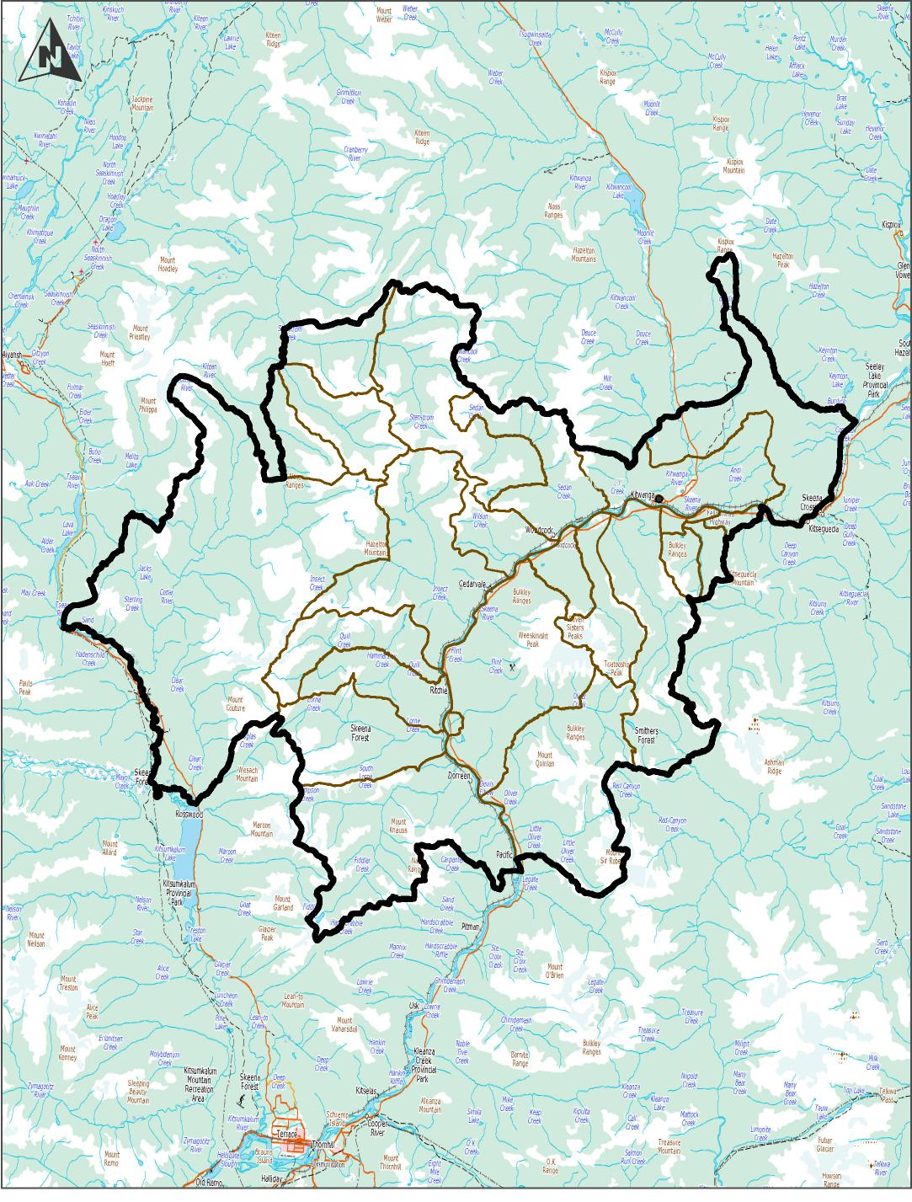
Gitwangak

GUIDING PRINCIPLES FOR THE DEVELOPMENT OF OBJECTIVES AND STRATEGIES FOR MANAGEMENT OF GITWANGAK CULTURAL RESOURCES

The following are the main guiding principles upon which the objectives and strategies for management and protection of cultural resources are based. These principles are founded in our Ayookxw (Gitxsan law) and supported by recent legal decisions.

- Sustaining the land and the ecological resources of the land is central to Gitwangak cultural heritage. Gitwangak culture is directly connected to and dependent upon the presence and quality of the ecological resources of Gitwangak Territory. Gitwangak land and the resources of the land must be treated with respect.
- Current generations of Gitwangak hold and manage their Territories IN TRUST for future generations. Current generations may take what they need but must not waste, in order that the Territories will sustain future generations.
- We, the Gitwangak, are the owners and caretakers of our intellectual properties, cultural sites and features, and artifacts. These cultural resources were developed through time by Gitwangak and belong to the Gitwangak. The Gitwangak Huwilp members are strongly connected to these resources. Current generations have the responsibility to preserve these resources in order that they may be inherited by future generations of Gitwangak.
- The date of 1846, established in the Provincial Heritage Conservation Act as the cut-off date for the protection of archaeological resources, has no relevance to the Gitwangak in determination of Gitwangak cultural values and importance of Gitwangak cultural resources, including archaeological resources. We, the Gitwangak, have the right and responsibility to maintain, protect, preserve, and develop our cultural resources; the right and responsibility includes past, present, and future expressions of our culture.
- It is of great importance to share Gitwangak history and culture, both internally with young generations of Gitwangak, and with other peoples, in order to:
- inform and educate all peoples about Gitwangak heritage and culture
- promote understanding of and respect for the land and the cultural heritage that has developed from the land
- promote recognition of the need for sustainable management of the land and preservation of Gitwangak cultural heritage resources
- promote cultural continuity and revitalization.
- Gitwangak cultural interests must be effectively communicated to government, industry, and other peoples in a manner that:
    - is culturally appropriate to Gitwangak
    - is relevant to non-aboriginal agencies and people
    - establishes cross-cultural respect and understanding with government, industry, and other peoples.

CULTURAL AND ARCHAEOLOGICAL TERMINOLOGY

The following section is a summary of terms and concepts used in this document, along with general descriptions to provide a common basis for understanding. These definitions and descriptions have been established by balancing principles from Gitwangak culture with standard resource management practices.

- ARCHAEOLOGICAL IMPACT ASSESSMENT (AIA): A detailed field analysis of an area (generally small and localized), conducted by a professional archaeologist. The analysis is generally based on information from an Archaeological Overview Assessment (AOA) that indicates a moderate to high archaeological potential of the area and is primarily conducted on behalf of a company planning a development. The AIA requires a permit to be issued by the Provincial Archaeology Branch to the archaeologist that will conduct the analysis. A copy of the application for the permit will be sent to Gitwangak by the Archaeology Branch, with a request for Gitwangak comment to be submitted within 30 days.

- ARCHAEOLOGICAL OVERVIEW ASSESSMENT (AOA): An office-based exercise, conducted by an archaeologist, that provides mapped overview zonation of an area (Gitwangak Territory) into low, medium, and high potential for the presence of cultural sites, features, and artifacts. Considered in the assessment are criteria such as topographic features, locations of natural resources, traditional knowledge, and cultural heritage. The AOA is utilized to focus the Preliminary Field Reconnaissance (PFR) and Archaeological Impact Analysis (AIA).

- ARCHAEOLOGICAL SITES: A location that contains physical evidence of past human activity and that delivers its primary documentation and interpretative information through archaeological research techniques. (Archaeology Branch, 2008 )
- An Archaeological Site is a subset of Traditional Use Sites.

- BUFFER ZONE: An area of land surrounding a cultural resource in order to provide protection to the cultural resource. The buffer zone is restricted from industrial development. Buffer zones can vary in width, depending on Gitwangak cultural importance, category of resource, and site-specific criteria. Dimensions of a buffer zone will be implemented and recorded as horizontal distance, measured from the outside edge of the defined resource. Establishment of buffer zones requires documentation of the cultural and scientific rationale for the buffer zone.
- CONSERVATION: any activity undertaken to protect, preserve, or enhance the heritage value of Gitwangak heritage property. Heritage value is the historical, cultural, aesthetic, scientific, or educational worth, or usefulness of a site or object (Heritage Conservation Act [RSBC 1996] Chapter 187).

- CULTURAL AREAS: Any area within Gitwangak Territory that the Gitwangak consider has cultural importance, regardless of the presence or absence of physical remains of activities or beliefs.

- CULTURAL HERITAGE RESOURCES (also termed as CULTURAL RESOURCES in the Land Use Plan text): Those cultural resources considered culturally important to the Gitwangak; resources that provide a connection or linkage between the past, present, and future of Gitwangak, including, but not limited to:

- Gitwangak Territory and House Territories
- Fish, wildlife, plants
- Water
- Land forms, landmarks, place names
- Cultural areas
- Gitwangak Traditional Cultural Expressions
- Cultural sites and features
- Artifacts

- CULTURAL HERITAGE RESOURCE FIELD ASSESSMENT (CHRFA): A field reconnaissance of an area (small or large) to assess the existence of or potential for the presence of cultural sites and features. The field reconnaissance does not require a permit from the Provincial Archaeology Branch and does not require a formal Archaeologist Report to be submitted to the Provincial Archaeology Branch. In order to carry out a CHRFA on Gitwangak Territory, the assessing person(s) must meet one of the following three criteria:

    - Is a registered professional in good standing with the Association of B.C. Forestry Professionals and has
      - demonstrated experience in identifying cultural heritage sites and resources
      - received specific training from the Gitwangak on the importance and identification of Gitwangak cultural heritage sites and features
      - developed a consistent mechanism, suitable to Gitwangak and the development proponent, for recording and reporting on the assessment of cultural heritage resources, or,
    - Is an individual, Gitwangak or non-Gitwangak, authorized by the Office of the Hereditary Chiefs to conduct Cultural Heritage Resources Assessments on Gitwangak Territory, or
    - Is a qualified professional archaeologist, with experience in field assessments of First Nations cultural heritage resources within the general cultural area of the British Columbia Northwest Coast-Interior Plateau.

- CULTURAL SITES: Any site that is of cultural value to the Gitwangak; places where cultural practices were/are conducted; places that provide significant connections to the heritage/history of a people.

Cultural sites include ALL sites of cultural value to Gitwangak, without constraint of historical age or material remains. Cultural sites are integral to the cultural heritage of a people.

Cultural sites (including archaeological sites and designated Heritage Sites) include:
- land forms/landscapes; place names within Gitwangak Territory
- features; land that has been modified by activities or practices of the Gitwangak; cannot be removed from the site without destroying the feature, i.e. an integral part of the landscape within which the feature is situated. Examples of features include:
    - house depressions
    - trails
    - cache pits
    - Culturally Modified Trees (CMTs)
    - grave sites
    - artifacts; objects that have been manufactured by Gitwangak; are within a site but can be removed from the site. The cultural site is the specific location on the land where the artifacts are located; the type of artifact determines the nature of the site and influences the cultural value and significance of the site. Examples of artifacts include:
- totem poles
- projectile points
- chipped stone flakes
- tools
- pottery, baskets, boxes

- CULTURAL VALUE: The cultural value or ethnic significance, of any particular element of Gitwangak heritage reflects the nature of the attachment/connections between the land, object, site, or knowledge, and its original owner/maker or caretaker. Land, objects, sites, or knowledge that were/are most dear to the owner/maker/caretaker are those that hold the highest cultural value.

- All Gitwangak cultural heritage resources have an inherent cultural value.
- Assignment of a “low” cultural value is a ranking of value relative to other cultural heritage resources and should not be considered as a lack of respect for the Gitwangak heritage resource.
- Cultural value can be determined only by the Gitwangak people. Determination of cultural value is the responsibility of the current owner/caretaker of the resources.
- For purposes of preparation of this Gitwangak Land Use Plan, cultural heritage resources are assigned a relative cultural value ranging from very high to low, based on the Gitwangak attachment/connection to the resource.
- The Gitwangak attachment/connection to the resource could include, but not be limited to, one or more of:
- spiritual
- historic/heritage
- emotional
- practical
- education
- economic
- legal:
integral to and embedded within these attachments/connections is the “sense of place” held by the Gitwangak.

- CULTURE: A shared, learned, system of values, beliefs, and attitudes that shape and influence perception and behaviour.

- Culture includes all that a people inherit from the past, practice in the present, and protect for future Gitwangak generations; that identifies and defines who and what the people are. The culture is formed by the land, and includes the language, customs, laws, practices, foods, clothing, spirituality, art, songs, dress, appearance, stories, oral histories, and traditional knowledge of the Gitwangak.
- Culture is an integral part of the heritage of the Gitwangak and cannot be separated from the land and resources where the people lived and developed.

- GITWANGAK TRADITIONAL CULTURAL EXPRESSIONS: Gitwangak Traditional Cultural Expressions are Gitwangak Intellectual Properties of any form, whether tangible or intangible, in which Gitwangak traditional culture and knowledge (including ecological knowledge) are expressed, appear, or are revealed, and comprise the following forms or combinations of forms of expression:

  - verbal expressions, such as Gitwangak Adawaak ( oral histories), Simalgy’ax language, Ayookxw (law), stories, epics, legends, poetry, riddles and other narratives; words, signs, names (including geographical place names), and symbols;

  - musical expressions, such as songs, Limx’oy (laments), and instrumental music;

  - spiritual expressions

  - expressions by action, such as dances, plays, ceremonies, rituals and other performances;
whether or not reduced to a material form; and

  - tangible expressions, such as productions of art, in particular, drawings, designs, paintings, carvings, sculptures, woodwork, metalware, jewelry, baskets, needlework, textiles, dress, costumes; handicrafts; musical instruments; Ayuuks (family crests); Git’mgan (totem poles); and architectural forms;

which are
          - the products of creative intellectual activity, including individual and collective creativity;
          - characteristic of Gitwangak cultural and social identity and cultural heritage;

          - maintained, used or developed by the Gitwangak community, or by individuals having the right and responsibility to do so in accordance with Gitwangak law and practice.

Gitwangak Traditional Cultural Expressions are properties owned by the Gitwangak who maintain, protect, and develop them primarily as cultural resources. However, these properties may also be economic assets that can be, if Gitwangak wishes, traded or licensed for income generation and economic development.

Gitwangak Traditional Cultural Expressions evolved from and were shaped by the surrounding land and the natural resources of the land; they are directly and inextricably connected to and reliant upon the sustained presence and quality of the ecological resources of the land. Traditional Cultural Expressions are expressions of Gitwangak beliefs and values, embodiments of Gitwangak skills and know-how, and reflections of Gitwangak history. Traditional Cultural Expressions are strongly connected to Gitwangak Huwilp members and are of great cultural value to Gitwangak, defining very clearly the identity of the Gitwangak people; who we are and how we connect to our Territories.

- HERITAGE: What a people inherit; the shared, inherited, history and culture of the Gitwangak people, providing connections between the past, present, and future:
- the land and land forms where they lived
- the customs, practices, and laws of the Gitwangak people
- the resources of the land that were utilized
- the oral or written history
- the sites where customs/traditions were conducted
- the traditional knowledge of the people
- spiritual and material realms

- HERITAGE INSPECTION: a physical examination and other research necessary

  - to identify the heritage value of a property or a portion of it, and,
  - to establish, if the property is a heritage site or heritage object,

    - the need for protection or conservation, or,
    - conformance with heritage protection requirements (Province of BC, 2009).

- HERITAGE INVESTIGATION: An archaeological or other systematic study of heritage property to record its history, and may include the recording, removal, and analysis of artifacts, features, and other material necessary for the purposes of heritage investigations (Province of BC, 2009).

- PRELIMINARY FIELD RECONNAISSANCE (PFR): A preliminary field investigation of an area (small or large) to assess the existence of or potential for the presence of cultural sites and features, and to recommend more detailed archaeological field studies where appropriate. Does not require a permit from the Provincial Archaeology Branch and does not require a formal Archaeology Report to be submitted to the Provincial Archaeology Branch.

- SENSE OF PLACE: A feeling or perception held by Gitwangak to a certain place on the landscape. This “place” on the landscape will possess a strong identity and character, and a high degree of authenticity to which people attribute a special meaning and relationship. The loss of “sense of place” may have significant impact on individuals and communities with connections to that place; “sense of place” needs to be considered in any management decision regarding cultural resources (adapted from Cresswell, 2005; Budhwa, 2008).

- SIGNIFICANCE: An overall ranking of the importance or noteworthiness of a particular element of Gitwangak heritage. There are many considerations to evaluating significance: the primary consideration is cultural value. Additional considerations could include:
- educational value
- scientific value
- historic value
- economic value
- legal value
- rarity.
  - Determination of the significance of a cultural heritage resource is complex, may be very time consuming, and involves consideration and balance of a number of values that frequently may compete.
  - Significance is generally determined by an archaeologist, following archaeological investigation of the cultural resource.
  - Determination of significance needs to consider not only the cultural value to the Gitwangak people but the diversity and range of values to the broader community at the local, regional, and Provincial level.

- TRADITIONAL USE: Any Gitwangak use of any aspect of Gitwangak Traditional Territory.

- TRADITIONAL USE AREA: A broad cultural area, as opposed to a localized, specific site, within which landscape-level cultural activities such as hunting and trapping occur. The traditional use area encompasses the cultural sites, features, artifacts, and cultural trails.

- TRADITIONAL USE SITE: Specific places within the landscape where traditional activities were/are performed. Traditional Use Sites may lack physical evidence of human-made artifacts or structures, yet maintain cultural significance to a living community of people. Determination of the importance of a site needs to consider the use of the site in relation to the function of the larger House Territory or entire Gitwangak Territory.

- TRAILS: Paths or corridors used by Gitwangak for trade, travel, or migration; trails often connect the entire landscape, building links between traditional use areas and between different Nations.

MANAGEMENT DIRECTION: OBJECTIVES AND STRATEGIES

For each resource or resource use, management direction presents:

- A preamble that provides context for the objectives and strategies, states concerns or issues regarding the resource, and states the management intent as broad goals for management of the resource.

- Objectives for the resource or resource use that state WHAT the end result or desired future conditions are to achieve the broad goals or management intent, and provide a reference to the LUP map to indicate WHERE these results or conditions are desired. Objectives are intended to be measurable, time specific, geographically specific, and can apply to the whole plan area or to specified parts of the plan area.

- Strategies that are designed to achieve the stated objectives. Strategies describe HOW the objective may be achieved, and relate to activities and how those activities (forest practices) may be conducted.

- Rationale for the objectives and strategies.

- For each Objective, management direction also provides recommended examples of an SRMP format, providing Measures, Targets, and Management Considerations. These parameters provide measurable criteria for achievement of the stated Objective and are recommended for inclusion into a legal format of this Gitwangak Land Use Plan.

Consultation Policy

Currently, consultation with Gitwangak is a legally required government-to-government process. There is no legal requirement for consultation between Gitwangak and development proponents who intend to implement developments on Gitwangak Territory.

The present legally-required consultation is a process whereby the provincial government agencies refer prepared development proponent plans to Gitwangak for review and discussion. Frequently, Gitwangak does not conduct any review or provide any response to the referral information, for reasons including:

- lack of internal organization and capacity to provide a review and response
- lack of comprehension of the scope and technical content of the plans
- lack of interest and commitment
- lack of time and funding to complete the review and response.
There is no organized, structured consultation process directly with development proponents that will ensure that Gitwangak concerns and perspectives are incorporated into the development proponent plans prior to proponent investments of time and money in development of their plans. Therefore, development proponent plans are implemented without knowledge or consideration of our concerns, interests, and cultural and subsistence use of our Territories.
The result has been damage to water, fish, and wildlife habitat, loss of biodiversity, loss of subsistence foods, medicines, ceremonial resources, and cultural sites, and reductions in our ability to exercise our Aboriginal Rights on our Gitwangak Territories.
Gitwangak Huwilp members are concerned about the ineffectiveness of the current consultation process, and we desire to implement effective, meaningful consultation with all appropriate levels of government and with all development proponents regarding any planned developments on our Territories.
We desire meaningful consultations regarding:
- cultural and heritage resources, including all natural resources of the Territories
- economic opportunities for Gitwangak Huwilp members
- monitoring and reporting implementation and impacts of all developments on our Territories.

Consultation can occur at two levels:

- Government-to-government consultation; Gitwangak government, federal government, and provincial government
- Consultation with development proponents as an integral component of working relationships.

Government-to-government consultation is at a higher level than Land Use Plans, is legally required, and therefore is not a component of this Land Use Plan.
Consultation directed by this Land Use Plan is intended to address the potential physical impacts on Gitwangak cultural resources that may result from development activities on Gitwangak Territory. The intent is to conserve our cultural resources through development of mutual understanding and working relationships between Gitwangak Huwilp members and development proponents.

Natural resources are integral to the heritage and culture of the Gitwangak; our heritage and culture was formed by the land and the resources of the land, and cannot be considered separate from the land. Consultation regarding cultural resources includes consultation around management of the natural resources from which Gitwangak culture and cultural resources developed.

Meaningful consultation between development proponents and the Chief of the House Territory on which the development will occur is a primary component of management and conservation of Gitwangak cultural resources, and is mutually beneficial to all parties.

Meaningful consultation with respect to Gitwangak cultural heritage may be defined as:

- The proponent has provided to the appropriate House Chief (or Chiefs) all information relevant to a proposed development, including relevant maps, to enable Gitwangak to determine the potential impact of the development on Gitwangak cultural and natural resources.

- The House Chief (or Chiefs) has provided to the proponent all appropriate information relevant to Gitwangak cultural resources, including relevant maps, to enable the proponent to comprehend the Gitwangak interests in conservation of our cultural heritage.

- The proponent and House Chief (or Chiefs) have met and discussed the above information and have made every reasonable effort to reach agreement on how a development could proceed in a manner that will meet Gitwangak cultural interests for conservation of our cultural and natural resources.

- The proponent has incorporated measures into plans for the development that recognize, respect, manage, and conserve Gitwangak cultural and natural resources.

The optimum timing for initial consultation with development proponents regarding cultural and natural resources is during the annual discussion when proponents can present to Gitwangak their development proposals for the upcoming year.

We have historically, for thousands of years, currently, and into the future will continue to occupy and utilize our Gitwangak Territories for subsistence, cultural, and spiritual purposes. Our Territory is our home and our “breadbasket.” We expect and require all development proponents that wish to operate on our Territory to compensate Gitwangak for the privilege of working on our Territory.

OBJECTIVE

To protect Gitwangak cultural and natural resources through consultation; to develop and maintain effective and respectful working relationships with development proponents.

      - STRATEGIES

- All proposed developments on Gitwangak Territories will require consultation regarding cultural and natural resources prior to any field work or permitting for field work.

  - All requests and referrals for consultation and/or information will be submitted by development proponents to the Gitwangak Watershed Facilitator. The Gitwangak Facilitator will ensure that appropriate Hereditary Chiefs and representatives receive the submitted information in a timely manner to permit a timely response to the proponent.

  - Consultation will be conducted in a timely manner, commensurate with the size and complexity of the proposed developments.

- Consultations will require meetings with all relevant persons in attendance. All relevant persons includes representatives of the development proponent, the Chiefs of the affected House Territories, and the Office of the Hereditary Chiefs. Gitwangak will participate as a group. Chiefs of each Territory have the final responsibility for all resource management decisions for their Territory. The Office of the Hereditary Chiefs will facilitate the meetings, assist, and support the House Chiefs during consultation, and will assist the House Chief in internal discussions and determination of the final decisions. The House Chief may choose to consult with House members prior to making a final decision.

- Development proponent personnel that attend consultation meetings will be persons that have the authority to negotiate agreements and modify proponent plans as a result of the consultations.

- Consultation meetings with development proponents will occur annually, at an agreed date whereby the proponent will present their annual and long-term plans. Consultation meetings will also occur quarterly throughout the year, to present monitoring reports regarding development progress, impacts to our Territories, and progress on accommodation of Gitwangak interests. Meeting schedules can be revised by mutual consent of Gitwangak and the proponent.

- Consultation, to the extent possible, will have continuity of persons in attendance, in order to develop and maintain a continuous level of understanding of information exchanged and working relationships developed. Continuity of persons involved allows for continuous building of information, understanding, confidence, and trust, as opposed to starting over with new faces and personalities.

- Funding for consultation meetings and monitoring will be negotiated with and provided by the development proponent.

- A royalty payment to the affected Gitwangak House, based on the volume of the resource harvested/removed from or otherwise provided by the House Territory, will be paid by the development proponent for the privilege of working on Gitwangak Territory. Amount and terms of the royalty payment will be negotiated by the Gitwangak Hereditary Chiefs and the development proponent.

- Clean-up, mitigation, or restoration of damage to or contamination of the Gitwangak Territory land, air, fish, and wildlife habitats resulting from development on our Territory will be the total responsibility of the development proponent. Gitwangak will not be responsible for penalties or costs of clean-up, mitigation, or restoration resulting from the actions of development proponents.

- Consultations will occur at two levels:

- With the development proponent, at the strategic or reconnaissance level, to exchange information, identify concerns, and proactively resolve problems prior to significant financial investment;

- With the Archaeologist, at the detailed or operational level, to ensure the inclusion of Gitwangak interest and perspectives in all Heritage Inspections and Heritage Investigations permits, investigations, reports, and recommendations.

- All information regarding the location of cultural resource sites, features, and artifacts resulting from development proponent field reconnaissance or archaeological investigations will be provided to Gitwangak, with UTM co-ordinates, for inclusion in a Cultural Resource Database.

- Appendix 1 presents a recommended consultation protocol to be followed by Gitwangak and all development proponents.

- Development Proponent Responsibilities

- Prior to any implementation of field work, the development proponent and Chiefs of the affected House Territories will discuss the planned development. The intent is for information exchange:

- to inform Gitwangak as to the location and potential impact of the development

- to inform the proponent of the ecological and cultural sensitivity of the proposed development area and the Gitwangak perspective regarding the potential impact to the natural and cultural resources of the area.

Discussion means meetings with all relevant persons in attendance. All relevant persons includes the representatives of the development proponent, the Chiefs of the affected House Territories, and the Gitwangak Office of the Hereditary Chiefs. The Office of the Hereditary Chiefs will facilitate the meetings and assist and support as required the House Chiefs of the affected Territories throughout the discussion. Discussions between the development proponent and the Chiefs of the affected House Territories will occur at the strategic or reconnaissance level of the proposed development, prior to any detailed field planning and development. The intent is to proactively exchange information, identify concerns, and resolve potential problems prior to significant investment in a development.

- Gitwangak-Archaeologist Relationship

- One or more Gitwangak Huwilp members will be employed by the archaeologist as a cultural representative for any archaeological investigation on Gitwangak Territories. Members of the House Territory on which the investigation will be located will be first offered the employment opportunity.

- Prior to any application for a permit for archaeological investigations, the archaeologist that will conduct the investigation will contact the Chief of the affected House Territory for a preliminary discussion, to ensure that the permit application includes the Gitwangak perspective and to notify Gitwangak that the archaeologist plans to work on Gitwangak Territory.

- Prior to any field investigation, the archaeologist will meet with the Chief of the affected House Territory to present and discuss a detailed work plan for the investigation. At this point, Gitwangak interests and values will be integrated into the archaeological planning process.

- Following completion of the field investigation, the archaeologist will meet with the Chief of the affected House Territory to apprise Gitwangak of the work completed and results of the work, and to provide a draft copy of the final report.

- The archaeologist will make available sections of the final report to present the Gitwangak cultural perspective regarding the investigation and archaeologist recommendations, provide opportunity for Gitwangak to prepare the written submissions, and include those submissions as an integral part of the final report that will be submitted to the development proponent and the Provincial Archaeological Branch.

- Gitwangak will store the archaeological reports in a central Gitwangak information repository/database, as hard copy and in digital form.

- Awareness and Implementation of Gitwangak Consultation Policy

- The consultation policy will be made known, available, and provided to all government agencies that deal with development proponents of the various potential industries that may intend to implement projects on Gitwangak Territories.

- The consultation policy will be provided to any development proponent that directly contacts the Gitwangak Office of Hereditary Chiefs.

- The consultation policy will be provided to the Gitxsan Chiefs Office, and available to development proponents that contact the Gitxsan Chiefs Office.

- An engagement agreement will be negotiated with each development proponent regarding timing and methodology of further consultation.

Example of SRMP Legal Plan Format:
Objectives | Measures/Indicators | Targets
1.0 Conduct meaningful consultation with all proponents that plan to initiate developments on Gitwangak Territory. | 1.1 Number of proposed developments where meaningful consultation occurs with Gitwangak prior to any field activities. | All
 | 1.2 Number of proposed developments where the development proponent receives the Gitwangak Consultation Policy prior to any field activities. | All
Management Considerations:
Management considerations that advise and could be implemented by a development proponent to achieve the objectives, measures, and target, would consist of relevant strategies from Section 9.1.1.1 inserted here.

RATIONALE

- Meaningful consultation is intended to build co-operative working relationships between Gitwangak and development proponents.

- Co-operative working relationships will gradually build mutual trust, respect, and confidence in the process.

- Mutual trust, respect, and confidence will result in greater understanding of and respect for Gitwangak cultural heritage, connections to our cultural and natural resources, the cultural importance of our resources, and lead to more effective and respectful management of our resources.

Gitwangak Traditional Use Areas And Sites

Throughout (valley bottoms to alpine) the Gitwangak Traditional Territories there are numerous traditional sites and areas that were used by Gitwangak Huwilp members for a variety of traditional uses such as fishing, hunting, gathering of resources for food, medicine, cultural and ceremonial purposes, habitation, trapping, and worship. Cultural sites cannot be considered in isolation from each other: they are interconnected and relied on together through the seasons; the loss of one site impacts the other sites. Examples of these sites and areas include, but are not limited to:

- Sacred sites
- Fishing sites.
- Village sites.
- Medicinal plant sites.
- Culturally modified trees (CMT).
- Food gathering sites.
- Hunting and trapping areas
- Boundary markers.

Many of these sites receive contemporary use; other sites are not currently used but retain significant cultural, historical and legal value. Many of the Traditional Use Sites have been accurately located using G.P.S. technology, and mapped precisely according to G.P.S. derived co-ordinates. Other sites have been documented but not accurately mapped. Still other sites are known to Gitwangak Huwilp members but have not been documented or mapped through Traditional Use Studies.

The continued existence of traditional use sites and archaeological sites, in the present and into the future, is of great importance to Gitwangak Huwilp members:

- As a historic, emotional and spiritual connection to our lands.
- As a cultural museum for education of Gitwangak youth and the general public about Gitwangak history and culture.
- As legal proof of historical Gitwangak occupancy and use of Gitwangak Territories. The sites must remain in existence in order to facilitate Archaeological surveys to prove Gitwangak ownership of our territories before European contact and 1846.

In the past several decades construction of Highway 16 and logging roads, and clearcut harvesting of timber has damaged or destroyed many traditional use sites. Cabins have been destroyed, medicinal and food plant sites, trapping and hunting areas have been logged, trails accessing and connecting these areas have been obliterated, and aquatic and terrestrial habitats for fish, bird and mammal species traditionally used by Gitwangak Huwilp members have been damaged. Many areas that may have had high potential as archaeological sites have been logged or impacted by road construction without an archaeological survey.

Gitwangak Huwilp members are concerned that continued development and logging on Gitwangak Territories will destroy or damage additional traditional use sites and potential archaeological sites, and will continue to diminish our abilities and opportunities to:

- provide archaeological evidence to establish proof of Gitwangak occupancy and use of our traditional territories.
- educate future generations about Gitwangak history and culture.
- use the sites in the future to exercise Aboriginal Rights and continue traditional uses on our territories.
- develop future Gitwangak economics through cultural tourism, ecotourism, and education.

Gitwangak desire to conserve our cultural sites through meaningful consultation and avoidance of cultural sites.

The management intent (goal) is to recognize the significance of the sites to Gitwangak, and to maintain the cultural heritage resources including archaeological sites, traditional use sites and trails, and structural features (Kispiox Land and Resource Management Plan 2001)
Section 9.2 presents objectives and strategies for conservation of cultural sites. Additional sections focus on management and protection of traditional use and the natural resources of the land.

9.2.1 OBJECTIVE

Preserve identified cultural sites (see Landscape Unit map) whether pre-1846 or post-1846.

STRATEGIES

The highest priority will be conservation of cultural sites by avoidance of the sites. Specific buffer widths and other measures to conserve the site will be determined through proactive consultation for every cultural site potentially affected by a proposed development.

- No damage or disturbance to any Gitwangak cultural site, pre-1846 or post-1846, without meaningful consultation and agreement between the Gitwangak House Chief on whose Territory the site is located, and the development proponent.

- Preserve sites through avoidance of the site by establishment of a wind-firm buffer surrounding the site (or a cleared buffer, if appropriate). Width of the buffer is to be as outlined in Table 2. Primary considerations for the buffer width is the relative cultural importance to Gitwangak; additional considerations include topography, slope stability, geographic location, vegetation, and the potential for windfall.

Table 2 provides recommendations for general buffer widths to achieve acceptable levels of avoidance of cultural sites, based on the relative cultural importance to Gitwangak of the differing categories of sites as documented in Appendix 3. These are recommendations, not rigidly prescribed buffer widths, and are intended to inform development proponents of the expected “ballpark” level of protection for Gitwangak cultural sites. The intent is that the majority of sites will receive avoidance protection that closely approximates the buffer widths, but that the widths may be increased or decreased based on site-specific considerations, through proactive and meaningful consultations between the House Chief and the development proponent.

TABLE 2:
RECOMMENDED GENERAL AVOIDANCE BUFFER WIDTHS

Relative Cultural Site Importance | Recommended General Buffer Width (metres)
- Sites with cultural features above ground (e.g. fishing sites, cabin sites, cache pits):  VH  H  M-H  M, M-L  L  Included within this site category are human remains, gravesites, burial sites, and cremation sites.  (See section 9.2.A for buffer widths around grave, burial, and cremation sites.) | 200  100  75  50  25
- Sites with NO cultural features above ground (e.g. lithic scatter, buried artifacts). | 0  NO avoidance buffer distance, but no ground disturbance; no industrial or recreational activity except on frozen soils/snow pack >.75 m depth.

- Establish core ecosystems (Old Growth Management Areas) and connecting Ecosystem Networks in locations that will provide adequate protection to as many cultural sites as possible. (See Section 9.13.1 Biodiversity; Objectives and associated strategies.)

- Culturally Modified Trees (CMTs) are considered a cultural site; due to the large number and diverse locations of CMTs throughout the Territories, protection of CMTs is considered separately from other cultural sites (see Section 9.4 Culturally Modified Trees).

- Cultural sites, specific and localized in character that can be adequately protected by wind-firm buffers are detailed below. These include but are not limited to:
  - Cabin site
  - Cache pit
  - Camp site
  - Fishing site
  - Grave site, burial site, cremation pit
  - “Face” trees
  - Boundary markers
  - Trail blazes
  - Trapline blazes
  - Medicinal Plant site
  - Pictograph site
  - Smoke House site
  - Village site

Traditional Use areas that are general, large, and widespread in nature, and are not appropriate to protect and maintain through use of buffers, are:

    - Wildlife habitats
    - Hunting areas
    - Trapping areas
    - Food gathering areas
    - Mountain
    - Water

and are best described as Traditional Uses (See Section 9.3 Gitwangak Traditional Uses). Management practices to maintain these Traditional Use values are presented in Objectives 9.3.1, 9.3.2 and associated Strategies.

- Where sites have not been accurately located and mapped through GPS technology (see Gitwangak data base records), and resource development is planned, Gitwangak and development proponent jointly conduct a GPS survey, funded by the proponent, to accurately establish the site location and required buffer of surrounding timber.

- Where vandalism of a site is a concern, development proponent complete permanent deactivation of resource extraction roads not required for continuing access that provide access to within 400 meters of the site. Roads to be deactivated to a standard that will prevent motorized (4x4 truck, all-terrain vehicles, snowmobiles) access closer than 400 meters to the site.

The assessments and actions required to protect sites from vandalism, and deactivation of roads, to be determined and implemented as part of an access management plan.

- Gitwangak determine, and make known, fines and penalties that will be levied on development proponents and private citizens that damage or destroy known and mapped Gitwangak cultural sites and features.

- Gitwangak and Ministry of Forests to cooperatively prepare and place, where appropriate, signs that state the purpose of the reserves and deactivation. Location and information content of signs will be determined through consultation between Gitwangak, Province, and involved development proponents.

OBJECTIVE

Identify, make known (to Gitwangak Hereditary Chiefs, MFLNRO, and development proponents), and protect sites that to date have not been identified, documented, and shown on the LUP maps.

STRATEGIES

- When evidence of traditional use is discovered (e.g. CMTs, cache pits, structures, blazed trails, boundary markers, etc.) by Gitwangak or by development proponents, or other users of the land:

- Cease any activity that may result in damage or alteration to the site.
- Notify the Gitwangak Hereditary Chief of the House Territory, the Office of the Gitwangak Hereditary Chiefs and the Ministry of Forests of the discovery of the evidence.
- Consult with the Gitwangak House, the Office of the Gitwangak Hereditary Chiefs and the Ministry of Forests regarding how to protect the site and how the activity near the site can be continued.

- Conduct an Archaeological Impact Assessment (AIA) for every proposed development, including silviculture site preparation, that is

    - within an area of high potential for cultural heritage sites, as determined by an archaeological overview assessment (AOA)
    - within 300 meters of any cultural site listed in the Gitwangak Cultural Resource Database.
    - where a preliminary field reconnaissance (PFR) or cultural heritage resource field assessment (CHRFA) indicates there is a cultural site, or a high potential for a cultural site, that could be impacted by the proposed development.

Where the proposed development is within 200 metres of a cultural site identified in the Gitwangak Cultural Resources Database, the area to which the archaeological field examination is applied will include the cultural site and the land between the cultural site and the proposed development. The rationale is that close proximity to a cultural site increases the probability of the presence of additional cultural heritage resources. The intent is to assess the presence or absence of additional cultural heritage resources situated between the cultural site and the proposed development, and to assess the potential for impact of the development on the cultural site and any additional cultural resources situated between the site and the proposed development.

Include the results of this field examination in the archaeologist’s final report, together with recommendations for protection of the cultural site and any adjacent cultural resources present. Provide this information to the House Chief of the appropriate Territory. The level of intensity of the field examination of the cultural site and the land between the site and the proposed development will be at the discretion of the examining archaeologist, based upon the presence, absence, and type of cultural heritage resources, and may range from a reconnaissance level survey to a full AIA.

- Conduct a Cultural Heritage Resource Field Assessment (CHRFA; see Section 8.0 Definitions and Descriptions of Terminology) for any proposed development that is within an area of moderate potential for cultural sites, as determined by an Archaeological Overview Assessment (AOA):

- Where the CHRFA finds a cultural site, or a high probability of a cultural site, within or in close proximity to the proposed development, an Archaeological Impact Assessment (AIA) will be conducted for that proposed development.
- All CHRFA will require recording and reporting of the results of the field assessment to the House Chief of the appropriate Territory.
- Results of the CHRFA will be recorded in the Gitwangak cultural Resource Database.
- One or more Gitwangak Huwilp members will be employed by the development proponent as cultural representative(s) for any cultural resource field assessment on Gitwangak Territory. Members of the House Territory on which the field assessment is located will be first offered the employment opportunity.

- Gitwangak will develop and make available field cards for documentation of information that Gitwangak desires from all Archeological Impact Assessments (AIA), Preliminary Field Reconnaissance (PFR), Cultural Heritage Resource Field Assessments (CHRFA), and other forms of reconnaissance/assessments of Gitwangak cultural and natural resources. This information may be additional to information that is routinely documented by conventional AIA, PFR, and CHRFA, and will be utilized by Gitwangak to supplement and complement the standard assessment data. Field cards will be developed and distributed by the Gitwangak Office of Hereditary Chiefs and will be available to Gitwangak Chiefs and House members, general public, and all development proponents representatives that plan to conduct work on Gitwangak Territory.

OBJECTIVE

To provide a common data base of Traditional Use Sites and Archaeological Sites that makes information known to the Province and to development proponents, in order to facilitate better protection and management of Traditional Use Sites and Archaeological Sites.

      - STRATEGIES

Gitwangak to prepare and make available a common data base of known Traditional Use Sites and Archaeological Sites. Data base to be periodically updated to incorporate new or refined knowledge.

RATIONALE FOR OBJECTIVES 9.2.1, 9.2.2, 9.2.3 and associated Strategies
- Without identification and established protection, alteration, damage, and destruction of the sites will continue, with the resulting loss to Gitwangak of this historic, emotional and spiritual connection to their lands, loss of potential for education of future generations about Gitwangak history and culture, and loss of archaeological evidence to establish title to Gitwangak lands.

- Core ecosystems and connecting ecosystem networks will be established to meet biodiversity and habitat objectives. Utilizing the core ecosystems and ecosystem networks to protect Gitwangak traditional and archaeological sites ensures that the ecosystems and networks provide multiple benefits.

OBJECTIVE

Gitwangak to conduct a funded Traditional Use Study (TUS) to map the locations of Gitwangak cultural sites.

      - STRATEGIES

- Gitwangak Office of the Hereditary Chiefs prepare a business plan that:

- States the purpose and desired results of a TUS, and provides a comprehensive rationale for the need for a TUS.

- States the methodology to be applied to the TUS (e.g. interviews with elders, GPS ground trothing of information, etc.)

- Identifies the TUS implementation team skill and academic requirements, and potential team members.

- Provides estimated timelines and costs to complete the TUS.

- Identifies potential funding sources to facilitate the implementation of the TUS.

- Gitwangak Office of Hereditary Chiefs negotiates with potential funding sources to access adequate funds to conduct the TUS.

- The selected TUS team implements a TUS and records the developed, mapped, and tabulated information in a Gitwangak Cultural Heritage Resource Database.

      - RATIONALE

- In order to protect cultural sites, the location of the sites must be known, accurately mapped and described, and the relevant information must be made available to development proponents that wish to proceed with development on Gitwangak Territories.

- Without accurately mapping, describing, and recording information regarding cultural sites, culturally rich historic information known to older generations will be lost for future generations. As a result of information being lost, and cultural sites being destroyed by development as a result of lack of location information, the cultural history of future generations will become diminished and impoverished.

- Loss of cultural sites eliminates the opportunity for archaeological investigation and development of legal evidence of Gitwangak occupation and use of Gitwangak Territories.

Example of SRMP legal format for Protection of Cultural Sites:
Objectives | Measures / Indicators | Targets
1.0 Preserve cultural sites | 1.1 Number of pre-1846 cultural sites whose integrity is maintained, except where authorized by applicable legislation, and consent for alteration of Gitwangak sites is given by Gitwangak. | All
1.0 Preserve cultural sites | 1.2 Number of post 1846 Gitwangak cultural sites whose integrity is maintained, except where consented by Gitwangak. | All
1.0 Preserve cultural sites | Management Considerations  Preservation refers to mapped and unmapped cultural heritage sites.  Management of cultural heritage resources should be consistent with The Gitwangak Land Use Plan. The LUP addresses:  - Measures for preservation of different groupings of cultural heritage resources,  - Consultation protocols, and  - Procedures designed to develop effective working relationship between Gitwangak and development proponents.
2.0 Preserve cultural heritage resources | 2.1 Percentage of authorities issued for timber harvesting or road construction where consultation occurs to facilitate continued traditional uses of cultural heritage resources. | 100%
2.0 Preserve cultural heritage resources | 2.2 Percent of identified sites that are reported to Gitwangak, development proponent, and government for use in a database. | 100%
2.0 Preserve cultural heritage resources | Management Considerations  - Cultural sites include but are not limited to culturally modified trees (CMTs), trails, cache pits, house pits, grave sites, fishing sites, pictograph sites, smoke houses, cabins, camping sites and archaeological sites. Cultural areas include hunting, fishing and berry-picking areas.  - Continued mapping of cultural sites is required.  - Gitwangak are to update database of Gitwangak sites annually.  - Archaeological sites are traditional use sites such as culturally modified trees (CMTs), trails, cache pits, house pits, grave sites, pictograph sites, smoke house, cabins, artifacts, and areas traditionally used for camping, hunting, fishing and berry-picking, where archaeological investigation has occurred and found physical evidence of past human activity.
3.0 Address Gitwangak interests in access to cultural sites | 3.1 Proportion of cultural sites where Gitwangak access interests are addressed. | 100%
3.0 Address Gitwangak interests in access to cultural sites | Management Consideration  - Following consultation, interests are addressed regarding access concerns occurring before, during and following industrial development.

9.2.A Gitwangak Ancestral Human Remains

Gitwangak ancestral human remains were traditionally cremated in cremation pits that were used multiple times, as a graveyard. This practice was in use until the time of European contact, from which time human remains were interred in grave sites, within designated cemeteries, and in graves throughout Gitwangak Territories. Human remains were also buried in unmarked burial sites, the locations of which are generally unknown.
Interments within designated cemeteries were documented; burial records are maintained by the Department of Indian Affairs, Vital Statistics Branch. There are no official Indian and Northern Affairs Canada (INAC) records of burials on Gitwangak Territories outside of designated cemeteries.
Gitwangak human remains are the ancestry of current and future Gitwangak generations and are strongly connected to and highly respected by Gitwangak Huwilp members; grave sites, burial sites, cremation pits, and their human remains are sacred to Gitwangak. Additionally, sites of human remains connect family members to our histories and provide evidence of Gitwangak occupation of our Territory.
The locations of Gitwangak human remains may be known, in grave sites or cremation pits, or may be discovered through archaeological investigations, disturbance of ground by industrial activity, natural events such as stream bank erosion, wind throws, or other incidental means. Gitwangak human remains may also be repatriated to Gitwangak from museums or other sources external to Gitwangak Territories.
Human disturbance to Gitwangak ancestral human remains is an act of disrespect for Gitwangak ancestry, and is a very serious consideration for Gitwangak Huwilp members.
Gitwangak human remains may be exhumed and re-interred ONLY by following established consultation protocols, procedures, ceremonies, and rituals; otherwise, the spirit of the deceased will never rest in peace.

9.2A.1 Objective

Preserve human remains, grave sites, burial sites, and cremation pits in a manner that will retain the integrity and dignity of and respect for the human remains and sites.

9.2A.1.1 Strategies

- Disturbance to Gitwangak Human Remains

- There should be NO human disturbance to Gitwangak ancestral human remains, whether in a designated cemetery, a known grave, burial, or cremation pit site, or discovered incidentally through archaeological investigation, industrial development activity, or other means.

- Where a natural event such as stream bank erosion has exposed or threatens to disturb human remains, the remains may be exhumed and re-buried at another location.

- It is recognized that some disturbance to a site may occur as a result of archaeological investigation. In the event that archeological investigation discovers human remains, the archeologist will immediately cease investigation of that site and request consultation and instruction from the appropriate Gitwangak representative (see Strategy [iii]) regarding further disturbance to the site and the human remains.

- Industrial development will not be accepted as an appropriate reason for disturbing Gitwangak ancestral human remains. In the event of a conflict from a development, either planned or in progress, the highest priority approach will be to relocate the development so that the human remains and the site on which the remains are located are not disturbed.

- It is the responsibility of every corporation that plans a development on Gitwangak Territory to conduct sufficiently detailed archaeological investigations to locate cultural sites that contain human remains prior to commencing the development, in order that the development may be effectively relocated without a loss of infrastructure investment.

- In the event that the development cannot be relocated in a manner and to a location that will protect the human remains from disturbance, or where human remains are incidentally discovered during a development, planning and progress of the development will cease. Representatives of the development company will notify and consult with the appropriate Gitwangak representatives (see Strategy [ii] and Strategy [iii]). The Gitwangak and Company representatives will jointly prepare, subject to any RCMP investigation, a plan regarding management of the human remains.

- Notification of Discovery of Human Remains on Gitwangak Territory

- When human remains are discovered by any means, the person or corporation that made the discovery will immediately notify:

    - The Gitwangak Office of the Hereditary Chiefs. The Facilitator of the Gitwangak Hereditary Chiefs will direct the notifications to the Chief of the House Territory on which the human remains were discovered. The Chief will notify immediate family members, if known.

- Discovery of any human remains, under Canadian law, must be immediately reported to the RCMP in order that the RCMP may investigate and determine whether or not there has been a crime committed.

The RCMP will follow established legal and internal procedures, which usually includes:
    - Contact with a Coroner
    - Contact with a professional archaeologist to examine the site and remains. Given the sensitive nature of human remains, the Gitwangak must have input regarding the archaeologist who is contracted to carry out the examination
    - Determining if the human remains need to be exhumed for further forensic analysis. This would be a joint RCMP and Gitwangak decision.
    - Analyzing exhumed remains as required to determine ancestry, age, sex, etc.
    - Returning the remains to Gitwangak for further analysis or burial as soon as the RCMP have no further need to hold the remains.

- When the human remains are returned by the RCMP to Gitwangak, the Chief of the House Territory on which the remains were discovered will receive the remains.

- Consultation Regarding Human Remains

- Any investigation of a site will cease upon discovery of human remains. The archaeologist or other project leader will consult with the Chief of the House Territory on which the remains are located and request instructions, subject to any RCMP investigation, regarding:

    - Further site investigations
    - Exhumation of the human remains
    - Analysis of the remains for ancestry, age, sex to provide Gitwangak with historical data and evidence of occupation of the Territory
    - Re-burial of the remains.

- Plans for developments that may disturb human remains will not be implemented without meaningful consultation with Gitwangak; any progress on a development that has disturbed human remains will immediately cease operation. Representatives of the development company will consult with all of the following:

    - Gitwangak Office of the Hereditary Chiefs
    - Chief of the affected House Territory
    - Living family members of the remains, if known

regarding the development, whether planned or in progress.

The first consideration, of the highest priority, will be to preserve the human remains in its primary context (i.e. where the remains were originally discovered) in order to retain the cultural and archaeological values. The primary method of preservation, of highest priority, will be to relocate the development to avoid disturbance to the human remains. The development may proceed only if there is no possible means to relocate the project. Where the development cannot be relocated to protect the remains, Gitwangak and the company representatives will jointly prepare a plan, subject to any RCMP investigation, that provides measures for:

    - Methodology of exhuming the human remains
    - Who will conduct the exhumation of remains
    - Required analysis of the remains for ancestry, age, sex, etc. to provide data for Gitwangak historical records and evidence of occupation
    - Where the remains will be re-buried
    - The re-burial ceremony that will be conducted
    - Compensation to the House or family members for the disrespect to Gitwangak ancestors
    - Compensation to the House or family members for the cost of the feast that, under Gitxsan law, must be held as part of the burial ceremony.

The development corporation will be responsible for the cost of exhumation, analysis, and re-burial (including digging grave, constructing fence, and clearing buffer) of the remains, and for Gitwangak compensation. Compensation for disrespect and for the required ceremonies and feast will be approximately $10,000; the exact amount will be negotiated with the House and/or family members.

- The Facilitator of the Gitwangak Office of Hereditary Chiefs will receive any notifications of developments that may disturb human remains, and will direct the requests to the Chief of the relevant House Territory for consultation and decisions regarding the human remains.

- Repatriation of Gitwangak Human Remains

- Repatriation relates only to Gitwangak Huwilp members; repatriation does not involve development corporations.

- In the event that human remains of Gitwangak ancestors outside the Traditional Territory become known, the Gitwangak Office of the Hereditary Chiefs will pursue repatriation of these remains to Gitwangak Territory.

- Gitwangak ancestral human remains that are repatriated to Gitwangak will be received by the Chief of the House Territory from which the remains were taken, if known. Otherwise, the remains will be received by the Facilitator of the Gitwangak Office of the Hereditary Chiefs.

- The repatriated human remains will be buried on the House Territory from which they were taken. If the Territory of origin is unknown, the remains will be interred in the Gitwangak cemetery.

- Burial ceremonies for repatriated remains will be the same as for all other Gitwangak reburial ceremonies.

- Procedures for Exhumation and Reburial of Gitwangak Human Remains

- Any Gitwangak ancestral remains that have been exhumed or repatriated should be reburied on Gitwangak Territories.

- When remains are exhumed and reburied, the interment site chosen will be as close to the original site as possible, or in the Gitwangak cemetery, at the discretion of the family members, if known.

- When it is unknown as to family, house, or clan of the human remains, burial or exhumation and reburial of the remains will be the joint responsibility of all Gitwangak clans.

- The closest living relative, the House, or the Facilitator of the Office of the Gitwangak Hereditary Chiefs, on behalf of all the Gitwangak clans will:

    - determine the type of ceremony (traditional or current-day practices)
    - select the site for re-burial
    - supervise the exhumation of the remains
    - arrange for the casket
    - re-enact the burial ceremony in the chosen location
    - hold a feast to inform Gitwangak Huwilp members what has been done and to pay for the work.

- When the remains are re-buried on the original site, for example on the site of an archaeological investigation, Gitwangak Huwilp members will hold a ceremony to pay respect and to witness that the process was completed to Gitwangak standards.

- When remains are exhumed from within a cemetery with records of the original burial, documentation that the remains were exhumed and reburied in another part of the cemetery will be submitted by the Office of the Hereditary Chiefs to the Department of Indian Affairs, Vital Statistics.

- Reburial of human remains on the Territory will have the same reburial ceremonies as held within a Gitwangak cemetery. Repatriated remains will have the same ceremonies as for any other Gitwangak ancestral human remains.

- Gitwangak Internal Reburial Ceremonies

The procedure for reburial may follow traditional practices or current-day practices.

- The Gitwangak House Group must be notified by the archaeologist as to when the return of remains is to occur. Remains are to be placed in a Bent Box or casket.

- The House Chief and members shall be present upon the arrival and shall conduct the traditional ceremonies required for proper burial.

- In preparation for burial of remains, the House Group must plan and then invite others to attend the event. Upon the arrival of the remains, the chiefs will then proceed with the ceremony; singing of lament songs.

- The remains shall be brought to its original site, if possible, or taken to the Gitwangak interment site for burial. (Members of a Chief’s father clan shall be appointed to dig the grave prior to burial and place an “Outer protector box” within the grave.)

- Once the remains are buried, the Chief shall announce a feast to follow, where all workers selected shall be paid for jobs completed.

- This feast reflects that all business is conducted and is re-affirmed by the giving of gifts and by speeches made by the Guest Chiefs.

- When the family, House, or clan of the human remains is unknown, preparation, ceremonies, and burial will be the collective responsibility of all Gitwangak clans. The Facilitator of the Office of Gitwangak Hereditary Chiefs will be the representative of all clans, and will be responsible for the organization of the burial ceremonies. Cost of the burial and feast will be the responsibility of all clans, not an individual House.

- Documentation and recording of the day’s event are kept and shall be placed in the Gitwangak database.

- Management of Gitwangak Grave Sites, Cremation Pit Sites, and Burial Sites

- Grave sites, cremation pit sites, and burial sites contain the remains of Gitwangak ancestors and must be treated with respect and protected against human disturbance.

- Known sites of human remains will have the sites’ locations shown on Gitwangak database maps that are provided to development proponents, provincial government agencies, and general public as a larger map polygon with no information that identifies the specific type or location of the sites. The intent is to avoid distribution of specific information that may result in vandalism or looting of sites of human remains. The sites will remain in their present condition and will be protected from disturbance by industrial developments by:

    - consultation between the development proponent and the House Chief (see Section 9.1 Consultation)

    - application of avoidance buffer widths as outlined in Section 9.2, Objective 9.2.1 and Table 2.

- Where a proposed development cannot be relocated to avoid disturbance to a known site and identification of the specific location of a site is necessary to protect the site; where a previously unknown site has been located and disturbed through a development activity; or when human remains for any reason will be exhumed and re-interred, the site of the interred or re-interred human remains will be managed through the following practices:

    - record the specific site location with GPS co-ordinates
    - retain the original marker or provide a new and permanent marker, at Gitwangak discretion
    - clear any bush or trees from the site
    - provide a permanent protective fence around the site
    - provide a buffer zone to the interment site. The buffer zone will be cleared of forest for a distance of 1.5 site tree lengths (generally 40-60 metres) in all directions around the fence. The intent of the buffer is to prevent any falling trees from damaging the fence and site features.
    - provide permanent (concrete or steel) markers, located and mapped with accurate GPS coordinates, at each corner of the cleared buffer, to facilitate future identification and clearing of the established buffer.

- Where the site is within a protected area under the Gitwangak Land Use Plan or Kispiox, Kalum, or Bulkley SRMPs (Old Growth Management Area, Ecosystem Network reserve, rare ecosystems, designated wildlife habitat area, etc.), there will be no cleared buffer. Clearing will be restricted to trees whose roots will directly affect the gravesite.

- The buffer can initially be cleared by mechanical means; following clearing operations, the buffer zone will remain a machine-free zone.

- Clearing and fencing will occur following consultation with the development proponent. Responsibility for clearing will lie with the development company. Responsibility for costs of fencing will lie with the development company; construction of the fence will be completed by the affected Gitwangak House.

- Outside the cleared buffer, the forest can remain intact, or can be harvested or otherwise developed, subject to constraints for other cultural and land management values.

Example of SRMP legal format for Objective 9.2A.1:
Objectives | Measures / Indicators | Targets
1.0 Preserve human remains, grave sites, burial sites, and cremation pits in a manner that will retain the integrity and dignity of and respect for the human remains and sites | 1.1 Number of Gitwangak sites of human remains that retain the integrity and dignity of and respect for the human remains and sites | All
 | 1.2 Number of sites where human remains are discovered where consultation occurs regarding the exhumation and interment of the remains | All
 | 1.3 Percentage of ancestral human remains that are interred or re-interred on Gitwangak Territories or in Gitwangak cemeteries that receive established Gitwangak rituals and ceremonies | 100%
 | 1.4 Number of sites of human remains, potentially or incidentally disturbed by development activities, that are accurately mapped and identified, cleared, and protected by a permanent fence. | All
 | 1.5 Width of cleared buffer surrounding the protective site fence | 1.5 site tree lengths (generally 40-60 m)
 | 1.6 Number of sites of human remains that are disturbed by development activities where compensation is paid by development proponents to the affected House and family | All
Management Considerations
“Management Considerations are as detailed in Strategies (i) to (vii).”

Gitwangak Traditional Uses

Traditional uses describe the ways in which Gitwangak Huwilp members used our territories and the resources found on the territories. Traditional uses may be carried out on very geographically specific areas (such as fishing sites, village sites, grave sites, etc.) or may require areas that are broad in nature, (such as hunting and trapping areas and access trails).

Gitwangak Huwilp members utilized all the land on our territories, from valley bottom to alpine tundra, including swamps, streams, and lakes, to conduct our traditional uses of hunting, fishing, trapping, gathering of food and medicinal plants, and spiritual worship, to provide for our sustenance and cultural customs. A diversity of ecosystems and forest conditions including aquatic (streams, swamps, springs, lakes) systems, significant areas of mature and old forest, areas of young forest and new growth, dense forest and clearings were required to produce the variety of plants, birds, animals, and fish that were harvested and utilized.

Every House Territory historically and currently is the “breadbasket” that provides culture, foods, and medicine for the Wilp members. Traditionally, the Chief of each Territory plans for management of the resources of the Territory in a holistic manner, designed to provide for the sustenance and wellbeing of the following seven future generations of Gitwangak Huwilp members.

A list of animals, birds, fish and plants utilized by Gitwangak for traditional food, culture, medicinal and ceremonial purposes is presented in Appendix 6.

In the past several decades, clearcut timber harvesting operations have impacted much of Gitwangak lands, resulting in a loss of numerous traditional use sites, damaging or altering many areas where traditional uses were conducted, and converting structurally diverse mature and old growth forests to structurally simple young forests. As a result of the conversion from mature and old growth forests to young growth forest, large areas of habitats required to support plants, birds, fish, animals that Gitwangak Huwilp members traditionally used for sustenance and cultural purposes have been lost to Gitwangak use for many decades into the future. Therefore, on those lands, the traditional use can no longer be conducted.

Gitwangak Huwilp members are concerned that timber harvesting will continue to alter the forest and stream habitats, thereby changing forest conditions required to produce the plants, animals, birds, and fish that are necessary for Gitwangak traditional uses.

The management intent (goal) is to recognize the significance of the House Territories and associated resources to Gitwangak and to maintain the opportunities for traditional uses of our territories to provide for our culture, foods, and medicines.

OBJECTIVE

Within each House Territory, (see LUP map) maintain or restore the natural range of ecosystems and forest conditions, including areas of mature and old seral stage forest, in order to produce and sustain the resources (food, medicine, fur, water, etc.) necessary for the exercise of Aboriginal Rights and continuance of traditional uses for present and future generations (See Biodiversity Objectives 9.13.1-9).

STRATEGIES

- Within each House Territory, retain representative ecosystems or site series surrogates, at a level that will result in a moderate or lower level of risk to ecological functions.

- Within each House Territory, maintain a range of mature and old growth core ecosystems (Old Growth Management Areas), including valley bottom to high elevation forests.

- Within each House Territory, maintain ecosystem networks that contain a core of mature and old forests, to connect the core ecosystems.

- Within each House Territory, maintain wildlife movement corridors along riparian features to connect House Territories, landscapes, and low elevation ecosystems with upland ecosystems.

- Within each House Territory, within areas mapped as appropriate for timber harvesting, utilize a range of silvicultural systems, to provide a range of opening sizes, ages, and structural features. Appropriate silviculture systems include:
  - Single tree selection system.
  - Group selection system. (0.1 ha to 1.0 ha canopy gaps)
  - Range of small (1.0 ha) to large (up to 250 ha) clearcut openings, with significant structural retention.

- Within each House Territory maintain rare ecosystems as no-logging areas, and reforest harvested areas with a full range of naturally occurring species.

- Within all territories, prohibit the use of pesticides to avoid contamination of human food and medicinal plants, and damage or loss of wildlife food plants.

RATIONALE

- Gitwangak Huwilp members have a strong desire to continue our traditional uses of our Traditional Territories.
- In order to produce the variety of plants, birds, animals, and fish that were traditionally utilized, a diversity of ecosystems and forest conditions is required.
- It is believed that the application of the objectives for biodiversity and wildlife, combined with retention of large areas of mature and old forest in the Water Management Units will maintain conditions suitable for the sustainable continuation of Gitwangak traditional use of their territories.

    - OBJECTIVE

Within each House Territory (see LUP map), restore and maintain traditional berry patches, or develop and maintain new berry patches, to reclaim and restore the traditional practice of berry harvesting.

      - STRATEGIES

- Within each House Territory, identify and map the locations of traditional berry patches, and/or the location of new potentially productive berry patches, for the range of berries traditionally used by Gitwangak Huwilp members.

- Gitwangak elders, Ministry of Forest ecologists, and Forest Licensees work collaboratively to determine appropriate methods and timing to restore or develop productive berry patches.

- Gitwangak Huwilp members, Ministry of Forest ecologists, and Forest Licensees implement treatments to restore or develop the productive berry patches. Treatments may include:

  - Felling of existing forest
  - Removal of felled trees
  - Burning or other disturbance to stimulate growth of berry bushes
  - Frequent disturbance (burning or other) through time to improve soil conditions, stimulate growth of berry bushes, and remove the regenerating competing forest trees.

      - RATIONALE

- Berry harvesting of numerous berry species is a traditional practice within each House Territory; every House historically developed and maintained traditional berry patches. Historically and currently, berry patches are a cultural and subsistence resource of very high value to Gitwangak Huwilp members. For many years, the Ministry of Forests has banned the burning of forest that maintains productive berry patches, in order to develop and maintain commercial tree species for the timber industry. Many productive berry patches have been lost to Gitwangak through reforestation and lack of maintenance burning. Gitwangak Huwilp members have a desire to reclaim and restore the traditional practice of berry harvest for cultural, subsistence, and economic purposes.

- The traditional berry patches were situated in the most productive soil, moisture, and climatic conditions, located and developed through centuries of experience and knowledge of our Territories. Normal forest succession, maintained through biodiversity management practices will not reliably maintain through time highly productive berry patches within each House Territory. Frequent disturbances of specific berry patches through repeat burnings or other disturbance mechanisms is required to reliably maintain productive berry patches within each House Territory for the benefit of Gitwangak Huwilp members.

Culturally Modified Trees (Cmts)

A CMT is a tree that has been altered by aboriginal people as part of their traditional use of the forest. Non-aboriginal people also have altered trees, and it is sometimes difficult to determine if an alteration (modification) is of aboriginal or non-aboriginal origin. There are no reasons why the term “CMT” could not be applied to a tree altered by non-aboriginal people. However, the term is commonly used to refer to trees modified by aboriginal people in the course of traditional tree utilization (Culturally Modified Trees of British Columbia; Archaeology Branch, B.C. Ministry of Small Business, Tourism and Culture, March 2001).

All Gitwangak Houses throughout time have created Culturally Modified Trees. These trees are cultural features throughout the Gitwangak Territories, and are one physical, on-the-ground proof that the Gitwangak Huwilp members occupied and used our territories and exercised our Aboriginal Rights and Title throughout time. Culturally Modified Trees range in date from before 1846 through to modern times, are evidence of Gitwangak cultural continuity, and provide strong evidence of cultural practices that have survived and continued after contact with non-aboriginal people.

Many CMTs throughout the Gitwangak Territories have been removed or damaged by road construction and timber harvesting, without research, sampling, or documentation.

Gitwangak Huwilp members are concerned that continued resource development and extraction will result in further loss or damage of the CMT resource, diminishing our cultural and heritage resource, and weakening our ability to prove ownership and Aboriginal Title to our territories.

Culturally Modified Trees are included in the Land Use Plan separately from Traditional Use Sites because:

- CMTs are numerous and situated in many broad locations throughout the territories.

Culturally Modified Trees include, but are not limited to:

- bark-stripped trees
- aboriginally-logged trees; test hole, undercut, felled, sectioned, notched, planked trees
- canoe trees
- pitch and kindling collection, delimbed, message trees,
- arborglyph, arborography, blazed, cambium collection trees

and include a diversity of tree species.

Management intent is to recognize the significance of House Territories and associated resources to Gitwangak and to maintain the cultural heritage resources including archaeological sites, traditional use sites and trails, and structural features (Kispiox Land and Resources Management Plan 2001).

OBJECTIVE

Within all Gitwangak Traditional Territories, protect or sample, research, record and preserve data on ALL Culturally Modified Trees, regardless of age and type.

STRATEGIES

- All CMTs are important to Gitwangak Huwilp members, regardless of the age of the modification. The 1846 date of European contact has no relevance to our connection to and cultural importance of CMTs. All CMTs are to be managed for protection of our cultural heritage, regardless of their date.
- Any proposed development that
- has CMTs within or closely adjacent to the proposed development area
- may have CMTs on or closely adjacent to the proposed development area, as determined by an Archaeological Overview Assessment (AOA), or proximity to a recorded Gitwangak cultural site
will be subjected to an Archaeological Impact Assessment (AIA) conducted by a qualified professional archaeologist with experience in field assessments of First Nations cultural heritage within the general cultural area of the British Columbia Northwest Coast-Interior Plateau.
- All CMTs:
- within a proposed development area
- within a 100 metre radius surrounding a proposed development
- within the area between a proposed development and any cultural site recorded in the Gitwangak Cultural Resource Database, when the proposed development is located within 200 metres of the cultural site

will be recorded , to a standard of information not less than the Level 1 Site Recording Form, and preferably to the standard of the BC Archaeological Site Inventory Form.

- Where uncertainty exists regarding whether or not a tree is a CMT, apply the precautionary principle, and accept and manage the tree as a CMT.

- The highest priority will be protection of CMTs through

  - Avoidance of the CMT sites by redesign of the proposed development, or as a secondary, lower priority,
  - By retention of a buffer surrounding the CMTs, sufficiently wide to prevent wind damage to the CMT(s).

- Every CMT examined by the archaeologist will

- be photographed
- have GPS location co-ordinates recorded
- be analyzed and described on the Level 1 or BC Archeological Site Inventory Form.

The archeologist will record all historical information; additional cultural features that are present; interpret the pattern and context of the CMTs; and will provide recommendations for management and protection of the CMT(s).

- Where CMTs will be removed or damaged to facilitate the proposed development, the AIA will record all information regarding these CMTs to the standards of the BC Archaeological Site Inventory Form, regardless of the date of modification.

- All information recorded and reported by the archaeologist conducting the AIA will be submitted to:

- the Office of the Gitwangak Hereditary Chiefs, for review, assessment, and recording in the Gitwangak Cultural Heritage Resource Database
- the provincial Archaeology Branch, BC Ministry of Small Business, Tourism, and Culture, for recording in the Archaeology Branch Heritage Resource Inventory to a standard that can be used as legal evidence regarding the Gitwangak occupation and traditional use of Gitwangak Territories.

- The archaeologist who conducts the AIA will include within the Archaeological report that is submitted to the Archaeology Branch, the perspective and comments of the Gitwangak Chief of the Territory where the CMTs are located, regarding the proposed development and the archaeologist recommendations for management and protection of the CMTs affected by the proposed development.

- Disk or wedge samples of every CMT that will be removed or damaged are not arbitrarily required. However, based on meaningful consultation with the Hereditary Chief of the affected House Territory and at the discretion of the Chief, the archaeologist or development proponent will remove and analyze cross-sections from selected CMTs. Information resulting from the cross-section analysis will be submitted to the Office of the Gitwangak Hereditary Chiefs and the BC Archaeology Branch for inclusion in the Gitwangak and Province Resource Inventory Databases.

- The development proponent will not proceed with any development work prior to meaningful consultation with the Hereditary Chief of the affected House Territory, regarding the CMTs within, and adjacent to, the proposed development area.

RATIONALE

It is of great importance to Gitwangak Huwilp members that Culturally Modified Trees continue to exist undamaged on all the territories:

- As physical proof that Gitwangak Huwilp members exercised their Aboriginal Rights and Title on their territories throughout time.

- As a historic and cultural tie to their lands.

- As a part of a living cultural museum for education of present and future generations of Gitwangak and all other people.

Sample SRMP legal format for Management of CMTs:
Objectives | Measures / Indicators | Targets
4.0 Identify and record locations of CMTs; minimize impact to these where appropriate | 4.1 Percentage of identified CMTs of any historical date, recorded in a Gitwangak database. | 100%
Management Consideration
- When collecting CMT related information, best efforts should be made by forest licensee to use the procedures manual, located at: http://www.tca.gov.bc.ca/archaeology/policies/recording_culturally_modified_trees.htm
- The Gitwangak Land Use Plan includes the comprehensive CMT Policy and BMPs for CMT Management, detailed in Strategies 9.4.1.1.

Gitwangak lax’yip (traditional territories)

External boundaries of the Gitwangak Territory are actively mapped and agreed upon by Gitwangak Huwilp members. The location of boundaries of individual wilps within the larger Gitwangak Territory are occasionally a subject of discussion and uncertainty for wilp members; mapping of these internal Lax’yip boundaries may, from time to time, require re-evaluation, adjustment, and re-mapping. Adjustments to the Lax’yip boundaries requires mutual agreement and consent by the hereditary Chiefs and house members of all affected wilps. All discussions, evaluations, and agreements are made within the Feast Hall, according to Gitxsan Ayookxw.

    - OBJECTIVE
To resolve disagreements and disputes regarding the location of internal Lax’yip boundaries within the greater Gitwangak Territory.
      - STRATEGIES
      - Affected wilps discuss and provide evidence relating to the Lax’yips in question in the Feast Hall, according to Gitxsan Ayookxw.
      - Discussions and agreements are determined within the Feast Hall and witnessed by all Gitwangak Wilps.
      - Gitwangak GIS department will reflect the agreed-upon Lax’yip boundaries by adjustments to the mapped boundaries.
      - Mapping of adjusted boundaries will be made known to provincial government agencies and development proponents in order to facilitate ongoing consultation regarding planning of proposed development on Gitwangak Territory.

Cedar

One of the most important resources on Gitwangak Territories, used extensively throughout time and currently, is Western Red cedar. Cedar provided a decay resistant wood for houses and smokehouses, totems, bowls, and utensils. Cedar bark was used for baskets, mats, clothing, bats, rope, twine, and thread. Additionally, cedar and cedar bark was a form of currency in barter and trade. Cedar is also an extremely valuable commercial tree species to the forest industry. Currently, cedar is harvested at a disproportionately high rate relative to its presence in the forests, due to its high market value. Ecosystems productive for cedar are generally low elevation (<800 meters) and valley bottom sites, moist to wet, of moderate to rich nutrient status.

On Gitwangak Territories, the majority of the forest stands containing cedar have been harvested, due to the low elevation, easy access and low timber harvesting costs. Currently, the remaining forest stands with significant cedar components are being targeted for immediate harvest, due to the relatively high value of the cedar component.
Gitwangak Huwilp members observe the depletion of cedar from our territories and are concerned that a resource traditionally and currently of very high value to Gitwangak is being depleted at a rate that is not sustainable and is becoming increasingly difficult to acquire by Gitwangak for our own use.

Traditionally, Gitwangak Chiefs managed the resources of our Territories with a holistic and far-viewing perspective, planning for their flow of life from Mother Earth for seven generations in advance of future Gitwangak Huwilp members. Due to the high cultural value and practical importance, and the slow growth rates and longevity of cedar trees, our desire is to plan in advance for cedar management for not less than 15 future generations of Gitwangak Huwilp members.

Management intent is to recognize the value of the resource to Gitwangak and maintain cedar for Gitwangak use.

OBJECTIVE

Within all Gitwangak Territories where cedar grows, maintain through time a sustainable source of cedar, for Gitwangak traditional, cultural, and sustenance use.

STRATEGIES

Strategies are identified for both short-term and long-term sources of a sustainable supply of cedar for Gitwangak cultural and domestic use.

- Short-term sources: applicable for a one to twenty-year supply of cedar:

Any or a combination of these listed sources of cedar may be utilized. Short-term approaches are foreseeably applicable for the next one to twenty years before the existing supply of cedar accessible and suitable for Gitwangak requirements is depleted by timber harvesting.

- Gitwangak locate and harvest cedar logs and/or cedar bark, at any time suitable to Gitwangak, at Gitwangak expense, from any land on Gitwangak Territories that is not privately owned. Such harvest of cedar is part of Gitwangak historic traditional use and Aboriginal Rights.

- Gitwangak identify, ground reconnaissance and verify, and map the locations of specific forest stands containing cedar suitable for Gitwangak use. MFLNRO reserve these stands (including all tree species in the stands) for Gitwangak exclusive use.

- Forest Licensees agree to make cedar available to Gitwangak. Gitwangak and Forest Licensees work out an agreement whereby Gitwangak places an order for cedar of a specific size, quality, and volume, to be delivered to Gitwangak either in Gitwangak Village or other locations that are mutually acceptable. Volume of cedar may range from a single log to several truckloads of cedar. Gitwangak need to expect to pay for the purchase and delivery of the cedar logs.

- Gitwangak and Forest Licensees work out an agreement whereby the logging contractor “logs around” and leaves standing an agreed upon percentage of cedar on specific cut blocks, to be available for Gitwangak harvest at Gitwangak expense and time frame. Individual trees of appropriate quality could be marked to leave standing.

- Gitwangak and Licensees consult annually regarding proposed harvest operations on Gitwangak Territories. Licensees inform Gitwangak of the presence and quality of cedar on all cut blocks that contain cedar, and provide opportunities for Gitwangak artisans to strip cedar bark and harvest small cedar before timber harvest commences.

- Long-term source:

The long-term source is intended to ensure a long-term sustainable source of cedar for Gitwangak use. All listed strategies for developing and maintaining a sustainable cedar supply are recommended; the strategies form a holistic approach to long-term cedar management. Long-term means 200+ years; i.e., sustainable through time.

- Develop a cedar management plan for Gitwangak Territories that:
  - identifies goals of the management plan
  - identifies sites ecologically appropriate for establishment and culture of cedar
  - inventories existing cedar stands by volume, proportion of cedar content, age, height, and quality
  - documents Gitwangak current and future use cedar, estimates of Gitwangak volumes, sizes, and qualities of cedar required, and estimated areas of identified cedar stands required to provide a sustainable supply of cedar
  - identifies potential of specific cedar stands primarily for long-term cedar management, and secondarily for other species. Potential includes appropriate silvicultural and harvesting systems and access considerations.
- Implement reforestation activities, on all sites ecologically suitable for cedar establishment and growth, to plant, or otherwise establish, and culture a component of cedar, at a density designed to provide through time not less than the proportion of cedar that originally occupied the site.

- Identify areas of land within Gitwangak Territories that are ecologically suitable for the establishment and culture through time of cedar. MFLNRO reserve specific areas of cedar sites for Gitwangak exclusive use. Gitwangak manage these lands primarily as a source of cedar for Gitwangak use. Management tenures could include a Community Forest, Woodlot, or other form of legal tenure.
- Consider partnerships or co-management with Forest Licensees for long-term management of cedar to provide a sustainable supply of cedar for Gitwangak requirements and for Licensee commercial purposes.

RATIONALE

The ability to acquire Western Red cedar is of great importance to Gitwangak Huwilp members, in order to be able to continue our traditional use of our territories.

- Currently it is becoming increasingly difficult for Gitwangak to acquire cedar for our cultural purposes.

- The objective and strategies are designed to recognize the value of cedar to Gitwangak and to develop a methodology whereby cedar will be readily available to Gitwangak for traditional uses.

- Dedication of land primarily to establish and cultivate through time a component of cedar is necessary to develop cedar for totems, bent boxes, carvings, and other purposes that require large, clear cedar. Status quo forest management that will clearcut forests at age 60-100 years will produce volume but not quality; it will never produce cedar of an age and quality suitable for many Gitwangak cultural purposes.

Example of SRMP legal format for Management of Cedar
Objectives | Measures / Indicators | Targets
5.0. Maintain a sustainable source of cedar for Gitwangak traditional, cultural and subsistence use | 5.1 Percentage of polygons identified on Map XXX and specified in a management plan for a long-term supply of cedar from Gitwangak Traditional Territory for Gitwangak cultural and domestic Purposes (to be developed), that are fully reserved for Gitwangak management and harvest. | 100%
 | 5.2 Percentage of proposed cutblocks having a component of cedar, where consultation with the Gitwangak around the use of cedar occurs. | 100%
Management Considerations
- Gitwangak are required to identify to licensee our needs for traditional, cultural and subsistence needs.
- Identify the amount of available supply of cedar for Gitwangak needs.
- Licensees are required to consult with the Gitwangak on proposed or planned cutblocks that have a cedar component.

Gitwangak Interests and Vision For Future Gitwangak Use Of Territories

The Huwilp members of Gitwangak have lived and worked on our Traditional Territories for centuries.

An excellent account of Gitxsan (including Gitwangak) general Territory geography and biology, histories, language, customs, food, and medicine is provided in the Doctor of Philosophy thesis Health, Wholeness, and the Land: Gitxsan Traditional Plant Use and Healing (Leslie Main Johnson, 1997).

Through time, the resources of the Gitwangak Territories have been utilized by Gitwangak Huwilp members to provide for sustenance, cultural and spiritual values, and economic currency for barter and trade. It is of great importance to the Huwilp members of Gitwangak that we maintain our culture and our connection to and stewardship of our traditional territories.

The Gitwangak vision for future Gitwangak connection with and use of our territories includes:

- Education of present and future generations of Gitwangak, other aboriginal and non-aboriginal people regarding Gitwangak history, economics, culture, spiritual values; how Gitwangak lived, used and sustainably managed the resources of the territories through time.

- Use of Gitwangak young, educated Huwilp members to implement long-term plans and manage our Territories.

- Gitwangak Huwilp members working co-operatively together within the community to achieve our goals.

- Participate on an equal basis with Provincial and Federal agencies, Licensees, and adjacent communities in restoration of damaged ecologies throughout Gitwangak Territories.

- Participate on an equal basis with Provincial and Federal agencies, Licensees, and adjacent communities in planning, sustainable management, inventory, and monitoring of the resources of the Territories. Integrate and incorporate Gitwangak long-term plans with conventional industrial developments.

- Participate in economic activities within Gitwangak Territories, to provide economic gain to Huwilp members of Gitwangak, through resource extraction, silviculture, guiding, tourism, cultural, and educational initiatives. Participation may include revenue sharing, contracts, direct jobs, or business ventures, etc.

- When private lands, existing leases and licenses (for example, Grazing Licenses and leases, fishing, hunting, and trapping licenses etc.) on Gitwangak Territories are to be sold or returned to the Province of British Columbia, it is a Gitwangak interest that Gitwangak members be notified of all pending sales and/or returns and provided an opportunity to purchase the property or acquire the lease or license.

Throughout time, the Huwilp members of Gitwangak have been sustained by the resources of our territories; the land was our source of sustenance, culture and economic wealth. Our strong desire is to be able to continue to receive sustenance and economic benefits from our traditional territories.

In order to maintain or develop opportunities for Gitwangak to achieve our vision for our traditional territories, a holistic approach to resource management throughout the planning area is required. The holistic approach means that:

- Gitwangak, Agencies, and Licensees throughout the area work co-operatively together to provide benefits for the larger area community, by which all peoples of the region can benefit, directly or indirectly. Information exchanges among all parties regarding future long-term projects, interests, and desires is necessary.

- During resource management planning and implementation, all parties consider how best to accommodate the initiatives of the other parties, in order to diversify and expand the economies of the region and contribute to economic health and stability of the region.

- Dominant industries and agencies recognize that maintenance of healthy functioning ecosystems and development of a diverse economy is a direct benefit to the communities of the region, and thus will directly or indirectly benefit their own industry or organization.

- Implementation of objectives and strategies stated in this Land Use Plan (see Sections 9.1 to 9.13 Objectives and Strategies) will contribute to achievement of the Gitwangak vision for our territories.

- Specific projects within Gitwangak Territories that are currently being considered by Gitwangak include:

  - development of eco-tourism throughout the Territories
  - construction of cabins and tourist facilities that will attract and assist tourists to remain longer in the community, thereby providing economic benefit to Gitwangak
  - construction of a traditional cedar longhouse in the village of Gitwangak.

OBJECTIVE

Provide information to planning processes regarding educational, cultural, recreational, and economic initiatives on Gitwangak Territories by frequent information exchange between Gitwangak, Provincial Ministries, Licensees and adjacent communities.

STRATEGIES

- Gitwangak provide Licensees, Agencies, and communities with information regarding planned Gitwangak initiatives on Gitwangak Territories, in order to co-operatively maintain or develop the desired land and resource conditions required for the venture to be successful. Licensees, Agencies and communities provide information to Gitwangak regarding planned activities on Gitwangak Territories, i.e. co-operative consultation regarding Gitwangak Territories.

RATIONALE

- Gitwangak Huwilp members have a strong desire to continue to receive sustenance and economic benefits from our Traditional Territories, and to be able to maintain our cultural attachment and use of our territories.

- Other stakeholders also have an interest in receiving benefits from the resources of the land, including economic, recreational, and aesthetic benefits.

- To ensure that the required landscape condition will exist in order for Gitwangak to share in benefits from the resources of our territories, it is necessary that there be a sharing of information between Gitwangak, Province, proponents, and surrounding communities as to anticipated or planned ventures, and that there be co-operative planning of resource use to allow all stakeholders to benefit from the resources of the territory without foreclosing options for benefits by other stakeholders.

OBJECTIVE
Proactively participate in planning of all development on Gitwangak Territory.
      - STRATEGIES
- Gitwangak Huwilp members proactively and cooperatively participate with federal and provincial governments, development proponents, and adjacent communities in planning for resource development on Gitwangak Territories.
- Proactive participation is intended to negotiate appropriate types and locations of development and the practices and constraints to be applied to the developments.
- Gitwangak to participate in strategic level planning, including but not limited to:
  - Land and Resources Management Plans (LRMPs)
  - Sustainable Resource Management Plans (SRMPs)
  - Forest Stewardship Plans (FSPs)
  - Utility corridor plans
  - Other strategic plans.

- Gitwangak to participate in operational level planning, including but not limited to:

- Harvesting and silviculture plans
- Access management plans
- Mineral, gas, and oil exploration and extraction plans
- Independent Power Project plans (IPPs)
- Commercial recreation plans.

    - Gitwangak participation in plans will include:

- Government-to-government consultations
- Participation in collaborative planning with a variety of stakeholders
- Building working relationships with development proponents and adjacent communities through information exchange and cooperative and collaborative planning.

      - RATIONALE

    - Proactive planning will ensure that the Gitwangak perspective is presented, explained, and understood by development proponents before significant investment in development plans occurs.
    - Proactive planning will contribute to building of working relationships with government agencies, development proponents, and adjacent communities.

    - Improved working relationships will increase mutual respect and trust between Gitwangak and other parties, and will result in more effective communication, comprehension, and accommodation of Gitwangak interests and values.
    - Proactive planning is to the mutual benefit of all participating parties and will result in increased respect for and treatment of land and resources of Gitwangak Territory.
    - Proactive planning is not intended to block resource development but to meaningfully incorporate Gitwangak values and interests in a manner that accommodates Gitwangak culture and subsistence use of the Territory, sustains ecosystem function and viable populations of all fish and wildlife species, and permits some resource extraction.

    - OBJECTIVE

To designate portions of the Gitwangak Territories for direct management by the Gitwangak Houses for cultural, domestic, and commercial purposes.

STRATEGIES

- Gitwangak Wilps and Ministry of Forests discuss, identify, and designate areas of land within each Wilp, to be tenured as
- a Community Forest, or,
- a woodlot, or,
- other forms of tenure
for exclusive management by Gitwangak Wilps.

- Gitwangak Wilps collectively and cooperatively prepare plans that will outline objectives and strategies for management of the tenures.

RATIONALE

A forest tenure within each House Territory would provide some potential economic benefits, provide opportunity to manage select portions of each Territory in a holistic manner that could contribute to cultural and subsistence resources (such as cedar) and promote pride, stewardship, training, and capacity development in younger Huwilp members.

OBJECTIVE

Dedicate and maintain an un-roaded and un-logged land base (delineated as Water Management Units on the LUP map) within the planning area that maintains large contiguous areas of undeveloped mature and old forest for the following purposes:

- maintenance of water quality, hydrologic stability of watersheds, and fish habitat.
- maintenance of biodiversity and habitats of old growth dependent wildlife.
- maintenance of Traditional Use Sites such as trails that are linear in character and are difficult to protect and maintain where road development and timber harvesting occurs.
- maintenance of opportunities to continue Gitwangak traditional uses of the land.
- maintenance of opportunities for establishment of wilderness tourism and cultural and educational ventures, to contribute to Gitwangak economies.
- provision of certainty for Gitwangak Huwilp members that substantial areas of our Traditional Territories will remain undisturbed by industrial development and in a condition suitable for Gitwangak traditional use or future economic ventures (other than timber harvesting) that require a wilderness environment.
- Sequestration and storage of carbon.

STRATEGIES

- Identify areas of terrain and forest not appropriate for road development and timber harvest, and areas of terrain and forest considered appropriate for road development and timber harvest, based on criteria of ecological sensitivity as described in Section 4.0 Methodology Of Plan Preparation, i.e., identify a timber harvesting land base, and a non-harvesting land base.

  - Map specific headwater basin areas of terrain and timber zoned NOT appropriate for road development and timber harvest as Water Management Units (see Section 9.8 Water Quality And Hydrology, Objective 9.8.2 and associated strategies) and maintain as un-roaded, un-logged areas to contribute to watershed management, habitat and biodiversity objectives, and certainty for Gitwangak Huwilp members regarding long-term planning and management of their territories and resources.

  - Map the areas of terrain and timber zoned appropriate for road development and timber harvest as Operable Timber Harvesting Units (see Section 9.12 Timber, Objective 9.12.1 and associated strategies) which will become the “Working Forest” within which commercial timber harvesting operations can be conducted, subject to land use zonations and practices for management of non-timber resources.

RATIONALE

- Gitwangak Huwilp members throughout time have been sustained by the resources of our territories; the land was our source of sustenance, culture, and economic wealth. Our strong desire is to be able to continue to receive sustenance and economic benefits from our traditional territories.

- The Gitwangak vision for future Gitwangak connection with and use of our territories includes development of Gitwangak economics through guiding, tourism, cultural and educational initiatives, and restoration and development of traditional fisheries.

- Gitwangak require certainty that substantial areas of our territories will be maintained as un-roaded, un-logged forest, in order to facilitate our long-term planning for future development of our economies through guiding, tourism, cultural and educational initiatives, and restoration and development of traditional fisheries.

- To provide certainty for Gitwangak that the desired condition of the forest and terrain will be maintained, suitable areas of our territories require identification, mapping, and a commitment to dedicate these areas to a use other than commercial resource extraction.

- Identification and dedication of areas that are not appropriate for road development and timber harvesting, based on the criteria of ecological sensitivity and identified on the LUP map as Water Management Units will provide the desired certainty for Gitwangak Huwilp members.

- Identification and dedication of areas that are appropriate for road development and timber harvesting as Operable Timber Harvesting Units will provide certainty for the Forest Industry that there is a dedicated “Working Forest” where they can develop long-term economic and operational planning. Identification and dedication of the “Working Forest” will also provide certainty for Gitwangak Huwilp members in that we will know where road development and timber harvesting will take place; this will allow Gitwangak to formulate our long-term plans to avoid conflict with forestry operations.

Water Quality and Hydrology

The Land Use Plan area is situated primarily within the Skeena River watershed, with a small area (Upper Kiteen River valley) within the Nass River watershed, and includes many large and small tributary streams, numerous wetlands, and a few lakes. The main streams, many of the tributary streams, and the lakes provide highly productive habitat for fish. Traditionally and currently, lakes and streams provide water of high quality for Gitwangak consumption. Currently, the village of Gitwangak takes domestic water from a well on the floodplain of the Skeena River, and pumps the water to a storage tank at higher elevation, from where the water is supplied to the valley by gravity feed.
Within the Gitwangak Territory there are 48 registered water licenses and one Community Watershed with current status. Additionally, there are 31 registered water licenses that have been abandoned, cancelled, or refused.

The current registered water licenses serve diverse objectives:

- 20 licenses provide domestic water supply
- 10 licenses provide irrigation water supply
- 2 licenses provide residential electrical power water supply
- 11 licenses are intended to provide commercial/general electrical power
- 5 licenses are intended for conservation/water pond purposes.

Locations of all registered water licenses and the Community Watershed are shown on the Gitwangak Land Use Plan.

Extensive road development, skid trails, and clear cut logging of watersheds have resulted in removal of riparian vegetation, accelerated run-off, stream bank damage, diversion of groundwater and surface water flow from natural / drainage patterns, erosion, and downstream siltation of streams and lakes. Fish habitat has been negatively impacted and aquatic habitat connectivity has been distrupted.

There have been few assessments related to watershed hydrology and requirements for watershed restoration projects; as a result, there has been little stream and watershed restoration within the Plan area.

Restoration of water quality and hydrologic integrity of damaged watersheds throughout the Gitwangak Territory is of primary importance to the Gitwangak Huwilp, to restore the properly functioning condition of our streams and rivers.

As logging continues, road construction and timber harvesting will occur on increasingly steeper and broken, gullied terrains at higher elevations, and further upstream within the steep, broken, gullied valleys of Kitwanga, Cedar, and Kiteen River watersheds, and the large creek valleys tributary to the Skeena River. Clear cut areas will increasingly expand throughout the watersheds of the Plan area. The amount of soil exposure and potential for erosion and siltation will increase, as well as the potential for slope failures on the steep valley slopes. The foreseeable result will be a negative impact on water quantity, quality, and fish habitat.

Water quantity and quality (including peak flows, low flows, turbidity, temperature, and chemistry) is of primary importance to Gitwangak. Water is the giver of life, for virtually all life forms; it is the most important resource on earth. No individual stream or lake is more important than another; they are all part of a holistic ecological system that requires protection from alpine to the ocean.

Traditionally, the most important resource available to Gitwangak Huwilp members was the various fish species found throughout the rivers and lakes of the Territory. Although the traditional salmon fishing sites were located on the Skeena River, watersheds of the Territory contributed to the richness and diversity of the Skeena fishery, and fish were taken throughout the Territories by the Gitwangak people as we travelled and subsisted on our land.

Management of water quality and quantity is regulated through four acts of water legislation in British Columbia:

- Water Act
- Water Protection Act
- Drinking Water Protection Act
- Water Utilities Act (and the old Public Utilities Act)

Currently, it appears that there is no Act that provides for protection and management of groundwater. There is a proposed new Water Sustainability Act introduced by the BC government into the legislature on March 11, 2014 that may address groundwater management, and that will replace the existing Water Act.

Water held in aquifers is known as groundwater. Aquifers perform important ecological functions, such as:

- provides water for human and animal consumption
- provides groundwater inflow to rivers, streams, lakes, and wetlands
- contributes to maintaining and stabilizing flow, temperature, and volumes of surface water
- contributes to maintaining riparian habitats and riparian systems functioning.

An aquifer is defined as a saturated, permeable, geological unit that can transmit significant quantities of water under ordinary hydraulic gradients. There are two types of aquifers:

- an unconfined aquifer is an aquifer in which the water table forms the upper boundary of the aquifer. Unconfined aquifers occur near the ground surface. Examples of an unconfined aquifer include flood plains, alluvial fans, river terraces, and some glacial fluvial features. Unconfined aquifers have relatively quick recharge rates through water infiltration of the coarse porous material.
- A confined aquifer is an aquifer that is trapped between two less permeable geologic units. Confined aquifers occur at depths. The rate of recharge can be very slow and low due to the impermeable layer that confines the aquifer and resists water infiltration.

On Gitwangak Territory, there are no known mapped unconfined or confined aquifers, although there are several mapped in the adjacent Kispiox and Bulkley valleys. However, there are numerous floodplains, alluvial fans, river terraces, and glacial fluvial deposits that would be considered aquifers if investigations and mapping for aquifers were conducted.

Gitwangak concerns regarding water include:

- Lack of respect by development proponents for the value of water
- Poorly installed culverts in Highway 16 and industrial roads and the CNR
- Lack of protection for small streams, springs, wetlands, swamps, and lakes
- Lack of protection for groundwater and aquifers
- Potential future scarcity of water for human, animal, fish, and plant sustainability
- Negative impacts to water relating to the high rate of forest harvesting within Gitwangak Territory watersheds
- That continued industrial development will result in further negative impacts to water quality, watershed hydrology, and fish stocks of the Territories
- Declines in the fish stocks of the Plan area watersheds
- Blockage to fish habitat by beaver dams
- The potential for new mines, independent power projects, mineral, gas and oil exploration, transmission of dangerous good through Gitwangak Territory, and the resulting potential for negative impacts on water quality
- Potential for uncontrolled pumping of surface water and water from subsurface aquifers for commercial and/or industrial purposes
- The perceived lack of any accountability for or restoration of historic damage, and that past damage will be ignored and not restored.

The Forest and Range Evaluation Program Protocol for Evaluating the Condition of Streams and Riparian Management Areas (Province of BC; April 29, 2007) states that the properly functioning condition of riparian habitat is the ability of a stream, river, wetland, or lake, and its riparian area, to:

- withstand normal peak flood event without experiencing accelerated soil loss, abnormal movement, or bank movement,
- filter run-off,
- store and safely release water,
- maintain fish habitat in streams and riparian areas as fully connected fish habitat, so that fish habitat is not lost or isolated as a result of some management activity,
- maintain an adequate root network and large woody debris supply, and
- provide shade and reduce bank micro-climate change.

It is the interest and desire of Gitwangak Huwilp members to maintain the streams, rivers, lakes, and wetlands of our Territories in a properly functioning condition as described above. Comparison to the Range of Natural Variability can be used as a coarse-filter guide to potential impacts on attributes, and hence to assess the likelihood of achieving properly functioning condition (e.g. Riparian Management Guidebook, Province of BC 1995).

The Forest and Range Evaluation Program has developed two protocols related to water management:

- Protocol for Evaluating the Potential Impact of Forestry and range Use on Water Quality (Water Quality Management Routine Effectiveness Evaluations)
- Protocol for Evaluating the Conditions of Streams and Riparian Management Areas (Riparian Management Routine Effectiveness Evaluations).

The Gitwangak Watershed Table supports the use of these protocols as a tool for monitoring and evaluating the effectiveness of water management practices on Gitwangak Territory and to develop information that could be used to modify and improve existing practices.

Additionally, the Gitwangak interest and desire is to protect the water quality of aquifers underlying Gitwangak Territory and to restrict the removal of water from these aquifers to a rate that:
- maintain the water flows and volumes of the surface water bodies into which the unconfined aquifers flow within the Range of Natural Variability
- will not exceed the rate of water infiltration into the confined aquifers but will maintain through time the natural water levels of the aquifers.

Management intent (goals) for water resources; to protect and maintain surface and groundwater:
- To provide a safe and sufficient domestic water supply to support healthy communities.
- To maintain water quality, quantity, peak and low flows within the range of natural variability in all rivers, streams, lakes, and wetlands and to protect the hydrologic integrity of their watersheds (water quality includes temperature, turbidity, and chemistry).

Achievement of these goals is necessary to maintain our water resources in the desired properly functioning condition.

9.8.1 OBJECTIVE

Maintain the hydroriparian zone of specific rivers, streams, lakes, and wetlands as a full reserve (see Land Use Plan map).

STRATEGIES

- Identify, map, and dedicate the hydroriparian zone of these specific riparian zones to be retained as un-roaded and un-logged areas, to be managed for water quality and hydrologic integrity.

- Where required to protect the hydroriparian zone of numerous closely spaced Order 1 and Order 2 streams, the hydroriparian zone reserve will include the hydroriparian zone of these streams plus the upland area (outside the hydroriparian zone) situated between these streams.

- Road construction through the hydroriparian zone is to be permitted, where necessary, to access timber beyond these riparian features; road location and design is to be completed by a qualified professional to minimize negative impacts on water quality and hydrology.

- The number of roads through the hydroriparian reserve should be minimized; limit road crossings through the hydroriparian zone of any single stream to a single crossing.
Example of SRMP legal format for Objective 9.8.1
Objectives | Measures/Indicators | Targets
1.0 Maintain the hydroriparian zone of specific rivers, streams, lakes, and wetlands as a full reserve (see Land Use Plan map) | 1.1Percent of identified hydroriparian zones where timber harvest has occurred. | 0%
Management Considerations:
- Intent is to ensure properly functioning streams, lakes, and wetlands.
- Identify, map, and dedicate the hydroriparian zone of these specific riparian zones to be retained as un-roaded and un-logged areas, to be managed for water quality and hydrologic integrity.
- Where required to protect the hydroriparian zone of numerous closely spaced Order 1 and Order 2 streams, the hydroriparian zone reserve will include the hydroriparian zone of these streams plus the upland area (outside the hydroriparian zone) situated between these streams.
- Road construction through the hydroriparian zone is to be permitted, where necessary, to access timber beyond these riparian features; road location and design is to be completed by a qualified professional to minimize negative impacts on water quality and hydrology.
- The number of roads through the hydroriparian reserve should be minimized; limit road crossings through the hydroriparian zone of any single stream to a single crossing.

OBJECTIVE

Maintain the headwater basins of specific rivers and streams as a Special Management Zone, to be managed as Water Management Units (see Land Use Plan map).

STRATEGIES

- Identify, map, and dedicate headwater basins of specific rivers and streams that contain one or more of the following conditions:

- numerous closely spaced Order 1/Order 2 streams
- extensive areas of steep, unstable terrain
- numerous avalanche/slide tracks
- extensive areas of terrain that is difficult and expensive for road development and timber harvesting

as water management units, to be managed primarily for water quality and watershed hydrologic stability.

- The hydroriparian zone portion of the water management units to be fully reserved from road development and harvest.

- Timber harvest within the water management units to be permitted only within the areas identified “not hydroriparian zone” on the LUP map, and conducted only with non-roaded harvest systems.

Example of SRMP legal format for Objective 9.8.2:
Objective | Measures / Indicators | Targets
Ensure proper hydrological functioning of streams, lakes and wetlands within water management units identified on the Land Use Plan map as Water Management Units (WMU) | 1.1 Proportion of wetlands, lakes and streams within the WMU that have full retention of the forested area of their hydroriparian zone, excluding harvesting for traditional uses, mining, compelling forest health issues, or variances as stated in measure 1.3 below. | 100%
 | 1.2 Number of new roads allowed within Water Management Units for commercial forestry operations. | 0
 | 1.3 Number of roads currently existing within a Water Management Unit that are permanently deactivated following completion of harvesting and silviculture obligations | All
 | 1.4 Variance by which cutblocks overlapping the outer edge of the water management unit boundary may extend into the unit, while maintaining the riparian management practice applicable to the forest land base outside of it. | Up to 50% of the cutblock area, or up to 200 m distance, whichever is less
Management Considerations
- Management intent is to provide operational flexibility for cutblock planning, and to account for inaccuracies due to the scale of mapping.
 | 1.5 “Functioning condition” as defined by the Protocol for Evaluating the Condition of Streams and Riparian Management Areas, for each local and downstream stream receiving water from a cutblock within the Water Management Unit. | Properly functioning
Management Consideration
- Assessment protocol is available online at: http://www.for.gov.bc.ca/hfp/frep/site_files/indicators/Indicators-Riparian-Protocol-May2007.pdf
- Monitoring to include streams within cutblocks and streams down slope from cutblocks to which cutblock streams are tributary. The intent is to assess the cumulative hydrological impacts of accelerated snowmelt and groundwater interception as small in-block streams merge down slope from the cutblocks.

RATIONALE FOR OBJECTIVES 9.8.1, 9.8.2, AND ASSOCIATED STRATEGIES

The valleys designated as Water Management Units consist of continuous steep slopes, potentially unstable glacial till soils, many small streams and gullies, and numerous large deep side canyons. Timber development and harvesting in the Water Management Units would result in many stream crossings, steep cut and fill road slopes of exposed soil vulnerable to erosion, and may increase the potential for mass wasting and changes in the natural hydrologic regime. Because of the high fisheries values in the rivers, the consequences of increased erosion, siltation, and increased peak flows would be high.

Water Management Units are comprised primarily of hydroriparian zone terrain, where water affects the land and the land affects the water. At lower elevations occasional small areas of gentle-to-moderate slopes within forested terrain have been identified as “not hydroriparian zone.” Upper elevation slopes of several watersheds (notably Sedan Creek, Insect Creek, Quill Creek, Loren Creek, and Anweiler Creek) are primarily alpine tundra or sub-alpine forest of gentle-to-moderate slopes, rolling terrain, with many small closely spaced lakes, swamps, and Order 1 and 2 streams, many seepage sites, and with saturated soils, a high groundwater table, and a deep longlasting annual snowpack. These areas are the birthplace of water that feeds the downslope streams and will be managed as Water Management Units.

A comprehensive list of ecological functions of the hydroriparian zone, as presented in the Hydroriparian Planning Guide (2004), is provided in Appendix 2. The listed functions refer, in part, to coast ecosystems; however, the functions as listed are generally applicable to all hydroriparian ecosystems, except where referenced to specific coastal ecosystems. Appendix 2 has been included to provide an indication of the ecological values and functions of hydroriparian ecosystems in general.

The flood plains, creek fans, and adjacent slopes included in the hydroriparian zone are highly sensitive to disturbance, functionally dynamic, require the continued presence of large trees throughout to contribute to maintenance of stream bank stability and water quality, and provide high fish habitat values.
The designated Water Management Units and hydroriparian zone reserves are comprised of sites of high ecological sensitivity (see Section 4.0 Methodology); disturbance of these sites has a high probability of a negative impact on water quality, hydrologic regime, and fish habitat. Maintenance of the areas as designated Water Management Units, with no road development in Water Management Units and no road development or timber harvest within hydroriparian reserve zones will contribute significantly to:

- maintenance of water quality,
- maintenance of hydrologic integrity of watersheds,
- protection of fish habitat,
- protection of areas that are of high cultural importance, historically and currently, to Gitwangak Huwilp members,
- conservation forests for long-term sequestration and storage of carbon,
- maintenance of biodiversity and effective wildlife habitat through retention of the large contiguous areas of mature and old growth forest,
- opportunities for Gitwangak Huwilp members to continue traditional uses of their territories,
- opportunities for Gitwangak ventures in wilderness tourism and cultural education,
- maintenance of linear Traditional Use Sites, such as trails, that are difficult to protect and maintain through a landscape where road development and timber harvesting is conducted, and,
- sequestration of carbon.

    - OBJECTIVE

Protect streams, wetlands, wetland complexes, and lakes, including those that do not support populations of fish, with reserves and buffers of retained trees (see Table 3).

      - STRATEGIES

- Maintain upland reserves and buffers of trees around all riparian features as outlined in Table 3. The reserve and management zone widths presented in Table 3 are as stated in the Forest and Range Practices Act (FRPA), Forest Planning and Practices Regulations (FPPR), with the exceptions of:

- Specific riparian features included within Ecosystem Networks (see Section 9.13 Biodiversity; Objective 9.13.4 and associated Strategies).
- Specific riparian features included within Water Management Units (see Section 9.8 Water; Objective 9.8.2 and associated Strategies).
- Riparian Class S4 and S5 streams (see following rationale).
- Wetlands that are mapped as Gitwangak High Value Habitat Patches and all Riparian Class W3 wetlands (see Section 9.10 Wildlife, Objectives 9.10.6, and associated Strategies).
- Riparian Class L3 lakes.
- Retention within the Riparian Management Zone.

Gitwangak recognize the percentage retention within the Riparian Reserve Zones for Riparian Class S1, S2, S3 streams, W1 and W5 wetlands, and L1 lakes as the legally binding minimum level of retention. However, we believe and are concerned that the basal area retention percentages specified in FRPA are NOT adequate to protect and maintain riparian ecosystems in a properly functioning condition, particularly for Riparian Class S4, S5, S6 and non-classified streams, and all classes of lakes and wetlands.

In order to address the Gitwangak concerns and interests regarding the protection of riparian ecosystems, the following strategies are presented, and detailed in Table 3.

- Maintain a Riparian Reserve Zone on Riparian Class 4 and 5 streams, W3 wetlands, and L3 lakes that are not otherwise protected by Forest Ecosystem Networks, Water Management Units, or High Value Habitat Patch reserves.

- Retain trees within the Riparian Management Zones of the riparian features in (ii) above, to the levels specified in Table 3. Retain all deciduous trees and all shrub and herbaceous understory vegetation.

- Retention levels for Riparian Class 6 streams to exceed the current legally binding FRPA minimum (zero), to a level up to 100% retention, on a site specific and discretionary basis.

- Where blowdown occurs within the Riparian Reserve Zone or Riparian Management Zone, the blowdown trees will be left in place as large woody debris, as fish habitat and biodiversity resources.

- Protect non-classified streams, lakes, and wetlands wherever commercially and operationally feasible, on a site specific and discretionary basis.

- Where economically and operationally feasible, selectively remove only the high value trees and retain all low value trees, deciduous, snags, understory trees, and shrub and herbaceous vegetation within the riparian management zone of all riparian classes of streams, lakes, and wetlands, including non-classified riparian features.

- Where feasible, concentrate full cycle retention trees (wildlife tree patches) around riparian ecosystems.

- Consider protection of riparian habitat values as well as water quality when assessing and designing Riparian Management Zone retention levels.

- Consider protection of rare ecosystems when assessing and designing Riparian Management Zone retention levels.

- Consider joint monitoring by Gitwangak, MOFR, and Forest Licensees, and compilation of a common data base, of results of various retention levels. Monitor and record, on selected streams, the levels of retention, incidence of windfall, changes in stream temperature and turbidity, effectiveness of small scale connectivity habitats through the cut blocks, etc., in order to provide data for implementation of adaptive management of riparian features.
Example of SRMP legal format for Objective 9.8.3:
Objective | Measures / Indicators |  | Targets
Maintain ecological functioning of streams, rivers, wetland complexes and lakes, including those that do not support populations of fish. | 3.1 Number of rivers and streams where industrial activity has caused significant consequences for fish habitat or human water consumption by the following disturbances to channel beds or banks:  - channel bank erosion;  - channel aggradation, degradation or dewatering; or  - change in channel morphology. |  | 0
 | 3.2 Number of rivers, streams, lakes, and wetlands that maintain forested reserves and buffers around the riparian features as outlined in Table 3. |  | 100%
Management Considerations for Measure 3.2
Three studies using well-established scientific methodology evaluated the riparian function of a number of streams within the British Columbia central interior. The results were conclusive: current policies of little or no retention adjacent to streams DO NOT maintain the riparian ecosystem in a properly functioning condition. Forested reserves adjacent to these streams are required to maintain the properly functioning condition.
 | 3.3 Number of rivers, streams, lakes, and wetlands where blowdown within the RRZ and/or RMZ is retained as large woody debris |  | All
Management Considerations for Measure 3.3
LWD has habitat, biodiversity, and connectivity values, and contributes to stream morphology. Removal of blowdown will remove valuable habitat/biodiversity components from the riparian ecosystem.
Management Considerations
- “Significant” relates not to the level of disturbance but to the consequence of disturbance. A small disturbance could have a large consequence and a large disturbance could have a small consequence.
- Industrial developments include, but are not limited to; timber harvesting, road construction, building of permanent facilities.
- Operations should consider larger Riparian Reserve Zones (RRZ) than specified under the Forest and Range Practices Act for retention where possible.
- Where economically and operationally feasible, selectively remove only the high value trees within the Riparian Management Zones (RMZ).
- Removal of 50% of the basal area from the Riparian Management Zones of streams, wetlands, and lakes will permit harvesting of the highest quality, most valuable timber from the zone while retaining 50% of the basal area to contribute to protection and effective functions of the riparian ecosystems.
- Where feasible, concentrate wildlife tree patches around riparian ecosystems.
- Consider preservation of riparian habitat values, water quality, rare ecosystems and windthrow susceptibility when assessing and designing RMZs.
- Monitoring of retention levels to consider:
- Level of retention;
- Incidence of windfall;
- Changes in stream temperature and turbidity;
- Effectiveness of small scale connectivity habitats through cutblocks.
- Apply adaptive management principles in management of riparian features.
- Establish water monitoring stations on selected water bodies for long term evaluation of water quality and quantity attributes (water quality includes temperature, turbidity and chemistry).
  - Terrain stability to be considered in relation to its impact on water quality and quantity before logging. Baseline information should be gathered for watershed sub-basins prior to development. Information to consider:
- Equivalent Clearcut Area.
- Road densities in high elevations.
- Road densities for the entire sub-basin.
 | 3.4 Number of rivers and streams in riparian classes S1 to S5 where industrial activity has either:  - added large woody debris that would not naturally be in the channel; or  - removed naturally deposited large woody debris;  Except where necessary to satisfy safety considerations. | 0
Management Considerations for Measure 3.4
- Large woody debris can contribute to habitat values and hydrology of streams in a positive or negative way, and should be maintained at naturally occurring levels.
 | 3.5 Number of new roads and trails that prevent ground water from reaching natural groundwater receiving sites. | 0
Management Considerations
  - Natural groundwater drainage patterns can be maintained with adequate cross drains in roads and trails.

      - RATIONALE

The rationale for Objective 9.8.3 and associated strategies is as follows:

- Water is the most precious resource on earth; the survival of most living organisms depends on water.

- Water is part of an aquatic system; small wetlands, springs and seepages converge and become progressively larger streams. Streams that do not support fish are tributary to fish bearing streams.

- Water does not require the presence of fish to have value. Many organisms are dependent on riparian habitats that do not support fish populations.

- The cumulative channel length of small streams Riparian Class S4, S5, S6 can comprise up to 70%-80% of the total channel length within a watershed (Shreve, 1968). Three studies using well-established scientific methodology evaluated the riparian function of a number of streams within the British Columbia central interior. The results were conclusive: current policies of little or no retention adjacent to streams DO NOT maintain the riparian ecosystems in a properly functioning condition. Forested reserves adjacent to these streams are required to maintain the properly functioning condition.

- Streams, lakes, and wetlands occupy a relatively small percentage of the forested landscape and have a disproportionately high value for survival and maintenance of many forms of life.

- The trees and understory vegetation surrounding streams, wetlands, and lakes are an integral part of the riparian ecosystem, and influence water temperature, chemistry, turbidity, and food supply for fish.

- Individually, small streams, wetlands, and lakes are not very important at the landscape level; cumulatively they have great importance, as riparian habitats, and as reservoirs and feeder streams that influence the water quality and flow of larger streams.

- Reserves and buffers of trees and understory vegetation are essential around all classes of streams, lakes, and wetlands:

  - to contribute to maintenance of water quality and flow within the range of natural variability within every watershed,
  - to maintain small scale connectivity through the landscape,
  - to maintain the quality and effectiveness of riparian habitats.

- Removal of ≤50% of the basal area from the Riparian Management Zones of streams, wetlands, and lakes will permit harvesting of the highest quality, most valuable timber from the zone while retaining ≥50% of the basal area to contribute to protection and effective functions of the riparian ecosystems.
- Monitoring of retained buffers and reserves around riparian features will develop a data base of researched information that may be applied to adaptive management of riparian resources, and will contribute to achievement of the objectives for sustainable resource management.
TABLE 3: TARGET % RETENTION IN RIPARIAN RESERVE ZONES
AND RIPARIAN MANAGEMENT ZONES
Riparian Class | Reserve Zone Width (m)  (Not less than) | %Retention  (Not less than) | Management  Zone Width (m)  (Not less than) | %Retention  (Not less than)
Streams:
S1--S6 specific streams  W1-W5 specific wetlands  L1-L4 specific lakes | See Biodiversity Objectives and Wildlife Objectives, Water Management Unit Objectives 9.8.1, 9.8.2, and associated Strategies for objectives and strategies for specific rivers, streams, lakes, and wetlands.
S1 (large rivers >/= 100m width) | 0 | 0 | 100 | 50
S1 (except large and specific rivers) | 50 | 100 | 20 | 50
S2 | 30 | 100 | 20 | 50
S3 | 20 | 100 | 20 | 50
S4 | 15 | 100 | 15 | 50
S5 | 15 | 100 | 15 | 50
S6 | Discretionary |  | Discretionary
Wetlands:
W1 | 10 | 100 | 40 | 50
W2 | Not applicable - None in the plan area.
W3 | 10 | 100 | 20 | 50
W4 | Not applicable - None in the plan area
W5 | 10 | 100 | 40 | 50
Lakes:
L1 | 10 | 100 | 20 | 100
L2 | Not applicable. - None in the plan area
L3 | 10 | 100 | 20 | 50
L4 | Not applicable - None in the plan area
Notes:
  - Where rivers, streams, lakes, and wetlands are included within Forest Ecosystem Networks, the reserves and buffers will be as specified in Biodiversity Objective 9.13.4 and Water Management Units Objective 9.8.1, 9.8.2..
  - Where rivers, streams, lakes, and wetlands, not included in a Forest Ecosystem Network or Water Management Zone, are designated as a Gitwangak High Value Habitat Patch, the reserve will include the full hydroriparian zone.
  - Reserve and buffer retention percentage means the percentage of naturally occurring pre-harvest forest basal area and structure of mature and old forest that occupies (or historically occupied) the site.
  - Reserves and management zones around all riparian features may be increased in size and % retention to meet management objectives for other resources.
  - RMZ retention levels are not intended to apply to every cut block, but are intended to be the average RMZ retention within total harvested RMZ area adjacent to each river, stream, lake, or wetland, of each specified riparian class, not otherwise protected by biodiversity, wildlife, or water management unit objectives. The purpose of the RMZ retention is to:
- provide “feathering” and protection of the RRZ
- contribute to small scale connectivity through the landscape.
  - The Gitwangak interest is to protect non-classified streams, lakes, and wetlands, as well as classified riparian features, as an integral part of a holistic water system that will result in a properly functioning condition for all rivers, streams, lakes, and wetlands.
    - OBJECTIVE

Restore the water quality and hydrologic integrity of damaged watershed throughout the plan area.

      - STRATEGIES

- Conduct an adequately funded, comprehensive assessment of all streams and watersheds throughout the Gitwangak Territory that have been impacted by industrial development.

  - Include within this assessment the negative impacts that have resulted from the encroachment of beavers.

- Identify damaged or threatened streams and watersheds.

- Prepare a watershed restoration plan that

  - Priorizes streams and watersheds that require restoration measures

  - Prescribes measures for restoration that may include:
    - Road deactivation
    - Culvert and bridge removal
    - Grass seeding
    - Planting of trees to provide over time large woody debris and root structures
    - Removal of beaver dams or retention of beaver dams
    - Removal of log jams, in-stream debris, or placement of large woody debris in streams
    - Other.

- Prioritization of streams and watershed should be based on:
  - Vulnerability of fish stocks
  - Social and economic value of fish stocks
  - Streams, lakes, wetlands of special cultural importance to Gitwangak.

- Gitwangak, Department of Fisheries and Oceans, Provincial agencies, and development proponents to form adequately funded partnerships to implement watershed assessments, prepare watershed restoration plans, and implement watershed restoration projects.

Example of SRMP legal format for Objective 9.8.4:
Objective | Measures / Indicators | Targets
Restore the water quality and hydrologic integrity of damaged watersheds throughout the plan area | 5.1 Proportion of watersheds with damaged water quality or hydrological integrity where primary causes of watershed damage have been adequately addressed by:  - natural processes; or,  - operationally and financially feasible activities that do not cause further damage or interfere with natural restoration processes, where funding is available. | 100% by 2020
Management Considerations
- Intent is to pursue funding to conduct watershed restoration work, but recognize that funding is not guaranteed.
- A Watershed Restoration Plan (WRP) should be developed that includes:
- Identification of damaged or threatened watersheds;
- A cost benefit analysis to prioritize watershed restoration opportunities with respect to conserving, restoring and improving fisheries values in the plan area;
- Prioritization of WRP projects should be based on vulnerability of fish stocks, social and economic value of fish stocks, level of negative impact, and ecological and economic feasibility;
- A risk assessment should be undertaken to prioritize road deactivation work with respect to water quality and fisheries impacts.

      - RATIONALE

- There has been significant and widespread damage to water quality and watershed hydrologic integrity throughout Gitwangak Territory.
- Fish stocks of all species have declined since industrial activity commenced in the watersheds of Gitwangak Territory.
- Gitwangak Huwilp members desire to be fully involved in all assessments, preparations of restoration plans, and implementation of these plans. We need to build capacity for future employment, and provide economic benefits for our subsistence. Most importantly, Gitwangak traditional law requires us to protect and sustain the resources of our Territories for future generations.

    - OBJECTIVE

Manage human activities to maintain the hydrologic stability of watersheds.

      - STRATEGIES

- For every 3rd order or 4th order watershed sub-basin of the planning area (delineated by a professional hydrologist), the equivalent to clearcut area (ECA) not to exceed the thresholds presented in Table 4 without a hydrologic assessment and guidance from a qualified professional. The qualified professional should conduct the assessment and use the results to provide guidance for future operations. The assessment does not necessarily have to be a complete Coastal or Interior Watershed Assessment.

- Existing cut blocks, already engineered and approved, may proceed, but new blocks will require an assessment and professional guidance prior to any further harvesting within the watershed.

Example of SRMP legal format for Objective 9.8.5:
Objective | Measures / Indicators | Targets
Manage human activities to maintain the hydrologic stability of watersheds | 2.1 Number of watersheds identified on Gitwangak Land Use Plan map as ECA Threshold Watersheds where a hydrologic assessment is completed prior to any harvesting that would cause the thresholds identified in Table 4: Equivalent Clearcut Area (ECA) Thresholds for Watersheds to be exceeded, except for cut blocks that, on October 31, 2008:  - are approved under section 196(1) of the Forest and Range Practices Act;  - are declared areas under section 14(4) of the Forest Planning and Practices Regulation; or  have a cutting permit in place. | All
Management Considerations
- The intent is to permit the harvest of existing blocks, but to require hydrologic assessments prior to any further harvesting that would cause the thresholds to be exceeded.
- Hydrologic assessments should be conducted by a qualified professional who will use the assessment to provide guidance for future operations. The assessment does not necessarily have to be a complete Coastal or Interior Watershed Assessment.

TABLE 4: EQUIVALENT CLEARCUT AREA TARGETS
(Not to exceed target % of watershed area)
Watershed | Target %  (as a percentage  of total sub-basin area) | Watershed | Target %  (as a percentage  of total sub-basin area)
Sedan | 28.6 | Mulwain | **15
Mill | 25.3 | Oliver | 24.7
Lower Kitwanga | 22.5 | Flint | 24.9
Tea | 23.1 | Lorne | 27.4
Burdick | 24.8 | Insect | 28.4
Andi | *22.2 | Quill | 28.3
Shandila | 24.2 | Kiteen | **25
Price | 29.9 | Cedar | **25
Wilson | 23.9 | Clear | **25
Boulder | 27.2 | Douglas | **25
 |  | Fiddler | **25
 |  | Little Oliver | **25
* Target percentage already exceeded.
** Estimated ECA Threshold targets, based on value of water quality of the Gitwangak Territory and previously established Ministry of Forests and Range ECA Thresholds for similar streams within the Skeena-Stikine Forest District watersheds. These estimated ECA Threshold numbers should be verified or modified by a qualified professional hydrologist (recommend Dave Wilford, MFLNRO).

Watershed sub-basins and target ECA listed in Table 4 have been determined by:
- Bulkley Aquatic Resource Committee (provincial and federal representatives)
- The Kispiox Expert Water Panel (Gitxsan, provincial and federal representatives)
- Estimates by F. Philpot for streams that do not have ECAs determined by expert water panels

Target ECAs are based on the estimated area of operable timber harvesting land base above and below the H 60 elevation

- Additional considerations, to inform the hydrologic assessment and operational guidance include:
  - The road density above the elevation contour line that defines the upper 60% of the watershed area.
  - The road density less than 100 metres from a stream.
  - The road density on erodible soils less than 100 metres from a stream.
  - Terrain stability analysis of the watershed area.
  - The road density for the entire sub-basin.
  - The number of stream crossings per square kilometer of watershed area.

    - OBJECTIVE

Minimize the potential for any surface soil erosion that can enter any riparian feature (river, stream, lake, and wetland).

      - STRATEGIES

- Plan and implement industrial activities so that there are no occurrences of exposed erodible soil
- That are within the first 10 metres of the riparian area past the edge of the stream, river, lake, or wetland
- That are hydrologically connected to any river, stream, lake, or wetland.

- Strategies for preventing or minimizing surface erosion and sediment deposition from active and seasonally deactivated roads into rivers, streams, lakes, and wetlands include, but are not limited to the following, as listed in Table 5. This set of recommended practices has been adapted from the Forest and Range Evaluation Program Protocol for Evaluating the Potential Impact of Forestry and Range Use on Water Quality (Water Quality Management Routine Effectiveness Evaluation, May 2007), and presents strategies that apply primarily to location, design, construction, maintenance, and deactivation of industrial roads.

Table 5 — Checklist of Management Features Associated with Forestry Disturbed Sites

Activity of Concern | Observed condition(s) contributing to stream sedimentation | Possible means to reduce stream sedimentation
Location of Road | - Road built too close to stream. | 1A. Locate road away from stream.
Location of Road | - Road built on steep, unstable slopes. | 2A. Avoid steep, unstable slopes.
Location of Road | - Road approach to stream crossings does not allow for separation of artificial and natural drainage. | 3A. Avoid stream crossing where lay of land requires road approaches with long gradients flowing towards stream.
Design of road and cutblock | - Deeply dug ditches unavoidably direct water towards stream. | 4A. Avoid deeply dug ditches in proximity to streams. (Possibly use rock ballast to raise road.)
Design of road and cutblock | - Insufficient and/or poorly placed culverts do not effectively separate road and natural drainage. | 5A. Plan for sufficient number of strategically located culverts to avoid excess drainage water concentration. Ditch blocks, kick-outs, and sediment traps may be required.
Design of road and cutblock | - Bridge deck is lower than adjacent road grade, resulting in surface sediment flowing from road onto bridge. | 6A. Design bridge deck to be slightly higher than road grade, with gentle slope away from bridge.
Design of road and cutblock | - Road alignment wide with heavy cut and fill slopes and large surface area within proximity of natural drainage. | 7A. Design narrower road that follows natural breaks in topography to channel surface water safely off road away from natural drainages.
Design of road and cutblock | - Root balls of wind thrown trees exposed in or near stream channel within riparian zone. | 8A. Ensure that remaining trees left within riparian zone are wind firm.
Construction of road/ harvesting of cutblock | - Excessive, unnecessary soil disturbance along alignment by heavy machinery. | 9A. avoid soil disturbance wherever possible.
Construction of road/ harvesting of cutblock | - Large areas of bare soil area left exposed in cutbanks, fills slope. | 10A Rock armour, seed, or spread out logging debris over disturbed area to protect soil.
Construction of road/ harvesting of cutblock | - Disturbance of soils in wet areas by heavy equipment. | 11A Avoid such areas or use brush mats to avoid compaction and incision of skid trails.
Construction of road/ harvesting of cutblock | - Presence of low quality road, subgrade and surfacing materials as evidenced by heavy road rutting, obvious surface erosion etc. | 12A. Use good quality road subgrade and capping materials.
Construction of road/ harvesting of cutblock | - Observed incision into native soil in areas of concentrated flow such as outfalls of culverts, fill slopes. | 13A Place rock armouring over areas of concentrated flow.
Construction of road/ harvesting of cutblock | - Observed coarse textured sediment trail from sample site reaching stream. | 14A. Construct sediment basin capable of handling coarse sediment expected from new road construction.
Construction of road/ harvesting of cutblock | - Insufficient and/or poorly placed culverts do not effectively separate road and natural drainage. | 15A. Install a sufficient number of strategically located culverts to avoid excess drainage water concentration. Ditch blocks, kick-outs, and sediment traps may be required.
Management | - Road rutted leading to concentrated flow towards creek. | 16A. Ensure good quality road fill and surfacing used and grader produces crowned road.
Management | - Road surface bermed leading to concentrated flow towards creek. | 17A. have grader remove berms.
Management | - Allowing traffic passage during wet weather or during spring thaw when surface is soft. | 18A. Reduce or prevent vehicular traffic during wet weather or just after spring thaw.
Management | - Presence of unnecessary traffic on higher risk roads. | 19A. Reduce or prevent vehicular traffic on road.
Management | - Heavy logging debris in stream channels resulting in sedimentation. | 20A. Fall away, yard away, or clean stream to former condition.
Management | - Free grazing livestock have access to streams in high use areas. | 21A. Control livestock so as to avoid concentration of activity in or adjacent to stream.
Management | - Concentrated road drainage reaching natural drainage. | 22A. Install strategically placed cross ditches, water bars, and ditch blocks.
Deactivation | - Slope failures on road built on steep slopes reaching creek. | 23A. Pull back and end haul road fill to safe location.
Deactivation | - Old culvert collapsed. | 24A. Pull culverts and armour crossing.

- Develop regional or district Best Management Practices (BMP) for prevention or minimization of surface soil erosion. BMPs to build upon Strategies (i) and (ii), and should consider:

- Terrain stability surface erosion potential and sediment transfer analysis and reports.
- Road density on erodible soils
- Road density, less than 100 metres from a stream.
- Number of stream crossings.
- Kispiox Expert Water Panel recommendations for pre and post development monitoring activities.
- Other relevant data.

Best Management Practices to be developed as a regional or district guide, not specifically for any particular watershed. Special conditions in any specific region need to be treated on a site-specific basis.

Example of SRMP legal format for Objective 9.8.6:
Objectives | Measures/Indicators | Targets
1.0 Limit the potential for soil surface erosion | 1.1 Number of occurrences of exposed erodible soil caused by industrial activities  - that are within the first 10 metres of the riparian area past the edge of the stream, river, lake, or wetland, or,  - that are hydrologically connected to a river, stream, lake or wetland, except:  - active, seasonally or temporarily de-activated haul roads.  - Where no practicable alternative exists and timely mitigating measures are implemented to prevent siltation of water bodies. |  | 0
1.0 Limit the potential for soil surface erosion | Management Considerations  - Best Management Practices (BMP) established for minimizing soil surface erosion within the plan area. (Refer to Table 5 for examples of BMPs.)  - BMP’s should consider road density, road proximity to water courses and number of stream crossings.  - Application of best available information to be applied in managing soil surface erosion prior to the development of BMP’s.  - Hydrologically connected, in the Gitwangak LUP is not intended to be applied to active, seasonally, and temporarily de-activated roads; these roads will be managed by implementation of Best Management Practices and Measure 1.2.  - The intent is that construction of new roads and future deactivation of existing roads will be completed to a standard, using Best Management Practices that will result in no roads being hydrologically connected to any stream, river, lake, or wetland.  - Flexibility is provided by the two sub-bullet “exceptions” through not including haul roads and the clause regarding “no practicable alternative;” however, the responsibility is on the Licensee to demonstrate that no practicable alternative exists.
1.0 Limit the potential for soil surface erosion | 1.2 Percent of stream crossings on roads constructed after 2015 that have appropriate mitigating measures implemented to prevent soil deposition into the stream in accordance with a professionally-conducted risk assessment. | 100%

    - Objective
Maintain water quality (temperature, chemistry, and turbidity), quantity, and hydraulogic stability to a standard suitable for the intent of the registered water licenses and Community Watershed.
      - Strategies
- Prior to any development activity 500 metres or less from the mapped license point of intake, development proponent initiate meaningful consultation with the registered water license holder, and utilize the services and advice of a professional hydrologist when necessary to ensure that the activity does not intercept or contaminate the water (groundwater and surface water) source for the water license or destabilize the hydraulogic regime of the watershed.
- Within the watershed of the registered Rosswood Clear Creek Community Watershed (Carlotta Creek), the equivalent to clearcut area (ECA) not to exceed the threshold of 15% without a hydraulogic assessment and guidance from a qualified professional. The qualified professional should conduct the assessment and apply the results to future operations. Assessment does not necessarily have to be a complete Coastal or Interior Watershed Assessment.
- Development proponents holding water licenses registered for generation of power for commercial or general purposes will consult with Gitwangak (see Section 9.1 Consultation) regarding construction and utilization of infrastructure (dams, generating stations, roads, transmission lines) and potential impacts on Gitwangak cultural and natural resources and traditional uses of our Territories.
Example of SRMP legal format for Objective 9.8.7
Objectives | Measures/Indicators | Targets
1.0 Maintain the water quality (temperature, chemistry, and turbidity), quantity, and hydraulogic stability to a standard suitable for the intent of the water licenses and Community Watershed. | 1.1 Number of registered water licenses where development proponents initiate meaningful consultation with water licensee prior to any development 500 metres or less from license point of intake | All
 | 1.2 ECA Threshold applicable to Rosswood Clear Creek Community Watershed (Carlotta Creek) that will trigger a watershed hydraulogic assessment by a qualified professional prior to any further development in the watershed | 15%
Management Considerations
- All other LUP objectives and strategies also apply to streams and lakes providing water for the water licenses and Community Watershed.
- ECA is restrictive due to the importance of water for human consumption and other domestic purposes.
 | 1.3 Number of water licenses registered for commercial or general power generation where development proponents meaningfully consult with Gitwangak prior to commencement of any development. | All
Management Considerations
- Power generation requires construction of dams, diversion infrastructure, powerhouses, roads, transmission right-of-way clearing, and transmission line construction, all of which may negatively impact Gitwangak cultural and natural resources and ability to continue traditional use on portions of Gitwangak Territory.

      - Rationale
- A safe and sufficient domestic/residential water supply is one of the goals for the Land Use Plan
- Without a safe and sufficient water supply for human consumption, livestock consumption, and irrigation, human habitation of the properties cannot be sustained.
- Power projects and the resulting infrastructure can negatively impact Gitwangak resources and use of the land. Meaningful consultation is required to minimize the potential negative impacts to Gitwangak Territories.
    - Objective
Manage commercial/industrial removal of surface water from rivers, streams, lakes, and wetlands, and subsurface water from aquifers to a rate and volume that will sustain hydroriparian habitats, Valued Ecosystem Components (VEC), ecosystem functions, and water supplies for domestic consumption.
      - Strategies
- Prior to any commercial/industrial development activity to remove water from any river, stream, lake, wetland, or aquifer on or under Gitwangak Territory, the development proponent and Province of BC will conduct meaningful consultation with Gitwangak.
- Prior to any commercial/industrial development activity to remove water from any river, stream, lake, or wetland of Gitwangak Territory, an independent qualified professional hydrologist will determine the Range of Natural Variability (RONV) of that water body flow rate and volume.
- The RONV will be based on monitoring of the water body over a period of not less than five years prior to start of any commercial/industrial activity. The RONV will account for variation in seasonal flow rates and volumes.
- The qualified professional hydrologist will calculate and specify a rate and volume of water removal from that surface water body that will maintain the residual flow rate and volume of the water body within the RONV throughout seasonal flows.
- The specified rate of removal may require adjustment throughout the year to account for seasonal variation in flow rates and water volumes in order to maintain residual water flow and volumes within the RONV throughout all seasons. During drought periods, the removal of water may have to temporarily cease.
- All water removals will abide by the flow rates and volumes specified by the qualified professional hydrologist.
- During seasons of low flow rates, under no circumstances will the water removal result in residual flows and water volumes within that water body being less than the five-year average RONV low flow rate and water volume.
- The specified rate and volume of surface water removal will be the cumulative removal permitted by all development proponents combined.
- Water removal from an unconfined aquifer will be considered water removed from the surface water body into which the aquifer groundwater flows. The RONV and specified rate and volume of water removal for that surface water body will be applicable to and will control water removal from the unconfined aquifer.
- Prior to any commercial/industrial activity, to remove water from any unconfined aquifer on Gitwangak Territory, a qualified professional hydrologist will monitor the surface water flow rates and volumes and will determine the five-year RONV of the surface water body into which the aquifer groundwater flows and will calculate and specify a rate and volume of water removal from the aquifer that will maintain residual water flow rates and volumes within the seasonal RONV for that surface water body. Water removal within the low flow water level season will be managed as specified in Strategy (vii).
- The specified rate and volume of water removal from the unconfined aquifer will dictate the cumulative rate and volume of water removal applicable to all development proponents combined.
- Removal of water from any river, stream, lake, or wetland, or unconfined aquifer that flows into those surface water bodies, will not result in greater than 0% damage to or loss of any hydroriparian habitat, Valued Ecosystem Component, ecosystem, or ecosystem function. The burden of proof that no loss or damage occurred rests upon the development proponent to be determined and documented by preliminary and ongoing monitoring and measurements of the hydroriparian ecosystems and habitats downstream of the point of water removal, or adjacent to a lake or wetland. Preliminary and ongoing monitoring and measurement results will be submitted to the licensing authority and to Gitwangak.
- Prior to any commercial/industrial activity to remove any water from any confined aquifer underlying Gitwangak Territory, the size, capacity, water volume, and infiltration recharge rate of the aquifer will be determined by a qualified professional hydro-geologist.
- The volume of water in the confined aquifer will not be reduced to less than 80% of the original volume of the aquifer. Any further rate of removal will not exceed the water infiltration recharge rate of the aquifer. There will be ≥80% water retention at all times within the aquifer.
- All commercial/industrial water removal ventures must be licensed and must have metering of the rates and volumes of water removal from any surface water body, unconfined, or confined aquifer.
- Rivers, streams, lakes, wetlands, and aquifers from which water is removed should be monitored through time and the RONV for that water body should be periodically updated to reflect ongoing annual variability, climate change, and the requirement to amend the acceptable rate or volume of water removal.

Example of SRMP legal format for Objective 9.8.8
Objectives | Measures/Indicators | Targets
1.0 Manage commercial/industrial removal of surface water from rivers, streams, lakes, and wetlands, and subsurface water from aquifers to a rate and volume that will sustain hydroriparian habitats, Valued Ecosystem Components (VEC), ecosystem functions, and water supplies for domestic consumption. | 1.1 Percentage of proposed ventures where meaningful consultation occurs between Province of British Columbia, development proponents, and Gitwangak prior to any development activities | 100%
 | 1.2 Percentage of proposed ventures where the Range of Natural Variability (RONV) of the flow rate and volume of the surface water body is determined by a professional qualified hydrologist | 100%
 | 1.3 Percentage of proposed ventures where the rate and volume of water removal is specified by a qualified professional hydrologist and will maintain the residual flow rate and volume within the RONV | 100%
Management Considerations
- Water removal from an unconfined aquifer is considered to be water removed from the surface water body into which the aquifer flows. The RONV and specified rate and water volume removed for that surface water body will be applicable to water removal from the unconfined aquifer.
 | 1.4 Percentage of ventures where the proponent abides by the rate and volume of water removal specified by the qualified professional hydrologist | 100%
 | 1.5 Percentage of ventures where the water body residual rate of flow and volume is reduced below the five-year average RONV low-flow rate and volume | 0%
 | 1.6 Damage to, or loss of, hydroriparian habitats, Valued Ecosystem Components, ecosystem, or ecosystem function resulting from removal of water | 0
 | 1.7 Percentage of proposed ventures for removal of water from a confined aquifer where size, capacity, water volume and infiltration recharge rate of the aquifer is determined by a qualified professional hydro-geologist | 100%
 | 1.8 Water volume to which a confined aquifer may be reduced by water removal | ≤80%
 | 1.9 Rate at which additional water may be removed from the confined aquifer following draw-down to 80% volume | Rate of infiltration recharge
 | 1.10 Number of proposed ventures required to be licensed, and the volume and rate of water removal metered | All
Management Considerations:
- The RONV should be based on monitoring of the water body through the five-year period prior to commencement of operations
- The RONV on which the rate and volume of water removal is based will include variation from year to year and from season to season throughout each year.
- Rate and volume of removal will require adjustment throughout the year to account for seasonal variation in flow rates and water volumes in order to maintain residual flow rates and volumes within the RONV throughout all seasons.
- During severe drought seasons, the removal may have to temporarily cease.
- Water removal ventures from surface water bodies and aquifers must consider cumulative removal by all proponents combined. Cumulative removal of water must result in the residual flows and volumes remaining within the RONV.
- The RONV for affected water bodies should be monitored through time and periodically updated to reflect annual variabilities, climate change, and the resulting requirement to amend the calculated rate and volume of water removed.

9.8.8.2 Rationale
- Fully functioning rivers, streams, lakes, wetlands, and long-term sustainable aquifers are necessary to maintain through time the health and function of Gitwangak Territory and Gitwangak Huwilp members.
- Reduction in flows and volumes of water in surface water bodies and unconfined aquifers can negatively impact riparian values and resources such as fish, incubating salmon eggs, bethnic invertebrates, floodplains silt and gravel deposition, spawning beds, water temperatures, hydroriparian habitats and ecosystems, and hydroriparian ecosystem function.
- Without knowledge of, and working within, the Range of Natural Variability of flows and volumes of rivers, streams, lakes, and wetlands, and the groundwater that supplies these water bodies, unmanaged and uncontrolled removal of water from these water bodies can result in significant damage to, and loss of, hydroriparian ecological values and depletion of water for domestic use.
- Without knowledge of the size, capacity, water volume, and infiltration recharge rate of confined aquifers, unmanaged and uncontrolled removal of water can result in aquifer depletion and loss of the water resource for human consumption and domestic use. Confined aquifers, in general, have a very slow natural rate of recharge; aquifer depletion can result in the loss of water for human use for a very long period of time.
- Climate change is a reality. Climatologists predict increasingly severe storms, fluctuations in weather, and both flood and drought conditions. Riparian ecosystems will become more vulnerable and sensitive to disturbance and water fluctuations. Control of commercial/industrial water removal is a necessity to maintain functioning ecosystems and water supply for domestic consumption.
- All life depends on water for survival. Water is the most important resource on earth. A precautionary approach to management and removal of water for commercial/industrial purposes is required.

Fisheries

The planning area of the Gitwangak watershed has historic values rated very high (Atlas of Resource Values in the Gitwangak Watershed). The Skeena, Kitwanga, Cedar, and Kiteen rivers, their tributary streams, and the lakes of the area support stocks of steelhead, Chinook, sockeye, chum, pink, and Coho salmon, as well as Cutthroat trout, Rainbow trout, Dolly Varden char, Bull trout, Rocky Mountain whitefish, lake trout, and Pacific lamprey.

Due to a variety of reasons, including damage to water quality and spawning and rearing habitat from road construction, timber harvesting, and commercial and sports fishing, fish stocks have declined.

Bull trout are classed by the Conservation Data Centre of BC as a blue-listed (of special concern) species because populations are declining throughout its global range. The decline is attributed primarily to habitat degradation, disruption of migratory patterns, and over-fishing.

The ability to harvest fish is extremely important to Gitwangak Huwilp members; fish are a mainstay of our subsistence. Throughout time, currently and into the future, fish have been, are, and will continue to be a staple source of our food. The fish stocks are also important to commercial and recreational fisheries. Although salmon have been the greatest source of subsistence food, we regard all species of fish as important.

Gitwangak concerns regarding fisheries of the planning are include:

- The declining levels of fish stocks throughout the plan area.
- The past damage and potential continuing damage to water quality, spawning and rearing habitat resulting from timber harvesting, road construction, independent power projects, mineral, gas, and oil exploration and extraction.
- The lack of adequate fish stock and habitat inventory data for the streams, lakes tributary to the main rivers of the watershed.
- The effects of climate change on water quality and hydrology, exacerbated by extensive clearcutting of forest cover.
- The effects of increased numbers of beaver dams on fish access and habitat, resulting from increased beaver food supply of expanded deciduous growth in clearcut harvested areas.
- The potential for introduction of fish species that are not indigenous to the plan area, due to increased access to the area.

Management intent (goal) is to maintain or increase wild indigenous fish populations, including salmon, steelhead, trout, Dolly Varden char, Bull trout, Rocky Mountain whitefish; to maintain, restore, and enhance fish habitat; to protect sensitive fish populations and habitat; and to provide for aboriginal, commercial, tourism, and recreational use of fisheries (Kispiox LRMP, 2001).

OBJECTIVE

Maintain or restore wild and indigenous fish stocks of all fish species of the plan area; restore declining populations of naturally occurring stocks to the historic capability of the habitat to support the populations.

STRATEGIES

- Focus activities on maintenance of undamaged habitats and restoration of damaged habitats (see Section 9.8 Water, Objectives and associated Strategies) to achieve the naturally occurring capability of the habitats.

- Develop reliable inventory data of fish stocks and habitats of the smaller (tributary) streams within the watershed to supplement the inventory data available for the main streams and to provide data to assist in decisions regarding water management and restoration of the tributary valley watersheds.

OBJECTIVE

To conserve Bull trout habitat throughout the river systems of the plan area (see LUP map).

STRATEGIES

- Identify Bull trout habitat within the planning area.
- Focus activities on maintenance of undamaged habitats and restoration of damaged habitats (see Section 9.8 Water, Objectives, and associated Strategies).

OBJECTIVE

Gitwangak Huwilp members to be actively involved in management of fisheries within the Gitwangak Watershed Area.

STRATEGIES

- Gitwangak, federal Department of Fisheries and Oceans, provincial agencies, and development proponents form funded partnerships to implement ongoing fisheries management measures, including but not limited to:

- Identify and document sensitive streams and sensitive stream sections; temperature sensitive streams, productive spawning gravels, productive rearing habitat etc. Implement measures designed to maintain the capability of the habitat.

- Identify and document fish bearing streams with damaged ecologies requiring restoration of habitat. Implement measures to restore the capability of the habitats.

- Identify and document fish-bearing streams where access to productive spawning and rearing habitat is blocked by beaver dams. Implement measures to restore access to the habitats that give full consideration to the ecological benefits as well as the liabilities of beaver dams.

- Develop and make available to First Nations, general public, and development proponents, in the form of signs, documents, verbal communications, information regarding the vulnerability of existing fish stocks and conservation measures required to conserve these stocks.

Identify and document fish stocks that are weak and require specific management measures to remain viable and increase in numbers; identify the timing of migrations and the hazards to these vulnerable fish stocks including incidental catch during harvest of other stocks of fish. Implement measures designed to maintain and restore the vulnerable stocks to levels of greater viability, including promotion of beach seining as opposed to gillnetting of salmon.
- Implement policies developed by Gitxsan Fisheries Authority and Git’Awdzer Fishing Corporation for a commercial fishery on the Skeena River.

- Gitwangak maintain and make known the traditional cultural custom of the requirement for permission from the House Chief for any activities on the House Territory. Permission would include sharing of knowledge regarding streams and fish values to ensure appropriate treatment of fish stocks and fish habitats.

RATIONALE FOR OBJECTIVES 9.9.1 to 9.9.3

- The fish stocks of the planning area historically, currently, and in the future, are extremely important to Gitwangak Huwilp members, for cultural purposes as well as a staple source of food.

- We desire to be directly and actively involved in management and conservation of fish stocks and fish habitats on our Traditional Territories. We are required by our Gitxsan laws to protect and sustain the resources of our Territories for current and future generations.

- Effective fish habitat, for all species of fish, is dependent on water quality (turbidity, temperature, chemistry) and water flows (watershed hydrologic stability).

- The objectives and strategies focus on maintenance or restoration of water quality and watershed stability in order to provide quality of habitat that will restore and sustain fish populations of all fish species.

Example of SRMP legal format for Objectives 9.9.1 and 9.9.2:
Objectives | Measures/Indicators | Targets
1.0 Maintain habitat for indigenous fish populations | 1.1 Number of fish bearing streams, rivers and lakes adversely impacted by industrial development except where permitted under applicable legislation. | Zero
1.0 Maintain habitat for indigenous fish populations | Management Considerations  - Maintenance of salmon habitat consistent with the Wild Salmon Policy is a high priority - http://www-comm.pac.dfo-mpo.gc.ca/pages/release/bckgrnd/2005/bg013_e.htm.  - Inventories to be conducted to identify all fish-bearing streams for the entire plan area, with emphasis on salmon, summer-run steelhead, bull trout, and dolly varden. Areas most likely to be affected by industrial development or potentially having vulnerable fish stocks should receive first funding priority.
2.0 Restore habitat for indigenous fish populations | 2.1 Percentage of damaged fish-bearing streams, rivers and lakes where pre-damage functionality is restored by operationally and financially feasible activities that do not cause further damage or interfere with natural restoration processes. | 100%
2.0 Restore habitat for indigenous fish populations | Management Considerations  - Intent is to pursue funding to conduct habitat restoration work, but recognize that funding is not guaranteed. See Management Considerations under Objective 5 in Section 5.1 Water for Watershed Restoration Plan.  - Restoration of salmon habitat consistent with the Wild Salmon Policy is a high priority.  - Restoration of the Kitwanga River-Kitwancool Lake sockeye salmon stocks to achieve the productive capacity of the system is a high priority.  - Inventories to be conducted to identify all fish-bearing streams for the entire plan area, with emphasis on salmon, summer-run steelhead, bull trout, dolly varden and eulachon. Areas most likely to be affected by industrial development or potentially having vulnerable fish stocks should receive first funding priority.

Wildlife

The Plan area provides a range of ecosystems that supports a wide diversity of wildlife species. Large mammals include Grizzly bear, Black bear, wolf, lynx, Mountain goat, and Mule deer. A variety of bird species such as woodpeckers, hawks, owls, eagles, songbirds, upland game birds, and numerous species of waterfowl on a seasonal basis, inhabit the area. Also resident are small mammals and furbearers such as marten, voles, shrews, weasels, squirrels, marmot, fisher, wolverine, plus bats, snakes, and amphibians.

Additionally, the Kermode bear, a white colour phase of the black bear, and an animal of cultural significance to Gitwangak, is found throughout Gitwangak Territories. The Kermode bear is uncommon, of low population density, and is protected provincially from hunting.

Grizzly bear, wolverine, and Coastal Tailed Frog are classed by the Conservation Data Center of B.C. as blue-listed (of special concern) species; Fisher is a red-listed (endangered) species. Northern Goshawk is listed as a species of management concern. Mountain goat and moose are numerous within the plan area but provincially are classed as yellow-listed (apparently secure; not at risk but of management concern) by the Conservation Data Center. Grizzly bear, fisher, Coastal Tailed Frog, and wolverine are species inhabiting the plan area that are listed under the Identified Wildlife Management Strategy (BC MOELP, MOF 2004).

The Huwilp members of Gitwangak traditionally utilized a wide range of wildlife for subsistence, cultural and ceremonial purposes. Currently many Gitwangak Huwilp members still harvest numerous wildlife species for a diversity of purposes.

All wildlife, including mammals, birds, reptiles, and invertebrates, are of value to Gitwangak. We utilize some species to a greater extent than others, but all lifeforms are of value to us.

Traditionally, the Chief of each House Territory was the primary conservation regulator and monitor of wildlife harvest of that territory. Gitwangak traditional law required a request for consent from the House Chief for access and hunting on each House Territory.

Hunting and wildlife viewing are popular activities within the plan area. The Licensed Guiding Areas of guide outfitters overlap the Gitwangak Territories of the plan area.

Gitwangak Huwilp members are concerned about wildlife of our Territories in the context of subsistence resources, Gitwangak economies, and our spiritual beliefs.

Gitwangak concerns or issues regarding wildlife are:

- Continuing loss of old growth forests that provide habitat for species that are old growth dependent, or that are associated primarily with old forests.
- Continuing fragmentation of forests and disruption to wildlife movement and migratory routes.
- Increased and unregulated hunting pressure (legal and illegal hunting) and increased disturbance from human and machine traffic, resulting from increased access throughout the plan area.
- Potential for depletion of furbearers to unsustainable population levels through trapping, compounded by increased access by resource development roads to previously remote habitats (particularly for threatened and endangered species such as wolverine and fisher).
- Access to wild meat for subsistence purposes is of primary importance to Gitwangak Huwilp members. The concern is that opportunities for Gitwangak members to acquire subsistence food through hunting on our Traditional Territories will continue to decline due to reductions in animal populations resulting from over-hunting (legal and illegal), and damage to habitats by industrial and agricultural resource development.
- The potential for chemical pollution of the environment and the resulting contamination of human, fish, and wildlife habitats from mining, mineral/gas/oil exploration, independent power projects, pesticide applications, pipelines, and timber harvesting operations.
- Potential for disease transmitted to indigenous wildlife species from introduced species such as domestic livestock.
- The reduction or disruption of wildlife habitats due to existing and increased development of grazing leases and farmland clearing.
- That Gitwangak Huwilp members
- are not directly involved in management of wildlife on Gitwangak Territories
- receive no funding, training, or capacity-building to assist and motivate Gitwangak youth to become involved in wildlife management on our Territories.
- People (aboriginal and non-aboriginal) are not following Gitwangak traditional law regarding request for Houses Chief consent for access and hunting on the House Territory.
- Gitwangak Village people are not properly handling and storing garbage, resulting in the attraction of bears into the Village.
- The potential impact on Gitwangak Territory of wildlife management objectives that differ from Gitwangak objectives, that may result from inclusion of an area of Gitwangak Territory in the Kitselas First Nation Agreement in Principle.
- Lack of communication between Gitwangak and neighbouring Gitxsan, and other First Nations, regarding management of wildlife on overlapping and adjoining territories.
- Lack of inventory information on species hunted for subsistence foods (moose, goat, and deer) to facilitate informed planning and wildlife management.
- Lack of monitoring and enforcement of Traditional and Provincial law regarding wildlife.
- Lack of awareness of how wildlife uses the land; migration corridors and timing.
- Lack of a long-term holistic system for management of wildlife on Gitwangak Territory.
- Lack of a recovery plan for the depleted moose and mule deer populations on Gitwangak Territory.
- Lack of consideration for the biodiversity and habitat values of beaver dams and ponds, indiscriminatory breaching of beaver dams and draining of ponds.

Gitwangak interests and desires for wildlife management on Gitwangak Territories include:

- to maintain sustainable populations of native wildlife species in order that our House Territories will continue to provide wildlife resources for sustenance, cultural, and ceremonial purposes.

- to be actively and directly involved in the monitoring and enforcement of wildlife management on our Traditional Territories. It is very important to Gitwangak Huwilp members that Gitwangak youth receive training, capacity building, and opportunities to participate in management of our Territories.

Management intent (goal) is: to maintain natural ecosystems and habitat to sustain viable populations of all native wildlife within their natural range; to protect or enhance populations and habitat of rare or endangered and regionally significant species; to provide for sustainable harvest of big game species (i.e. moose, Mule deer, Whitetail deer, Mountain goat, Black bear, Grizzly bear) and furbearers; to provide for aboriginal use of wildlife resources; to maintain viable guiding and trapping industries; and to provide and promote opportunities for viewing, study, and appreciation of wildlife in their habitat (Kispiox LRMP 2001).

Objectives and strategies to achieve the management intent are presented for:

    - General wildlife management practices that are applicable to all wildlife.
    - Specific wildlife management practices for:

- Grizzly bear, fisher, wolverine, and Coastal Tailed Frog; species required by government under the Identified Wildlife Management Strategy (2004) to be addressed in higher level plans (LRMP and SRMP)
- Mountain goat and Northern Goshawk; listed by the Conservation Data Centre of B.C. (2005) as species of management concern
- Ungulate winter range (Mountain goat, moose, and Mule deer).

A. GENERAL WILDLIFE MANAGEMENT: ALL WILDLIFE

    - OBJECTIVE

Establish and maintain through time, areas of mature and old growth forest, as shown on the Land Use Plan map.

9.10.1.1 STRATEGIES

- Identify and designate areas of mature and old forest to be retained as Old Growth Management Areas, sufficiently large and extensive to maintain levels of risk to ecosystem function at moderate or lower, and to maintain interior forest conditions, located at elevations ranging from valley bottom to subalpine forest, representing the biogeoclimatic zones, subzones, variants and ecosystems (site series or site series surrogates) of the planning area (see Section 9.13 Biodiversity, Objectives 9.13.1, 9.13.5 and associated strategies for details).

      - RATIONALE (See 9.10.8.2 Rationale)

    - OBJECTIVE

Establish Ecosystem Networks (EN) that connect the core ecosystems (Old Growth Management Areas) and include the riparian flood plains and immediately adjacent upland slopes, as shown on the LUP map. (See Section 9.13 Biodiversity, Objective 9.13.4.)

      - STRATEGIES

- Identify and designate connecting Ecosystem Networks that include:

  - The full flood plain and adjacent upland slopes, with not less than 100% retention of the naturally occurring basal area and forest structure.
  - An upland buffer in which some timber harvesting may take place, utilizing selection systems on a multiple entry basis. (See Section 9.13 Biodiversity, Objective 9.13.4 and associated strategies for details).

      - RATIONALE (See 9.10.8.2)

    - (a) OBJECTIVE

Establish and maintain wildlife movement corridors along main tributary streams that connect valley bottom riparian corridors with subalpine and alpine ecosystems, as shown on the LUP map (See Section 9.13 Biodiversity, Objective 9.13.4).

      - (a) STRATEGIES

- Identify and designate wildlife movement corridors that include:

  - A core of timber with retention of not less than 100% of the naturally occurring basal area and forest structure.

  - An upland buffer in which some timber harvesting may take place, on a selection harvest-multiple entry basis.

      - (See Section 9.13 Biodiversity, Objective 9.13.4 and associated strategies for details.)

(a) RATIONALE(See 9.10.8.2)

9.10.3(b) OBJECTIVE

Maintain forest stand structure and functions as a wildlife movement corridor through the low elevation forested pass that connects Cedar River to the Kiteen river drainages (see LUP map and also Kalum Sustainable Resource Management Plan, April 2006).

9.10.3(b) STRATEGIES

- Within Polygon “A” (see LUP map), retain 100% of the forested area
- Within Polygon “B” (see LUP map), timber harvesting will be limited to partial cutting systems; retain a forested corridor, ≥70% mature and old forest structure and functions and continuous forest.

- Timber harvesting within the corridor to utilize selection or small patch cut systems ≤ 1.0 ha in area, maintaining discrete, non-contiguous canopy gaps.

- A single development access road from the Cedar river valley currently exists within Polygon “B”. Permit NO additional road construction within Polygon “A” or Polygon “B”. Deactivate the existing road once timber harvesting and silviculture activities beyond the corridor are completed, to minimize impacts on the effective function of the wildlife movement corridor.

Example of SRMP legal format for Objective 9.10.3b:
Objectives | Measures / Indicators | Targets
1.0 Maintain forest stand structure and functions as a wildlife movement corridor through the low elevation forested pass that connects Cedar River to the Kiteen River drainages | 1.1 Amount of timber harvesting within Polygon “A” | None
 | 1.2 Functional and structural retention maintained within Polygon “B” | ≥70%
 | 1.3 Maximum opening size within Polygon “B” | ≤1.0 ha
 | 1.4 Characteristics of retained forest within Polygon “B” | - Continuous forest;  - Multi-canopy, multi-aged forests;  - Discrete canopy gaps;  - Large old trees, snags, coarse woody debris
 | 1.5 New access within Polygon “A” or Polygon “B” | None
 | 1.6 Existing access roads within Polygon “B” deactivated following completion of timber harvest and silviculture obligations beyond Polygon “B” | All
Management Considerations
“Management Considerations are as detailed in Strategies (i) to (iv).”

9.10.3(b) RATIONALE

Low elevation forested passes between major valleys are high use wildlife areas, providing optimum movement potential, thermal and protective cover, minimal snow depth, and minimal wildlife effort to move between valleys, for a diversity of wildlife species.

These passes can be regarded as a critical habitat feature, and require protection to maintain effective connectivity and wildlife movement function.

    - OBJECTIVE

Establish and maintain forested riparian reserves and buffers surrounding lakes, wetlands, and watercourses (See Section 9.8 Water, Objective 9.8.3 and Table 3).

      - STRATEGIES

    - Identify and designate forested riparian reserves and/or forested buffers around streams, non-classified drainage channels, wetlands and lakes, in order to protect water quality AND to provide small-scale habitats and connectivity throughout the landscape.

      - Retain not less than 100% of the naturally occurring basal area and forest structure within the riparian reserves.

      - Retain some of the naturally occurring basal area and forest structure within the Riparian Management Zone. The percentage retention to vary, depending on the riparian classifications and on site specific operational and economic considerations.

(See Section 9.8 Water, Objective 9.8.3 and associated strategies for details).

      - RATIONALE (See 9.10.8.2)

    - OBJECTIVE

Establish and maintain wildlife tree patches throughout ALL cutblocks, within ALL Silvicultural systems (See Section 9.13 Biodiversity, Objective 9.13.6).
      - STRATEGIES

- Identify and designate wildlife tree patches and single trees, to be maintained through time as NO LOGGING wildlife features, within every planned cutblock throughout the landscape (See Section 9.13 Biodiversity, Objective 9.13.6 and associated strategies for details).

- Wildlife tree patches will:

    - Be representative of the stand, including but not limited to, the non-merchantable timber types,
    - Contain a high degree of structure to provide a diversity of habitat functions.

      - RATIONALE (See 9.10.8.2)

    - OBJECTIVE

Maintain the function and effectiveness of floodplains, fans, and non-forested habitats, identified on Land Use Plan map as “high value patch habitats.”

      - STRATEGIES

- Where the identified habitat is a riparian ecosystem, retain not less than the full hydroriparian zone of the identified ecosystem as a permanent reserve.

- When the identified habitat is a brush ecosystem or dryland talus deposit, retain a forested reserve of not less than 50 metres width around the habitat patch.

- Wherever possible, include the identified “high value habitat patch” within an Old Growth Management Area or a Forest Ecosystem Network.
Note: Special habitats for General Wildlife are shown on the Gitwangak LUP map as “High value wildlife habitat” patches.
Example of SRMP legal format for Objective 9.10.6
Objectives | Measures/Indicators | Targets
1.0 Maintain effectiveness of riparian habitats in polygons identified on the LUP map as “high value patch habitat” | 1.1 Proportion of the forested area of the hydroriparian zone retained for each identified feature, except where no practicable alternative exists to:  - build roads or trails.  - access or harvest timber that is outside the hydroriparian zone.  - mitigate a safety concern.  - negate impacts on adjacent forest values from a compelling forest health issue. | 100%
2.0 Maintain effectiveness of alder brush and talus deposit habitats in polygons identified on the LUP map as “high value patch habitat” | 2.1 Width of the retained forested area surrounding each identified feature, except where no practicable alternative exists to:  - build roads or trails.  - access or harvest timber that is outside the retained forest area.  - mitigate a safety concern.  - negate impacts on adjacent forest values from a compelling forest health issue. | ≥50 meters
Management Considerations
- Wherever possible, include the “high value patch habitat” within an Old Growth Management Area or a Forest Ecosystem Network.

      - RATIONALE (See 9.10.8.2)

    - OBJECTIVE

Maintain the functions and effectiveness of forested ecosystems identified on the Land Use Plan map as “high value habitat patch.”

      - STRATEGIES

- Within predominantly deciduous ecosystems <10 ha, retain all deciduous stands and the patches of conifer that are embedded in the deciduous stands.

- Within a larger deciduous ecosystem (≥10 ha) where timber harvesting is to occur, utilize selection systems or small patch cut (≤ 1.0 ha) and multiple harvest entries that will maintain ≥70% structure and function of the ecosystem. Canopy gaps and opening sizes are to be commensurate with the size of the ecosystem, and will be designed to maintain the effective function of the ecosystem.

- Retain identified conifer forested “high value habitat patches” (≥2.0 ha) in their entirety and use selection systems or high levels of retention adjacent to the ecosystem to retain the effective function of the ecosystem.

Example of SRMP legal format for Objective 9.10.7
Objectives | Measures/Indicators | Targets
1.0 Maintain the functions and effectiveness of forested ecosystems identified on the Land Use Plan map as “high value habitat patch.” | 1.1 Percentage of each identified deciduous ecosystem less than 10.0 ha fully retained, including small embedded conifer patches | 100%
 | 1.2 Percentage of each identified predominantly deciduous ecosystem ≥10.0 ha retained | ≥70%
 | 1.3 Percentage of each identified conifer ecosystem ≥2.0 ha fully retained | 100%
Management Considerations
- Wherever timber harvesting will occur within the larger ecosystems, utilize selective systems or small patch cuts (≤1.0 ha) and multiple harvest entries that will maintain ≥70% structure and function of the ecosystem. Canopy gaps and opening sizes are to be commensurate with the size of the ecosystem and will be designed to maintain the effective function of the ecosystem.
- Use selective systems or high levels of retention adjacent to retained conifer ecosystems to maintain the effective function of the ecosystem.

    - OBJECTIVE

Within each Gitwangak House Territory, maintain a diversity of forest habitats through time, including mature and old forests, young forests, areas of herbs, shrubs, forbs, deciduous species, coniferous species, harvested patch sizes ranging from very small (<0.1 ha) to large (100+ ha), wetland and stream habitats, and dryland habitats.

      - STRATEGIES

- Utilize a variety of silviculture systems, and silviculture treatments, including not less than 100% retention of specific areas of timber, to achieve the habitat objective.

      - RATIONALE FOR OBJECTIVES 9.10.1 to 9.10.8

  - It is believed that implementation of the objectives and strategies for biodiversity, combined with retention of the large, contiguous, roadless, unharvested areas of mature and old forest, identified on the LUP map as Water Management Units, and protection of ecosystems identified as “high value patch habitats” will maintain a diversity of habitats that will support viable populations of most wildlife species.

    - OBJECTIVE

To ensure development proponents understand the importance to Gitwangak Huwilp members of the wildlife species and wildlife habitats of the Gitwangak Territory.

      - STRATEGIES

- Gitwangak and development proponents consult regarding all proposed developments on Gitwangak Territory before any work in the field commences (see Section 9.1 Consultation, Objective 9.1.1 and associated strategies).

      - RATIONALE (see Rationale 9.10.12.2)

    - OBJECTIVE

Limit or control access throughout Gitwangak Territories in order to regulate hunting pressures and minimize disturbance and harassment of wildlife.

      - STRATEGIES

- Gitwangak work with neighbouring First Nations and Province to develop an access management plan to determine:

  - Roads to be deactivated and standards of deactivation.
  - Roads to remain open.
  - Roads to be controlled by gates, and penalties for hunting and trapping behind gates.
  - Erection of information signs regarding permission for hunting and trapping within Gitwangak Territories.

- Gitwangak and Province to design, prepare, and publish information pamphlets to improve public education regarding wildlife and hunting on Gitwangak Territories, including habitat areas, wildlife management areas, wildlife migration corridors, House Territories, permission requests from Gitwangak and Province, etc.

9.10.10.2 RATIONALE (See 9.10.12.2)

9.10.11 OBJECTIVE

To create a data base of wildlife inventory information for species used for sustenance food, including:
- estimated population numbers,
- number of animals harvested,
- location of harvest

in order to provide data for improved wildlife management.

9.10.11.1 STRATEGIES

Gitwangak, neighbouring First Nations, and Province to develop information sharing agreements and create data base of wildlife information that can be used to facilitate informed decisions for regulation of wildlife harvest.

9.10.12 OBJECTIVE

Gitwangak Huwilp members to directly and actively participate in inventory of wildlife populations, monitoring of wildlife harvest, enforcement of laws and regulations regarding hunting, and management of wildlife habitat, with the administrative co-operation and collaboration of the Ministry of Environment and neighbouring First Nations.

9.10.12.1 STRATEGIES

- Gitwangak prepare and present to the Province a comprehensive business plan that documents:

- Why and how it would be beneficial to Gitwangak and the Province for Gitwangak to be actively involved in wildlife management.
- How Gitwangak could supplement and complement Ministry of Environment wildlife monitoring, management, and enforcement.
- Requirements for a funded training program to develop Gitwangak capacity to facilitate Gitwangak participation in wildlife management.
- Number of Gitwangak Huwilp members that would be committed to training programs and long-term seasonal or permanent employment in wildlife management.

- Gitwangak and Province to train and develop capacity for Huwilp members to participate through the Ministry of Environment in management of wildlife resources and monitoring and enforcement of hunting laws and regulations.

- Gitwangak, neighbouring Gitxsan Houses, neighbouring First Nations, and Province to develop policy agreement on monitoring of hunting, habitat management, and enforcement of hunting and fishing laws and regulations.

9.10.12.2 RATIONALE for OBJECTIVES 9.10.9 to 9.10.12

- Gitwangak Huwilp members have a strong desire to be involved in planning, inventory, and management of wildlife resources, and monitoring and enforcement of human activities on Gitwangak Territories.

- The objectives and strategies are designed to outline how we believe that our desire to be involved in wildlife management on our Traditional Territories may be implemented.

- Involvement of Gitwangak Huwilp members in wildlife management on our Traditional Territories may provide access to operational funding that the standard MOE budget could not provide.

- Presence of Huwilp members on the Territories in a wildlife management capacity could provide information to hunters regarding wildlife requirements, sensitive habitat, Gitxsan law, and requirements for permission to hunt on Gitwangak Territory.

B. IDENTIFIED WILDLIFE MANAGEMENT STRATEGY (2004) SPECIES

B-1 GRIZZLY BEAR

The planning area contains high value habitat for Grizzly bear. Three broad categories of high value habitats are identified on the Land Use Plan maps; mountainous terrain containing herb-dominated avalanche tracks and sub-alpine parkland meadows; valley bottom areas along salmon-bearing rivers; and herbaceous riparian meadows-wetland-brush complexes throughout the lower slopes of the Territory.

In addition to the mapped areas, sites of high value that have not been mapped are located throughout the plan area and include rich water-receiving forest sites; skunk cabbage or horsetail association; and productive berry sites.

Sites identified on the LUP map as “high value habitat patches” provide high habitat values for Grizzly bear and for a diversity of other species. These have been mapped to provide “known” information to assist in resource management planning.

The highest value habitats are areas that are considered essential for bear survival. These areas have high forage, bedding, or proven denning value, and are used repeatedly by one or more bears. Highest value habitats are relatively small, one to five hectares in size, and include sites such as:

- Salmon fishing sites (e.g. Cedar, Kiteen, and Kitwanga rivers).
- Old burns, openings dominated by blueberry and huckleberry bushes.
- Herb dominated avalanche tracks with adjacent forest.
- Skunk cabbage swamps.
- Seral and riparian deciduous forest.
- Wetland complexes and seepage sites.
- Alder brush patches.
- Non-forested swamps.
- Herbaceous riparian meadows.
- Devil’s club patches.

Maintenance of the quality and effectiveness of the highest value habitats depends on maintaining the sites in an undamaged condition, and maintaining thermal and security cover surrounding the sites. The quality and effectiveness of these very high and high value habitats should be maintained or restored wherever in the landscape unit the valued habitats occur, except near communities and high use recreational areas.

Forested buffers surrounding these sites are important habitat components that contribute to thermal and security cover for Grizzly bear. Forested buffers also protect high use Grizzly trails and bedding sites.

For purposes of this Land Use Plan, the very high and high value habitats to which reserves, buffers, and special management measures apply are located primarily within the following mapped polygons:

- Provincially mapped high value habitat complexes identified on the LUP map.
- Mapped Grizzly bear watersheds (Kalum Forest District) identified on the LUP map.
- Gitwangak mapped “high value patch habitats” identified on the map.

It is anticipated that additional very high/high value habitats may be identified by Licensees during their forest planning work. It is expected that Licensees will utilize the services of experienced habitat biologists to determine the value of these habitats and measures required to maintain the quality and effectiveness of these habitats. Gitwangak, to proactively assist the Licensees, can identify and bring forward to the Licensees and Province the presence and location of high and very high habitats for further field examination by Qualified Professionals. Very High value habitats correspond to the British Columbia Resource Inventory Committee (BCRIC) Class 1 habitats. High value habitats correspond to the BCRIC Class 2 and 3 habitats.

Gitwangak Huwilp members encourage and support the Ministry of Environment to identify and field verify valued habitat and designate legally protected Grizzly bear Wildlife Habitat Areas (WHA).

Concerns regarding Grizzly bear are twofold:

  - Impacts on Grizzly bear resulting from road access through or close to Grizzly habitat:

    - Mortality from legal and illegal hunting.
    - Displacement due to disturbance from human contact and machine traffic.

  - Reduction in the quality and effectiveness of habitat due to habitat destruction or damage from road construction and timber harvesting

- Removal of forest within and immediately adjacent to the site; loss of thermal and security cover; loss of visual screening.
- Development of regenerating forest; the clearcuts “close canopy” at about age 30-40 years, forming a dense coniferous canopy that shades out herbaceous and shrub-berry growth, thus eliminating food sources for bears.

Information used to develop objectives and strategies for management of Grizzly bear was provided by several reference sources (Turney, L. and Blume, R., March 2002; Blume, R. and Turney, L. June 2002; Mahon, T. February 2003; Mahon, T. 2003; Kalum LRMP May 2002; BC Wildlife Habitat Rating Standards, Version 2.0 May 1999).
B-1.1 MANAGEMENT OF GRIZZLY BEARS

9.10.13 OBJECTIVE

Maintain or restore the quality and effectiveness of high value Grizzly bear habitats, as shown on the L.U.P. maps or distributed throughout the planning area as small patches of critical or high value habitat, not classified on maps, by:

- Minimizing potential for human-bear interactions.
- Minimizing negative impacts (habitat alteration or damage) to the habitats.
- Preventing long-term displacement of bears or reduced habitat use by bears.

9.10.13.1 STRATEGIES

- Include areas of Very High/High value habitat associated with the flood plain and valley bottom ecosystems within connecting Ecosystem Networks, as shown on the L.U.P. map and described in Section 9.13 Biodiversity, Objective 9.13.4 and associated strategies.

- Construct no new permanent roads within the Ecosystem Networks, except:

  - where a permanent road must cross through the EN to access timber on the other side that otherwise would be isolated from harvest.

  - where terrain conditions (such as slope, gradient of road, terrain stability) constrain the road location and dictate that sections of permanent road enter and leave the EN to access timber that otherwise would be isolated from harvest.

The intent is not to prevent access and harvesting but to minimize access and the resulting negative impacts to bears and to habitats.

Existing and new permanent roads through or within the ENs may be gated to control access, human-bear interactions, and disturbance to bears. Requirement for gates or other forms of access control to be determined through development of an Access Management Plan (See Objective 9.10.10 and associated strategies.

- Minimize the total length of active roads within each watershed. Deactivate all temporary roads when operations are complete.

- When designing cutblocks within the designated Ecosystem Network buffer zone that encloses the core reserve, use selection systems as described in Section 9.13 Biodiversity, Objective 9.13.4 and associated strategies.

- Wherever possible, outside the Ecosystem Network, where the management decision is to harvest within valuable Grizzly bear habitat, harvest using one, or a combination of,

    - Selective systems (canopy gaps 0.1 ha to 1.0 ha)
    - Small patch cuts (1.0 ha to 5.0 ha) with variable levels of retention (10% to 20%+)
    - Variable size partial cuts (greater than 5.0 ha) with variable levels of retention (20% to 30%+) of the existing forest.

Retention is to be dispersed more or less evenly throughout the cutting units; larger openings to have higher levels of retention. Significant well-dispersed coarse woody debris (CWD) to provide foraging habitat is to be retained on site. The intent is to provide a mosaic of stand ages and structures and short sightline distances. Cutting unit opening sizes are to reflect the habitat values and will be smaller (e.g. less than 2.0 ha) in or immediately adjacent to the higher value habitat and may be larger in lower valued habitat (e.g. generally less than 5.0 ha, with some openings greater than 5.0 ha). Openings greater than 5.0 ha are not to be extensive and should have sufficient internal or adjacent retention that forest influence is maintained (e.g. 50% of the opening within one tree length of the edge of a retained patch or the forested edge of the cut block.

Opening sizes are to be mixed and matched to be appropriate to the size of the identified habitat, for example,

- High value habitat of 1 ha to 5 ha may be encased in reserves within a cut block.

- Habitats of 40 ha may be fully reserved, or partially reserved and harvested with selection – small patch cut systems.

- Habitats of 200+ ha may have some reserves, some small and some larger openings, with retention appropriate to the opening size.

- Identify through assessment of habitats by a qualified habitat biologist, critical and high value patch habitats throughout all watersheds. Ecosystems that provide very high and high value habitats are listed in Table 6.

- Around non-forested wetlands ≥1.0 ha identified as very high value habitats, retain 100% of a forested reserve not less than the full hydroriparian zone, plus an additional 50 metres width.

- Around non-forested wetlands ≥1.0 ha identified as high value habitat, retain 100% of a forested reserve not less than the full hydroriparian zone.

- Around non-forested habitats ≥1.0 ha (such as avalanche tracks, brush patches, berry patches, dry meadows) identified as very high value habitats, retain 100% of a forested reserve not less than 100 meters in width.

- Around non-forested habitats ≥1.0 ha (such as avalanche tracks, brush patches, berry patches, dry meadows) identified as high value habitat, retain 100% of a forested reserve not less than 50 metres in width.

- Non-forested Grizzly bear habitats ≥1.0 ha that have not been assessed by a qualified biologist are to be considered very high value habitat and protected accordingly as described above.

- For forested ecosystems ≥1.0 ha, determined by a qualified habitat biologist to be of very high to high value (e.g. skunk cabbage-cedar swamps, hemlock-horsetail swamps, deciduous forests), retain 100% of the habitat ecosystem; around the forested ecosystems, utilize selection systems or high levels of retention to maintain a forested buffer for protective visual screening.

- Avoid road development within 150 meters from avalanche chutes, alder-fen seepage areas, meadows, fens, wetlands, deciduous south facing slopes, and other ecosystems listed in Table 6 wherever possible.

Where necessary to access timber, temporary roads may be utilized within 150 meters of the above listed habitats. Temporary roads are to be permanently deactivated immediately following completion of harvesting operations.

The intent is not to prevent access and harvesting but to minimize human-bear interactions and long-term disturbance and displacement of Grizzly bears from valued habitat areas.

- All road building or timber harvesting operations taking place within or adjacent to identified valuable Grizzly bear habitat to be conducted within winter months, or times of lowest bear use, wherever possible.

- Harvesting of high-valued forested habitats (e.g. Spruce-Devil’s club, Hemlock-Horsetail-Skunk cabbage) should be planned to minimize the total area of these habitats in structural ages 40-100 years over the rotation of the forest.

- Silvicultural activities within wet, rich sites to be designed to produce clumpy conifer stocking, with numerous canopy gaps that will produce herbs, shrubs, and deciduous trees, to produce forage species as Grizzly bear habitat. Licensees, MFLNRO, and MOF to develop and implement Grizzly bear stocking standards for regeneration and tree spacing that will produce clumpy conifer stocking and “gapiness” that approximates (about 35 %) canopy gaps found in naturally developed old growth forests.

- Vegetation management practices within valued Grizzly bear habitat to maximize retention of herbs and shrubs that are valuable forage species.

- Timber harvesting within or adjacent to valued Grizzly bear habitat to be planned for short time periods of logging activity, followed by prolonged (10-25 year) periods of no logging activities, to minimize potential for long-term disturbance and displacement of Grizzly bears from habitat areas.

- Established Grizzly bear trails to be mapped when located, and protected within adequate reserves and buffers as determined by a qualified Bear Habitat Biologist.

- Ministry of Environment, under the Forest and Range Practices Act, identify, map, and designate Grizzly bear Wildlife Habitat Areas. General Wildlife Measures prescribed under the WHA Order are to be consistent with the direction of this Land Use Plan.

Example of SRMP legal format for Objective 9.10.13
Objectives | Measures / Indicators | Targets
1.0 Preserve the highest value grizzly bear habitat within Gitwangak Territory  - BCRIC Class 1  - BCRIC Class 2  - BCRIC Class 3 | 1.1 Proportion of the Grizzly habitats listed in Table 6, ≥1.0 ha fully retained until Wildlife Habitat Area (WHA) polygons have been identified at a 1:20,000 mapping scale for the Gitwangak Territories | 100%
 | 1.2 Proportion of the forested area of each polygon identified as a WHA retained as functional thermal or security cover in mature and old growth condition, except for the following cases, where the minimum retention of forested area in each polygon will be not less than 90%:  - access;  - operational safety considerations; or  - to minimize impacts on adjacent environmental values | 100%
 | 1.3 Width of functional forest cover surrounding non-forested wetland habitats ≥1.0 ha identified as very high value habitats | Full hydroriparian zone, plus additional ≥50 m width
 | 1.4 Width of functional forest cover surrounding non-forested wetlands habitats ≥1.0 ha identified as high value | Full hydroriparian zone
 | 1.5 Width of functional forest cover surrounding non-forested habitat ≥1.0 ha identified as very high value habitat | ≥100 m
 | 1.6 Width of functional forest cover surrounding non-forested habitats ≥1.0 ha identified as high value habitats | ≥50 m
Management Considerations
- Gitwangak Huwilp desire establishment of Wildlife Habitat Areas (WHA) and support and encourages the MoE to identify and designate WHAs within Gitwangak Territory.
- Wildlife Habitat Areas have not yet been mapped for the Gitwangak LUP area. WHAs, when mapped, will capture bedding and forage areas as well as provide thermal and security cover.
- Very high, and high value habitats (BCRIC Classes 1, 2, and 3) are to be identified by a qualified professional. Grizzly habitats listed in Table 6 not assessed by a qualified professional are to be considered as very high value habitats and protected accordingly as described in Measures 1.2 to 1.6.
- The target of Measure 1.6 is based on the need for operational flexibility, where necessary. If harvesting is to occur within WHAs, it should be located along the edges of the mapped polygons.
- Functional thermal cover includes habitat conditions that afford for a dry place when it is cool and wet, and a cool place when it is hot and dry; these conditions are generally provided in old-growth settings utilizing full canopy mature and veteran trees.
- Functional security cover provides visual screening, especially from roads, and exists when vegetation obscures a person’s view of a grizzly bear.
- High use grizzly trails should be mapped and managed to maintain their integrity for travel and communication.
- The majority of very high and high value habitats will be located within the mapped Grizzly Bear Habitat Complexes (GBHC), Grizzly Bear Watersheds (GBW), and Gitwangak “high value habitat patches.” Additional very high and high value habitats located outside these mapped polygons and identified by Licensees during planning work should also be managed for the habitat values as outlined in Measures 1.1 to 1.6
- Following the establishment of WHAs, where harvesting operation may occur within or adjacent to the valued grizzly bear habitats, considerations include the following Best Management Practices:
- Selection and small patch cut systems that create canopy gaps and openings <10 ha, and generally <5 ha.
- Cutting unit opening sizes that reflect the adjacent habitat values and are smaller than 2 ha immediately adjacent to the highest value habitat, and larger in lower valued habitat.
- Variable levels of retention (e.g. 10 to 30+ %) that minimize line of sight distance and maximize patch heterogeneity.
- Concentrated development followed by prompt silviculture and deactivation to minimize the length of operation within a GBHC or GBW.
- Timing of operations within or adjacent to the valued grizzly bear habitats preferably during winter or during times of low or no bear use.
2.0 Maintain the quality and effectiveness of grizzly bear foraging habitat | 2.1 Proportion of foraging habitat listed in Table 6: High Value Grizzly Bear Habitat in the Gitwangak LUP Area, not designated as WHA and occupying greater than 1 ha within a cutblock , that maintains herbaceous and woody forage supply for grizzly bears through to stand rotation, as assessed at the achievement of free-growing status for regenerated stands. | 100%
Management Considerations
- Vegetation management practices, within valued grizzly bear forage habitat to maximize retention of valuable forage species. Practices may include:
  - reduced stocking standards in wetter or richer sites, targeting up to 600 stems/ha at free-to-grow.
  - pruning, spacing or thinning.
3.0 Minimize human-bear conflicts | 3.1 Proportion of grizzly bears killed or relocated as a result of human-bear conflicts | Reduction
3.0 Minimize human-bear conflicts | Management Considerations  - For expert resources on minimizing bear-human conflict, see Appendix D: Minimizing Human-Bear Conflicts.  - Until replaced by alternative programs, use BMP’s as described by the provincial Conservation Officer Service and the Bear Aware program.  - Proponents of industrial development should account for impacts to grizzly bear habitat and the potential interactions between humans and grizzly bear.  - This SRMP supports continuation of the provincial Bear Aware program, or similar efforts to increase public awareness of bear/human interactions and reduce bear mortalities.  - It is recognized that grizzly bear mortality cannot be eliminated entirely in areas heavily developed for settlement or agriculture, and that grizzly bears attracted by habitat or human-provided food are likely to be killed as a result of conflicts with humans.
4.0 Minimize long-term displacement of grizzly bears from industrial access development | 4.1 Minimum distance of permanent roads from grizzly bear habitat identified in Table 6: High Value Grizzly Habitat in the Gitwangak LUP Area | 150 m (where practicable)
Management Considerations
- Access restrictions could be used to minimize roaded motorized access within selected portions of grizzly bear winter habitat areas for periods of time. This can be achieved through the identification and use of control points, where access restrictions such as bridge removal or gating can be employed.
- Industrial development within or adjacent to valuable grizzly bear habitat should be planned for short periods of time, followed by long periods (10 to 25 years) of no development.
- De-activate access roads within or immediately adjacent to the area/watersheds of high value Grizzly habitat to minimize the length of drivable roads within the valued habitat area.

Table 6. High Value Grizzly Bear Habitat in the Gitwangak LUP Area
BEC variant | Site Series # | Site Series Name
CWH ws1 + ws2 | 05 | HwBa - Queen's cup
CWH ws1 + ws2 | 06 | BaCw - Devil's club
CWH ws1 + ws2 | 07 | Ss - Salmonberry
CWH ws1 + ws2 | 08 | Act - Red-osier dogwood
CWH ws1 + ws2 | 09 | Act - Willow
CWH ws1 + ws2 | 10 | Pl - Sphagnum
CWH ws1 + ws2 | 11 | CwSs - Skunk cabbage
ESSF wv | 06 | Bl - Devil's club - Lady fern
ESSF wv | 07 | Bl - Valerian - Sickle moss
ESSF wv | 08 | Bl - Horsetail - Glow moss
ESSF wv | 09 | Bl - Lady fern - Horsetail
ICH mc2 | 03 | HwCw-Oak fern/EP-Red-osier dogwood fans
ICH mc2 | 05 | Sx – Devil’s club- Lady fern/Sx – Black twinberry floodplain
ICH mc2 | 51 | At – Beaked hazelnut
ICH mc2 | 07 | CwSx – Horsetail – skunk cabbage
 |  | Sitka alder – Spiny wood fern (seepage sites)
 |  | South aspect At-Douglas maple (≥5%) sites
 |  | Sitka alder – Cow parsnip avalanche chutes
 |  | Thimbleberry – Cow parsnip moist meadows
 |  | Willow swamps and willow-sedge wetlands (willow dominant, ≥20% cover)
MH mm2 | 08 | HmYe – Sphagnum
MH mm2 | 09 | YeHm – Skunk cabbage

Note: CWHws1 and ws2 / 04 are excluded from Table 6. In situations where competing vegetation (silviculturally) that is considered to be grizzly bear forage makes achievement of a target stocking standard difficult, then reduced stocking standards should be acceptable to prevent aggressive control of such competing vegetation. CWHws1 and ws2 / 04 is a blue listed ecosystem.

      - RATIONALE

- Grizzly bears are classed by the Conservation Data Center of B.C. as a blue-listed (of special concern) species.

- Grizzly bears are of Gitwangak and Provincial significance. The Province has developed a Grizzly Bear Conservation Strategy. We have a strong desire to maintain viable populations of Grizzly bear on our Territories.

- The objective and strategies are designed to meet the intent of the Provincial Grizzly Bear Conservation Strategy and to achieve our desire to manage for Grizzly bear on Gitwangak Territories, and incorporate recommendations by qualified wildlife habitat biologists.

B-2 UNGULATE WINTER RANGE: MOOSE, MULE DEER, AND MOUNTAIN GOATS

Gitwangak Huwilp members are dependent on moose, Mule deer, and Mountain goat for sustenance purposes; moose and goat are also utilized for cultural heritage values.

We have a recognized Aboriginal Right to harvest moose, Mule deer, and Mountain goat within Gitwangak Traditional Territories.

The plan area provides important habitat for moose, Mule deer, and Mountain goat. The quality of winter habitat is critical to winter survival, providing forage, thermal cover, snow interception cover and opportunities for escape or defense against predators; winter range habitat is considered to be CRITICAL habitat.

Moose winter range within the plan area is associated primarily with the flood plains and adjacent coniferous timber of the main stem rivers and large tributary streams, and the low elevation wetland-timber complexes. Large coniferous timber is an essential component of moose winter range, necessary to provide thermal and security cover and snow interception.

Mule deer winter range is associated with a variety of habitats that provide both thermal cover and browse supply. Winter survival is contingent on there being sufficient browse material above the snow and accessible through the snow to meet survival nutrient requirements. Trees and shrubs make up the bulk of the winter diet; grasses are consumed where available for a short period in early spring; diet changes from trees and shrubs to primarily grass species. This happens generally on steeper, south-facing slopes that lose snow and start to green up in late winter-early spring.

Within the Gitwangak Territories, the greatest proportion of mule deer winter range is overlapped by moose winter range. Management practices for moose winter range will benefit mule deer; management for mule deer winter range will benefit moose.

Forest harvesting and wildfires have resulted in some secondary moose winter range by providing early seral forage in area adjacent to mature/old forest that provides snow interception and thermal protection.

Historically, caribou ranged the mountain habitats of the Gitwangak Territory and were utilized by Gitwangak for subsistence and cultural purposes. Discarded caribou antlers are still occasionally found in the alpine meadows. No management objectives are presented for caribou, but they are a species of interest to Gitwangak.

Gitwangak Huwilp members have noticed a steady decline in moose population on our Territories due to increased hunting pressure (legal and illegal) resulting from increased industrial road access. Gitwangak Huwilp members believe that the moose populations are severely stressed.

Appendix 4 documents required habitat attributes and recommended Best Management Practices for sustainability of viable moose populations.

Mountain goats utilize mature forests on steep south to west facing slopes as winter range, generally within 400 meters of steep escape terrain. Goat winter habitat is present at localized sites throughout the steep mountains of the plan area. The majority of the goat wintering sites are within areas considered to be not appropriate for timber harvesting operations; however, several localized confirmed or potential winter habitat sites (potential mapped by MOE computer models and confirmed by helicopter field reconnaissance, 2006) are situated within or very close to forested areas considered to be operable and appropriate for timber harvest. Identified Mountain goat winter habitats are shown on the LUP map.

Gitwangak Huwilp members report significant declines in the Mountain goat populations of our Territories, due to past hunting pressure, with very slow or little recovery of the previous population numbers.

Sites mapped as “potential” goat winter range but currently unconfirmed by sightings of wintering goats on site are desired by Gitwangak and Ministry of Environment to be managed as goat winter range, including canyon goat habitats; goat winter range is CRITICAL habitat and is to be maintained in conditions suitable for wintering goat.

Canyon goats, for the purposes of this LUP, are mountain goats that utilize low elevation canyons as winter habitat for escape terrain, and forage within and above the canyons for food supply. It is believed that the canyon goat populations may be resident in these canyons throughout the year, with little migration to and from the higher elevation mountain habitats. The canyon habitats are immediately adjacent to, and below the operable timber harvesting land base; the goats are highly vulnerable to legal and illegal hunting, industrial disturbance, and loss of forage supply, thermal and snow cover resulting from timber harvest above and adjacent to the canyon habitats. Canyon goat habitats within the Gitwangak Territories include the low elevation canyons of Little Oliver creek, Lorne creek, and Anweiler creek.

Concerns regarding moose and Mountain goat winter range are:

- Lack of a comprehensive plan for rebuilding the declining moose population

- Loss of mature forest cover from timber harvesting, resulting in a loss of snow interception and thus reduced availability of forage, an increase in energy required to move from place to place, a diminished ability to escape from predators, or defend against predators, due to the deeper snow, and a loss of thermal cover for protection against winter cold and spring heat stress.

- Lack of protection against increased heat stress resulting from global warming.

- Increased road access, resulting in an increase in direct mortality from legal and illegal hunting, and increased disturbance and displacement from human interaction and machine noise, including recreational vehicles such as trucks, all-terrain vehicles, and snowmobiles.

- Potential for disease introduced by domestic livestock, and increased disturbance and competition from introduced livestock.

Gitwangak interests and desires for management of moose, Mule deer, and Mountain goat include:

- Restoration of degraded winter range and maintenance of the effectiveness of the Mountain goat winter range.

- Control of access within our Territory to prevent overhunting.

- Restoring population numbers to provide Gitwangak hunters with wild meat from our Territories for subsistence purposes; development of a comprehensive management plan for rebuilding the declining moose population.

- Determination of hunting kill limits on our Territory.

- Monitoring of hunting, moose - Mule deer- goat populations, and enforcement of hunting laws and regulations.

- Involvement of Gitwangak Huwilp members in monitoring and enforcement activities on Gitwangak Territories.

    - (a) OBJECTIVE

Maintain or restore the effectiveness of ungulate winter range (moose, Mule deer, and Mountain goat), as shown on the LUP map within the planning area, by:

- Minimizing damage to the habitat (loss of thermal cover and security cover, loss of food supply, diminished protection from predators).
- Minimizing mortality and disturbance to animals from hunting, human and machine traffic, including recreational vehicles.
- Maintaining or restoring thermal and snow interception cover and forage within ungulate winter range.
- Minimizing potential for transmittal of disease from domestic livestock (sheep, cattle, horses, alpaca, and llamas) to moose, Mule deer, and Mountain goat.

      - (a) STRATEGIES

- MOOSE AND MULE DEER HABITAT

- Province and Gitwangak to apply Gitwangak traditional knowledge and Ministry of Environment computer modeling and inventory and research data to identify primary and secondary moose and Mule deer winter range of high and medium value. Map and make known the moose and Mule deer winter range information to the Planning Table.

- Include high value moose and Mule deer winter habitat associated with flood plain ecosystems and adjacent wetlands and wetland-forest-brush complexes within connecting Ecosystem Networks (EN), as shown on the 1:50000 scale LUP map and described in Section 9.13 Biodiversity, Objective 9.13.4 and associated strategies.

- Construct no new permanent roads within Ecosystem Networks (EN), except:

    - Where a permanent road must cross through the EN to access timber on the other side that otherwise would be isolated from harvest.
    - Where terrain conditions (such as slope, gradient of road, terrain stability) constrain the road location and dictate that sections of permanent road enter and leave the EN to access timber that otherwise would be isolated from harvest.

The intent is not to prevent access and harvesting but to minimize access and the resulting negative impacts to animals and habitats. Construction of a new permanent road within an EN would require an amendment to the plan, submitted to the administrative council responsible for implementation of the Land Use Plan.

Existing and new permanent roads through or within the ENs may be gated to control access, human-moose interactions, and disturbance to moose and Mule deer. Requirement for gates or other forms of access control to be determined through development of an Access Management Plan (See Objective 9.10.10 and associated strategies.

- Timber harvesting within the harvestable portion of the Ecosystem Network to use selection systems as described in Section 9.13 Biodiversity, Objective 9.13.4 and associated strategies.

- No harvest within areas identified by a qualified professional specifically as moderate, high, and very high mapped value forage areas within the larger encompassing moose and Mule deer winter range. Retain security and snow interception cover around these forage areas. Focus forage areas within shrub species complexes as outlined in Appendix 4: Moose Habitat Attributes for Life Requisites.

- Wherever possible, within moose and Mule deer winter habitat of high and moderate value outside EN corridors, harvest using group selection systems or small clearcuts (1-5 ha) with high levels of retention, to provide small openings with browse species surrounded by dense conifer forest for thermal and security cover and a short sight line for visual screening.

- Within moose and Mule deer winter habitat of high and moderate value, silviculture treatments for vegetation management retain to the largest extent possible shrubs of high forage value (e.g. Red Osier dogwood, willow). Prune old woody willows and dogwood to encourage browse production. Use brushing treatments to enhance moose and Mule deer winter forage.

- Within or adjacent to high valued moose and Mule deer winter habitat, minimize permanent road systems, deactivate temporary road systems as soon as timber harvesting and silviculture operations are complete. Deactivate to a standard that will prevent 4-wheel drive access. Wherever feasible, deactivate to a standard that will prevent all-terrain vehicles or snowmobile access.

- Within or adjacent to Moose and Mule deer winter habitat, identify and make known the location of mineral licks and wallows. Retain adequate forest vegetation around these habitat features to provide security cover for protection of the animals using these features. Wherever possible, enclose these features within Ecosystem Network core reserves, Old Growth Management Areas, or Wildlife Tree Patches. Make known to the Ministry of Environment the location of the features and request consideration for establishment of Wildlife Habitat Areas to provide legal protection for these features.

- The Gitwangak Huwilp members support and encourage the Ministry of Environment to identify, map, and designate Moose and Mule deer Winter Range, include mapping of valuable forage habitats, and develop General Wildlife Measures for managing Moose and Mule deer winter range under the Forest and Range Practices Act.

- Refer to Appendix 4: Moose Habitat Attributes for Life Requisites and Best Management Practices for Moose Winter Range for supporting information.

Example of SRMP legal format for Objective 9.10.14a Moose Winter Range
Objective | Measures / Indicators | Targets
1.0 Maintain, enhance or restore the moose winter range habitats identified on the Gitwangak LUP map – Moose Winter Range | 1.1 Number of subhygric to subhydric sites, large enough to be considered a silvicultural treatable unit, where moose forage production is facilitated post timber harvest. | All
 | 1.2 Percent of mature forest retained as thermal cover within 100 m of mapped forage areas. | 10%
 | 1.3 Percent of mature + old forest canopy retained for snow interception in each winter range outside of mapped forage areas. | >30%
 | 1.4 Security cover within or adjacent to cut blocks must be provided. | 80% of the security cover shall be separated by no greater than 200 meters.
 | 1.5 Percent of security cover retained directly adjacent to moderate, high and very high value mapped forage areas. | 100%
 | 1.6 Amount of timber harvesting within moderate, high and very high value mapped forage areas | None
 | 1.7 Percentage of the area of any given cutblock that is more than 100 m away from adjacent mature forest cover for snow interception | <20%
 | 1.8 Percentage of mineral licks and wallows that have been discovered that are made known to Gitwangak, development proponents, and Ministry of Environment | 100%
 | 1.9 Percentage of known mineral licks and wallows that are protected by adequate security cover | 100%
 | 1.10 Percentage of discovered mineral licks and wallows made known to MOE that are considered for designation as Wildlife Habitat Areas for legal protection | 100%
Management Considerations
- Within identified moose winter range, harvest using silviculture systems, block configurations, patch sizing and patch distribution that will provide forage, visual screening, thermal and security cover, and snow interception while integrating timber and silvicultural management objectives.
- Emphasis for thermal cover, snow interception and security cover management is adjacent to mapped forage areas. A forested buffer of 50 to 100 m wide is recommended, depending on topography; recommended that forested buffers be retained adjacent to moderate, high and very high value mapped forage areas.
- Moose forage production can be facilitated post timber harvest by promoting gap openings through reduced stocking standards, cluster planting, spacing and pruning at the silvicultural treatment unit level.
- Develop General Wildlife Measures for managing moose winter range through Ungulate Winter Range designation under FRPA.
- Moose winter range management plans to be prepared for winter ranges that are subject to forest development, where funding is available. These plans should include a monitoring component to ensure adaptive management can correct any errors, should they be found, in moose winter range placement or the management regime.
Refer to Appendix 4: Moose Habitat Attributes for Life Requisites and Best Management Practices for Moose Winter Range for supporting information.
2.0 Through access management, minimize mortality and disturbance to moose within and adjacent to the moose winter ranges identified on Map 12: Cranberry SRMP – Moose Winter Range | 2.1 Number of roads, excluding mainlines, within 500 m of a moose winter range, where access is controlled following achievement of regeneration delay to effectively reduce motorized accessibility to the winter range. | All
 | 2.2 Number of roads within moose winter range to be deactivated, or have motorized vehicle access restricted following achievement of regeneration delay or within 1 year if roads are inactive. | All
 | 2.3Number of roads and right-of-ways of industries other than the forest industry, within 500 metres of Moose Winter Range, where access is controlled to effectively reduce motorized accessibility to the winter range. | All
 | 2.4 Number of proposed non-forestry developments that have prepared access management plans prior to initiating any development construction, as an integral part of their licence for occupation and operation. | All.
Management Considerations
- Access control includes road deactivation, restrictions that attempt to prevent access by 4WD and off-road vehicles, and legislative authorities for vehicle closure.
- Within a moose winter range, primary forest activities to focus within a short time frame, followed by a long phase of inactivity to reduce access related impacts to wintering moose.
- Moose winter range management plans should address both the risk of disturbance and methods for limiting access to moose winter ranges during their wintering period (November 1 to May 1).
- Moose winter range management plans are to be prepared by all non-forestry industries that plan developments within the plan area, prior to any development clearing or construction activities, as a condition to receiving a licence or permit from the Province of B.C. to proceed with the project.

Rationale for Measures 2.3 and 2.4
- Industries other than the forest industry may also negatively impact moose winter range. These industries also need to plan for management of the plan area resources.
- Non-forestry industries will potentially cause permanent loss of moose winter range, due to the permanent nature of the developments.

- MOUNTAIN GOAT HABITAT

- Identified Goat winter range within the canyons AND ESCARPMENTS of the plan area:

Within the plan area, in the Kispiox and Kalum Forest Districts, several canyons and escarpments have been identified to have the characteristics of goat winter range. Additional canyons goat winter range may be identified within canyons and escarpments of the Bulkley Forest District.

Many of these identified habitats are currently classed by the Ministry of Environment as “potential” low, medium, or high value goat winter range; no use by goats has to this date been field verified.

Canyon goat winter ranges are at low elevations, in a restricted location, in close proximity to timber harvesting development, and are highly vulnerable to disturbance, habitat (forage) destruction, and hunting pressures. Gitwangak Huwilp members desire that this critical habitat of class medium-high value be managed to maintain their effective functions, whether or not goats are currently utilizing their “potential” winter ranges.

9.10.14.1 (a) STRATEGIES

        - Restrict timber harvesting operations within and adjacent to Mountain goat canyon and escarpment winter range:

  - No timber harvesting activities within areas identified as goat winter range.
  - No harvesting of timber within 500 meters of areas identified as goat winter range. No activity except when addressing worker safety for:

    - Felling danger trees.
    - Felling for guy line anchors.
    - Felling of trees for tail hold anchors.

Trees felled to address worker safety will remain on site unless worker safety is compromised.

- Restrict road construction, timber harvesting, and log hauling operations within 1000 meters of the identified goat winter range to the period June 15th to October 31st to minimize mechanical and human disturbance.

- Restrict helicopter logging within 2000 meters of goat winter range to the period June 15th to October 31st to minimize mechanical and human disturbance.

    - Restrict construction of haul roads through or adjacent to Mountain goat canyon and escarpment winter range.

- No new permanent or semi-permanent haul roads to be constructed within 1000 meters of the identified goat winter range unless no other options exist to access the timber beyond the goat winter range.

    - Where and when field verification provides identification of active goat use of these habitats.

- Permanent and semi-permanent roads closer than 1000 meters from identified goat winter ranges to have a gate or other access control to restrict general access while the road is operational and to be deactivated within one year following the end of primary forest activities. Access control and deactivation is to be to a standard that will prevent motorized access closer than 1000 meters to the goat winter range, including recreational four-by-four trucks, all-terrain vehicles and snowmobiles.

- Temporary roads within 1000 meters of identified goat winter range to be deactivated immediately following completion of primary forest activities to a standard that prevents motorized access closer than 1000 meters to the goat winter range, including recreational four-by-four trucks, all-terrain vehicles and snowmobiles.

- Restrict road construction within 1000 meters of the identified goat winter range to the period June 15th to October 31st to minimize mechanical and human disturbance.

    - Restore damaged Mountain goat winter range.

- Where any identified goat winter range of the canyons and escarpments, including the 500 meter reserves surrounding the identified goat winter range, has been impacted by timber harvesting, restore and rehabilitate the winter range through application of silviculture treatments that reforest and accelerate the development of mature forest canopy to provide snow interception, security and thermal cover and forage production.

- ALL OTHER IDENTIFIED MOUNTAIN GOAT WINTER RANGE (see LUP map)

- Areas identified and mapped as Mountain goat winter range are to include
  - Escape terrain (cliffs and adjacent very steep terrain)
  - Timbered forage area, thermal, security, and snow interception cover.

- Restrict timber harvesting operations within and adjacent to Mountain goat winter range:

  - No timber harvesting activities within areas identified as goat winter range. No activities except when addressing worker safety by:

    - Felling danger trees.
    - Felling for guy line anchors.
    - Felling of trees for tail hold anchors.

Trees felled to address worker safety will remain on site unless worker safety is compromised.

- Restrict road construction, timber harvesting, and log hauling operations within 500 meters of identified goat winter range, to the period June 15th to October 31st to minimize mechanical and human disturbance.

- Restrict helicopter logging, or any other helicopter activity (e.g. heli-skiing), within 2000 meters of goat winter range to the period June 15th to October 31st to minimize mechanical and human disturbance.

- Restrict construction of haul roads through or adjacent to Mountain goat winter range:

- No permanent or semi-permanent roads to be constructed within 500 meters of identified goat winter range unless no other options exist to access timber beyond the goat winter range.

- Permanent and semi-permanent roads closer than 500 meters from identified goat winter ranges to have a gate or other access control to restrict general access while the road is operational and to be deactivated within one year following the end of primary forest activities. Access control and deactivation is to be to a standard that will prevent motorized access closer than 500 meters to the goat winter range, including recreational four-by-four trucks, all-terrain vehicles and snowmobiles.

- Temporary roads within 500 meters of identified goat winter range to be deactivated immediately following completion of primary forest activities to a standard that prevents motorized access closer than 500 meters to the goat winter range, including recreational four-by-four trucks, all-terrain vehicles and snowmobiles.

- Restrict road construction within 500 meters of identified goat winter range, to the period June 15th to October 31st to minimize mechanical and human disturbance.

- Restore damaged Mountain goat winter range:

- Where identified goat winter range has been impacted by timber harvesting, restore and rehabilitate the winter range through application of silviculture treatments that reforest and accelerate the development of mature forest canopy to provide snow interception, security and thermal cover and forage production.

- The Gitwangak Huwilp members support and encourage official designation of Mountain goat winter range as Ungulate Winter Range under the Forests and Range Practices Act, and to prescribe General Wildlife Measures for managing Mountain goat winter range. The General Wildlife Measures must be consistent with the direction of this Land Use Plan.

Example of SRMP legal format for Objective 9.10.14(a): Mountain Goat Winter Range
Objectives | Measures / Indicators | Targets
1.0 Minimize adverse disturbance to goats within mountain goat winter range identified on the Gitwangak LUP map: Mountain Goat Winter Range | 1.1 Area within mountain goat winter range harvested without approved exemptions. | 0 ha
 | 1.2 Number of industrial activities, within 500 m horizontal distance of a mountain goat winter range, that cause adverse disturbance to mountain goats. | 0 activities
 | 1.3 Percentage of industrial activities, that have not been exempted, that takes place between November 1 and June 15 within 500 m of goat winter range. | 0%
 | 1.4 Number of industrial activities within 500 metres of canyon dwelling goat winter range. | 0 activities
 | 1.5 Number of industrial activities within 1000 metres of canyon dwelling goat winter range that cause adverse disturbance to canyon dwelling goats. | 0 activities
Management Considerations
- Operators will (as per UWR regulations) refrain from felling trees within mountain goat winter range.
- Felling of single trees, such as danger-trees, guy-line anchor, or tail-hold trees, is permitted within a mountain goat winter range when it is required to address worker safety. Trees felled for these purposes will be left on site to provide coarse woody debris for other animals.
- Adverse disturbance is to be determined by a Qualified Professional biologist, including determination of sufficient forage, snow interception, and thermal protection to meet the habitat requirements of mountain and canyon-dwelling goats.
- Retention of forest cover is required to deliver habitat attributes critical to the survival of this species. These attributes include patches of mature/old forest, in areas close to escape terrain, which provide winter forage production, snow interception, and thermal/security cover.
- Where forests within mountain goat winter range have been disturbed by fire or logging, and where habitat is limited, these areas should be silviculturally treated to accelerate their restoration and rehabilitation, to achieve mature and old forest habitat attributes (snow interception, security and thermal cover, and forage production). Treatments should be based on the recommendations of a qualified professional forester and a qualified professional biologist.
2.0 Minimize the number of roads within 500 m of mountain goat winter range and 1000 m of canyon-dwelling goat winter range | 2.1 Percentage of roads within 500 m of mountain goat winter range and roads within 1000 m of canyon-dwelling mountain goat winter range that have not been exempted, deactivated within one year following the completion of industrial activities. | 100%
 | 2.2 Percentage of existing roads within 500 m of mountain goat winter range and 1000 m of canyon dwelling mountain goat winter range that are deactivated or managed to mitigate adverse disturbance. | 100%
 | 2.3 Percentage of roads that are controlled or deactivated to a standard that will prevent recreational four-by-four trucks, all-terrain vehicles, and snowmobiles from access closer than 1000 metres from canyon-dwelling goat winter range and 500 metres from mountain goat winter range | 100%
Management Considerations
- Access roads within 500 m of mountain goat winter range and 1000 m of canyon-dwelling mountain goat winter range are to be constructed in a manner that facilitates effective deactivation.
- Where no practicable alternatives to building roads within these buffer areas exist, roads and trails should employ strategies to protect goats and their habitats from disturbance. These strategies may include:
  - placing adequate timber buffers around mountain goat winter ranges;
  - locating roads and trails no closer to mountain goat winter range than made necessary by operational site constraints; or
  - other suitable techniques.
- Exemptions may be considered for:
  - construction of roads or trails in mountain goat winter range where no other access options exist;
  - construction of semi-permanent mainline roads within 500 m of mountain goat winter range to access timber beyond a specific mountain goat winter range
but only when demonstrated by a qualified professional wildlife biologist that there is a low level of risk to goats.
- Existing roads and trails within 500 m of a mountain goat winter range, and within 1 000 m of canyon dwelling/escarpment goat winter range, should be assessed for disturbance risk to mountain goat populations. Mitigation plans should be developed accordingly.
- Where road access has a potential impact on identified mountain goats, a risk assessment should be conducted and appropriate measures be taken to help ensure population viability.
3.0 Minimize adverse disturbance to mountain goat winter range from helicopter logging activities | 3.1 Percentage of helicopter logging occurring within 2000 m line of sight of a mountain goat winter range, that have not been exempted, that takes place between November 1 and June 15. | 0%

      - (a) RATIONALE

- Moose, Mule deer, and Mountain goats are species of significance to Gitwangak and to the Province. Gitwangak Huwilp members depend on moose for sustenance purposes and utilize mountain goat for sustenance and cultural heritage purposes.

- Winter range habitat is critical to winter survival of moose, Mule deer, and Mountain goats. Effective winter habitats provide forage, thermal and protective cover, snow interception cover, and opportunities for escape or defense against predators.

- Moose winter range is provided mainly by valley bottom river flood plains and adjacent wetland-timber complexes, and low elevation timbered upland areas. Due to the location of the winter habitat, and road access throughout the valley bottoms, wintering moose are vulnerable to hunting (legal and illegal) and disturbance from human and machine traffic. Maintenance of flood plain and wetland complex areas as no-logging areas, with significant reserves and buffers to the winter habitat are required to maintain the effectiveness of the habitats.

- Mule deer winter range is dependent upon the presence of thermal cover, tree and shrub forage, and early spring grass forage. Maintenance of winter habitat attributes and lack of disturbance from human, machine, or domestic livestock is required to maintain the effectiveness of these habitats.
9.10.14(b) OBJECTIVE

Limit negative impacts by domestic livestock (sheep, cattle, horses, alpaca, and llamas) on wildlife (moose, Mule deer, Mountain goat).

9.10.14.1(b) STRATEGIES

- Province to issue no additional grazing leases or grazing permits within or immediately adjacent to any identified ungulate (moose, Mule deer, and Mountain goat) winter–early spring range.

- Maintain or establish a late seral shrub community within identified moose and Mule deer winter and early spring ranges. Limit shrub use by livestock to 10% annual growth, for shrub species identified by the Ministry of Environment (MOE) as important for ungulate forage requirements.

- No livestock use of identified Mule deer early spring grass grazing areas, for times periods identified by MOE.

- No livestock permitted on identified, specified Mule deer winter-early spring ranges within a time period specified by MOE, in order to prevent displacement of Mule deer from critical habitat.

- No livestock (grazing or packing) within identified Mountain goat natal (birthing) areas during the kidding period.

- No domestic sheep, domestic goats, alpacas, or llamas within identified Mountain goat habitat specified by MOE, in order to prevent potential transmittal of disease from domestic animals to indigenous wildlife.

- Erect wildlife-safe fences on Crown range land in important areas where wildlife congregate or use travel corridors, in order to segregate and protect indigenous wildlife species from domestic livestock.

- Erect signs identifying Moose, Mule deer, and Mountain goat winter range.

9.10.14.2(b) RATIONALE

- Ungulate winter-early spring ranges, and adjacent Mountain goat kidding areas, are critical habitat for the indigenous wildlife. Harassment, displacement, competition for shrub and grass forage, and potential exposure to disease from introduced domestic livestock will have negative impacts on the native wildlife species.

- Identification of these critical habitats and specified areas, and establishment of dates of use by domestic livestock, will contribute to maintenance of the effectiveness of these critical wildlife habitats and prevention of introduced disease from domestic species.

- Identification and recognition of these critical habitats, and respect for these habitats through no additional issuance of grazing leases or permits on ungulate winter-early spring ranges will contribute to the maintenance of effective ungulate critical habitats and prevention of introduced diseases.

B-3 FISHER

The fisher is a relatively rare animal and is a red listed (endangered or threatened) species in British Columbia.

Fishers are generally associated with riparian and dense wetland mature-to-old forests with large, decadent trees that house cavities. The presence of a productive shrub layer for prey species and significant amounts of coarse, woody debris for resting, denning, and refuge from predators provide important habitat attributes. Riparian-to-riparian, and riparian-to-upland connectivities are also important. Fishers avoid large openings due to their exposure and vulnerability to predators (Identified Wildlife Management Strategy, 2004).

The primary long-term threat to sustainability of fisher populations is loss of forested habitat from human development. A secondary threat to fisher populations is through changes in mortality rates and reproductive potential resulting from trapping of fishers (Identified Wildlife Management Strategy, 2004). Increased access resulting from forestry operations increases the opportunity for trapping and increases the potential for trappers to negatively impact the sustainability of fisher populations.

    - OBJECTIVE

Maintain habitats throughout the plan area that will sustain viable populations of fisher, by:

- Retention of small scale riparian reserves and buffers throughout the landscape (See Section 9.8 Water, Objective 9.8.6 and associated strategies).
- Retention of representative old growth forests (See Section 9.13 Biodiversity, Objective 9.13.1, 9.13.5).
- Retention of connecting Ecosystem Networks along main river floodplains (See Section 9.13 Biodiversity, Objective 9.13.4).
- Retention of wildlife movement corridors along tributary streams (See Section 9.13 Biodiversity, Objective 9.13.4, Section 9.10 Wildlife, Objective 9.10.2, 9.10.3, 9.10.4).
- Retention of stand structure within harvested cutblocks (see Section 9.10 Wildlife, Objective 9.10.5 and associated strategies, and Section 9.13 Biodiversity, Objectives 9.13.6 and associated strategies for details).

9.10.15.1 STRATEGIES

Strategies are as stated in Section 9.10 Wildlife, Objectives 9.10.2, 9.10.3, 9.10.4, 9.10.5, 9.10.6, 9.10.7, 9.10.8, Section 9.13 Biodiversity, Objectives 9.13.1, 9.13.2, 9.13.4, 9.13.5, 9.13.6, 9.13.7, 9.13.8, and Section 9.8 Water, Objective 9.8.2, 9.8.3, 9.8.4, 9.8.6.

      - RATIONALE

- It is believed that the application of objectives and strategies for other resources, such as water, biodiversity, Grizzly bear, moose, goats, and goshawks will provide habitats suitable for the sustainability of viable populations of fisher.

B-4 WOLVERINE

The wolverine is classified by the Conservation Data Centre of B.C. as blue-listed (of special concern) and is listed under the Identified Wildlife Management Strategy, 2004, as a species requiring additional or specific management to sustain viable populations.
Wolverines are dependent on a variety of seasonal foods throughout the year and use a wide assortment of habitat structural stages; mature and old forest structural stages are predominant. Wolverines are wide-ranging animals and have large home territories, from low elevation to high elevation habitats.
Because of their low densities, large home ranges, and relatively low reproductive rates, wolverine populations have low resilience to population reductions. The primary threat to population sustainability is the additive mortality resulting from trapping. Increased access resulting from resource development greatly increases the ability of trappers to harvest wolverines in previously inaccessible areas (Identified Wildlife Management Strategy, 2004).
Sustaining viable populations of wolverines requires maintenance of areas with limited resource, recreational, and trapping activities (refugia); seasonal foraging areas, and adequate wildlife management and dispersal corridors. Connectivity of valley bottom habitats, specifically along water courses, connectivity of valley bottoms to high elevation habitats, and connectivity of refuges is essential (Identified Wildlife Management Strategy, 2004).
Wolverine is a species of cultural significance to Gitwangak Huwilp members. Our interests include the presence of sustainable populations of wolverine within the landscape; we desire management of the land to maintain or restore wolverine populations at sustainable levels.

    - OBJECTIVE
Maintain habitats throughout the plan area that will sustain viable populations of Wolverine.
9.10.16.1 STRATEGIES
Strategies are as stated in Section 9.10 Wildlife, Objectives 9.10.2, 9.10.3, 9.10.4, 9.10.5, 9.10.6, 9.10.7, 9.10.8, Section 9.13 Biodiversity, Objectives 9.13.1, 9.13.2, 9.13.4, 9.13.5, 9.13.6, 9.13.7, 9.13.8, and Section 9.8 Water, Objective 9.8.2, 9.8.3, 9.8.4, 9.8.6.

9.10.16.2 RATIONALE

- It is believed that the application of objectives and strategies for other resources, such as water, biodiversity, Grizzly bear, moose, goats, and goshawks will provide habitats suitable for the sustainability of viable populations of wolverine.

Example of SRMP legal format for Objectives 9.10.15 and 9.10.16
Objective | Measures / Indicators | Targets
1.0 Minimize impact to known high value fisher and wolverine habitat | 1.1 Percentage of known fisher and wolverine denning sites impacted by industrial development. | 0%
Management Considerations
- Habitat capability/suitability mapping should be completed concurrently for fisher and wolverine.
- Fisher denning habitats are currently identified as large veteran cottonwood trees which tend to grow on floodplains, but not exclusively.
- Develop BMP’s for managing fisher and wolverine habitat.
- Achievement of biodiversity objectives listed in Section 9.13 will contribute to the maintenance of fur-bearer habitat throughout the plan area.
- Minimizing the duration of active roads and their conduciveness for human use, in proximity to mountains in the ESSF and MH BGC zones, will reduce risk to wolverine den site disturbance.

B-5 NORTHERN GOSHAWK

The Northern goshawk is a forest raptor that is presently yellow listed (species apparently secure; not at risk) but is a species of management concern.

The Northern goshawk has been placed on this list due to the loss of nesting/post-fledging areas and alteration of habitat as a result of clearcut timber harvesting. As an indicator of forest ecosystem health, goshawk occupancy is a sign of a functional natural landscape.

Goshawks are primarily adapted to forest habitats, and typically nest in mature/old growth coniferous stands that are even aged and have a closed canopy and an open understory. Their breeding territory consists of three components: The nest area, the post-fledging area, and the foraging area. The nest area usually includes multiple nest sites, plucking perches and roosts and is the center of activity for newly fledged young. Once established, goshawks exhibit a very strong attachment to nest areas, and often use them intermittently for many years. Goshawk studies estimate that the nest and post-fledging areas within the LUP plan area are about 24 hectares in size. Nest sites, nest areas, and post fledging areas are critical habitat components for the sustainability of goshawks; protection and maintenance of these areas is a priority for conservation of Northern goshawks(Todd Mahon: Kispiox Focal Wildlife Species Guidelines 2003).

Recent scientific investigation regarding goshawk breeding territory requirements indicates that continued occupancy of the nest/post-fledging area increases with size of the mature-old forest reserve encompassing the nest/post-fledging area. Based on monitoring of nest success, research has determined that a reserve size less than 25 hectares is ineffective and that a reserve 100 hectares or larger and linked to suitable forage area is the most effective size.

The foraging area is the largest territory component and consists of the hunting territory typically used by a pair of goshawks. The overall territory size can vary widely, but generally ranges from 2000 to 3000 hectares in size. Within the foraging area, mature forest is used disproportionately more relative to its abundance, and kill sites are located disproportionately more often in mature timber (Todd Mahon, Kispiox Forest Wildlife Species Guidelines, 2003).

Northern goshawks are noted to prey on squirrels, grouse, thrush-sized birds, and woodpeckers, among other species. They utilize perch trees from which they launch ambush attacks on prey. They are also noted to hunt prey in second growth forests using the edge of mature to old stands, thus demonstrating some level of adaptability provided there is sufficient mature and old forest to support most of their life requisites.

Foraging areas, or concentrated use areas within foraging areas, may be of equal or greater importance (relative to Goshawk nest and fledging areas) to maintaining individual or local populations, but the current level of knowledge is inadequate to accurately define the minimal/optimal habitat requirements at the foraging area scale. Further, all forested landscapes within the plan area are likely used by goshawks for foraging, and guidelines to address foraging habitat requirements are more appropriately managed through landscape scale higher-level plans than for individual territories (Todd Mahon, Kispiox Forest Wildlife Species Guidelines, 2003).

Nest monitoring of known nest sites in the Cranberry and Kispiox watersheds over the past 13 years indicates a declining number of active territories. Similar trends are occurring within other Districts. It appears that timber harvesting is not the only mechanism affecting breeding success. Climate change, resulting in higher precipitation causing lower prey abundance, and increased black fly activity resulting from higher spring and summer temperatures may be the cause of reduced breeding success and a decline in goshawk nest re-occupancy.

In the context of this changing climate, one way to mitigate these impacts is to ensure that the environment (habitat and prey) that goshawks are living in presently is not further stressed by forest management practices. Specifically, this means that practices do not work toward a minimum threshold of habitat requirement, but develop forest stewardship practices that provide abundant suitable habitat and prey (Frank Doyle; Goshawk Nest Monitoring in the Cranberry and Kispiox Watersheds, 2008).

Goshawks are a regionally important wildlife species. Gitwangak interests include management practices that will result in sustainability of the Northern goshawk on Gitwangak Territories.

9.10.17 OBJECTIVE

Maintain nesting and post fledging habitat at known goshawk nest areas to support continued use and reproduction at those areas (see LUP maps for locations of known nest areas within the planning area).

  - .17.1 STRATEGIES
(Derived from Mahon, T. 2003 and personal communication with Frank Doyle.)

- Establish goshawk habitat areas (GHA), not less than 100 hectares in size, for not less than 100% of known goshawk NEST AREAS.
- Goshawk habitat areas to be ecologically based, as determined by a qualified biologist, to maximize the value of the area in maintaining nest area occupancy and breeding success.
- Where nests occur, the GHA to be located to provide not less than a 100 meter, and where possible, greater than 200 metre, forested buffer around each nest.
- No mechanized activity within 500 meters of active nest area, February 15 to August 15.
- No human activity within 200 meters of active nests February 15 to August 15.
- Maintain direct connectivity through retention of mature or old forest, from the perimeter of the nest and post-fledging area to comparable mature-old forest at the foraging area. Not less than 30% of the edge of GHA will be directly connected to adjacent mature-old forest.
- As additional science-based data regarding response of goshawks to forest development is determined, modify management strategies as required to maintain suitable goshawk habitat to sustain viable populations of goshawks throughout Gitwangak Territories.

9.10.17.2 RATIONALE (See 9.10.19.2)

    - OBJECTIVE

Identify and protect potential Goshawk Habitat Areas.

      - STRATEGIES

- When a potential goshawk nest area is identified, through sighting or hearing a goshawk, or other means, the licensee to have the area surveyed by a qualified biologist to (Mahon, T. 2003):
  - Confirm the identification of the observed raptor or nest.
  - Locate alternative nests, plucking perches, roosts, and locations of high-value nest area habitat.
  - Delineate the apparent nest area based on the above criteria, recommend a Goshawk Habitat Area where appropriate, review alternative GHA proposals provided by licensee.
  - Prepare recommendations for consideration by the Licensee regarding forest management practices within the goshawk foraging area surrounding the goshawk habitat area.

      - RATIONALE (See 9.10.19.2)

    - OBJECTIVE

Maintain potential for alternate goshawk nest and foraging areas within the planning area.

      - STRATEGIES

- Apply Section 9.13 Biodiversity, Objectives 9.13.1, 9.13.2, 9.13.4, 9.13.5 and associated strategies to maintain dispersed forested areas that provide conditions suitable for Goshawk Habitat Areas and effective foraging areas.

    - OBJECTIVE

Maintain foraging habitat around known goshawk nest and post-fledging areas.

      - STRATEGIES

- Maintain direct connectivity through retention of mature or old forest, from the perimeter of the nest and post-fledging area to comparable mature-old forest of the foraging area. Not less than 30% of the edge of GHA will be directly connected to adjacent mature-old forest.

- Identify, by a qualified professional, the appropriate area surrounding the nest/post-fledging area to be managed as the foraging area. The foraging area is defined as the hunting area typically used by a pair of goshawks.

- Utilize partial cutting systems (e.g. selection systems, patch cuts ≤1.0 ha, shelterwood, small clearcuts with high levels of retention) within the identified foraging area, to maintain ≥60% mature-old forest structure and function within the foraging area for maintenance of prey species and for effective foraging.

9.10.20.2 RATIONALE (see Rationale 9.10.21.2)

9.10.21 OBJECTIVE

Restore capable goshawk habitat throughout the plan area.

9.10.21.1 STRATEGIES

- Conduct goshawk capability/suitability mapping to identify capable goshawk habitat and the current conditions and suitability of the goshawk habitat within the plan area.

- Develop a long-term plan to restore capable habitat to a suitable condition, and to maintain the restored habitat through time.

The plan is to include:

- Spatial representation of the habitat area to be restored
- Retention strategies to provide sufficient mature-old growth structure and function
- Silviculture system strategies to restore and maintain habitat requirements while providing opportunities for timber harvesting.

- The plan is to utilize the land use zonation and management strategies developed by this Land Use Plan as a base for development of a goshawk restoration plan.

Example of SRMP legal format for Objectives 9.10.17 – 9.10.21 Goshawk
Objective | Measures / Indicators | Targets
1.0 Maintain nesting and post-fledging habitat at known goshawk nest areas, to support continued use and reproduction in those areas | 1.1 Number of known goshawk nest and post-fledging areas retained. | All
 | 1.2 Amount of mechanized activity within 500 m of active goshawk nest(s) between February 15 and August 15. | No activity
 | 1.3 Amount of human activity within 200 m of active goshawk nest(s) between February 15 and August 15. | No activity (unless no practicable alternative exists)
Management Considerations
- The most effective nest and post-fledging area is ≥100 ha. This area is generally large enough to include the buffer, the distribution of alternative nests, roosts, plucking perches and juvenile post-fledging area movement.
- The shape and boundaries of nest and post-fledging areas should be ecologically based to maximize the value of the area, to maintain nest area occupancy and breeding success. Where multiple nests occur, the nest- and post-fledging area should maximize the amount of high-quality nest-area habitat included within it (e.g. generally Hw leading, age class >=8, canopy closure class 5>=, open understory).
- A qualified professional should be notified immediately upon discovery of a goshawk or active nest. It will be the responsibility of the qualified professional to determine the size and configuration of the nest- and post- fledging area and adjacent habitat connectivity, in consultation with the respective forest licensee.
- If human activity must occur within 200 m or mechanical activity within 500 m of an active goshawk nest between February 15 and August 15, forest licensees are requested to notify the Ministry of Environment so that goshawk activity can be monitored.
- Habitat capability/suitability mapping should be completed for goshawk, using provincially approved standards.
- A concerted effort should be undertaken to identify active nest-post fledging areas to assist in the spatial identification of territories and implementation of plan direction.
- See Gitwangak LUP – Goshawk Nesting/Post Fledging Habitat
2.0 Maintain foraging  habitat around known goshawk nest and post-fledging areas | 2.1 Proportion of perimeter of nest and post-fledging area that is directly connected by mature or old forest to comparable forest in the foraging area. | Minimum of 30%
Management Considerations
- Upon locating a goshawk nest-post fledging area, a sensitivity analysis should be conducted of the forage area, as best as it can be defined. The analysis should be in the form of a risk assessment with respect to:
  - percentage of mature and old forests;
  - degree of forest fragmentation; and
  - other considerations that may be impacting utilization of available habitat supply
- Where practicable, forest licensee should plan operations to minimize loss of habitat supply within active forage areas, utilizing current science.
 | 2.2 Percentage mature and old forest structure and function retained within determined foraging area around known goshawk nest and post-fledging areas. | ≥60%
3.0 Restore capable goshawk habitat throughout the plan area. | 3.1 Identification of capable goshawk habitat and assessment of suitability of habitat. | By 2018
 | 3.2 Development of a long-term plan to restore capable habitat to a suitable condition. | By 2022
 | 3.3 Implementation of restoration measures to restore capable habitat to a suitable condition. | Commence by 2023. Continue through time.
Rationale
- Throughout the Gitwangak Territory watersheds, active territories are declining, nest re-occupancy is declining, and breeding success is reduced.
- Without active management to identify, formulate, and implement plans for restoration of goshawk nesting-post fledging and foraging habitat at a landscape level to maintain viable populations of goshawks, the species will continue to decline and will become extirpated or extinct within our landscape.
Management Considerations
Gitwangak, Province of BC and Forest Licensees should co-operatively plan for identification and restoration of capable goshawk habitat. This will require determination of the characteristics of suitable habitat, amount of habitat required to maintain viable populations of goshawk for reproductive success and persistence in the landscape. and silvicultural systems to be applied over long time periods (150+ years) that will result in maintenance or development of suitable habitat within appropriate landscapes.

9.10.21.2 RATIONALE FOR OBJECTIVES 9.10.16 to 9.10.21

- The Northern goshawk species is currently considered secure within the northwest region of the province; there still remains large areas of mature and old forest that provides the preferred habitat for goshawks and the prey upon which they depend.

- Monitoring of known nest sites in recent years indicates a declining number of active goshawk territories through the region. The reasons for the decline are not conclusive. Maintenance of a favourable environment (habitat and prey) is necessary to prevent further stress and loss of goshawks from area forests. This means that forest practices should not work to a minimum threshold of habitat requirement.

- Nest areas / post-fledging areas / foraging areas are dominated by mature-old forest. Within foraging areas, mature-old forest is used disproportionately more, relative to its abundance, than other habitats.

- It is probable that many goshawk nest areas have been damaged or lost as a result of timber harvest operations. The potential is high, as timber harvesting continues through the plan area, to unknowingly destroy additional nest areas.

- Large areas of capable/suitable mature-old forest foraging areas have been lost due to clearcut timber harvest operations.

- Goshawks are an umbrella species; they are an indicator of forest ecosystem health. Effective management for goshawks results in effective management for many species.

- The time to manage for a species is while there are still healthy populations of the species. Once a population has declined to an endangered status and required habitats have been destroyed, it is much harder and more expensive to restore the species to sustainable levels.

- Gitwangak Huwilp members believe that effective management for the Northern goshawk will benefit many other species as well, and will contribute to maintenance of healthy and functional ecosystems and sustainability of the natural resources of our Territory. We desire to effectively manage for the long-term restoration and sustainability of the Northern goshawk.

B-6 Coastal Tailed Frog

Coastal Tailed Frogs are habitat specialists and occur only in suitable mountain streams. Suitable habitat for the Coastal Tailed Frog is declining in British Columbia, particularly in areas that have been clearcut at higher elevations. The Coastal Tailed Frog is a blue-listed (vulnerable) species in British Columbia and is designated as a species of special concern in Canada. They are most likely present only in the Kalum portion of the Gitwangak LUP plan area, but possible within the Bulkley and Kispiox areas also.
Within the Kalum Forest District, several Wildlife Habitat Areas for legal protection of identified Coastal Tailed Frog Habitats have been established. Ministry of Environment has established General Wildlife Measures under the Government Action Regulations for protection of these habitats. Wildlife Habitat Area 6-066 is within Gitxsan Territories to the west of Fiddler Creek.
Due to their specialized habitat requirements, the Coastal Tailed Frog is vulnerable to habitat loss and alteration associated with logging. Logging impacts include stream exposure, increased sedimentation, bank erosion, and windfall, as well as reduced summer flow rates and increased peak discharges. Sedimentation fills the spaces between rocks, reducing the availability of refuge sites used to escape floods, bedload movements, predation, and warm temperatures. Large-scale habitat disturbance, loss, and fragmentation through road building and timber harvesting are also likely to be detrimental to the species (Accounts and Measures for Managing Identified Wildlife, Accounts V. 2004).
Additional factors that contribute to the vulnerability of Coastal Tailed Frog populations include its long larval period, potentially limited dispersal capabilities, low reproductive rates, and low tolerance of warm temperatures. Tadpoles are vulnerable to local extirpations or population declines from massive bedload movements in the creeks. Survival to the adult stage appears to be particularly low in second-growth forests, which are predominant in its range. Livestock grazing may also impact stream habitats where livestock grazing occurs (Accounts and Measures for Managing Identified Wildlife, Accounts V. 2004).
The Gitwangak LUP outlines best management practices aimed at maintaining important Coastal Tailed Frog streams and suitable breeding areas.

    - Objective

Maintain the integrity of and linkage between Tailed Frog streams and Tailed Frog breeding areas.

      - Strategies

        - Wherever Tailed Frog streams are identified within Gitwangak Territories, report the information to the Ministry of Environment together with a recommendation for establishment of a Wildlife Habitat Area for legal protection of these Tailed Frog habitats.
        - Establish Ecosystems Network hydroriparian zone reserves along specific streams (see Sections 9.8 Water, Objectives 9.8.1 and 9.8.2, and Section 9.13 Biodiversity, Objectives 9.13.4).
        - On all streams (including S5 and S6) where Tailed Frogs exist and hydroriparian core reserves have not been established:
  - establish riparian reserve zones that extend to the break in slope above the gullied/ravine terrain, or a minimum of 30 metres on either side of the stream (whichever is greater);
  - consider establishment of reserves above the slope break to ensure hydrological stability of the streams below;
  - ensure connectivity between streams in the upper watershed basin and connectivity into adjacent watersheds
  - establish Old Growth Management Areas to protect known Tailed Frog streams
  - utilize Best Management Practices for industrial activities within stream watersheds of Tailed Frog occurrence, as outlined in Section 9.8 Water, Objectives 9.8.6 and Table 5.

Example of SRMP legal format for Objectives 9.8.22 Tailed Frogs

Objective | Measures / Indicators | Targets
1.0 Maintain and link Tailed Frog streams and breeding areas | 1.1 Number of field sightings of Tailed Frogs reported to MoE | 100%
1.0 Maintain and link Tailed Frog streams and breeding areas | 1.2 Number of identified Tailed Frog streams that are recommended to MoE for establishment as Wildlife Habitat Areas. | 100%
1.0 Maintain and link Tailed Frog streams and breeding areas | 1.3 Percentage of times when Best Management Practices are followed if inventories of occurrence or field inspections demonstrate occurrence of Tailed Frog. | 100%
1.0 Maintain and link Tailed Frog streams and breeding areas | Management Considerations  - Licensees are encouraged to utilize the Best Management Practices below should an inventory of occurrences demonstrate there is Tailed Frog in the plan area, or if field inspection demonstrates occurrence of Tailed Frog. Best Management Practices for Tailed Frog include:  - establish riparian zones that extend to the break in slope above gullied/ravine terrain, or a minimum of 30 m on either side of the stream (whichever is greater);  - consider establishment of reserves above the slope break to ensure hydrological stability of streams below  - ensure connectivity between first and third order streams in the upper basin and connectivity into adjacent watersheds if terrain is conducive  - practice due diligence with respect to road layout, construction, maintenance, and deactivation to prevent sediment transfer into streams.

      - Rationale

Gitwangak desires management of Coastal Tailed Frogs.
Current road building and harvesting practices do not adequately manage and maintain the integrity and connectivity of the smaller (S4, S5, S6) streams that provide habitat for Tailed Frogs.

The time to manage for a species is before they are extirpated. Once a species has declined to endangered status and the required habitats have been destroyed, it is much more difficult and expensive to restore the species to sustainable levels.

Botanical Forest Products

Botanical forest products are non-timber based products gathered from forest lands. Gitwangak Huwilp members historically (for centuries) and currently utilize botanical forest products for ceremonial, medicinal, and subsistence food, crafting, and building purposes, and for economic benefit. A partial list of botanical forest products historically and currently used by Huwilp members includes:

- Pine mushrooms, and other mushrooms and fungii
- Medicinal plants, particularly Devil’s club and Indian hellebore
- Lily pond roots
- Tree sap; food and medicine
- Ferns and lilies; rhizomes
- Berries
- Fireweed
- Sphagnum moss
- Cedar trees
- Chaga (fungus on birch trees)

All plants used by Gitwangak are important. They are used at different times, for different purposes.

Most botanical forest products will be maintained in the landscape through application of Biodiversity objectives and associated strategies. Cultural objectives 9.3.1, 9.3.2, 9.4.1, and 9.6.1 and associated strategies provide objectives and strategies for management of food, medicinal and ceremonial plants in general, and specific objectives and strategies for management of berries, CMTs, and cedar. Specific objectives and strategies for pine mushrooms are provided within this section 9.11 Botanical Forest Products.
Gitwangak concerns regarding botanical forest products include:
- loss through timber harvesting of subsistence food, medicinal, and ceremonial plants, and loss of economic benefits from harvest of Pine mushroom sites
- poor Pine mushroom picking practices
- increased road access, and resulting loss of medicinal plants through overharvesting and sale for personal gain of the medicinal plants. Specific examples are access to and loss of Devil’s club and Indian hellebore.
- the potential negative effects of pesticides on botanical forest products used by Gitwangak
- pollution of botanical forest products that are used by Gitwangak
- invasive plants that compete with botanical forest products used by Gitwangak
- the lack of knowledge by non-Gitwangak people regarding Gitwangak use of plants for food, medicinal, and ceremonial purposes
- the lack of concern for sustainability of traditional food, medicinal, and ceremonial plants
- the lack of education that informs non-Gitwangak people regarding the importance to Gitwangak Huwilp members of botanical forest products.

Pine Mushrooms

The Pine mushroom is a commercially valuable wild mushroom species throughout the plan area, and provides an important source of cash income for:

- Gitwangak House members.
- Aboriginal and non-aboriginal members of surrounding communities.

Harvesting of Pine mushrooms provides significant seasonal income for numerous Gitwangak Huwilp members. The location of productive mushroom patches in close proximity to Gitwangak village is very important to Gitwangak pickers, as many Gitwangak pickers have no motorized transportation and depend on foot or bicycle transport to picking sites.

Pine mushrooms are found throughout the plan area, primarily within the Interior Cedar-Hemlock biogeoclimatic zone, and to a lesser extent within the Coastal Western Hemlock biogeoclimatic zone. In general, Pine mushrooms are not found at higher elevations, within the Engelmann spruce-Subalpine fir biogeoclimatic zones.

Characteristics of productive Pine mushroom habitat are:

- Subxeric to submesic (dry, well-drained) submesotrophic (nutrient poor), coarse textured soils, generally with high coarse fragment content.
- Located on upper slopes, ridge crests, or tops of knolls, with primarily morainal and colluvial veneer surficial materials, and also on gravel benches of coarse glacio fluvial outwash.
- Classified as ICH mc1 01b, ICH mc2 01b, and CWH ws2 03 site series. Mesic sites transitional to these site series are also productive for Pine mushrooms.
- Generally, each productive Pine mushroom site is of limited size within the larger moister surrounding forest, averaging 3 to 4 hectares per site, ranging from less than 1 hectare up to 50 hectares.
- Associated with host species of Western hemlock and Lodgepole pine; in general, hemlock is the dominant species in the stand, often in mixtures with pine. Stands containing cedar, spruce, birch, aspen, and cottonwood appear to be not very productive for Pine mushrooms.
- Ages of 80 years to 200 years appears to be the most productive stand age for Pine mushroom habitat.
- Sparse herb and shrub layer; primarily high forest floor coverage of mosses.
- Mainly at elevations less than 800 meters.
The Pine mushroom is dependent on the presence of host trees, with which it forms a symbiotic relationship. Removal of the host tree results in death of the Pine mushroom plant. Recolonization of a cleared area by Pine mushrooms is dependent upon reforestation of the site with the required host tree; the Pine mushroom can then re-establish the symbiotic relationship with the host tree by:

- dissemination of Pine mushroom spores from adjacent colonies of mushrooms in the surrounding forest.

- root contact of the regenerated host tree with an established host tree in the adjacent stand that has a colony of Pine mushrooms attached to its roots.

Research indicates that, for a regenerated forest to become productive Pine mushroom habitat, it needs to reach the age of approximately 80 years, in order to achieve the vigor required to support the Pine mushrooms in a symbiotic relationship. Additionally, research indicates that old forests (>200 years) need to be renewed, through natural or timber harvesting disturbance, in order to restore vigour in the forest stand and provide productive habitats for Pine mushroom.

During the past several decades, timber harvesting using clearcutting systems has cleared many sites that were productive Pine mushroom habitat. In general, the sites are relatively small, and are associated with larger surrounding sites of higher moisture and nutrient content supporting stands of larger trees. The most productive Pine mushroom sites are within forests of age class 80-200 years, which are also the forests of highest quality timber products; the remaining Pine mushroom sites are therefore threatened by timber harvesting activities that typically are focused on harvesting the best quality timber to provide positive economic returns.

Gitwangak concerns and the concerns of other aboriginal and non-aboriginal mushroom pickers are:

- That timber harvesting operations will continue to clearcut productive Pine mushroom sites.
- That an opportunity to utilize Gitwangak House Territories to provide economic benefits to House Members, in an area of depressed economic activity, will be lost for many decades.
- That there are no plans for management and maintenance of productive Pine mushroom sites, regeneration or recolonization of mushroom sites.
- That there is unregulated mushroom harvesting; no controls over amount of harvesting, methods of harvesting, or length of harvesting season; the result will be a progressive decline in mushroom site productivity through time.
- That there are no controls or standards regarding mushroom picker camps, garbage, pollution, health issues, and garbage left by pickers throughout the forest.
The management intent (goal) stated in the Kispiox LRMP, is to maintain mushroom resources and provide opportunities for sustainable harvesting of mushrooms.

OBJECTIVE

Within each House Territory, maintain a range of ecosystems and habitats that will provide the range of botanical forest products utilized by Gitwangak Huwilp members for cultural, medicinal, and subsistence purposes necessary for the exercise of aboriginal rights (see Traditional Use Objective 9.3.1, Biodiversity objectives and associated strategies).

STRATEGIES

- Maintain or restore a range of ecosystems and forest conditions (habitats), including mature and old forests, wetlands, recently disturbed sites (including burns), riparian sites, young and mid-aged herbaceous-shrub, deciduous, and coniferous sites (see Traditional Use Objective 9.3.1 and associated Strategies).

- Within all Gitwangak Territory, prohibit the use of pesticides (insecticides and herbicides) to avoid contamination of human food and medicinal plants.

OBJECTIVE

Within each House Territory, maintain not less than 50% of the area of sites with the characteristics of productive Pine mushrooms (PPMH) sites (including those sites previously logged and those sites not yet logged):
- ICH mc1 (01b) and transitional submesic sites
- ICH mc2 (01b) and transitional submesic sites
- CWH ws2 (03) and transitional submesic sites

through time, in the most productive forest age classes of 80 years to 200 years.
      - STRATEGIES
- Defer any further timber harvest of sites with the characteristics of productive Pine mushroom sites until identification and mapping of all (logged and not yet logged) sites with the characteristics of PPMH has been completed and the magnitude of the 50% target is known. Recognize that productive Pine mushroom sites in close proximity to Gitwangak Village are of primary importance to Gitwangak Huwilp members, due to the costs or lack of transportation to more distant sites.
- Province and Gitwangak identify and map all logged and not yet logged sites with the characteristics of productive Pine mushroom sites. Mapping to be completed using a combination of:
- landform, vegetation, moisture, and nutrient data
- Gitwangak Huwilp member knowledge
- sample ground truthing mapped sites for verification / calibration of results.
The minimum size of PPMH area required to be identified and mapped is 0.3 ha for homogenous sites and 1.0 ha for site series complexes. Smaller areas can be mapped at the discretion of the technical mapping group; the group is encouraged to do so by Gitwangak. Site series that are mapped as complexes will identify the submesic portions that are considered as PPMH, or will identify the full complex as PPMH.
- Following identification and mapping of productive Pine mushroom sites, calculate the total hectares of PPMH required to be maintained in the age range of 80 to 200 years to achieve the 50% target.
- Licensees will report to Gitwangak and the Ministry of Forests:
  - the PPMH area harvested
  - the PPMH area retained
  - the planned time frame of retention (e.g. rotational reserve versus harvest deferral for a specified period)
in order to facilitate tracking of PPMH sites through time, and monitoring the effectiveness and achievement of the management Objective 9.11.2 and associated strategies.
- Harvest of the PPMH sites through time is appropriate, provided that not less than 50% of the identified PPMH area within each House Territory remains in the age class 80-200 years:
- If the percentage of identified PPMH 80-200 years drops below 50% within any House Territory, NO further logging of any PPMH within that House Territory to occur until PPMH sites of a younger age class attain >80 years.
- If the overall percentage of identified PPMH 80-200 years within the total Gitwangak Territory drops below 50%, NO further harvest of any PPMH to occur within any House Territory in the Land Use Planning Area until PPMH sites of a younger age class attain 80 years.

- Calculate and establish an effective rotation age to apply to PPMH sites that have been or will be harvested, reflecting the desired age range. Manage PPMH sites to an extended rotation age that will maintain 50% of the PPMH between the ages of 80 years and 200 years through time.

- MFLNRO to maintain the data base of location and age classes of identified PPMH sites on Gitwangak Territories, and to share the data base with Gitwangak and Licensees. Gitwangak and Licensees to provide their known information to the Ministry of Forests for inclusion in the data base.

- Monitor effectiveness of the strategies over time.
- Incorporate new information or methodology as it becomes available.
- Re-evaluate the Objective and Strategies at regular intervals (e.g. every five years, or as determined by the administrative organization responsible for implementation and monitoring of the LUP).

Example of SRMP legal format for objective 9.11.2:
Objectives | Measures / Indicators | Targets
1.0 Maintain productive pine mushroom sites across the plan area | 1.1 Percentage of productive pine mushroom sites maintained in an age range from 80 to 200 years. | not less than 50%
Management Considerations
- Pine mushrooms usually grow in forests with an age of 80 to 200 years. The intent is to have at least 50 percent of the productive area in an age range that can grow mushrooms, recognizing that mushrooms may not grow every year in a particular location. The entire age range does not have to be represented to achieve this target.
- Best efforts are to be made to map all highly productive pine mushroom sites in the plan area.
- Best efforts are to be made to research the effects of various harvesting and silvicultural regimes in the recolonization and maintenance of productive pine mushroom sites.

RATIONALE

  - The Pine mushroom is a commercially valuable wild mushroom species and provides an important source of economic income for Gitwangak House members and aboriginal and non-aboriginal members of surrounding communities. Gitwangak desire management of the Pine mushroom in order to maintain opportunities for economic benefits for Gitwangak House members.

  - Using the land for economic purposes by Gitwangak Huwilp members is an inescapable component of Gitwangak aboriginal rights, as affirmed by the Delgamukw court action and reaffirmed by the Tsilcot’n decision.

  - Many productive Pine mushroom sites have been logged; many more sites are threatened by planned timber harvest activities. Once harvested with conventional clearcut systems, the Pine mushroom habitat will not be productive for Pine mushrooms for many years; for a regenerating forest to regain productivity for Pine mushrooms, the forest needs to be maintained for extended periods of time in an age class ranging from 80 years to 200 years.

  - In order to maintain opportunities for continued harvest of Pine mushrooms, it is crucial that:

    - The commercial and recreational importance of Pine mushroom harvest be recognized.

    - Productive Pine mushroom sites be identified and mapped.

    - An objective be established that provides target levels for management of the Pine mushroom habitat.

    - A management regime be applied that retains productive Pine mushroom habitat in an unlogged condition for extended periods of time, restores harvested habitat to forested age class that is productive for Pine mushrooms, and maintains the habitat for extended periods of time in the most productive forested age class.

      - Management of Pine mushroom habitat on every Gitwangak House Territory is desired by Gitwangak. The House Territory is basic to Gitwangak culture. The intent is to ensure that House Territories are recognized and considered in resource management practices; resources need to be conserved, maintained, and managed on every House Territory. No House Territory is to be depleted of any resource. Productive Pine mushroom habitat is to be maintained in similar proportions on all House Territories, relative to the presence of the habitat within each Territory.

    - OBJECTIVE
To conserve Pine mushroom site productivity.
      - STRATEGIES
- Gitwangak and Province to jointly develop a plan for conservation of Pine mushroom productivity, including:
- monitoring of and development of standards for picking of Pine mushrooms
- research and establishment of a season end for the harvest (pickers), purchase (mushroom buyers), and shipping (airlines) of Pine mushrooms, in order to allow some late season mushrooms to mature and spread spores for the regeneration and recolonization of the Pine mushroom plants.
- Gitwangak and Province to produce an information pamphlet, to be distributed to mushroom pickers, containing information regarding:

  - End of commercial mushroom season.
  - Gitwangak Territories.
  - Picking practices.
  - Camp standards, garbage disposal.

Example of SRMP legal format for objective 9.11.3:
Objectives | Measures / Indicators | Targets
2.0 To conserve Pine mushroom site productivity. | 2.1 Plan developed for conservation of Pine mushroom site productivity. | By 2018
2.0 To conserve Pine mushroom site productivity. | Management Considerations  - Gitwangak and Province jointly develop a Plan for Conservation of Pine Mushroom Productivity that provides for:  - development and monitoring of standards for picking of Pine mushrooms  - distribution of standards to mushroom pickers  - camp standards; garbage disposal.

RATIONALE

  - Conservation of Pine mushroom site productivity is not limited to management of forest harvesting operations; also important are the mushroom harvesting practices and timing of harvest.

  - Significant damage to productive Pine mushroom sites results from careless or damaging mushroom harvest practices (such as raking back the moss, etc.). Development of standards of picking practices and education of mushroom pickers is required to protect sites and conserve site productivity through time.

OBJECTIVE
Research the effect of clearcutting, partial cutting, and burning on the productivity and recolonization of Pine mushrooms. Where gaps in current knowledge exist, implement operational trials to research, and expand knowledge.

STRATEGIES
- Licensees, Province, and Gitwangak to jointly identify suitable areas and plan, implement, and monitor operational trials to research the effects of partial cutting systems and burning on productivity and recolonization of Pine mushrooms. Trials to include research involving:
- various size canopy gaps or levels of basal area removal
- various levels of host tree retention
- impacts of burning within harvested openings.

Example of SRMP legal format for objective 9.11.4:
Objectives | Measures / Indicators | Targets
3.0 Research the effect of clearcutting, partial cutting, and burning on the productivity and recolonization of Pine mushrooms. Where gaps in current knowledge exist, implement operational trials to research, and expand knowledge. | 2.1 Plan developed for conservation of Pine mushroom site productivity. | By 2018
Management Considerations
Licensees, Province, and Gitwangak to jointly identify suitable areas and plan, implement, and monitor operational trials to research the effects of partial cutting systems on productivity and recolonization of Pine mushrooms. Trials to include research involving:
- various size canopy gaps or levels of basal area removal
- various levels of host tree retention
- impacts of burning within harvested openings.

      - RATIONALE
- Much is known regarding the effect of clearcutting on Pine mushrooms in the short term. Little is known about the effects of partial cutting on Pine mushroom productivity or rate of recolonization.
  - Partial cutting may provide an effective means, in addition to extended rotations or retention from harvest, of maintaining Pine mushroom habitat productivity through time. Research is required to develop knowledge regarding the effect of various levels of basal area removal on Pine mushroom site productivity.

  - Gitwangak, Province, and Licensees have a vested interest in research regarding Pine mushroom productivity and recolonization. The involvement of Gitwangak, Province, and Licensees in operational trials should result in a sharing of the work load, time, and costs, with benefits to all parties.

  - The implementation of operational trials is necessary to develop knowledge for management of the Pine mushroom resource. Research is required to develop a variety of effective practices that will maintain productivity of Pine mushroom habitats through time and provide flexibility for Licensees in their forest harvesting operations.

Timber

The timber resource of the planning area consists primarily of Western hemlock, Amabilis fir, and subalpine fir (balsam), with components of Western Red cedar, Sitka-White-Engelmann spruce hybrids, Lodgepole pine, and deciduous species of birch, aspen, and cottonwood. Mature (age 140-250 years) and old (age 250+ years) forests of predominantly hemlock-balsam form the dominant forest types. Higher elevations support Engelmann spruce-subalpine fir forests in the eastern portion of the plan area, and Mountain hemlock, Amabilis fir-subalpine fir to the west. Younger stands (age 0 to 140 years) of mixed hemlock-pine-spruce-balsam-cedar and deciduous resulting from previous fire history and logging operations are established along the major valleys at lower elevations. Deciduous forests of aspen and birch are of relatively small to moderate size and discontinuous distribution, and are located at low elevations. Stands of cottonwood-spruce dominate the floodplain ecosystems of the main river valleys.
Timber quality of the dominant mature and old growth hemlock-balsam forest types is poor, containing a high proportion of defect resulting in a high percentage of pulp quality timber and a low component of sawlog quality timber. Quality of the forest stands less than 200 years age is relatively good, containing a moderate to high percentage of sawlogs. Quality of spruce-balsam-pine forests is relatively high; forests are generally <200 years due to fire history.
Timber harvesting within the planning area has taken place throughout the past five decades. Historically, harvesting concentrated on low elevation, younger timber types situated on gentle to moderate terrain that provided lower cost development and harvesting of forest stands of the highest sawlog component. Even when markets for pulp quality timber were strong, harvesting concentrated on the highest quality timber stands in order to maintain a steady flow of sawlogs to sustain local sawmills. Currently, due to poor log market conditions and high operating costs licensees are unable to economically harvest forest stands of a high pulp component; harvest operations are focused on stands of high sawlog content, high cedar content, and low pulp content. Stands of low quality and high development and harvest cost are being avoided and deferred to the future. With poor log markets currently and in the foreseeable future, it is expected that this practice will continue throughout the plan area.
Throughout the past several decades, the harvesting and milling of timber resources and the silviculture work of reforestation and tending the regenerating forest has provided continuous employment and economic income for local residents and contributed to economic stability for local communities. Maintenance of a sustainable timber harvesting and milling industry while maintaining the sustainability of non-timber forest resources is vital to maintaining the stability, economic, and social wellbeing of these communities.
Climate change/global warming appears to be a reality. Increasingly, scientific research is providing evidence that the global climate is warming, caused at least in part by the release of greenhouse gases (GHG) as a result of human activities. A real potential exists for global warming to increase to levels that will have catastrophic consequences for all life on our planet. An increasing number of scientists worldwide agree that greenhouse gas emissions MUST be controlled and reduced by 2050 in order to avert such worldwide catastrophe.
Carbon in the forest is stored in three separate pools; living biomass, deadwood and organic forest floor, and the forest soils. Carbon is released into the atmosphere through decomposition of the forest organic matter and release of the stored carbon gas from disturbed and exposed forest soils.
Natural disturbances such as wildfire, windthrow, insects and disease, and human disturbance such as timber harvesting result in death of trees, decomposition of organic matter, exposure and disturbance of forest soils, and release of greenhouse gases into the atmosphere.
The forests of the Gitwangak Territory plan area are classed primarily as Natural Disturbances Types 1 and 2; stands with rare or infrequent natural events that result in death of large areas of forest. Additionally, the plan area forests are comprised of relatively long-lived species such as hemlock, balsam, and cedar. Thus, our forests have great potential for carbon uptake and storage.
The choices that are made regarding forest management and utilization of harvested forest products can have positive or negative effects on the amount of carbon sequestration and storage by our forests. Properly done, management techniques that maximize carbon storage both in our forests and in our forest products can significantly contribute to counteracting greenhouse gases elsewhere in society.
Gitwangak concerns include:
- The concern that the Allowable Annual Cut determination is based on the full timber profile but the actual harvest is concentrated in the highest quality and lowest operating cost stands, with the result that the remaining forest becomes progressively of lower quality and higher harvesting cost, and lower economic viability. This approach does not maintain a SUSTAINABLE forest industry, and is detrimental to the long-term economic and social health and stability of local communities.

- Future long-term silviculture. The concern is that forests on Gitwangak territories will continue to be harvested but not adequately reforested and tended through time. Preparation and implementation of long-term silviculture plans is vital to long-term sustainability of the timber resource; Gitxsan law requires Gitwangak chiefs to plan ahead for the benefit of seven generations into the future.

- The rate at which timber harvesting has occurred and the extensive opening sizes on Gitwangak Territory that have resulted in severe negative impacts to water quality, fish and wildlife habitat, Gitwangak cultural resources, and Gitwangak ability to exercise Aboriginal Rights for hunting and harvest of subsistence foods and medicines.
- The cumulative effects on the Gitwangak Territories over time, resulting from timber harvesting operations of multiple Forest Licensees, combined with impacts from resource developments additional to the forest industry.
- The lack of compensation and payment to Gitwangak for timber harvested from Gitwangak Territory.

- The lack of consultation with Gitwangak by Province and Forest Licensees regarding timber harvesting on Gitwangak Territory.

- The lack of funding for Gitwangak to employ a professional forester or other qualified professional to review development proposals, provide ongoing monitoring of industrial operations, and provide technical reports and support services to assist Gitwangak chiefs in their consultation process.

- The lack of opportunity for involvement of Gitwangak Huwilp members in the forest industry; in timber harvesting operations and in management decisions regarding timber harvest.

- Climate change/global warming: conversion of forest land permanently to other human uses (deforestation, e.g. for agriculture or grazing livestock); and long term loss of mature-old forests (that store large amounts of carbon) through conversion to young forests that will not replace the carbon storage of mature-old forests for an extended time period (100+ years).
- Gitwangak recognizes that although forest land cleared for agriculture and range purposes decreases the potential timber harvesting landbase, it does provides economic diversification and substantial benefits for Gitwangak and surrounding communities. Gitwangak concerns are regarding continual expansions of clearing for agriculture and range use without a careful evaluation of the benefits and liabilities of increased deforestation.

Licensee and community concerns/requirements are:
- That there is a defined, dedicated, economically operable land base for timber harvesting, where forestry operations can be planned for the long-term and can be implemented under most market conditions; forestry (harvesting and manufacturing) operations to be sustainable through time, and to provide for sustainable local economics and employment.

- That the Land Use Plan will conflict with existing Section 196.1 and 196.2 cutblocks, approved in Forest Stewardship Plans prior to preparation of the LUP, and that the Licensees will be expected to revise their plans, with resulting increased costs or potential loss of their investment of time, money, and commitments.

Gitwangak interests and requirements regarding the use of Gitwangak Territory to support a timber industry are applicable to the full Gitwangak Territories within the Kispiox, Kalum, and Bulkley Forest Districts, including Timber Supply Areas (TSA) and Tree Farm Licenses (TFL), and include:
- Gitwangak wants a productive, economically efficient timber industry, subject to provisions for sustainability of non-timber forest reserves, that contributes to:
- benefits to Gitwangak economies and communities; Gitwangak MUST directly benefit from a timber industry on our Territories
- district and regional communities and economies.

- Opportunity for Gitwangak to participate directly in the timber industry through, for example,
  - consultation and direct, co-operative management planning for all forest tenures operating on Gitwangak Territory
  - Gitwangak forest management tenures (woodlots, community forests etc.)
  - logging and silviculture contracts with the tenure holder
  - manufacturing; milling
  - direct employment; jobs in logging, silviculture, milling, and including management, professional and technical forestry positions etc.

- Gitwangak are interested in exploring opportunities for partnerships with Forest Licensees for management and operation of forest tenures on Gitwangak Territory.
- Gitwangak are interested in revenue sharing of economic benefits of forestry operations, but not if revenue sharing results in a continued exclusion from co-operative management planning of forestry operations on Gitwangak Territory.
- Gitwangak are interested in investigating the potential for individual forest tenures for each House Territory (e.g. woodlot tenure) as compared to a single forest tenure combined collectively for all House Territories (e.g. a single Community Forest tenure).
- Certainty as to where timber harvesting will occur through time; a defined and agreed upon timber harvesting landbase that will be maintained through time.
- Maintenance of the long-term health and productivity of forest growing sites throughout the Territory, for timber production and non-timber forest resources.
- Production of timber products without the application of pesticides or chemical fertilizers.
- Management of forests utilizing a management regime and techniques that are designed to sequester and store carbon and other GHG, as well as produce timber products. Carbon sequestration and storage are compatible with and complementary to timber harvest and manufacture; both benefit humanity and need to be combined and integrated into strategies for forest management.
- Consultation with Province of BC regarding designation of conservation forests and the sale of carbon credits, to complement and supplement the production of timber products.
Factors that are required and need to be considered when investigating the potential for and benefits of a sustainable Gitwangak forest tenure include, but are not limited to,
- education, training, capacity, business skills; these are absolute requirements for management of forest tenure.
- a Timber Harvesting Land Base (THLB) and opportunity to access and manage the THLB (includes social, ecological, and economic access and management)
- productive growing sites
- adequate reforestation of harvested lands
- adequate ongoing silviculture to culture and harvest the trees
- local and global timber/lumber prices that will facilitate the profitable management and operation of a forest tenure.
Management intent (goals) for the timber resource, as presented by the Kispiox LRMP, is:
- To maintain the economic viability of timber harvesting.
- To maintain the health and productivity of forest resources by providing protection from fire, insects and diseases, and through reforestation.
- To provide a secure forestland base and a sustainable supply of timber to ensure the long-term viability of the timber industry.
- To maximize recovery of high quality wood.

OBJECTIVE

Dedicate and maintain a timber harvesting land base within the planning area that is ecologically appropriate for timber harvesting and silviculture investment, and provides opportunities for efficient, productive, and economically viable timber harvesting and silviculture operations, consistent with management objectives for forest resources other than timber products (As delineated on the LUP map of ecologically appropriate timber harvesting area).

STRATEGIES
- Identify areas of terrain and forest appropriate for timber harvest and areas of terrain and forest not appropriate for timber harvest, based on criteria of ecological sensitivity as described in 5.0 Methodology.
  - Map specific headwater basin areas of terrain and timber zoned appropriate for timber harvest, as operable timber harvesting areas, within which economics and consideration for non-timber resources will determine timber harvesting practices and schedules.

  - Map areas of terrain and timber zoned NOT appropriate for timber harvest as Water Management Units (See Section 9.8 Water, Objectives 9.8.1, 9.8.2, and associated strategies) and maintain as unlogged areas to contribute to watershed management, habitat, biodiversity conservation objectives, and carbon sequestration and storage.
- From the ecologically appropriate timber harvesting land base, net out area permanently reserved from harvest for management of non-timber resources, to determine the net area available and ecologically appropriate for timber harvesting operations (e.g. “Net out” areas include Old growth Management Areas, Ecosystem Networks, critical habitat areas, rare ecosystems, riparian reserves, and wildlife movement corridors, etc.)

- Zone the areas within the net ecologically appropriate timber harvesting land base as “OPERABLE TIMBER HARVESTING UNITS”, as outlined in the LUP map. Dedicate these operable timber harvesting units within the planning area to be the “WORKING FOREST”, within which commercial timber harvesting operations can be conducted.

- Recognize that the mapped boundaries of the Operable Timber Harvesting Units, as shown on the LUP map, are based primarily on air photograph interpretation and that ecologically appropriate and economically viable timber harvesting opportunities may exist outside the mapped boundaries.

Where ecologically appropriate and economically viable harvesting opportunities do exist outside the boundaries, the boundaries may be amended, on a site specific basis based on the following criteria:
    - Amendments to the Operable Timber Harvesting Unit boundaries to follow procedures stated in Section 10.0 Plan Implementation, Monitoring And Amendment.

    - The boundaries may be amended upwards in elevation, on a site specific basis.

    - The boundaries may NOT be moved downwards in elevation below the major slope break that is represented by the mapped boundary as the edge of Ecosystem Network Core Reserve.

    - The boundaries may NOT be moved upstream beyond where they are presently mapped in the valleys of Cedar river, Kiteen river, and their large tributary streams, Mulwain creek, Douglas creek, Clear creek, and the large tributary streams of the Skeena River.

    - The boundaries may NOT be moved into areas designated as Water Management Units.

- Within the operable timber harvesting units, forest management practices must respect and manage the non-timber resources.

- Gitwangak to employ qualified professionals (QP) to review proposals from all industrial proponents, monitor ongoing industrial operations, and provide reports and technical advice to the Gitwangak Chiefs regarding impacts to the Timber Harvesting Land Base, the Gitwangak Territories, and implementation of the Gitwangak Land Use Plan.

- Calculate Long Range Sustained Yields and set Allowable Annual Cuts based on the net operable area available and appropriate for timber harvesting i.e. Allowable Annual Cut is the result of land use planning, not the driving force that determines land use planning.

- Minimize the area permanently removed from the operable productive forest: Province to grant no new grazing permits, grazing leases, or other agricultural development tenures that will result in further clearing of operable timber harvest units, loss of timber harvesting landbase, and loss of forest areas that provide carbon sequestration and storage services without consultation with Gitwangak, and considered analyses of the benefits and liabilities of the deforestation compared to maintaining the land as forest land. Additionally, the Province will renew no existing grazing permits, grazing leases, or other agricultural development tenures without consultation with, and agreement by, Gitwangak. The intent is to maintain an identified and agreed upon timber harvesting landbase, and to reforest previously deforested timberlands, for timber production, maintenance of forest ecological resources, and carbon sequestration and storage functions.
Example of SRMP legal format for Objective 9.12.1 (Part 1):
Objectives | Measures / Indicators | Targets
1.0 Dedicate and maintain a productive timber- harvesting land base, that promotes an economically sustainable forest industry | 1.1 Net area of timber available for harvest. | Identify and maintain
Management Considerations
- Management of the timber-harvesting land base is to consider and respect non-timber resources.
- Net area of timber available for harvest and the resulting Allowable Annual Cut applies to post-Gitwangak LUP completion and approval.

Example of SRMP legal format for Objective 9.12.1 (Part 2):
Objectives | Measures / Indicators | Targets
5.0 Limit conversion of the available productive forest land base for non-timber purposes. | 5.1 Area permanently removed from the productive forest, for purposes other than timber harvesting. | Minimize
Management Considerations
- It is recognized that some conversion will occur; this will be addressed by the Ministry of Forests and Range and Gitwangak on a case-by-case basis. Examples of conversion include, but are not limited to, agriculture and the establishment of utility corridors.
- Efforts should focus on minimizing duplication of access by other resource sectors (e.g. shared use of logging roads by the mining sector).

The above example of legal format for Objective 9.12.1 includes SRMP Objective 1.0 plus SRMP Objective 5.0, i.e. Objective 9.12.1 is subdivided into two SRMP objectives.

      - RATIONALE

- The areas considered appropriate for timber development and harvest and delineated on the maps as Operable Timber Harvesting Landbase are characterized by:

    - Gentle to moderate terrain that provides opportunities for low development and harvesting costs.
    - Moderate to high site growth capability, suitable for silviculture investment and maintenance of a sustainable timber resource and timber products industry.

- Establishment of designated Operable Timber Harvesting Units as the “working forest” provides certainty for Forest Licensees and the surrounding communities. Licensees have certainty of a productive land base for long-term planning and management, certainty of a timber supply, and certainty for long-term investment. Surrounding communities have certainty that there can be a forest industry that can provide planning and management, harvesting, manufacturing, and silviculture employment.

- The areas considered not appropriate for timber development and harvest, and delineated on the maps as Ecosystem Networks and Water Management Units are characterized by:

      - Steep slopes, broken terrains, high water tables, potential slope instability, numerous large and small water courses and wetlands, that are ecologically sensitive to development, and that would result in high development and harvesting costs, and high cost of maintaining a permanent road system for ongoing silviculture investment and future timber harvest.

      - Large areas of continuous unroaded forest that currently maintain water quality and hydrologic integrity of watersheds, and that contribute to maintenance of biodiversity, wildlife habitats, and carbon sequestration and storage.

- Establishment of designated Ecosystem Networks and Water Management Units provides certainty for Gitwangak Huwilp members. Gitwangak has certainty that large, contiguous areas of their Traditional Territories will remain unroaded and unlogged to provide:

- Maintenance of water quality, watershed stability and integrity, and maintenance of fish habitats.
- Opportunities for continuation of traditional uses of the land.
- Maintenance of biodiversity and habitats of old growth dependent wildlife.
- Opportunities for establishment of wilderness tourism ventures.
- Connectivity corridors and refugia for wildlife species that require large territories for life requisites.
- Maintenance of Traditional Use Sites such as trails that are linear in character and are difficult to protect and maintain where road development and timber harvesting occurs.
- Large areas of long-lived forest that provide carbon sequestration and storage functions.
In summary, designation of Operable Timber Harvest Units, Ecosystem Networks, and Water Management Units provides long-term benefits and certainty for Gitwangak, Forest Licensees, and communities of the region.

OBJECTIVE
Maintain opportunity for Licensees to harvest Section 196.1 and 196.2 cutblocks, established under the Forest and Range Practices Act and approved in Forest Stewardship Plans prior to the implementation of the Land Use Plan (effective date June 1st 2015).

STRATEGIES
- Following completion of the LUP, identification of LUP zonations such as OGMA, ENs, high value wildlife habitat patches, Water Management Units, hydroriparian zones, community watersheds, cedar areas for Gitwangak cedar sustainable management, Province, Forest Licensees, and Gitwangak cooperatively and jointly review permitted and proposed cutblocks and resolve how forest harvest can proceed while respecting and conserving the LUP zonations and non-timber forest resources.
- Section 196.1 and 196.2 blocks on which financial investments have been incurred for field planning will receive preferential consideration. These blocks will be accepted as planned and “grandfathered” into the LUP, provided the blocks are compatible with, and will not impair or degrade, the effective function of the LUP zonations within which the blocks are located.
- Where the Section 196.1 and 196.2 blocks will impair or degrade the functions of an LUP zonation, Province, Licensees, and Gitwangak will jointly and cooperatively determine appropriate modifications to block boundaries, timing, in-block practices etc. that will facilitate harvesting of the cut block.
Example of SRMP legal format for Objective 9.12.2:
Objectives | Measures / Indicators | Targets
2.0 Maintain opportunity for Licensees to harvest Section 196.1 and 196.2 cutblocks, established under the Forest and Range Practices Act and approved in Forest Stewardship Plans prior to the implementation of the Land Use Plan. | 5.1 Number of Section 196.1 and 196.2 cutblocks issued prior to implementation of Gitwangak LUP that are available for Licensee harvest. | All
Management Considerations
- Following completion of the LUP, identification of LUP zonations such as OGMA, ENs, high value wildlife habitat patches, Water Management Units, hydroriparian zones, community watersheds, cedar areas for Gitwangak cedar sustainable management, etc. Province, Forest Licensees, and Gitwangak cooperatively and jointly review proposed cutblocks and resolve how forest harvest can proceed while respecting and conserving the LUP zonations and non-timber forest resources.
- Section 196.1 and 196.2 blocks on which financial investments have been incurred for field planning will receive preferential consideration. These blocks will be accepted as planned and “grandfathered” into the LUP, provided the blocks are compatible with, and will not impair or degrade, the effective function of the LUP zonations within which the blocks are located.
- Where the Section 196.1 and 196.2 blocks will impair or degrade the functions of an LUP zonation, Province, Licensees, and Gitwangak will jointly and cooperatively determine appropriate modifications to block boundaries, timing, in-block practices etc. that will facilitate harvesting of the cut block.

RATIONALE
- Historically, Gitwangak Territory has been badly managed and severely impacted and damaged by timber harvest operations. The intent of the LUP is to identify and zone ecologically sensitive areas and restore severely impacted areas, in order to maintain and/or restore and prevent further impairment to ecosystem functions. As a result of historic poor management and resulting ecological damage, Gitwangak Huwilp members believe that the LUP must be completed and implemented in order to provide context for evaluation of further timber harvest operations and to prevent further degradation of the non-timber resources of the Territory. The intent is NOT to prevent timber harvest, but to maintain the effective ecological functions of the LUP zonations.
    - Licensees have invested substantial money and time into field work on some Section 196.1 and 196.2 blocks. Failure to harvest the blocks will result in a loss of the Licensee investment, and will require last-minute modifications to operating plans and commitments to road construction and harvest contracts.

    - Licensees have based plans and budgets on Section 196.1 and 196.2 blocks. Where field investment has not yet occurred, loss of the Section 196.1 and 196.2 blocks still results in requirements for changes to plans, budgets, and commitments to contractors.

- The intent is to allow Licensees to harvest Section 196.1 and 196.2 blocks to the extent that harvest will not impair or degrade the ecological function of the LUP zonations, in order that the Licensee may benefit from their investment in planning and field work.

OBJECTIVE
Manage the timber harvest to represent the timber quality and terrain profile.

STRATEGIES
- Licensee timber harvest of forest stands
  - aged ≥250 years
  - with cedar content
  - on slopes ≥35%
will be proportionate to the occurrence of these age classes, cedar content, and terrain slope within the identified operable land base of the Licensee chart areas, outside the Gitwangak Land Use Plan retention zonations. The operable harvesting areas and the GLUP retention areas will be as mapped by the Gitwangak Land Use Plan. Performance in harvesting the profile will be averaged over five-year periods. Where multiple Licensees operate on the same land base, Licensees will coordinate operations and reporting of performance to cumulatively achieve the target of harvesting the profile.
- Performance in harvesting the profile as averaged over a specified five-year period should be reflected in future Allowable Annual Cut determinations; failure to proportionately harvest specific stand types age ≥250 years and/or on slopes ≥35% will be interpreted as the stands being uneconomic to treat and should result in future reduced Allowable Annual Cuts.
- Cedar is to be harvested proportionate to the occurrence of cedar on Licensee chart areas, following identification and dedication of cedar timber types that will be managed exclusively for a sustainable supply of cedar for Gitwangak cultural and subsistence purposes (see Section 9.6 Cedar; Objective 9.61 and associated strategies). The proportion of cedar may be determined by:
  - Area; as determined by Ministry of Forests and Range Forest Cover Maps, leading, second, or third species, or
  - Volume; as determined by Ministry of Forests and Range Forest Cover Maps.
Over-harvest of cedar averaged over a five-year period must be balanced by an under-harvest of cedar in the following five-to-ten year period in order to maintain a cedar harvest proportionate to the occurrence within the Licensee chart area.
Failure to proportionately harvest stands with cedar content will be interpreted as stands without cedar being uneconomic to treat and should result in future reduced AAC.
- In the event that Licensees (individually or cumulatively) fail to meet the targets, Gitwangak will document the failure and will recommend to the District Manager, Chief Forester, and Minister of Forests, Lands, and Natural Resource Operations that, because these stands are not being proportionately harvested the stands should be considered economically inoperable and will recommend that will be a proportional reduction of the Allowable Annual Cut.
- For purposes of documenting harvesting of the timber profile of Gitwangak Territory, the recording and reporting of harvesting information should be stratified by Forest District, TFL, and TSA.

Example of SRMP legal format for Objective 9.12.3:
Objectives | Measures / Indicators | Targets
3.0 Manage the forest harvest to represent the timber quality and terrain profile | 3.1 Stands harvested with age greater than 250 years. | Proportionate to occurrence within Licensee chart area operable harvest land base outside the GLUP retention zonations
 | 3.2 Stands harvested on slopes greater than 35%. | Proportionate to occurrence within Licensee chart area operable harvest land base outside the GLUP retention zonations
 | 3.3 Volume of cedar harvested | Proportionate to occurrence within Licensee chart area operable harvest land base outside the GLUP retention zonations
Management Considerations
- For purposes of harvesting the timber profile, the operable harvesting land base will be as presented on the Gitwangak Land Use Plan mapping.
- Retention zonations will be as presented on the GLUP mapping.
- Timber harvest will represent the timber quality and terrain profile of the planning area to the extent possible, as determined by timber type and quality, market prices and operational costs, and remain at the discretion of the licensee. The intent is to harvest the profile, while retaining opportunities for the economic viability of the licensee.
- Monitor the terrain and timber profile harvested. Performance in harvesting the profile as averaged over a 5-year period should be reflected in AAC determinations.
- Where multiple Licensees operate on the same land base, monitoring and reporting should be coordinated to cumulatively achieve the harvest of the timber profile.
- Document harvest performance of the timber profile on Gitwangak Territory by Forest District, TFL, and TSA.

RATIONALE
    - Continuation of the historic and current practice of concentrating the Allowable Annual Cut in the highest quality and most economically profitable stands will continue to systematically degrade the quality and value of the remaining forest. This practice does not maintain a sustainable forest industry, and is detrimental to the long-term health and stability of surrounding communities. Harvest of the timber and terrain profile, or reduction of the AAC to reflect the economically operable timber and terrain profile will contribute to community and industry long-term health and stability.

OBJECTIVE
Maintain long-term health and site productivity of the ecosystems producing the timber resource.

STRATEGIES
- Recognize that production of a sustainable supply of timber products through time, to support a viable forest industry, is dependent on maintenance of the health and function of ecosystems that produce the timber resource. Strategies to maintain ecosystem health and function include:

  - Implement harvest and silviculture systems (including site preparation techniques) that minimize impact on and alteration to soil composition and structure (i.e. scalping, rutting, and compaction) and site hydrology (erosion, interceptions and diversion of streams and groundwater, etc.).

  - Wherever possible, top and limb at the stump; leave all non-merchantable logs on site either as standing trees or felled at the stump; leave existing windfalls, decaying logs intact and in place; maintain high levels (recommend 10 – 30+% of the stand) of dispersed full cycle retention trees (e.g. wildlife trees) throughout cut blocks, to provide habitat features for a range of birds, mammals, plants, invertebrates, fungi, etc. and a continuing source of woody debris for water retention, soil structure, and nutrient release.

  - Maintain the general dynamics and conditions of native forests; conserve forest biodiversity as presented in Section 9.13 Biodiversity, Objectives and associated strategies.

  - Maintain a high diversity (species diversity, genetic diversity) of timber crop species, to maintain ecosystem resilience; regenerate harvested land with the full range of species ecologically suitable for the site, including deciduous species; utilize natural regeneration wherever possible to supplement planted seedlings; ensure a significant component (natural or planted regeneration) of Western Red cedar on all sites that are ecologically appropriate for cedar.

  - Implement vegetation management systems that treat individual crop trees and retain herbaceous, shrub, and deciduous tree species where they are not in direct competition for light with the crop tree.

Example of SRMP legal format for Objective 9.12.4:
Objectives | Measures / Indicators | Targets
4.0 Maintain the long-term health and site productivity of the timber harvesting land base | 4.1 Long-run sustained yield. | Maintain or increase
 | 4.2 Mean annual increment. | Maintain or increase
Management Considerations
- Implement silvicultural systems and treatments to realize overall productivity within the timber-harvesting land base.
- Consider local forest pests and diseases (e.g. lodgepole pine vulnerability to dothistroma) when restocking sites.
- Consider the effects of climate change on forest health and site productivity.

RATIONALE
    - A sustainable forest industry is dependent upon a sustainable supply of timber, which in turn is dependent on maintenance of the health and functions of ecosystems that support the timber resource; long-term site productivity to grow timber products requires healthy, functioning ecosystems.

OBJECTIVE
Develop long-term plans to address outstanding, current, and future silviculture obligations on Gitwangak territories.

STRATEGIES
- Gitwangak, Province, and Licensees to co-operatively develop long-term silviculture plans for Gitwangak Territories that address:

  - Silviculture funding
  - Manpower
  - Training/capacity building of Gitwangak Huwilp members
  - Silviculture practices/techniques
  - Silviculture research and trials.

The intent of the strategy is that Licensees work co-operatively with Gitwangak and Province to assist in development of the plans in order to create comprehensive plans for silviculture management on Gitwangak Territories. Licensees are expected to work proactively with Gitwangak and Province, but NOT to be held accountable for the outstanding, current, or future obligations of other Licensees. Licensees are expected to be financially responsible for the preparation and implementation of plans to address outstanding, current, and future silviculture obligations on Licenses for which they have management responsibilities.
Example of SRMP legal format for Objectives 9.12.5 and 9.12.6:
Objectives | Measures / Indicators | Targets
6.0 Develop long-term plans that recognize and respect Gitwangak interests in the forest resource. | 6.1 Percentage of plans where Gitwangak interests are incorporated. | 100%
Management Consideration
- Gitwangak and licensee are to develop a standardized protocol for ensuring Gitwangak interests are recognized (e.g. number of meetings, meeting locations, items to cover).
- Gitwangak interests include:
- co-operative forest management planning
- silviculture funding
- manpower
- training/capacity building of Gitwangak Huwilp members
- silviculture practices/techniques
- silviculture research and trials
- employment opportunities; including planning, engineering layout, timber cruising, silviculture, environmental monitoring
- non-timber product values.

and 9.12.6.2 RATIONALE for Objectives 9.12.5 and 9.12.6

    - Gitwangak desire sustainable management of their Traditional Territories.
    - Gitwangak desire to gain financial benefit from their Territories, require employment, and desire employment in the field of forest planning, silviculture, and environmental monitoring.
    - Gitwangak are an available workforce that live on their Territory, and require training in the field of forest planning, silviculture, and environmental monitoring.
    - Gitwangak, Province, and Licensee co-operation will provide opportunities for development of partnerships whereby Gitwangak Huwilp members can become stewards of their Territories.

OBJECTIVE

Develop a Gitwangak work team that can competently perform a range of technical work on Gitwangak Territories

9.12.6.1 STRATEGIES

- Gitwangak, Licensees, and Province develop and implement training and work programs that, over time, will result in development of a Gitwangak work team capable of competently performing a range of technical work, including but not limited to:
  - timber cruising
  - operational field planning
  - silviculture treatments
  - environmental monitoring
under the guidance and supervision of a Professional Forester or other qualified professional.
- Gitwangak investigate and consider the BCTS proposal regarding education and training of interested First Nations people in the occupations of technical forestry operations.

OBJECTIVE
Manage forests throughout Gitwangak Territory with a management regime and practices designed to sequester and store carbon, and maintain a timber harvesting landbase and a timber harvesting industry.
      - STRATEGIES
The following strategies are intended to contribute to a holistic management regime and practices designed to increase carbon sequestration and storage while maintaining a timber harvesting and manufacturing industry. Implementation of these strategies will require consultation, co-operation, and willingness on the part of all parties in order to successfully achieve the stated objective.
- Increase conservation of forests that are long-lived and expected to be stable, for carbon sequestration and storage. This strategy is particularly applicable to NDT 1 and NDT 2 forests that are difficult and expensive to develop and harvest, ecologically NOT APPROPRIATE for timber harvest, and which provide high conservation values for non-timber forest resources (for example, areas identified on the LUP map as Water Management Units, Ecosystem Networks, and Old Growth Management Areas, and areas that will be identified for representative ecosystem retentions).
- Minimize, and to the greatest extent possible, eliminate further deforestation of the Gitwangak Territory forests. Allow no further agriculture and grazing conversion of forests to non-forest condition. Minimize or eliminate other forms of forest conversion to non-forest condition. Re-forest areas of marginally productive agriculture and grazing lands that are not essential for the production of food.
- Increase the harvest rotation length of immature and young mature forests. Growing trees over longer rotation can increase the carbon storage on a site, in the tree biomass, forest understory, forest organic debris, and forest soils. Longer rotations also produce greater volume of high quality timber, higher volumes per hectare, resulting in reduced harvest costs and increased product values, and providing increased biodiversity, water quality, and wildlife values.
- Increase the proportion of long-lasting manufactured products. Solid wood products can store carbon for many years (e.g. 50-100+ years in building construction). Wood products can also be substituted for products such as concrete, clay bricks, and steel that require high carbon emission fossil fuel energy to produce. Use of trees to manufacture solid wood products will be of highest priority relative to production of short-lived wood products or biomass to produce fuels or burned to produce electricity.
- Minimize soil exposure and disturbance. Large amounts of carbon are stored in forest soils. Disturbance and exposure of forest soils releases stored gases from the soils; logged sites can become sources of CO₂ emissions for years following harvest.
- Limit wood waste and eliminate slash and waste pile burning. All usable wood waste on logged sites, except that retained on site for wildlife and site productivity purposes, should be utilized:
- to manufacture solid wood products, as the priority 1 use
- to produce bio-energy products or burned directly as fuel to produce electricity, in order to reduce dependence on traditional high emission fossil fuels such as coal, gas, and oil.
The current practice of harvesting only the valuable logs, and leaving the lower value logs as waste to decay MUST CEASE. Trees that cannot be utilized as forest products should be left standing to store carbon and provide wildlife and biodiversity values, subject to Workers Compensation Board regulations.
- When considering the utilization of biomass for bio-energy products, the planning economic calculations should include:
- fossil fuel energy and GHG emissions required to transport the biomass to the manufacturing site, produce the bio-product, and transport the product to market sites,
relative to
- the GHG emissions that would occur if the biomass were left in the forest and traditional energy was used in place of bio-energy, i.e. calculation of the net savings or net increase of GHG as a result of converting forest biomass to bio-energy products.
- Focus harvesting and silviculture operations on a smaller and more intensively managed timber harvesting landbase, that utilizes the most productive growing sites to most rapidly sequester and store carbon; and retain a larger area as conservation forest that is currently established with long-lived trees on lower productive growing sites in order to retain carbon that is already sequestered and stored in living biomass.

      - RATIONALE
- Climate change/global warming appears to be a reality. In order to reduce and control GHG emissions resulting from human activities within Gitwangak Territory forests, a management regime and practices that consider carbon sequestration and storage as an integrated part of the planning process for timber harvesting and silviculture is required. How we manage our forests and the choices we make regarding forest management, wood waste, and wood utilization will have positive or negative effects on sequestration and storage of carbon.

    - OBJECTIVE
Explore the potential for development and sale of carbon credits from forest land reserved from timber harvest for conservation of ecological values.

STRATEGIES
- Gitwangak and Province of BC to consult regarding:
  - Identification and designation of forest land, reserved from timber harvest for conservation of ecological resources, that can be applied to development of carbon credits. Identify advantages, disadvantages, and potential for development of working relationships and partnerships for management of carbon sequestration and storage forests.
Example of SRMP legal format for Objectives 9.12.7 and 9.12.8:
Objectives | Measures / Indicators | Targets
7.0 Dedicate forest land reserved from timber harvest to sequester and store carbon and generate carbon credit revenue. | 7.1 Percentage of forest reserved from timber harvest that are applied to generation of carbon credit revenues. | 100% (that meet carbon credit criteria)
 | 7.2 Percentage of forest dedicated to carbon credit revenues that are selected and managed by Gitwangak-Province of BC partnerships | 100%
Management Considerations
- The intent of the objective and measures is not to reduce the ecologically appropriate timber harvesting landbase, but to utilize forest area that is reserved or constrained from timber harvest to contribute to carbon sequestration and storage goals, and to generate revenue to contribute to local and provincial economies.
- Gitwangak and Province of BC consult to develop partnerships and working relationships for management of carbon sequestration and storage forests.

RATIONALE

The intent is not to reduce the ecologically appropriate timber harvesting landbase, but to utilize forest area that is reserved or constrained from timber harvest to contribute to carbon sequestration and storage goals, and to generate revenue from carbon credit sales to contribute to local and provincial economies.

OBJECTIVE
Explore the potential for Gitwangak to participate in the forest industry as Forest Tenure Licensees.
      - STRATEGIES
- Gitwangak and Province of BC consult regarding a Gitwangak Forest License, including:
- How Gitwangak could acquire forest tenure
- Types of forest tenure available
- Legal and financial responsibilities of a tenure holder
- Identification of specific areas of forest land that could be designated as a Gitwangak Forest License
- How a Gitwangak forest tenure would affect and interact with established forest licenses.
- Could forest tenure be applied to individual House Territories, or would tenure need to be a single Community Tenure.

- Gitwangak discuss internally:
- the education, capacity, management, and business skills required to effectively and profitably operate a forest tenure
- Management of a Gitwangak forest tenure is only one of many methods of participation in the forest industry. Other means of participation include, but are not limited to:
  - consultation and co-operative management with Province of BC and established forest licensees
  - contracting (logging and silviculture)
  - employees (professional foresters, forest technicians, logging, silviculture etc.)
  - partnerships/capacity building with established licensees.
- Gitwangak needs to evaluate their options before entering into forest tenure agreements.

Biodiversity

Biological diversity (biodiversity) is defined as “the diversity of plants, animals, and other living organisms in all their forms and levels of organization and includes the diversity of genes, species, ecosystems, and the evolutionary and functional processes that link them” (Forest Practices Code Biodiversity Guide Book 1995).
Climate, geology, ecology, and land uses are major influences on biological diversity. Within the plan area, eight distinct biogeoclimatic zones and associated variants are represented:
- CWHws1: Coastal Western Hemlock Zone; Wet Sub-maritime Subzone, Sub-Montane Variant
- CWHws2: Coastal Western Hemlock Zone; Wet Sub-maritime Subzone, Montane Variant
- ESSFwv: Engelmann Spruce-Subalpine Fir Zone; Wet Very Cold Subzone
- ESSFwvp: Engelmann Spruce-Subalpine Fir Zone; Wet Very Cold Parkland Subzone
- ICHmc2: Interior Cedar-Hemlock Zone; Moist Cold Subzone, Hazelton Variant
- MHmm2: Mountain Hemlock Zone; Moist Maritime Subzone, Leeward Variant
- MHmmp: Mountain Hemlock Zone; Moist Maritime Subzone, Parkland Variant
- At: Alpine Tundra Zone

The ESSFwv, ESSFwvp, MHmm2, and MHmmp Subzones are classed as Natural Disturbance Type 1 (NDT1): ecosystems with rare stand initiating events. Historically, NDT1 ecosystems were usually uneven-aged or multi-storied even-aged, with regeneration occurring in gaps created by death of individual trees or small patches of trees. When natural disturbances such as wind, fire, and landslides occurred they were generally of small size. The average return interval for these disturbances is generally about 350 years for the ESSFwv, ESSFwvp MHmm2, and MHmmp Subzones.
The ICHmc2, CWH ws1, and CWH ws2 zones are classed as Natural disturbance Type 2 (NDT2); ecosystems with infrequent stand initiating events. Historically these forest ecosystems were usually even-aged, but extended post-fire regeneration periods produced stands with uneven-aged characteristics such as multi-storied forest canopies. The predominant natural disturbance mechanism was wildfire, generally of moderate size (20 ha. to 1000 ha.), with occasional very large fires. The landscape was dominated by extensive areas of mature forest surrounding patches of younger forest. The average return interval for these natural disturbances is about 200 years within these biogeoclimatic zones.
Return intervals presented above for the NDT 1 and 2 were based on expert opinion during preparation of The Biodiversity Guidebook, 1995. Subsequent data-based research indicates return intervals considerably longer than presented by The Biodiversity Guidebook, to >3000 years for some NDT 1 BEC variants, and 500 to > 1000 years for some NDT 2 variants.
Biodiversity objectives for the planning area are presented by natural disturbance type, to reflect the differences in climate and the differences in size and scale of the natural disturbance events that create the diversity of forest ecosystems.
Biodiversity objectives for the planning area are based on an intermediate biodiversity emphasis.
Attempting to manage for every individual species is an impossible task. Management for biodiversity is based on an ecosystem management approach that assumes the habitat needs of most species will be met by managing forests in a way that maintains structural features and resembles natural disturbance processes such as fire, wind, insects, and disease, thus maintaining a range of habitats across the landscape. Where special management practices are required for individual species known to be at risk (e.g. Grizzly bear, fisher, and Bull trout), additional objectives and strategies for these species are included in the Section 9.10 Wildlife and Section 9.9 Fisheries.
Climate change will result in changes to forest ecosystems and biodiversity of the plan area. The magnitude of change is uncertain, but change will occur. Natural Disturbance Types may change, occurrence of fires, major storms, insect infestations, pathogen infections, and competition from invasive species are predicted to increase. Forest ecosystems and organisms will adapt, migrate, or vanish from the landscape in response to climate change.
Planning and management for maintenance of biodiversity occurs at all levels and is connected from one level to the next; provincial, sub regional, landscape, and stand levels. This Land Use Plan sets forth objectives and strategies to guide management at the landscape (planning area) and stand (cut block) level, and includes objectives and strategies for:
- Old growth retention
- Seral stage distribution
- Diversity of patch sizes
- Landscape connectivity
- Stand structure and full cycle retention trees (wildlife tree retention)
- Conservation of rare ecosystems
- Deciduous ecosystems
- Tree species diversity
- Representative forest ecosystem retention.
Gitwangak concerns are that timber harvesting is rapidly converting large areas of Gitwangak Territory to clear cuts and young regenerating forests. Additional and cumulative removal of forests also occurs through clearing for agriculture, grazing of livestock, mineral exploration and mining, independent power projects, and other industrial developments. Resulting impacts to the basic elements of natural biodiversity are that:
- Forests are being progressively and rapidly converted from complex mature-old forest to simplified young forests of even age and single canopy lacking snags, large decadent trees, canopy gaps, and large woody debris. The current forest management plan is to harvest forests on short rotations (±100 years) that will perpetrate the simplified forest conditions.

- Forests that historically were characterized by high levels of connectivity of old forests are being increasingly fragmented by roads and young forests, with no plans for maintenance or restoration of natural levels of connectivity.

The results of current forest practices DO NOT resemble or mimic the results of the natural disturbance mechanisms that historically disturbed and replaced forest stands on Gitwangak Territory.
Gitwangak Huwilp members are concerned that the habitats required to support the birds, plants, mammals, and fish that we have traditionally used for subsistence and cultural purposes will be eliminated for many decades. The continued existence and persistence in our Territories of these ecological resources is ESSENTIAL in order for Gitwangak to exercise our Aboriginal Rights. Our culture and subsistence is inextricably connected to and reliant upon the natural biodiversity of our Territories.
Huwilp member concerns regarding biodiversity and habitats include the predicted effects of climate change and the potential impacts that climate change MAY have on the natural resources of our Territory that are required for sustainability of Gitwangak culture and subsistence.
Gitwangak Huwilp members are also concerned regarding the lack of consultation, communication, and education regarding the proposed developments on our Territory and the resulting cumulative impacts over time that the developments will have on the biodiversity of our Territory. We are concerned about the lack of meaningful consultation and long-range landscape planning for restoring and sustaining the natural biodiversity of our Territories.
The Huwilp members of Gitwangak for centuries practiced a holistic or ecosystem- based land management on our traditional territories. Our subsistence and cultural use of the land has been based on the principles of sustainable management. Gitwangak Houses strongly support management for restoration and maintenance of biodiversity throughout Gitwangak Traditional Territories, and wish biodiversity to be maintained within each House Territory, to contribute to self-sufficiency of each House.
Gitwangak interests and goals for management of biodiversity on our Territories include:
- Retention of old and near-old forest ecosystems at a level that will achieve a moderate or lower risk to the biodiversity and ecological function of these ecosystems. Where required, this includes restoration of damaged ecosystems.
- Restoration and maintenance of landscape level connectivity throughout valley bottoms, valley bottoms to alpine, and connecting to territories beyond Gitwangak Territory.
- To sustain viable populations of all naturally occurring biodiversity species and communities. Viable means at a population level that will result in reproductive success and maintain persistence through time in the landscape.
- To preserve and maintain rare ecosystems, and environmentally sensitive areas such as wetlands, alluvial fans, floodplains, and riparian areas.
- To maintain deciduous ecosystems.
- To retain stand level structural diversity and connectivity within harvested cut blocks.
- To maintain rare, endangered, or threatened plant and animal species and communities.
- To recognize climate change as a reality, and to cooperatively work with Province of BC and development proponents to assist forest ecosystems and forest organisms to adapt to climate change, or to migrate in response to climate change, recognizing that future forests may be different than forests historically and currently established on Gitwangak Territory.
- OLD GROWTH MANAGEMENT AREAS (OGMA)
Old Growth Management Areas are areas that contain, or are managed to replace, specific structural old-growth attributes and which are mapped out and treated as special management areas (Forest Practices Code Biodiversity Guide Book; 1995).
Old growth ecosystems are at a significant risk throughout the Gitwangak Territory, as these are the ecosystems that presently and within the foreseeable future (60+ years) provide timber commodity products for the forest industry. Valley bottom ecosystems that provide richer growing sites, higher timber volumes, cedar content, and lower cost access and harvesting costs are at the greatest risk of loss to industrial development.

    - OBJECTIVE

To maintain the structural and functional features of old forest ecosystems; in areas indicated on the Land Use Plan map; in amounts presented in Table 7.
TABLE 7: OLD GROWTH MANAGEMENT AREA TARGETS
(BIODIVERSITY GUIDEBOOK 1995)
Landscape Unit: Gitwangak Territories
Kispiox, South Kalum, and Bulkley Districts
 | Biogeoclimatic  Zone  Variant | Age  (Years) | Target % of Crown Forested Land base by productivity class within each BEC variant  (Not less than %)
 | CWH ws 1 (NDT 2) | 250 | 9
 | CWH ws 2 (NDT 2) | 250 | 9
 | ESSF wv (NDT 1) | 250 | 19
 | ESSF wvp (NDT 1) | 250 | 19
 | ICH mc 2 (NDT 2) | 250 | 9
 | MH mm 2 (NDT 1) | 250 | 19
 | MH mmp (NDT 1) | 250 | 19
Based on intermediate biodiversity emphasis.

      - STRATEGIES
- The Old Growth Management Area targets in Table 7 apply to the landscape unit: the full area of Gitwangak Territories within the Kispiox, South Kalum, and Bulkley Districts. The strategy is, to the greatest extent possible, locate OGMAs within each Gitwangak House Territory, to provide a percentage OGMA retention by House Territory similar to the target level for the full landscape unit (Gitwangak Territory).

- Wherever possible, locate OGMAs in areas not appropriate for timber harvest, or in areas highly constrained for timber harvesting, to minimize the impact on the timber harvesting land base, while representing the range of ecosystems within the bio-geoclimatic zone and variant.

- Wherever possible, designate OGMAs sufficiently large to maintain interior forest conditions (greater than 600 meters width and length).

- Target for inclusion in the OGMAs:

  - Proportional area of productivity class within each BEC variant
  - The range of old growth species
  - Ecosystems that provide landscape connectivity values
  - Rare and endangered species and ecosystems (e.g. goshawk habitats, fur bearer denning sites, etc.)
  - Old Growth associated with environmentally sensitive areas such as wetlands, floodplains, riparian areas, steep and unstable slopes, etc.
  - Deciduous ecosystems
  - High value Wildlife Habitat areas
  - High value Pine mushroom habitat.
- Avoid proposed cut blocks and roads.

- Follow topographical features (streams, ridges, roads, cut block edges) to the extent possible.

- Capture small amounts of non-forest or young forest if these are completely surrounded by old growth forest in a large OGMA.

- No commercial timber harvesting within OGMAs. Tree cutting to be limited to incidental cutting for mining and exploration purposes and for First Nations traditional and cultural use purposes.

- No road building within OGMAs with the exception of:
- accessing timber that would otherwise be inaccessible,
- for mineral development.

The development proponent to consult with Gitwangak and Province prior to any road building within OGMAs.
- Allow natural processes (e.g. fire, insects) to occur within OGMA ecosystems, except where these processes threaten resources outside the OGMA.

- Accept OGMAs designated through previous planning processes within the Kalum, Kispiox, and Bulkley Districts. Where additional old growth retention is required to achieve old-mature forest ecosystem representation that will result in moderate to low risk to ecological function and natural biodiversity, identify and designate the additional areas for retention (see Objective 9.13.5).

      - RATIONALE

- Forests of Gitwangak Territory historically were primarily old and mature.

- Timber harvesting, agriculture and grazing livestock, and other industrial developments are rapidly depleting the old-mature forests and converting these ecosystems to simplified young forests that will in the future be re-harvested on rotations of a short time frame, perpetuating simplification of the forests and resultant loss of biodiversity.

- Old-mature forests most at risk are the forests of rich growing sites, low elevations, easy access, and cheap development and harvesting opportunities.

- Retention and maintenance of representative old-mature forest ecosystems at a level that will achieve a moderate to low risk to ecological function and natural biodiversity of these ecosystems is required in order to sustain through time the natural biodiversity of our Territories and to sustain the culture, foods, medicines, and opportunities for exercise of Aboriginal Rights of Gitwangak Huwilp members.

- SERAL STAGE DISTRIBUTION

Seral stages are: the stages of ecological succession of a plant community, for example, from the young stage to the old stage; the characteristic sequence of biotic communities that successively occupy and replace each other, altering in the process some components of the physical environment over time. (Forest Practices Code Biodiversity Guidebook; 1995). A diversity of seral stages creates a diversity of habitat types across the landscape.

    - OBJECTIVE

To maintain a distribution across the landscape of mature, old, and early seral forest reflective of the natural disturbance regime, as presented in Table 8 and Table 9.
TABLE 8: COMBINED MATURE AND OLD SERAL STAGE TARGETS
(BIODIVERSITY GUIDEBOOK; 1995)
Landscape Unit: Gitwangak Territories
Kispiox, South Kalum, and Bulkley Districts
Biogeoclimatic  Zone  Variant  NDT Type |  | Age  (Years; not  less than) | Target % of Crown Forested Land base  (Not less than)  %
NDT 1:
 | ESSF wv | 120 | 36
 | ESSF wvp | 120 | 36
 | MH mm 2 | 120 | 36
 | MH mmp | 120 | 36
NDT 2:
 | CWH ws 1 | 80 | 34
 | CWH ws 2 | 80 | 34
 | ICH mc 2 | 100 | 31
Based on intermediate biodiversity emphasis.

TABLE 9: EARLY SERAL STAGE TARGETS
(BIODIVERSITY GUIDEBOOK; 1995)
Landscape Unit: Gitwangak Territories
Kispiox, South Kalum, and Bulkley Districts
Biogeoclimatic  Zone  Variant  NDT Type |  | Age  (Years; not  greater  than) | Target % of Crown Forested Land base  (Not greater than)  %
NDT 1:
 | ESSF wv | 40 | 22
 | ESSF wvp | 40 | 22
 | MH mm 2 | 40 | 22
 | MH mmp | 40 | 22
NDT 2:
 | CWH ws 1 | 40 | 36
 | CWH ws 2 | 40 | 36
 | ICH mc 2 | 40 | 36
Based on intermediate biodiversity emphasis.

      - STRATEGIES

- The seral stage targets in Tables 8 and 9 apply to the landscape unit; the full area of Gitwangak Territories within the Kispiox, South Kalum, and Bulkley Districts. The strategy is, to the greatest extent possible, to maintain a similar distribution of seral stages for each Gitwangak House Territory as for the full landscape unit.

- Schedule timber harvesting of the operable timber harvesting units to provide the desired range of seral stages within each House Territory, and the planning area.

      - RATIONALE

- A diversity of age classes will provide a diversity of habitats and will contribute to the maintenance of natural biodiversity across the landscape.
Example of SRMP legal format for Objective 9.13.1 and 9.13.2
Objectives | Measures / Indicators | Targets
6.0 Maintain a range of forest seral stages by BEC variant that reflects the natural disturbance regime | 6.1 Percentage of early, mature and old seral forest retained in each landscape unit, by BEC variant. | Refer to Gitwangak Land Use Plan Tables 7, 8 and 9: Early, Mature and Old Seral Stage Targets
 | 6.2 Hectares of forest harvested in OGMAs shown on the Gitwangak Land Use Map – Old Growth Management Areas. | 0 ha
Management Considerations
- The OGMA amendment process is to follow the current approved policy: Old Growth Management Area Amendment Policy– Skeena Region as found at: http://www.ilmb.gov.bc.ca/slrp/srmp/south/nass/docs/skeena_region_OGMA_amendment_process_final.pdf
- Allow natural processes (e.g. fire, insects) to occur within OGMA ecosystems, except where these processes threaten resources outside the OGMA.
- OGMAs are to provide a percentage of old-growth retention by BEC variant across each landscape unit within the plan area.
- Primary considerations to determine the location of OGMAs include:
  - Old growth forests (greater than 250 years old).
  - Biogeoclimatic Variant and Landscape Unit representation.
  - Areas not contributing to the timber harvesting land base first, followed by constrained areas; strive for overlap with the Ecosystem Network, Grizzly Bear Wildlife Habitat Areas, Moose Winter Range, Mountain Goat Winter Range, Gitwangak Cultural Sites, and Visual Quality Objectives.
  - Avoid proposed cutblocks and proposed roads.
  - Spread timber harvesting land base impact evenly amongst all forest licensees.
  - Interior forest conditions within OGMAs (>600 metres length and width).
  - Gitwangak House Territory representation.
  - Follow natural features (streams, ridges, roads, cutblock edges, etc.) and metes and bounds as opposed to forest cover lines.
  - Capture small amounts of non-forest or young forest if completely surrounded by old growth in a larger OGMA.
- Secondary considerations to determine the location of OGMAs, secondary to the listed primary considerations:
  - Connectivity values.
  - Rare or uncommon ecosystems, where known and mapped.
  - Special habitats (e.g. goshawk habitat areas, fur-bearer denning sites).

Rationale:
The Gitwangak Territory is considered as a single Landscape Unit with an Intermediate Biodiversity Emphasis Option (BEO) applied to the whole Territory. The rationale is that each individual Gitwangak House Territory has historically been self-sufficient. The intent and expressed desire of Gitwangak Huwilp members is to maintain the self-sufficiency of each House Territory. A Low Biodiversity Emphasis Option (BEO) applied to portions of the Gitwangak Territory will differentially impact one or more House Territories; the impact will be negative in terms of biodiversity and therefore House sustainability, and will be inequitable between House Territories. Applications of Intermediate BEO across the full Gitwangak Territory will impact each House Territory equitably and will not disadvantage one House relative to the other Houses.
- PATCH SIZE DISTRIBUTION

A patch is described as a stand of similar aged forest that differs in age from adjacent patches by more than 20 years. When used in the design of landscape patterns, the term refers to the size of either a natural disturbance (fire, wind, insects) opening that led to even aged forests, or an opening created by forest harvest cut blocks (Biodiversity Guidebook; 1995).
The historic Natural Disturbance Type mechanisms of Gitwangak Territory resulted in a wide range of canopy gap and patch sizes, ranging from single tree gaps and small patches <1.0 ha (very common) and grading up to very large 1,000+ ha (uncommon to rare). The wetter forests (NDT 1 and 2) most frequently had very small to small/moderate size patches.
Different patch sizes and shapes create a diversity of habitats, thus contributing to the maintenance of biodiversity.
    - OBJECTIVE

To maintain a diversity of patch sizes and habitats throughout the landscape, as outlined in Table 10.
TABLE 10: PATCH SIZE TARGETS
(BIODIVERSITY GUIDEBOOK; 1995)
Landscape Unit: Gitwangak Territories
Kispiox, South Kalum, and Bulkley Districts
Biogeoclimatic  Zone Variant  NDT Type |  | Patch size: % of operable timber harvesting units within the landscape unit.
 |  | Small Patches  (0.1 to 40 ha)  % | Medium Patches  (40 to 80 ha)  % | Large Patches  (80 to 250 ha)  %
NDT 1:
 | ESSF wv | 30-40 | 30-40 | 20-40
 | ESSF wvp | 30-40 | 30-40 | 20-40
 | MH mm 2 | 30-40 | 30-40 | 20-40
 | MH mmp | 30-40 | 30-40 | 20-40
NDT 2:
 | CWH ws 1 | 30-40 | 30-40 | 20-40
 | CWH ws 2 | 30-40 | 30-40 | 20-40
 | ICH mc 2 | 30-40 | 30-40 | 20-40
Patch size means a single cut block or aggregate of several cut blocks.

      - STRATEGIES

- The patch distribution targets in Table 10 apply to the landscape unit: the full area of Gitwangak Territories within the Kispiox, South Kalum, and Bulkley Districts. The strategy is, to the greatest extent possible, to maintain a similar distribution of patch sizes within each Gitwangak House Territory as for the full landscape unit.

- The small patch sizes (<40 ha) will include a range of openings from 0.10 ha canopy gaps to 40.0 ha openings. Utilize the smaller canopy gaps’ patch sizes (e.g. 0.1 ha to 10.0 ha) to achieve objectives for visual quality, conservation of wildlife habitat, tourism, etc., and simulate small-scale disturbance that naturally occurs in NDT 1 and NDT 2.

- Large patches to be cut to form the large openings (80 ha to 250 ha). In order to achieve the large patches through time, large patches to be also identified within Forest Stewardship Plans and other landscape level development plans as leave areas, and retained to provide future opportunities for large patches for harvest. Patches >250 ha historically have been created through past harvesting operations; patches >250 ha are NOT to be created by future harvesting.
- Concentrate smaller canopy gaps and patches (e.g. 0.1 ha to 10.0 ha) adjacent to high value habitat and biodiversity zonations such as Ecosystem Networks, OGMAs, ungulate winter range, high value Grizzly habitats, wetlands, stream riparian reserves, etc., in order to improve connectivity values, lessen impacts of wind on the sensitive zones, provide adjacent thermal, protective, bedding, and visual screening cover.

Example of SRMP legal format for Objective 9.13.3
Objectives | Measures / Indicators
1.0 Maintain a diversity of patch sizes and habitats throughout the landscape | 1.1 Distribution and range of patch sizes by natural disturbance type within the forested area of each landscape unit. | Refer to Table 10 Patch Size Distribution
Management Considerations
- Small patch sizes (<40 ha) should include a range of openings, from 0.1 ha to 40 ha.
- Large patches should be cut to form the large openings (80 ha to 250 ha). In order to achieve large patches through time, they should be also identified as leave areas, and retained to provide future opportunities for large patches for harvest.
- Patch-size analysis will include openings greater than 250 ha.
Table 11. Recommended Distribution of Patch Sizes (harvest units and leave areas) (Biodiversity Guidebook 1995)
Natural disturbance  type (NDT) | Biogeoclimatic  (BEC) zone  variant | Percentage of Forest Area within Landscape Unit
Natural disturbance  type (NDT) | Biogeoclimatic  (BEC) zone  variant | Small patches  (<40 ha) | Medium patches  (40 to 80 ha) | Large patches  (80 to 250 ha) | Very large patches  (> 250 ha)
NDT 1 | ESSFwvp | 30 to 40 | 30 to 40 | 20 to 40 | 0 to 20
 | MHmmp | 30 to 40 | 30 to 40 | 20 to 40 | 0 to 20
 | MHmm2 | 30 to 40 | 30 to 40 | 20 to 40 | 0 to 20
 | ESSFwv | 30 to 40 | 30 to 40 | 20 to 40 | 0 to 20
NDT 2 | CWHws1 | 30 to 40 | 30 to 40 | 20 to 40 | 0 to 20
 | CWHws2 | 30 to 40 | 30 to 40 | 20 to 40 | 0 to 20
 | ICHmc2 | 30 to 40 | 30 to 40 | 20 to 40 | 0 to 20

      - RATIONALE

- A diversity of canopy gaps and patch sizes will provide a diversity of habitats, contribute to protection of sensitive zones, and contribute to maintenance of biodiversity across the landscape.

- Natural disturbance patterns will not be achieved by patch size targets of Table 11 for two reasons:

    - Harvesting disturbance occurs at a faster rate than natural disturbance (i.e. harvest rotations are planned for 100± years; natural disturbance rates range from NDT 3 of 125 years to NDT 1 rates of 350 to 3,000+ year rotation intervals).

    - Cut block size does not predict old forest patch size.

In essence, the patch size distribution of old forest is largely determined by harvest rate, not by the harvest patch size. Therefore, the cut block patch sizes of Tables 10 and 11 are intended to provide a diversity of patch sizes, resulting in a diversity of habitat types, but are not intended to mimic the pattern of natural disturbance type mechanisms.

LANDSCAPE CONNECTIVITY

The Biodiversity Guidebook defines connectivity as

“a qualitative term that describes the degree to which late successional ecosystems (old forests) are linked to one another to form an interconnected network …Breaking of these linkages results in forest fragmentation. Fragmentation due to forest harvesting should be viewed and managed to mimic fragmentation resulting from natural disturbance.”

The Gitwangak Land Use Plan directs the maintenance of forest connectivity by:

“managing the matrix”

maintaining stand level structural retention (see also Section E; Full Cycle Retention Trees)

maintaining habitat patches (see Section B; Seral Stage Distribution, and Section C; Patch Size Distribution)

maintaining Old Growth Management Areas (see Section A; Old Growth Management Areas)

maintaining Ecosystem Networks (see Section D; Ecosystem Networks)

maintaining at the landscape level, retention of a proportion of the total habitat within representative ecosystems (see Section D; Representative Ecosystems)

Connectivity includes:

riparian connectivity throughout valley bottoms

upland to upland connectivity

upland to stream connectivity

upland to wetland connectivity

cross-elevational connectivity

wetland complex connectivity

stream riparian connectivity

island remnant connectivity.
Ecosystem networks (EN) of the Gitwangak LUP are landscape corridors focused around streams, lakes, and wetlands. They consist of:

the EN core reserves, which encompass the full hydroriparian zone reserve established in Section 9.8 Water, Objective 9.8.1, and associated Strategies, with the exception of along the Skeena River where the high bench floodplains will not be fully included in the EN core reserve

the EN buffer established on each side of the EN core reserve, around specific streams, lakes, and wetlands.

Ecosystem networks protect hydroriparian ecosystems, capture biodiversity “hotspots,” high habitat values, old growth management areas, important wildlife movement corridors, and Gitwangak cultural features, facilitate movement and migrations of plant and animal species and gene pools through the landscape, and serve to connect landscapes across all elevations. Ecosystem networks also contribute to achievement of mature-old seral stage and patch size targets (see Objectives 9.13.2 and 9.13.3), and serve to shift the focus of forestry activities from timber to be removed, to forests to be left standing, such that a portion of the landscape has less emphasis on intensive forestry activities that alter natural stand structure, and seral and patch size distribution.
Additionally, ecosystem networks contribute to species adaptation to climate change and migrations in response to climate change, through maintenance of ecosystem functions, resilience, and landscape connectivity.
Representative forest ecosystem retention is retention of a proportion of the total habitat within broad representative ecosystems (site series surrogates) of each biogeoclimatic variant. These ecosystems will be identified using data from Province of BC Forest Cover maps and will be defined:

Primarily by ecosystem site productivity

Secondarily by tree species of the forest timber type polygon map.

Old forests are most at risk from timber harvesting; conservation concerns focus on representative old seral forest ecosystems. The intent is to retain a target level of old forest within representative broad ecosystems, by BEC variant, that will approximate the area of old forest expected under natural disturbance regimes. The purpose of such retention is to maintain sufficient old forest within each representative ecosystem to achieve a moderate to low level of risk to ecological function and biodiversity.

OBJECTIVE

Maintain structural connectivity in the Ecosystem Network (EN) identified on the Gitwangak Land Use Plan map.

STRATEGIES

The Ecosystem Network core reserve along the Skeena River will consist of the full Hydroriparian Zone of the Skeena River, excepting the full width of the high bench floodplain. Where a high bench floodplain exists, the width of the high bench floodplain that is included in the EN core reserve will be 100 metres width from the top of the slope break that defines the starting edge of the high bench floodplain.

The Ecosystem Network core reserve along all rivers, streams, lakes, and wetlands other than the Skeena River will consist of not less than the full hydroriparian zone of the riparian feature around which the EN is located (see LUP map). Cut block boundaries will not be amended to harvest within the hydroriparian zone.

The Ecosystem Network may, in some sections of Gitwangak Territory, include forest outside the Hydroriparian Zone, in order to capture and protect specific wildlife habitats and Gitwangak cultural features, and protect existing infrastructure such as Highways 16 and 37, CN railroads, and Indian Reserve lands.

Ecosystem Network core reserves and Ecosystem Network buffers will not be established within private property or Indian Reserves.

The forested core reserve, in combination with the forested buffer, will be sufficiently wide to provide not less than 200 metre width of interior old forest conditions throughout the length of the EN.

The forested core reserve of the EN will retain 100% of the naturally occurring mature and old forest basal area and structure. Incidental tree cutting related to Gitwangak cultural use purposes, and for mining and exploration purposes, will be permitted.

No road building within the forested core of the ecosystem networks, with the exception of:

      - Where a road must cross through the EN core to access timber on the other side that otherwise would be isolated from harvest. Temporary roads to be permanently deactivated immediately following completion of primary forest management activities (i.e. harvesting and reforestation).

      - Where terrain conditions (such as slope, road gradient, terrain stability) constrain the road location and dictate that sections of road enter and leave the EN core to access timber that otherwise would be isolated from harvest. Temporary roads to be permanently deactivated following completion of timber harvesting and planting operations.

      - For mineral development.

Construction of any road within the EN core would require an amendment to the plan following procedures stated in Section 10.0 Plan Implementation, Monitoring, And Amendment, and submitted to the administrative body responsible for implementation of the LUP.

The intent is not to prevent access to and harvesting of timber beyond the EN core, but to minimize access and the resulting negative impacts to the function of the EN core reserve.

- A forested buffer not less than 200 metres width will be established on either side of the EN core reserve along specific riparian features as shown on the Gitwangak LUP map.

- Limited forest harvesting will be permitted within the forested buffer, in a manner that will maintain throughout the forested buffer the following characteristics:

  - continuous forest cover
  - small discontinuous canopy gaps ≤1.0 hectares in size
  - ≥70% structure and function retained, including large, old trees, snags, and coarse woody debris
  - multi-canopy levels, multi-aged forest
  - in conjunction with the forested core, maintain interior forested condition ≥200 metres in width
  - 0% permanent road access, except where, for ecological or economic reasons, no other alternative is possible.

- Temporary roads within the EN buffer will be permanently de-activated upon completion of timber harvest and reforestation.

- Recognize, accept, and implement the mapped Bulkley District Landscape Corridors that are additional to the mapped Gitwangak Ecosystem Network Corridors, according to the standards and practices described in:
- Copper Land Use Plan; Bulkley-Cassiar Forest District, Sept. 1999.
- Bulkley LRMP; Objectives Set by Government; Sept. 2006.

NOTES:

- The Gitwangak Ecosystem Network core reserve along the Skeena River includes only the first 100-metre width of any high bench floodplain. The rationale for not including the full high bench floodplain in the EN is as follows:

- High bench floodplains along the Skeena River are significant in length and width.
- Considerable high bench floodplain land is privately owned and supporting residences and farms.
- The high bench floodplains of the Skeena River are bisected by the CN right-of-way on the north bank and the Highway 16 right-of-way on the south bank.
- The high bench floodplains provide rich growing sites for forests and agriculture and contribute significantly to the economy of local communities.
- Because of the fragmentation of natural connectivity along the Skeena River by private property, road and railway infrastructure, and the economic values of the high bench floodplains, the extent of the EN core reserve on high bench floodplain has been limited to 100 metres width.

- Gitwangak Ecosystem Networks and Bulkley District Landscape Corridors (LC) have been designed and mapped to achieve the same objective (i.e. maintain landscape connectivity). Where the Gitwangak ENs and Bulkley LCs overlap, they are nearly identical in spatial configuration, and are very similar in the manner in which they are intended to be applied to the land. Gitwangak Watershed Table and MFLNRO need to discuss these two corridor designations within the Bulkley District and come to an agreement on their descriptions, applicable practices, and implementation.

It is recommended that, where the Gitwangak and Bulkley corridors overlap, the hydro-riparian core reserve be retained as mapped and specified in the Gitwangak LUP. Some variation in the application of the EN buffers could be acceptable to closer conform to the previously established Bulkley Landscape Corridors.

Where Bulkley LC have been designated, in locations additional to the Gitwangak EN, it is recommended that the Bulkley LC be accepted as mapped and considered as part of the Ecosystem Networks for landscape connectivity.

Example of SRMP legal format for Objective 9.13.4
Objectives | Measures / Indicators |  | Targets
7.0 Maintain structural connectivity in the Ecosystem Network identified on the Gitwangak Land Use Plan Map | 7.1 Proportion of the Ecosystem Network core reserve harvested for reasons other than those listed in Table 12 Rationale for Amending the Ecosystem Network. |  | 0%
Management Considerations
- The Ecosystem Network will consist of the hydroriparian zone as the core reserve, and a buffer to the reserve around specific riparian features that will allow some low impact timber harvesting.
- The hydroriparian zone is a key value of the Ecosystem Network (EN). In general, the EN depicted on the Gitwangak Land Use Plan Map is the best approximation of the hydroriparian zone utilizing aerial photos, mapped topography and digital elevation models. Linework delineating the upper edge of the EN core reserve is intended to mirror the edges of the hydroriparian zone.
- The EN core reserve identified on the Gitwangak Land Use Plan Map – Ecosystem Network for Skeena, Kitwanga, Cedar, and Kiteen rivers and Fiddler Creek account for the hydroriparian zone and other Gitwangak interests.
- The amendment process for the EN will be the same as for spatially identified OGMAs, with the exception of the following circumstance:
  - Under item 4 of Table 12, licensee can proceed in the field with minor amendments to the EN, with notification of these amendments to Gitwangak after the fact, except for the rivers, streams, and lakes listed in item 4, which will require a major amendment
Allow natural processes (e.g. fire, insects) to occur within the EN, except where these processes threaten values or resources adjacent to EN.
 | 7.2 Road length within the EN other than roads constructed:  - To access timber that otherwise would be isolated from harvest beyond the EN.  - Where terrain conditions such as slope, gradient or terrain stability constrain road locations and dictate that sections of road enter and leave the EN to access timber that otherwise would be isolated from harvest.  - Where no practicable alternative exists. | 0 km
 | 7.3 Attributes of the Ecosystem Network buffer identified on the Gitwangak Land Use Plan Map. | - Immediately adjacent to the EN core reserve and 200 metres minimum width  - Continuous forest cover  - Small discontinuous canopy gaps ≤ 1.0 hectares in size  - ≥70% structure and function retained, including large, old trees, snags, and coarse woody debris  - Multi-canopy levels, multi-aged forest  - In conjunction with the forested core, maintain interior old forested conditions ≥200 metres in width  - 0% permanent road access, except where, for ecological or economic reasons, no other alternative is possible.

Table 12: Rationale for Amending the Ecosystem Network
Acceptable Rationale for Amendment | Major or Minor Amendment | Allowable Amendment
- Access issues that were overlooked or unknown during the initial Ecosystem Network delineation, where no practicable alternative exists (refer to Biodiversity Measure 7.2). | Minor | - To establish an appropriate road width through the Ecosystem Network.
- To account for cut blocks in place prior to the establishment of the Ecosystem Network, including those:  - approved under section 196(1) of the Forest and Range Practices Act;  - as declared areas under section 14(4) of the Forest Planning and Practices Regulation; or  - that have a cutting permit in place | Minor | - To the edge of the cut block, temporarily, to allow timber harvest.  - Return to original location following completion of timber harvest and silvicultural responsibilities.
- To address a compelling forest health issue (e.g. a forest pest or disease is established in the EN and spreads to the point where it threatens adjacent values and resources outside the EN). | Minor | - To the extent necessary to eliminate the threat to the land and water adjacent to the Ecosystem Network.
- New data and information such as ground truthing of the hydroriparian zone, new resource inventories, First Nations cultural sites and updated wildlife mapping. Notwithstanding the exceptions detailed under items 1 to 3 above, in no case will the Ecosystem Network be smaller than the hydroriparian zone. | Major for the following rivers:  - Skeena River  - Kitwanga River  - Cedar River  - Kiteen River  - Fiddler Creek  - Lorne Creek  - Quill Creek  - Insect Creek  - Sedan Creek  Minor for all other portions of the Ecosystem Network | - To improve the degree to which the EN captures values for Gitwangak, provides habitat for wildlife, or generally benefits biodiversity.  - To increase accuracy of the Ecosystem Network in terms of how it maps the hydroriparian zone.

      - RATIONALE; for the EN Core Reserve and the EN Buffer

References cited and reviewed that support the rationale for Objective 9.13.4 include:
- Canadian Council of Forest Ministers (2009). Vulnerability of Canada’s tree species to climate change and management options for adaption.

- Dystra, P.R. (2004). Thresholds in habitat supply: A review of the literature. Province of BC in Wildlife Report No. R-27; Ministry of Sustainable Resource Management, Ecosystem Conservation Section, and Ministry of Water, Land, and Air Protection, Biodiversity Branch.

- Price, K., Holt, R., Kremsater, L. (2007). Representative forest targets: Informing threshold refinement with science.

1.0 LANDSCAPE CONNECTIVITY FUNCTION
- Historically, natural connectivity throughout the Plan area was high; forests were predominantly contiguous old forests providing large connected areas of interior forest conditions. The current timber harvest, with a management regime of short rotational (80-120 years) clear-cutting has greatly altered the character of the forest; the resulting forest does not resemble the naturally occurring pre-harvest forest; connectivity characteristics have been greatly reduced.

- Climate change is a reality. Although the duration and effects of climate change are not known, modeling of forest responses indicate that forests will change; there will be species migrating within and through landscapes in order to adjust to changing climates and habitats. Species survival will depend on their ability to adapt to new climates or migrate to favourable climates; ecosystem resiliency is necessary. Ecosystem Networks contribute to ecosystem resilience, and function to facilitate adaptation to climate change and migration in response to climate change.

- The proposed Ecosystem Networks are intended to maintain connectivity through the landscape:
  - along main movement and dispersal routes of valley bottom streams
  - along main tributary streams that connect low elevations to high elevations

to provide favourable conditions for movement and dispersal for organisms that require or prefer old forest interior habitats. Retaining the ENs as proposed will reduce the risk and will increase the certainty that organisms that require old interior forest conditions, that move very slowly through the landscape, and that recover very slowly from disturbances (i.e. timber harvesting) will be able to persist and disperse through the landscape.
- Habitat abundance is more important than habitat patterns, until low levels of habitat are reached. Ecosystem networks providing connected interior old forest habitat will assist in mitigation of the high levels of loss of interior old forest habitat.

- Habitat aggregation appears to mitigate some of the effects of habitat loss, particularly at high levels of habitat loss. Ecosystem network core reserves and buffers result in aggregation of interior old forest habitat.

- Species vary in their tolerance of edge habitat. Similar to its influence on poor dispersers, the aggregation of habitat lowers the amount of habitat loss at which edge-sensitive species experience threshold decline. Ecosystem network core reserves and buffers aggregate connected interior old forest habitats, reducing the effect of fragmentation of habitat on edge-sensitive species.
- The current provincial management regime of timber harvesting is a large-scale experiment in habitat manipulation; there are no precedents and long-term results are unknown. Although the management regime does address connectivity, there is no plan in place to specifically address connectivity of old forest interior habitats through the landscape. Maintaining the Ecosystems Networks, including the core reserve and the buffers is specifically intended to provide for connectivity of old forest interior habitats in order to reduce risk and increase certainty of sustainability at the landscape level of organisms and their gene pools that require or favour such habitats.

The Ecosystem Networks as proposed are not intended to replace other measures for connectivity; they are supplementary and complementary to other measures and are intended to be part of a landscape system for maintenance and management of biodiversity.

- In many forest management jurisdictions across North America, variable retention forest harvesting is being considered as a means of retaining connectivity throughout the forested landscapes. Variable retention provides a variety of retention levels and patterns across the landscape, ranging from a minimum of ±5% to a high of ±70%. A good summary of variable retention harvesting is provided in the publication Variable retention forest harvesting: Research, synthesis, and implementation guidelines (Robert Serrouya and Robert D’Eon; April, 2004).

In the context of variable retention harvesting, the proposed buffer of the Ecosystem Network would be considered a high retention area applied to a small but disproportionately valuable part of the landscape, and would meet the intent of variable retention harvesting.

- The Ecosystem Network also contributes to the retention of total habitat within low elevation, richer ecosystems that are historically heavily impacted by timber harvesting. These are the ecosystems that are the most productive habitats for biodiversity, for Gitwangak cultural and subsistence use, as well as commodity timber production.

- The Canadian Council of Forest Ministers 2009, in order to conserve genetic diversity in response to climate change, state that options include, “creating and maintaining corridors that facilitate the migration of tree species and genotypes (as well as other plant and animal species).” Ecosystem Networks of the Gitwangak Territory incorporate this option into the Land Use Plan.

2.0 OTHER FUNCTIONS:

The Ecosystem Network provides functions in addition to the functions of connectivity:

- The buffers will provide protection from wind damage to the core reserve.

- The ENs will provide a significant contribution to Goshawk foraging habitat.

- The ENs overlap numerous Grizzly wildlife habitat area polygons and several Moose winter range polygons and will provide many of the habitat attributes that are recommended for Grizzly and Moose management.

- Furbearer habitat (wolverine, fisher, marten, wolf etc.) is enhanced by the ENs through improved connectivity along riparian features and retention of valuable habitat features.

- The EN will contribute to protection of Gitwangak cultural sites and continuance of traditional uses.

- The EN contributes to the area of mature and old forest required to achieve biodiversity seral stage targets.

OBJECTIVE

Maintain representative old forest structural connectivity throughout the forested landscape of Gitwangak Territory at a level that will result in a moderate or lower risk to the ecological functions and resilience of the represented ecosystems.

      - STRATEGIES
Note:
These areas of representative ecosystems are not currently identified on the Gitwangak Land Use Plan map. The “gap analysis” needs to be completed. This objective and strategy may have a significant impact on the Timber Harvesting Land Base and needs to be negotiated with the Ministry of Forests, Lands, and Natural Resources Operations in order to have credibility.
- Within every BEC subzone and variant, determine representative ecosystems within which areas of retention will be identified. Representative ecosystem selections criteria are:
  - Primary consideration: representation of ecosystem productivity classes
  - Secondary consideration: representation of leading tree species,
  - utilizing Forest Cover Map inventory database information.

Complete a “gap analysis” of the BEC variants of Gitwangak Territory to determine the degree to which the level of representation of the identified ecosystems is already provided by retention within:

Old Growth Management Areas

Ecosystem Networks (EN core reserve plus EN buffer)

Water Management Zones and Community Watersheds

Other landscape level retention zonations (e.g. parks, ecological reserves etc.)

Following the gap analysis, determine how much additional area of each ecosystem needs to be retained to achieve a moderate to low risk to ecosystem function. The target retention level to achieve moderate to low risk is ≥45% of total habitat within each ecosystem.

Spatially identify, dedicate, and map additional retention required to achieve moderate to low risk to ecosystem function and incorporate the retained areas into the Gitwangak LUP. Age Class 9 forests are to be selected first to provide additional retention. If sufficient age class 9 forests are not available, age class 8 forests will be the second choice. Additional retention will come from the next highest age class until sufficient retention has been identified.

Allow natural disturbance mechanisms to occur over time. The natural disturbance regime will result in the amount of old seral forest that would be expected naturally (i.e. would achieve the natural range of variations).

The target retention level does not include low levels (<20%) of stand level, within cut block retention, due to unfavourable habitats produced by the surrounding cut block and adjacent clearcut areas. Higher levels (e.g. ≥20%) retention may partially contribute towards the landscape level target.

See Appendix 5 for a summary of recommendations from the footnoted reference that presents and accounts for relationship of stand and landscape level retention.

Example of SRMP legal format for Objective 9.13.5
Objectives | Measures / Indicators | Targets
8.0 Maintain representative structural connectivity throughout the forested matrix of Gitwangak Territory at a level that will result in a moderate or lower risk to ecosystem function and resilience | 8.1 Percentage of old (age class 9) and almost old (age class 8) forest retained within representative site series or site series surrogates (e.g. H leading species and High site growth potential) for each biogeoclimatic variant. | ≥45% of total habitat
 | 8.2 Gap analysis completed to determine level of risk to function of representative ecosystems and determine where additional retention is required to achieve the objective of moderate or lower risk to ecosystem function and resilience. | By year 2018
 | 8.3 Additional retention as required spatially identified and incorporated into the Gitwangak Land Use Plan | Within year 2018-2020
Management Considerations
- Valley bottom and low slope ecosystems are most at risk from timber harvesting. These are the ecosystems that are most productive for:
- Habitats of most species
- Gitwangak traditional use and cultural resources
- Timber for harvesting and milling operations
- Retention at the landscape level, to contribute to the targets, can include OGMAs, Ecosystem Network core reserves, Ecosystem Network buffers, Wildlife Habitat Areas, inoperable areas, Water Management Units, and Protected Areas (e.g. Seven Sisters Park and Protected Area, Kitwanga Mountain Park).
- The target retention level does not include low levels (e.g. <15%) of stand level, within cutblock retention due to the unfavourable habitats produced by the surrounding clearcut and adjacent clearcut areas. Higher levels (e.g. >40%) of retention may partially contribute toward the landscape level target. (See Objective 9.13.6 objective, measure, target, and management direction for stand-level retention).
- Allow natural processes (e.g. fire, insects) to occur within the retained forest, except where these processes threaten values or resource adjacent to the retained forest, i.e., maintain natural disturbance regime.
- Age Class 9 forests (old growth) are preferred for retention over Age Class 8 (mature) forests, to provide old growth habitats.
- Landscape level retention needs to be spatially mapped in order to identify, retain, and protect sufficient representation of the range of ecosystems to achieve the target.
- Consider, where additional retention is required to achieve targets, locating retention adjacent to Ecosystem Network core reserves and buffers, to further aggregate habitat and contribute to maintenance of interior forest conditions within the Ecosystem Network. Representation should be within each biogeoclimatic subzone/variant; subzones are not combined.

      - RATIONALE
- The intent of the LUP is to establish objectives and strategies that will contribute to sustainability of the natural resources of Gitwangak Territory.
- Gitwangak values and interests are directly and inextricably connected to and reliant upon the sustained presence and quality of the ecological resources of the Territory. Sustaining the natural resources of the land is central to sustaining Gitwangak culture, economies, and subsistence for present generations and for future generations.
- A comprehensive review of the science literature, as provided in Representative Forest Targets: Informing threshold refinement with science by Karen Price, Rachel Holt, and Louise Kremsater; June 7, 2007, indicates that:
- Maintaining habitat at greater than 60% of total habitat equates to low risk to ecological function, i.e. a high probability that ecological integrity will be maintained.
- Maintaining habitat at equal or less than 30% of total habitat equates to high risk to ecological functions, i.e. a high probability that ecological integrity would not be maintained.
- Ecological function of the full range of ecosystems/site series is necessary to maintain the ecological function of habitats for the full range of species of the land (i.e. biodiversity).
- Long-term ecosystem function and resilience is necessary to sustain biodiversity, thus sustaining communities, production of forest commodity products, and Gitwangak culture, economies, and subsistence.
- In consideration of climate change, maintaining ecological function, resilience, and landscape connectivity is essential to assist organisms and ecosystems to adapt to change, or to migration in response to change.
- Gitwangak does not wish to manage the land to a level that will result in a high risk to ecological integrity and ecosystem function.
- Gitwangak does wish to manage the land at a level that will result in a moderate or lower risk to ecological integrity and ecosystem function, in order to sustain the natural resources of the land for future generations of Gitwangak and non-Gitwangak people.
- STAND STRUCTURE AND FULL CYCLE RETENTION TREES (WILDLIFE TREES)

Stand structure is: the distribution of trees in a stand, which can be described by species, vertical or horizontal patterns of trees, size of trees or tree parts, age, or a combination of these (Ministry of Forests Glossary of Terms). Stand structure includes living and dead trees and fallen dead trees.

A diversity of stand structure provides a diversity of habitats; large old trees, decadent trees with cavities, snags, and downed trees provide habitats not found in young forests of sound small trees. Deciduous forests provide habitats not found in coniferous forests.

Natural disturbances rarely kill all the living trees within the patch that the disturbance affects, and rarely remove trees from the site. As the young forest regenerates around the residual standing (and down) trees in the patch, these residual trees and downed trees provide habitat that otherwise would be missing from the young forest, thus providing CONNECTIVITY between the regenerating forest and the previous old forest.

Full cycle retention trees are trees deliberately left standing within harvested cut blocks, with the intention that they will never be harvested; they will remain as standing live trees, become snags (dead trees), fall to the ground and become coarse woody debris, and eventually decay and decompose, and complete their full cycle back into soil. Retained trees are referred to in Forest Stewardship Plans and the Forest and Range Practices Regulations as “Wildlife Trees” and “Wildlife Tree Patches (WTP)”.

Full cycle retention trees may be retained in patches of various sizes in specific locations on the cut block, or as single trees dispersed more or less evenly across the cut block, or in combinations of patches and single trees. Patch retention appears to be the more suitable system to provide wildlife habitat; single tree retention provides a better dispersion of large coarse woody debris across the cut block for soil and water conservation and nutrient cycling.

Throughout the harvested landscape, full cycle retention trees provide a linkage between the regenerating young forest and the original old forest, and contribute to the health and sustainability of the forest by providing an array of ecological services including:

  - As standing trees, they provide critical habitat (for denning, shelter, roosting, and foraging) for a wide variety of organisms such as birds, small mammals, insects, mosses, and lichens.

  - As standing trees, they provide silvicultural values such as a seed source, genetically adapted to site conditions, for natural regeneration of the harvested land, and partial shade and shelter for the developing regeneration.
  - As fallen trees, they provide protective cover, favorable microclimates, and breeding habitat for a wide variety of organisms including plants, vertebrates, and invertebrates.

  - As decaying coarse woody debris they provide a long term source of nutrients to contribute to soil fertility and act as a sponge for the absorption of water during wet seasons, for storage, then for slow release of water into the soil during the dry seasons.

    - OBJECTIVE

To retain unlogged through time a proportion of the existing forest within every cut block, to maintain the range of structural attributes of forest ecosystems within forest stands throughout the rotation (see Table 13).

TABLE 13: FULL CYCLE RETENTION TREE TARGETS
Landscape Unit: | % area of any individual cut block to be retained as full cycle retention trees  (not less than)  % | % area of total harvested cut blocks (annual harvest) to be retained as full cycle retention trees  (not less than)  %
Gitwangak Territories:  Kispiox, Kalum, and Bulkley Districts: | 3.5 | 15% average:  Variable within individual cut blocks
(Applies through all biogeoclimatic zones, subzone, and variants.)

      - STRATEGIES

- The full-cycle retention tree objectives and targets apply to the landscape unit: the full area of Gitwangak Territories within the Kispiox, Kalum, and Bulkley Districts. The strategy is, to the greatest extent possible, to maintain a similar distribution of full cycle retention tree areas within each Gitwangak House Territory as for the full landscape unit.

- Retain a variable density of full cycle retention trees throughout harvested cut blocks, ranging from a minimum of 3.5% to ≥ 30%, occasionally to 70%, of a cut block area, depending on resource objectives for each cut block. The variable level of retention to be dependent on Licensee discretion, to achieve Licensee management objectives, except within Ecosystem Network buffers.

- Retain full cycle retention trees dispersed more or less evenly across each harvested area as a combination of retained patches and retained individual trees. Wherever possible, retain greater than the minimum required percentage of full cycle trees, including numerous non-merchantable and low quality individual trees in addition to groups of trees.

- Retained patches to include the full forest structure, and be located to encompass such features as:

  - Trees and snags that show current use by wildlife (denning or nesting trees, feeding stations, etc.).
  - Deciduous and coniferous trees.
  - Trees or snags that provide special wildlife values (such as large, well branched trees, large snags, veteran trees, etc.).
  - Mineral licks, wetlands, springs, brush patches, small streams.
  - Medicinal plants for Gitwangak traditional use.
  - Pine mushroom habitat
  - Rare ecosystems.

- Retain single, dispersed, full cycle retention trees with the following characteristics:

- Large, well branched, wind firm.
- Pine mushroom host trees within Pine mushroom habitat.
- Decadent, low commercial value.
- Safe to leave standing (Comply with Workers Compensation Board standards and regulations).
- Located with more or less even spacing across the harvested area to provide nutrients, and water absorption and release across the harvested block.

- Designate and retain full cycle trees within ALL silvicultural systems:

- Within selections and shelterwood systems, delineate and MAP retention areas prior to the first harvest entry to ensure retention is appropriate in quality and locations and to ensure that retained trees are not harvested during future harvest entries.

- Within all patch and clearcut systems, delineate and MAP all retention areas to ensure that these retention areas (or dispersed trees) are identified and the location is known so they are not harvested during future harvest entries or adjacent logging.

Full cycle trees are to be retained at least until other suitable trees can offer equivalent replacement values. This will take at least one rotation (100+ years).

- Retain high densities of full cycle trees:

- Within the large cut blocks. Retention densities to increase as size of cut blocks increase. Large cut blocks (80-250 ha) to have ≥30% retention.
- Throughout all harvested blocks within the high value Grizzly bear habitat and moose and mule deer wintering habitat, ≥30% retention.

- Allow natural processes to occur within retention patches unless infestations, infection, or fires threaten resources outside the patch. Where intervention is required, treatment will retain a diversity of structural attributes or a replacement retention patch will be located.

- Do not salvage windfall trees. Allow trees blown down by wind within the Wildlife Tree Patches to remain where they fall, as full-cycle retention trees, to provide habitats, store and release water, release nutrients, and slowly decompose into the soil.

- Retention levels ≥20% within a cutblock can partially contribute to landscape level retention (Kremsater et al, 2008). See Appendix 5 for summary of recommendations from the above reference that relates and accounts for the relationship of stand level retention to landscape level retention.

Example of SRMP legal format for Objective 9.13.6
Objectives | Measures / Indicators | Targets
2.0 Maintain or recruit structural attributes of old forests to support stand-level biodiversity | 2.1 Percent of representative wildlife tree retention within cutblocks. | Refer to Table 14: Wildlife Tree Targets
Management Considerations
- Refer to Appendix A: General Wildlife Tree Management Guidelines.
- Document the contribution of wildlife tree retention in an appropriate record system.
- Where practicable, promote partial logging in stands conducive to shade tolerant tree species management.
- A scientific review of research on forest-dwelling birds supports the following:
- Irrespective of stand-level retention, sufficient landscape-level reserves are necessary to maintain low risk for old growth forest dwelling bird communities.
- Landscape reserves are necessary to maintain low risk to the most sensitive bird species.
- Within-stand retention of more than 40% equates to low risk for most forest-dwelling bird species.
- Within-stand retention of less than 15% equates to high risk for many forest-dwelling bird species.
- Trade-offs between stand and landscape-level retentions are poorly researched.
The landscape review suggests that birds may be the least sensitive indicators of habitat loss; these numbers should not be considered conservative.

Table 14: Wildlife Tree Targets (Forest and Range Practices Act Regulations)
Landscape Unit | Percent area of any individual cutblock to be retained as wildlife trees  (not less than) | Percent area of total harvested cutblocks (annual harvest) to be retained as wildlife trees  (not less than)
All units | 3.5 | ≥15%

      - RATIONALE

- A comprehensive review of the science literature, as provided in:

    - Kremsater, L, et al (2008). Accounting for stand level retention: background material. Prepared for the Ecosystem Based Management Working Group, North and Central BC Coast.

    - Price, K, Holt, R., and L Kremsater. (2007). Representative forest targets: informing threshold refinement with science: A Review paper written for RSP and CFCI. Prepared for the Ecosystem-based Management Working Group, North and Central BC Coast

indicates that

    - A ≥15% stand level retention within harvested cutblocks is recommended, in order to avoid large changes in community and rapid reductions in species.

    - A <20% stand level retention should not count toward landscape level retention due to unfavourable habitats produced by the surrounding cutblock and adjacent clearcuts.

    - Different organisms have differing responses to stand level retention; some respond positively to low levels of retention, others have a low threshold to disturbance and respond negatively to even high levels of retention. Variable retention across the landscape appears to be most appropriate, ranging from very low (3.5%) in some cutblocks up to 70% for other cutblocks, averaging ≥15% across all cutblocks.

- Stand level retention provides ecological functions and services within the regenerating stand, including

    - providing structural legacies (large trees, snags, downed trees etc.) that create complexity in the developing stands, and provide habitats that otherwise would be lost from the stands,

    - providing “lifeboating” refuges for some species and processes that otherwise would be absent from the developing stand, allowing them to persist within the developing stand,

    - providing connectivity between the developing stand and the original old forest, that can act as “stepping stones” for some organisms, allowing the organisms to achieve small scale movement within the stand and over time achieve landscape level movement,

    - providing protection for specific small habitat features or ecosystems, such as wetlands, dens, nest trees, rare ecosystems or organisms, etc.

- Stand level retention contributes to ecosystem resilience within the developing stand and thus may contribute to adaptation to climate change or migration in response to climate change.
- RARE ECOSYSTEMS

Rare ecosystems are ecosystems (site series or surrogate) that make up less than 2% of a landscape unit and are not common in adjacent landscape units (Biodiversity Guidebook 1995).

Ecosystems classified by the B.C. Conservation Data Center as red listed (extirpated, endangered, or threatened) or blue listed (at risk) are considered as rare ecosystems.

Blue or red listed plant communities potentially occur within the planning area.

Classification of rare ecosystems is periodically updated through time by the BC Conservation Data Centre. The intent of the LUP is that the most recently updated classification and listing through time of rare ecosystems will be utilized to identify and protect rare ecosystems on Gitwangak Territories.
TABLE 15: CONSERVATION DATA CENTER BLUE AND RED LISTED PLANT COMMUNITIES (November 23, 2012)
Plant Community Name | Biogeoclimatic  Site Units | Classification Listing
Plant Community Name |  | Skeena Stikine Forest District | Kalum Forest District
Carex limosa Menyanthes | CWHws1/wb13 | Blue | Blue
Pinus contorta – Arctostaphylus uva-ursi (Lodgepole pine – Kinnickinick) | CWHws1/02  CWHws2/02 | Red | Red
Tsuga heterophylla – pinus contorta – Pleurozium schreberi (Western hemlock – Lodgepole pine – Red-stemmed feathermoss) | CWHws1/03  CWHws2/03 | Blue | Blue
Abies Amabilis – Thuja plicata – Gymnocarpium dryopteris (Amabilis fir – Western Red cedar – Oak fern) | CWHws1/04  CWHws2/04 | Blue | Blue
Picea sitchensis – Rubus spectabilis (Sitka spruce – salmonberry) | CWHws2/07 | Blue | Blue
Populus balsamifera ssp tricocarpa – Alnus rubra – Rupus spectabilis (Black cottonwood – Red alder – salmonberry) | CWHws1/08  CWHws2/08 | Blue | Blue
Tsuga heterophylla – Arctostaphylus uva ursi – Cladonia spp (Western hemlock – Kinnikinnick – Clad lichens) | ICHmc2/02 | Blue | Blue
Populus balsamifera ssp. trichocarpa – Abes lasiocarpa – Oplopanox horridis (Black cottonwood –subalpine fir–Devil’s club) | ICHmc2/Fm03 | Blue | Blue
Picea mariana Lysichiton americanus – sphagnum spp (Black spruce – skunk cabbage – peatmosses) | ICHmc2/Ws09  ICHmc2/12 | Blue | Blue
Tsuga heterophylla – Rubus chamaemarus – sphagnum spp (Western hemlock – Cloudberry – peatmosses) | ICHmc2/09  ICHmc2/Wb04 | Red | Red
Picea mariana-Menyanthes trifoliate – sphagnum spp (Black spruce – buckbean – peatmosses) | ICHmc2/11  ICHmc2/Wb11 | Blue | Blue
Picea engelemanni x glavea – Betula papyrifera – Oplapanox horridus (hybrid White spruce – Paper birch – Devil’s club) | ICHmc2/54 | Blue | Blue

Little detailed ecosystem site-series mapping exists outside of harvested cut blocks; specific locations of most red and blue listed site series are not known.

    - OBJECTIVE

Maintain rare ecosystems in their entirety: no harvesting within rare ecosystems.

      - STRATEGIES

- Identify and map the location of rare ecosystems during preparation of Forest Stewardship Plans, Forest Development Plans and Site Plans.

    - Where rare ecosystems are known at the time of Forest Stewardship Plan, Forest Development Plan preparation, the location of the rare ecosystems is to be included on plan maps.
    - In general, rare ecosystems are small, infrequent, and are not known until field mapping at the cutting permit/Site Plan stage. Mapping of rare ecosystems during field mapping for preparation of Site Plans is required and is the most effective method to accomplish the identification and mapping of the rare ecosystems.

- Protect rare ecosystems by enclosing them wherever possible within:

  - Old growth management areas.
  - Forest ecosystem networks.
  - Wildlife movement corridors.
  - Full cycle retention tree patches.
  - Riparian reserves.

- No harvesting of rare ecosystems. Retain a buffer of timber around rare ecosystems sufficiently large to protect the rare ecosystem from wind damage and to maintain the conditions of soil chemistry, light, moisture, and temperature that sustain the ecosystem.

- The minimum size of red-listed and blue-listed ecosystems required for preservation is 0.25 ha. Where the red or blue listed plant community is the dominant component of a complex, the minimum size of the complex to be preserved is 1.0 ha.

- Where red or blue listed ecosystems exist that are smaller than the specified minimum size, these ecosystems could and should be protected through inclusion within full cycle retention tree patches.

- Access roads and logging trails will avoid red and blue listed ecosystems.

      - RATIONALE

- Red and Blue Listed ecosystems are rare within the landscape, and are disproportionately valuable to biodiversity, as they support unique organisms and communities not readily found elsewhere on the landscape.

- Because of their rarity, Red and Blue ecosystems are increasingly endangered by industrial resource extraction and require focused, special measures for their preservation to maintain their persistence and value within the landscape.

- Blue Listed ecosystems are less rare than Red Listed ecosystems but are increasingly threatened by timber harvesting as, frequently, they exist in moist to wet, rich growing sites that support the highest volume, most valuable timber stands and species, and are targeted for harvesting for their economic value.

- The Red and Blue Listed ecosystems classified by the BC Conservation Data Centre may change periodically through time with updated information. The intent of the Land Use Plan is to recognize and implement protection for rare ecosystems based on the most recent updated listings of rare ecosystems of the BC Conservation Data Centre, in order to reflect current conditions on the land.

- The number, location, and full extent of Blue Listed ecosystems are not presently known. Current methods of protecting Blue Listed ecosystems is to harvest a proportion (70%) of the total number of ecosystems, or alternatively to harvest a proportion (70%) of each individual ecosystem. Neither approach is appropriate; both approaches will result in Blue Listed ecosystems being reduced in number and/or effectiveness of ecological function, increasingly pushing them into the Red Listed category.

    - Harvesting a proportion of the total number is not appropriate because the total number, location, and extent of Blue Listed ecosystems are not currently known; there is no accurate means of determining when the target proportion has been reached.

    - Harvesting a proportion of each individual ecosystem is not appropriate as the effective function of the ecosystem will be reduced or lost.

- Reduction and loss of rare ecosystems will reduce biodiversity and effective ecological function and resilience across the landscape.

- Rare ecosystems frequently support species that provide cultural, medicinal, and subsistence resources to Gitwangak Huwilp members; loss of these ecosystems will negatively impact Gitwangak ability to exercise Aboriginal Rights and utilize their Territories to sustain their culture and provide for their subsistence.

- Loss of ecosystem effective function and resilience will reduce the ability of organisms to adapt to climate change or migrate in response to climate change.
Example of SRMP legal format for Objective 9.13.7
Objectives | Measures / Indicators | Targets
3.0 Preserve red-listed (endangered or threatened) plant communities, as classified by the BC Conservation Data Center and periodically updated through time | 3.1 Hectares of red-listed plant communities harvested, except:  - where required to access timber that otherwise would be isolated from harvest beyond the core area.  - where terrain conditions such as slope, gradient, or terrain stability constrain road locations and dictate that sections of road enter and leave red-listed plant communities to access timber that otherwise would be isolated from harvest.  - where access is required for mineral development  - where no practicable alternative exists. | 0 ha
Management Considerations
- For the most up-to-date list of rare ecosystems, refer to the Conservation Data Center list of rare and endangered plant communities, located online at www.env.gov.bc.ca/cdc/index.html
- Red-listed plant communities encountered during field operations are to be preserved from harvesting.
- Although red-listed plant communities smaller than the stated minimum size are not required to be preserved, it is desirable to preserve them by including them in wildlife tree patches or other forms of stand-level retention.
 | 3.2 Percentage of red-listed plant communities having their ecological integrity maintained, except:  - to access timber that otherwise would be isolated from harvest beyond the core area.  - where terrain conditions such as slope, gradient, or terrain stability constrain road locations and dictate that sections of road enter and leave red-listed plant communities to access timber that otherwise would be isolated from harvest.  - where access is required for mineral development.  - where no practicable alternative exists. | 100%
Management Considerations
- Best efforts are to be made to establish wind firm buffers around red-listed plant communities, to preserve their ecological integrity from industrial development. The intent of the buffer is to maintain conditions of soil chemistry, moisture, light, and temperatures that sustain the ecosystem. It is recognized that wind firm buffers are not always practicable.
4.0 Conserve blue-listed (at risk) plant communities, as classified by the BC Conservation Data Center and periodically updated through time | 4.1 Proportion of each blue-listed plant community within a cutblock retained, when 100% retention is not practicable. | Minimum of 70% by area or basal area
Management Considerations
- For the most up-to-date list of at- risk ecosystems, refer to the BC Conservation Data Center rare and endangered plant communities list online at http://www.env.gov.bc.ca/cdc/index.html
- Although blue-listed plant communities smaller than the stated minimum size are not required to be preserved, it is desirable to preserve them by including them in wildlife tree patches or other forms of stand level retention.

- DECIDUOUS ECOSYSTEMS

Deciduous ecosystems are located throughout the planning area

- within riparian flood plains
- at low elevations along slopes of the Skeena valley

and are small and localized relative to the surrounding conifer forest. The deciduous forests are comprised of “pioneer” species that follow disturbance, provide high wildlife and biodiversity values, and require periodic disturbance (fire, flooding, etc.) to maintain the deciduous forest cover.

To date, deciduous forests have been generally considered as having little commercial value. Currently, there is increasing interest in developing and utilizing deciduous forests as a commercial commodity.

    - OBJECTIVE

Maintain no net loss of deciduous ecosystems within the planning area.

      - STRATEGIES

- Gitwangak, Province, and Licensees to identify location of deciduous forests and develop a comprehensive deciduous management plan that:

  - recognizes and manages for the high habitat and biodiversity values of deciduous forests
  - provides for no net loss of the area of deciduous forest within the planning area; harvested deciduous forest are to be regenerated to existing deciduous species or replaced by harvested coniferous ecosystems regenerated with deciduous species
  - includes in regeneration Stocking Standards provisions for a component of deciduous species to be accepted as preferred and acceptable species and managed as an integral component of regenerated developing forests
  - provides for periodic disturbance of deciduous ecosystems (fire, harvesting, etc.) to restore the deciduous species to the ecosystems.

      - RATIONALE

- Deciduous species have high wildlife and biodiversity values.
- Deciduous species have commercial values and will provide alternative crop tree species that can contribute to niche and specialized markets.
- Deciduous trees have characteristics that will contribute to adaption to climate change or migration in response to climate change, and may contribute positively to short-term carbon sequestration and storage.

  - Deciduous trees have wind-dispersed seeds that travel long distances and rapidly invade recently burned areas.

  - Deciduous trees re-sprout from roots and stumps following fires.

  - Deciduous trees are relatively fast-growing, short-lived species, allowing shortened rotation ages and replacement with more robust genotypes.

  - Deciduous trees are denser than conifers, and therefore store more carbon. Because they grow faster and proportionately store more carbon, possibly they may be a valuable tool in carbon sequestration and storage over the short term.
- TREE SPECIES DIVERSITY

The forests of the planning area include a variety of tree species: coniferous species of Western hemlock, Amabilis fir, Subalpine fir, Western Red cedar, Lodgepole pine, and Sitka-Engelmann-White spruce hybrids; deciduous species of Paper birch, Trembling aspen, Black cottonwood, and Red alder.

Following natural disturbances, the forests regenerate to a variety of species, depending on the moisture and nutrient regime, elevation, and aspect of the site, and the nature of the disturbance.

Species and genetic diversity contributes to ecosystem resilience, the ability of the forest ecosystem to combat, recover from, or adjust to disease, insect infestations, climatic variations, and other disturbances. Additionally, the potential of forests to produce a variety of timber products is enhanced through the availability of a diversity of species.

    - OBJECTIVE

Maintain a diversity of coniferous and deciduous species across Gitwangak Territories that represents the natural species composition of each biogeoclimatic subzone.

      - STRATEGIES

- Where ecological site conditions are appropriate, establish a mixture of naturally occurring tree species on the site. Establish the full range of species that are ecologically suited to the site.

- Accept and actively manage for a component of deciduous species where they regenerate naturally. Plant deciduous trees on ecologically suitable sites where deciduous species will achieve resource management objectives for the site.

- Wherever suitable, timber harvesting operations should protect and site prescriptions should accept and retain advanced regeneration, poles, and saplings, to contribute to the regeneration of the site.

- Establish Western Red cedar as a significant component of regeneration on all sites ecologically appropriate for cedar.

- Incremental silviculture (stand tending) to ensure that all existing ecologically acceptable (including deciduous) species on site will be represented in the developing stand.

- No net loss of deciduous ecosystems (See Section 9.13 Biodiversity, Objective 9.18.8 and strategies).

- Where hemlock, balsam, and cedar are not planted, on ecologically suitable sites facilitate natural regeneration by maintaining these species as a component of full cycle retention trees dispersed throughout the cut blocks.

- Consider the above strategies in the context of climate change. While continuing to maintain tree species and genetic diversity as outlined in Strategies (i) to (vii), consider the following strategies for reforestation of harvest and natural disturbances on Gitwangak Territory and implement as appropriate:

- Use assisted migrations; movement of populations within a species range to improve productivity, adaptation, and health in new climates; or move populations northward or upward in elevations beyond the species normal range to account for changes in site conditions (e.g. moisture becoming limiting).
- Increase genetic and species diversity when planting forests to increase capacity and ecosystem resilience to buffer climate uncertainty.
- In co-operation with Province and Licensees, implement long-term multi-species provenance field trials to assess the climatic tolerance and suitability of seed sources in order to optimize assisted migration strategies.
- Regenerate forests with species and/or genotypes that have increased tolerance to changed moisture and temperature conditions, relative to the species that originally occupied the site.

Example of legal SRMP format for Objectives 9.13.8 and 9.13.9
Objectives | Measures / Indicators | Targets
5.0 Maintain a diversity of coniferous and deciduous species that represent the natural species composition at the landscape and stand levels | 5.1 Proportion of cutblocks, at free-growing stage, with a diversity of species ecologically appropriate to the site. | 100%
Management Considerations
- Wherever practicable, site prescriptions should accept and retain, advanced regeneration, poles and saplings, to contribute to the regeneration of the site.
- Best efforts are to be made, during planting and other post-harvesting operations, to promote western red cedar where ecologically suitable.
- Incremental silviculture (stand-tending) is to consider maintaining all existing ecologically acceptable (including deciduous) species in the developing stand.
- On ecologically suitable sites where hemlock, balsam, and cedar are not planted, facilitate natural regeneration by maintaining these species as a component of full-cycle retention trees dispersed throughout cutblocks.
 | 5.2 Net loss of area, other than for infrastructure, of areas greater than one contiguous hectare, having more than 50% deciduous trees by basal area. | 0 ha
Management Considerations
- It is recognized that natural loss of deciduous stands occur. Best efforts are to be made to minimize the loss of deciduous stands resulting from primary forest activities.
- Periodic disturbance (e.g. harvesting and wildfire) is required to perpetuate deciduous dominated stands.
- Management of deciduous stands will require stocking standards that allow for deciduous species as preferred and acceptable species.

      - RATIONALE

- Tree species and genetic diversity contributes to increased ecosystem resilience and health, maintenance of biodiversity, and provides for a diversity of commercially valuable forest products.

- Trees species and genetic diversity contribute to the ability of the forest organisms and ecosystems to adapt to climate change or to migrate in response to climate change.

- Climate change may be so rapid that the tree species of the plan area may not be able to adapt or migrate rapidly enough to survive; assisted migration and introduction of species new to the plan area can contribute to adaptation and persistence of Gitwangak Territory forests.

Cumulative Effects Of Multiple Industries

Timber harvesting has been occurring on Gitwangak Territories for the past five decades and has been the primary industry on the Territories. Currently, there is increasing interest from a variety of industrial proponents for mining, gas and oil exploration and development, electrical power in the form of Independent Power Projects (IPP) and BC Hydro transmission lines, highway and railroad traffic. There are plans to continue timber harvest operations and agricultural grazing licenses and recreational activities continue to impact Gitwangak Territories. The potential for long-term cumulative effects that will negatively impact Gitwangak Lax Yip is high and increasing.

Although all industries are regulated by the Province of British Columbia and/or the Government of Canada, Gitwangak is concerned that each industry is subject to different regulations by different Ministries and jurisdictions and each will be considered singly on its own merits without taking a holistic approach that considers the cumulative and often synergistic impacts of the individual industries combined over time. Additionally, Gitwangak is concerned that government will consider and regulate each development within each industry by itself, again, without reference to a holistic approach that evaluates the cumulative effects over time of multiple projects combined.

The Gitwangak interest is to consider the cumulative effects of all industries and all project developments over time, and how the cumulative impacts will affect our Lax Yip, the resources of the land, and the health, wellbeing, culture, and subsistence of Gitwangak Huwilp members. Further, the Gitwangak interest is to regulate the developments with a holistic approach that will maintain the health and function of our Territories and sustain the resources and people of the land through time.

The Gitwangak goal for management of cumulative effects on our Territories is to:

- Maintain developments on Gitwangak Territories at a level and in locations that results in sustainable use of resources of the land through time for the benefit of present and future generations.

    - Objective

Manage the combined cumulative effects of all industries to achieve sustainable management of Gitwangak Territories through time, as defined in the Gitwangak Land Use Plan Section 3.0 Sustainable Management.

      - Strategies

- All development proponents of all industries proposing to work on Gitwangak Territories will consult with Gitwangak as stated in the Gitwangak Land Use Plan.

- The Gitwangak Land Use Plan (GLUP) will be implemented to provide direction for management of all industries and development proposals on Gitwangak Territories. The GLUP will be applicable to all proposed developments on Gitwangak Territories.

- Cumulative effects will include the residual impacts of past developments combined with the impacts of current and proposed developments.

- New development proposals will utilize to the greatest extent possible, existing roads, cleared rights-of-way, harvested cutblocks, and other existing infrastructure in order to minimize fragmentation of the land impacts to intact ecosystems.

- Gitwangak will work with the Province of British Columbia, Ministry of Forests, Lands, and Natural Resource Operations (MFLNRO) to develop a set of monitoring criteria, a methodology for monitoring, and the Valued Ecosystem Components (VEC) to be monitored.

- The monitored data will be recorded for all developments for all industries and will be documented in a common database available to Gitwangak and Province of British Columbia for assessment of cumulative impacts to Gitwangak Territories.

- Gitwangak will work with the Province and MFLNRO to develop a set of VEC cumulative impact thresholds that can be utilized to assess and regulate the cumulative impacts of proposed and existing developments on Gitwangak Territories. The thresholds will be maintained to the greatest extent possible, as stated in the GLUP objectives, strategies, measures, and targets.

- Recognize that cumulative impacts from any industry or and development within a given industry may prevent, temporarily or permanently, further proposed developments from occurring.

- In the event that the VEC cumulative effects threshold cannot be achieved, negotiations will occur between Gitwangak, Province, and the development proponent to determine mitigation measures that must be implemented to minimize or compensate for negative impacts to the Gitwangak Territories.

Example of legal SRMP format for Objectives 9.14.1
Objectives | Measures / Indicators | Targets
1.0 Manage the combined cumulative effects of all industries to achieve sustainable management of Gitwangak Territories through time, as defined in the Gitwangak Land Use Plan Section 3.0 Sustainable Management. | 1.1 Number of development proponents from all industries that conduct meaningful consultation with Gitwangak regarding proposed work on Gitwangak Territories | All
 | 1.2 Number of development proponents from all industries that fully implement the GLUP on Gitwangak Territories | All
 | 1.3 Number of developments that utilize to the greatest extent possible existing infrastructure from previous developments. | All
 | 1.4 Development of Valued Ecosystem Components, (VEC), monitoring criteria, and methodology of monitoring all proposed developments, by Gitwangak and the Province of British Columbia. | By Year 2018
 | 1.5 Development of a common database to record monitoring of cumulative effects on Valued Ecosystem Components, by Gitwangak and Province of British Columbia | By Year 2018
 | 1.6 Development of VEC cumulative effects thresholds, by Gitwangak and Province of British Columbia | By Year 2018
 | 1.7 Percentage of times where negotiation and implementation of mitigation measures occur in the event that VEC thresholds cannot be achieved, by Gitwangak, Province of British Columbia, and development proponents | 100%
Management Considerations
- The Gitwangak Land Use Plan has been developed to protect the most sensitive habitats and terrain of the Territory, to manage for cumulative effects over time, and is based upon traditional knowledge and recent scientific research.
- Utilization of existing infrastructure such as roads, cleared rights-of-way, existing harvested blocks etc. will minimize impacts to intact forest ecosystems and fragmentation of the land.
- The GLUP objectives, strategies, measures, and targets provide Valued Ecosystem Component thresholds that can be utilized to monitor all developments.
- Cumulative impacts from developments may restrict or prevent future developments from occurring, temporarily or permanently.

      - Rationale

- Gitwangak Huwilp members are reliant on their Territories to provide resources for food, medicine, cultural and heritage purposes, and maintenance of mental, emotional, and physical health.
- Sustainable management over time of the Gitwangak Territories is integral to the wellbeing of the Gitwangak people, for present and future generations.
- Cumulative impacts through time of multiple industries present a high potential for unsustainable development and negative impacts to Gitwangak Territories.
- Monitoring and regulation of cumulative impacts of all industrial developments combined is vital to ensure sustainable management of Gitwangak Territories, the continued ability of Gitwangak people to use their Territories through time for traditional purposes, and to support and contribute to the mental, emotional, and physical health of the people.

PLAN IMPLEMENTATION, MONITORING, AND AMENDMENT

The Land Use Plan has been prepared as a “living” working document to contribute to sustainable resource management on Gitwangak Traditional Territories. The objectives and strategies are intended to be implemented, the implementation and effectiveness of the resource management practices are to be monitored, and at regular time periods the LUP is to be reviewed and amended where required to achieve sustainable management of the resources.

The Land Use Plan has been prepared with the intent that it will be provided to the Ministry of Forests, Lands, and Natural Resource Operations and development proponents that wish to operate on Gitwangak Territory. The intent is that the Plan will be the basis for and implemented through consultation, discussion, and development of cooperative working relationships between Gitwangak, Province of British Columbia, and development proponents. At some future time, the Plan may become the basis for a Sustainable Resource Management Plan that will provide legally binding direction for preparation of lower level plans.

Implementation Plan

Implementation is the application of the Land Use Plan objectives and strategies to on-the-ground management of land and resources.

In the event that the LUP becomes a Sustainable Resource Management Plan, some of the objectives stated in the LUP will become legally binding objectives (higher level plans). The remainder of the objectives and strategies will remain as District Manager Policy and will provide direction for an administrative council (AC) and technical subcommittees.

Legally binding objectives provide mandatory direction for resource management, and will be administered by government agencies, and implemented through Forest Stewardship plans or other operational plans.

District Manager Policy objectives are not legally binding but are an agreement between Gitwangak and the Ministry of Forests, Lands, and Natural Resource Operations regarding resource management on Gitwangak Traditional Territories. The policy objectives and strategies will be administered by an administrative council and subcommittees that include Ministry of Forests, Lands, and Natural Resource Operations and Gitwangak representatives, and applied through Licensee Forest Stewardship Plans, other operational plans, and Gitwangak-Government-Licensee agreements.

Gitwangak will consult with the Province and development proponents to incorporate the objectives and strategies of the Land Use Plan into Forest Stewardship Plans and other operational plans. Consultation between Gitwangak, Province, and proponents is mandatory prior to any work beginning on the Territory.

Monitoring

Monitoring of the Land Use Plan involves ongoing assessment of:

- Compliance with the LUP during implementation of the LUP (i.e. have the recommended strategies or additional strategies, designed to achieve the objectives, been applied?).

- Effectiveness monitoring (i.e. have the strategies and practices implemented been effective in achieving the management intent and objectives of the LUP?) If the desired results of the Land Use Plan are not being achieved, revisions or amendments to the LUP may be required.

Monitoring of the LUP is intended to be a shared responsibility between Gitwangak, the Province, and Industry.

Monitoring of this Land Use Plan will become a part of the overall strategy and monitoring reports for the Kispiox, Kalum, and Bulkley Districts.

Monitoring of the LUP will be administered by the Administrative Council (AC) and may require formation of a monitoring subcommittee. Components of monitoring include:

- Preparation of an annual monitoring plan at the start of each year that outlines the monitoring strategy, including:

    - What will be monitored (resources, practices, etc.).
    - Frequency of monitoring.
    - How will it be monitored (methodology).
    - Indicators to be assessed.
    - Manpower required, personnel to be included, and responsibilities of personnel.
    - Funding for monitoring.
    - Capacity building (training) for Gitwangak monitoring personnel.

- On-the-ground monitoring, as outlined in the annual monitoring plan.
- Annual yearend review of the results of the monitoring work, including a meeting of the AC and presentation of a monitoring report that outlines:

  - Documented results of monitoring, including implementation monitoring and effectiveness monitoring.
  - How the management intent and objectives of the LUP are (or are not) being achieved by the resource management practices being applied to the LUP area.
  - Recommendations for revisions or amendments to the Land Use Plan objectives, strategies, or map line work that may be necessary to achieve the overall LUP goal of sustainable resource management.

Amendments And Land Use Plan Review

The Land Use Plan has been prepared using the best available information and knowledge. It is recognized that:

- new information from scientific research, monitoring of the LUP, and experience with operational plans will develop through time,
- new issues, and new initiatives will develop through time,
- mapped line work is not always precise regarding locations of features and resources,

and that revisions or amendments to the LUP maps, and the LUP objectives and strategies may be required periodically to incorporate new or refined information, in order to best achieve the LUP goal of sustainable resource management.

The AC will administer monitoring of the LUP, and all amendments and review of the LUP. Revisions or amendments to the LUP may include:
- Minor revisions.
- Major revisions.
- Comprehensive review of the LUP.

Revisions, amendments, and comprehensive review of the LUP require:

- full involvement and approval of the House group (or groups) on whose House Territory the revision or amendment will apply,
- approval of the AC.

Recommendations and requests for revisions or amendments to the LUP need to be accompanied by:

- Mapped results of the field work that details where the revision or amendment will be applied on the ground.
- Detailed rationale stating why the revision or amendment is required, and how the LUP objectives will be affected.
- Where possible, a development proposal that outlines the location of additional anticipated revisions or amendments, so that the impact of the proposed amendments can be reviewed as a whole, rather than a series of individual revisions and amendments.

The defining characteristics of these amendment categories are described below, in Sections 10.3.2, 10.3.3, 10.3.4, and incorporate direction from the Provincial document : Keeping Land Use Direction Current: Policy on Reviewing and Amending Strategic Land Use Plans (Ministry of Sustainable Resource Management (October 20, 2004)

    - INTRODUCTION OF NEW INFORMATION TO THE LAND USE PLAN

- New information will be incorporated into the Land Use Plan through the Administrative Council (AC).
- New information may be submitted to the AC at any time. The Committee will decide during regular scheduled meetings how and when the new information will be incorporated into the plan, and implemented in the field.
- The AC may, at its discretion, refer the new information to a technical sub-committee to clarify the new information and/or to develop recommendations regarding incorporation and implementation of the new material.

    - MINOR REVISIONS TO THE LAND USE PLAN

Recommendations or requests for minor revisions to the LUP may be submitted to the Administrative Council at any time. The AC will process, and approve or reject the proposed minor revision during regular committee meetings, or may appoint a working group to further review the proposal.

Minor revisions are minor, unscheduled, technical changes to a plan that:

- do not substantively affect the intent of the plan’s existing strategic direction,
- do not have a significant effect on Gitwangak, the public, adjacent land owners or tenure holders,
- do not have significant socio-economic or environmental implications,
- are not expected to generate concerns or a negative reaction from Gitwangak Huwilp members, agencies, public or Forest Licensees,
- are administrative or maintenance oriented.

Minor revisions include, but are not limited to:

  - Small changes to mapped boundaries; the actual locations of operational activities in the immediate vicinity of these boundaries may vary from the boundaries shown on a map (e.g. boundaries of mapped high value habitat patches, ungulate winter range, traditional use sites, etc.) in order to:

  - adjust for inaccuracies in the boundaries,
or
  - to reflect better information on the presence or absence of resource values, provided the overall intent of the objective is achieved.

Operational boundaries that vary by <100 meters from the LUP mapped boundary will not require a request to the AC for an amendment, except when subject to the amendment requirements stated in Section 9.13 Biodiversity, Objective 9.13.4, Strategies 9.13.4.1 (ii) and 9.13.4.1 (iv).

In no case will any cut block boundaries be approved to allow harvesting within the hydroriparian zone core reserve of the Ecosystem Network.

Where operational boundaries are varied from the LUP mapped boundaries and a request for amendment is not required (as described above), Licensees will provide notification to the AC that the variance has occurred, in order that all parties are knowledgeable of the occurrence and nature of the variance.

  - Changes to boundaries that vary from protection specified in Section 9.1.1 for protection of cultural sites may not be varied without consultation with and consent from Gitwangak.

  - Implementation of strategies additional to those included in the LUP that will contribute to achieving the objective of the LUP.
  - Refinements or edits as needed to improve the clarity of resource management intent, or address errors or omissions.

    - MAJOR AMENDMENTS TO THE LAND USE PLAN

Recommendations or requests for major amendments to the LUP may be submitted to the AC at any time. The AC will process and approve or reject major amendments, or may appoint a working group to further review the proposed amendments.

Major amendments are significant, unscheduled changes to the Land Use Plan that have, or may have:

- a substantive effect on one or more aspects of the plan’s existing strategic direction,
- a negative effect on Gitwangak, public, adjacent land owners or tenure holders,
- significant socio-economic or environmental implications, or
- the effect of generating concerns or a negative reaction from Gitwangak Huwilp members, other agencies, public, or development proponents.

Major amendments include, but are not limited to:

  - Encroachment of any proposed cut block into the mapped Water Management Units by a distance of >100 meters.
  - Any proposed revisions to the mapped Ecosystem Networks; in no case will the Ecosystem Network be smaller than the hydroriparian zone.
  - Revisions to the stated management intent or management objectives.
  - New scientific information suggesting that aspects of the plan’s existing direction cannot continue without placing a particular resource value at risk.
  - Rapid and large scale changes to the condition of land and resource values since the plan was originally prepared (e.g. significant fire events, insect infestations, drought, etc.).
  - A proposed economic development use of land or resources of the Gitwangak Traditional Territories that is inconsistent with the plan’s existing direction and where the proposed use is:

- based on a new technology or method of operation that was not contemplated during the plan development,

or

- represents a new type of economic venture or activity that was not contemplated during plan development,

and

- meets with approval and support of the administrative council.

    - COMPREHENSIVE REVIEW OF THE LAND USE PLAN

From time to time a comprehensive review of the Land Use Plan will be required, to ensure that the LUP reflects current social, economic, and ecological values, and to incorporate new information, new issues, and new initiatives.

It is recommended that a comprehensive review occur at five year time periods, commencing from the time of implementation of the LUP. The effective date for implementation of the LUP will be June 1, 2015.

The Administrative Council may vary the time period for a comprehensive review and may consider, on an annual basis, when the effective date for a comprehensive review will occur. The AC may appoint a planning team and will provide the Terms of Reference for a comprehensive Land Use Plan review.

BIBLIOGRAPHY: LIST OF REFERENCES CITED AND CONSULTED

Blume, R., & Turney, L. (2002). Grizzly bear monitoring trial in the upper Nangeese River watershed, Kispiox Forest District. (Available from Ardea Biological Consulting, Smithers, BC).

B.C. Ministry of Forests and Range. (2008). Atlas of resource values in the Gitxsan watersheds; Gitwangak watershed atlas. Skeena Stikine Forest District.
B.C. Ministry of Forests and Range, Research Branch. (2007). The Bowron River watershed project: a landscape level assessment of the post-salvage changes in stream and riparian function. Report for Fish-Forestry Interaction Program, Available: http://www.for.gov.bc.ca/hre/ffip/Bowron.htm. [December 2009].
B.C. Ministry of Forests and Range, Research Branch. (2007). Prince George small streams project (2002-2006). Report for Fish-Forestry Interaction Program, Available: http://www.for.gov.bc.ca/hre/ffip/PGSSP.htm [December 2009].
B.C. Ministry of Forests and Range, Integrated Land Management Bureau. (2007) Review of moose and Mule deer winter range in the Kispiox and Cranberry Timber Supply Areas. Kispiox Sustainable Resource Management Plan. Available: http://www.ilmb.gov.bc.ca/slrp/srmp/north/kispiox/reference_material.html [December 2009].
B.C. Ministry of Small Business, Tourism, and Culture, Archaeology Branch. (2001) Culturally modified trees of British Columbia: A handbook for the identification and recording of culturally modified trees. Version 2.0.
B.C. Ministry of Water, Land and Air Protection. (2004). Procedures for managing identified wildlife. B.C. Ministry of Water, Land and Air Protection, Victoria, B.C. Available: http://www.env.gov.bc.ca/wld/frpa/iwms/procedures.html. [December 2009].
B.C. Ministry of Water, Land and Air Protection. 2004. Identified wildlife management strategy. B.C. Ministry of Water, Land and Air Protection, Victoria, B.C. Available: http://www.env.gov.bc.ca/wld/frpa/iwms/procedures.html. [December 2009].
Budhwa, R. (in press). Redefining cultural resource management in British Columbia.

Carson, B., Maloney, D., Chatwin, S, Carver, M. and P. Beaudry. (2009). Protocol for Evaluating the Potential Impact of Forestry and Range Use on Water Quality (Water Quality Routine Effectiveness Evaluation). Forest and Range Evaluation Program, B.C. Ministry of Forests and Range and B.C. Ministry of Environment, Victoria, BC
Coast Information Team. (2004). Hydroriparian planning guide report. Available from http://ilmbwww.gov.bc.ca/citbc/c-hpg-final-30Mar04.pdf [December 2009].

Doyle, F. (2008). Goshawk nest monitoring in the Cranberry and Kispiox Watersheds 2008. Unpublished report prepared for Cranberry-Kispiox Forest Investment Accounts Steering Committee. FIA #2760003.
Hansen, J. (2009). Storms of my grandchildren: the truth about the coming climate catastrophe and our last chance to save humanity. Bloomsbury USA: New York.
Gitanyow Huwilp Society. (2009). Gitanyow policy manual for management of cultural heritage resources. Unpublished manuscript.
Gitanyow Huwilp Society. (2006). Land Use Plan (LUP) for all Gitanyow Traditional Territories within the Kispiox and Cranberry Timber Supply Area. (Available from Gitanyow Huwilp Society, Gitanyow, BC).
Gitanyow Huwilp Society. (2008). Land Use Plan (LUP) for all Gitanyow Traditional Territories within the Nass South Timber Supply Area and the South Kalum Forest District. (Available from Gitanyow Huwilp Society, Gitanyow, BC).
Johnston, M. (2009). Vulnerability of Canada’s tree species to climate change and management options for adaptation: an overview for policy makers and practitioners. Canadian Council of Forest Ministers. Available online at: http://www.ccfm.org/pdf/TreeSpecies_web_e.pdf

Kremster, L, et al (2008). Accounting for stand level retention: background material. Prepared for the Ecosystem Based Management Working Group. Available online at: http://archive.ilmb.gov.bc.ca/slrp/lrmp/nanaimo/cencoast/ebmwg_docs/ei01b_stand_level_retention.pdf
Mahon, T. (2003). Grizzly bear habitat complex mapping, Kispiox Forest District. Report for B.C. Ministry of Forest and Range. Available online at: http://www.ilmb.gov.bc.ca/slrp/srmp/north/kispiox/reference_material/Mahon_2003_URAR.pdf [December 2009].
Mahon, T. (2003). Kispiox focal wildlife management guidelines for Grizzly bear (Ursus arctos horribilis). Report for Integrated Land Management Bureau, Kispiox Sustainable Resource Management Plan. B.C. Ministry of Forests and Range. Available online at: http://www.ilmb.gov.bc.ca/slrp/srmp/north/kispiox/reference_material/Mahon_2003_URAR_Mgmt.pdf [December 2009].
Mahon, T. (2003). Kispiox focal wildlife management guidelines for Mountain goat (Oreamnos americanus). Report for Integrated Land Management Bureau, Kispiox Sustainable Resource Management Plan. B.C. Ministry of Forests and Range. Available online at: http://www.ilmb.gov.bc.ca/slrp/srmp/north/kispiox/reference_material/Mahon_2003_ORAM_Mgmt.pdf [December 2009].
Mahon, T. (2003). Kispiox focal wildlife management guidelines for Northern goshawk (Accipter gentilis atricapillus). Report for Integrated Land Management Bureau, Kispiox Sustainable Resource Management Plan. B.C. Ministry of Forests and Range. Available online at :http://www.ilmb.gov.bc.ca/slrp/srmp/north/kispiox/reference_material/Mahon_2003_NOGO_Mgmt.pdf [December 2009].
Mahon, T. (2003). Northern goshawk (Accipiter gentilis??) habitat in the North Coast Forest District: foraging area and nest area habitat suitability models. Telkwa, BC : WildFor Consultants Ltd. Available online at: http://www.for.gov.bc.ca/hfd/library/documents/bib92473.pdf. [December 2009].
Mahon, T. et al. (2004). Predictive habitat mapping with Grizzly bear suitability ratings for the Kispiox and Cranberry Timber Supply Areas. Report for Integrated Land Management Bureau, Kispiox Sustainable Resource Management Plan. B.C. Ministry of Forests and Range. Available online at: http://www.ilmb.gov.bc.ca/slrp/srmp/north/kispiox/reference_material/Mahon_2004_URAR.pdf [December 2009].
Mahon, T. et al. (2005). Winter habitat suitability model for moose (Alces alces) in the Kispiox and Cranberry Timber Supply Areas. Integrated Land Management Bureau, Kispiox Sustainable Resource Management Plan. B.C. Ministry of Forests and Range, Skeena Region. Available online at: http://www.ilmb.gov.bc.ca/slrp/srmp/north/kispiox/reference_material/Mahon_2005_ALAL.pdf [December 2009].
Morgan, R. (Luu Giss Yee). (2013). Dim Wila Dil Dils’m; the way we live; Gitwangax Traditional Health Governance (prevention).
Parfitt, B. (2010). Managing BCs forests for a cooler planet: Carbon storage, sustainable jobs, and conservation. Canadian Centre for Policy Alternatives: Vancouver.
Price, K. (2008). Forest Ecosystem Networks: Summary of ecological knowledge. Unpublished report written for Philpot Forestry Services (Ltd.).
Price, K, Holt, R., and L Kremsater. (2007). Representative forest targets: informing threshold refinement with science: A Review paper written for RSP and CFCI. Workshop paper written for the Ecosystem-based Management Working Group, North and Central BC Coast. Available online at: http://www.forrex.org/program/con_bio/PDF/Workshops/Forest_Workshop/representation_paper.pdf [December 2009].
Raymer, B. & Dymond, C. (2009). Carbon source to carbon sink: ways to manage BC’s forests for carbon storage in BC Forest Professional Magazine (Nov-Dec 2009). Available online at: www.abcfp.ca
Rex, J., Krauskopf, Maloney, D. and P. Tschaplinski. (2009). Mountain pine beetle and salvage harvesting: small stream and riparian zone response in the Sub-Boreal Spruce zone in Extension Note 90. Forest Science Program, BC Ministry of Forests and Range. Available online at: http://www.for.gov.bc.ca/hfd/pubs/Docs/En/En90.pdf [Dec 2009].

Shreve, R. (1969). Stream lengths and basin areas in topologically random channel networks. In Journal of Geology. Issue 77:397-414. Chicago: University of Chicago Press.

Stewart-Smith, A.K., W. L. Harrower, T. Mahon, E.L. McLaren, and F.I Doyle, 2012. A Scientific basis for managing northern goshawk breeding areas in the interior of British Columbia: Best management practices. Forrex Forum for Research and Extension in Natural Resources, Kamloops, BC; Forrex Series 29: Available online at: http://www.forrex.org/forrex_series/forrex-series-29

Tripp, D.B., P.J. Tschaplinski, S.A. Bird and D.L. Hogan. (2009). Protocol for evaluating the condition of streams and riparian management areas (Riparian management routine effectiveness evaluation). Version 5.0. Forest and Range Evaluation Program, B.C. Ministry of Forests and Range and B.C. Ministry of Environment, Victoria, BC.
Tripp, D.B., P.J. Tschaplinski, S.A. Bird and D.L. Hogan. (2009). Field supplement to evaluating the condition of streams and riparian management areas (Riparian management routine effectiveness evaluation). Version 3.0. Forest and Range Evaluation Program, B.C. Ministry of Forests and Range, Victoria, B.C.

Turney, L., and R. Blume. (2000). Habitat assessment and suitability mapping for grizzly bear in the Nangeese watershed, Kispiox Forest District. B.C. Ministry of Forests.

Appendix 1
GITWANGAK CONSULTATION PROTOCOL
Appendix 1: Gitwangak Consultation Protocol

The following is the Gitwangak Consultation Protocol prepared to assist proponents and Gitwangak in commencement, continuation, and enhancement of meaningful consultation, development of positive relationships and appropriate information exchange.
It is expected that all proponents of industrial, commercial, recreational or government developments will utilize and participate in this protocol. It is also expected that all proponents will submit the required information in the format requested in this protocol.
1.0 Non-forest Industry Consultation

For all non-forest industry developments/projects, the following is required:
- Company Information:
- Legal name of company and year of incorporation
- Legal name of parent company
- Contact person’s name, telephone number and email
- Company mailing and street address
- Company corporate structure
- Internet site address
- Maps:
- Location map, 1:50,000 scale identifying the project location, rivers, lakes, Highways and resource roads
- Site maps to an appropriate scale (1:5,000 or 1:10,000) with contours, water bodies, roads, boundary of project, structures and infrastructure (existing and planned)
- Description of the Project:
- Type of project e.g. mining, power, tourism, road etc.
- Size of Project (hectares, kilometers) Capacity (tons, Megawatts) Volume
- Attach any preliminary reports, old report, historical information
- Description of the project timelines:
- Commencement of each phase
- Planned production
- Longevity of the project (life)

- A list of previous projects completed by the proponent
- Attach a list of relevant projects with a summary of information
- Environmental protection measures
  - List the known or anticipated environmental impacts and planned protection measures
- Request for Gitwangak; information the proponent needs from Gitwangak
- A list of all contractors and subcontractors that the development proponent is expecting to include in the project.
- Inclusion of ≥20% Gitwangak employment for all work on Gitwangak Territories.
This consultation protocol is applicable to both first time and continuing consultation with Gitwangak. Long term continuing consultation and information sharing requirements may change depending on the progress of the development and interaction between the Gitwangak and the Proponent.

2.0 Forest Industry Consultation

For forest industry projects, the information and format required is provided in Table 1.
The forest industry proponents will use this format for annual consultation and information sharing in regards to harvesting, silviculture, and road building activities.
Tabular information submitted as per Table 1 will be accompanied by relevant map:
- Location map at 1:50,000 or other appropriate scale identifying, at a minimum, the project location, rivers, lakes, highways, and resource roads.
- Site maps at an appropriate scale (1:5,000 or 1:10,000) with contours and planimetric information.

TABLE 1: Gitwangak Forest Industry Consultation Form
(to be completed by all forest industry proponents)
Name of Company: |  |  |  |  |  | Date of submission:
Contact Person: |  |  |  |  |  | House Territory :
Contact person email:
Blocks and Associated Roads:
Geographic Area | Licence | Block | Area (Ha) | Volume (m3) | New Block (Y/N) | Planning Stage | Planned Harvest or Construction Date | Date of Last Referral | Resource overlap or adjacency to cultural resources

3.0 Submission of Consultation Information

All referral and consultation should be sent by mail to:
The Office of the Gitwangak Hereditary Chiefs
P.O. Box 57
R.R. #1
South Hazelton, B.C.
V0J 2R0

The preferred method of submission of information is by electronic mail, followed by a hard copy, to facilitate efficient management, application, and storage of the submitted data.
It is the responsibility of the Gitwangak Watershed facilitator to direct consultation packages to the appropriate House Chief or Chiefs. A meeting will be requested with the proponent, to meet with the appropriate House Chief or Chiefs and the Office of the Gitwangak Hereditary Chiefs to review the project in more detail. Following the meeting the House Chief or Chiefs will respond to the information provided through the consultation process once they have reviewed and assessed the information. Replies to consultation packages and meetings will be in writing although verbal communication is allowed with written follow-up.
Gitwangak will participate at the meetings as a group. The Chief of each House Territory has the final responsibility for all resource management decisions for that Territory. The Office of the Gitwangak Hereditary Chiefs will facilitate the meeting, assist and support the House Chief(s) during consultation, and will assist the House Chief(s) in internal discussion and determination of the final decision.
Gitwangak considers the completion and continuation of this consultation protocol and process as a component of meaningful consultation. Meaningful consultation is a perpetual process in which Gitwangak interests are recognized and the result of the consultation is of benefit to Gitwangak.
4.0 A Basic Consultation Process
Proponent phone call to Office of the Hereditary Chiefs

House Chief or the Gitwangak Watershed facilitator returns the call

Relevant database information, and consultation protocol is provided to the proponent by email or other acceptable means

Proponent submits the consultation package to Gitwangak Office of the Hereditary Chiefs, by email, or by other mutually acceptable means. Email submission is to be followed by a print copy of the package.

The Gitwangak Watershed facilitator directs the consultation package to House Chief or Chiefs.

House Chief or Chiefs review the package and contact the proponent within 30 days of receipt of the package by the Office of the Hereditary Chiefs, to arrange a meeting. Contact will be by email or other mutually acceptable means.

Meeting between House Chiefs and Proponent: Detailed discussions regarding the proposed development

House Chief or Chiefs reply, in writing, to the consultation package and meeting.

Consultation repeats through this process, or the proponent and Gitwangak agree on a new course of action to continue a relationship.

Appendix 2

List of hydroriparian functions,
from the Hydroriparian planning guide (2004)
Appendix 2: List of hydroriparian functions, from the Hydroriparian planning guide (2004)
Hydroriparian Functions

As the interface between surface water and land, hydroriparian ecosystems are ecologically
important in several ways. Their ecological functions can be classified into three types:
maintaining environmental character, movement of materials linking portions of the landscape,
and reciprocal influences of water-on-land and land-on-water. Each point in the following list
describes a function, lists coastal hydroriparian ecosystems in which the function is important,
presents the extent of influence of the function, and gives the time it takes to recover from
disturbance. Planning tables can use the list to encourage discussion about the relative
importance of each function.¹

Hydroriparian ecosystems are important to the environment because they:

- store water and evacuate excess water from the land. This is the fundamental reason for the
occurrence of hydroriparian zones.

- contain biodiversity hotspots, with the most diverse structure, vegetation, and animal communities of the coastal temperate rainforest. These characteristics are the consequence of their dynamic nature, due to flooding, debris flows, downed wood, animal activity, productivity, landform, and elevation. Most coastal terrestrial vertebrates use hydroriparian ecosystems; invertebrate diversity is also high. Estuaries, fans, floodplains and wetlands are the most diverse ecosystems in the area. Extent is variable (different species travel different distances); core area extends to the edge of the influence of water on the land (biogeoclimatic ecosystem classification [BEC] site series). Recovery after forest disturbance is variable (from <50 years for some features to >250 years for large structure).

- contain rare ecosystems. Several shoreline, fan, and floodplain ecosystems are listed as rare (in old structural stage) in British Columbia. Extent is easily defined by BEC site series. Recovery is long (250 years).

- provide habitat for many rare and important species, including plants, fish, amphibians, birds, and mammals listed by the Conservation Data Centre (CDC) as threatened (blue listed) or at risk (red listed). On the coast, most listed birds use estuaries; tailed frogs live in small steep streams in the Outer Coast Mountains; and grizzly bears rely heavily on floodplains, fans, and estuaries on the mainland. Extent is variable; some habitat suitability models exist. Recovery can be very long; some populations may not recover.

- deliver water of a quality characteristic of the system. By definition, hydroriparian ecosystems are coincident with the principal flow pathways of water through the landscape. Prolonged contact of water with mineral and organic matter establishes the quality of water, including temperature, odour, colour, and dissolved mineral and organic content. In the CIT region, abundant water moves relatively quickly through most drainage basins and waters remain nutrient-poor. Lakes are dominantly oligotrophic. However, water quality may be significantly modified locally in wetlands and ponds. Forest disturbance accelerates both mineral and organic matter solution, but recovery normally is rapid (about 10 years for most characteristics). Hydroriparian ecosystems, particularly stream systems, influence watersheds and landscapes by:

- transporting water downstream above and below the ground. Forest canopies intercept a portion of precipitation, moderating water flows to hydroriparian ecosystems. Forest soils further store water and modulate runoff. Effects extend throughout the watershed. Recovery after forest disturbance is variable (10–25 years; roads may have permanent impacts on drainage pathways and timing).

- transporting sediment downstream, which modifies ecosystems as it moves. Sediment can increase productivity (e.g., by creating fans and floodplains in valley bottoms, renewing moderate gravel deposits along streams) or reduce productivity (e.g., by inundating stream channels with gravel, covering stream beds with fines, hence reducing habitat). Extends throughout the watershed. Recovery is variable (increased input up to 40 years after harvest; chronic increase of fine sediment with active roads).

- transporting small organic material from small headwater streams to other hydroriparian ecosystems. This movement is particularly important in nutrient-poor systems like those of the coast. Extends in a ribbon along stream systems. Recovery is quick (5–15 years).

- transporting downed wood that accumulates in channels, on fans, and on floodplains. Influences flow and sediment dynamics, especially flood dynamics. This function is critically important to channel and floodplain complexity. Extends from unstable hill slopes to stream systems, particularly within the transport zone. Recovery is long (>100 years).

- serving as corridors for plant and animal movement. A variety of invertebrates and vertebrates feed and travel along hydroriparian ecosystems. Extends variable distance along stream systems. Recovery varies among organisms (5–200 years).

Land and water influence each other by:

- providing sediment that influences channel morphology, channel stability, and aquatic habitat quality, particularly gravel substrate in which invertebrate biota live and fish spawn. Sediment provision is important throughout the stream system, but its effect is ecologically significant in intermediate and larger channels and on alluvial fans, where the sediment is deposited. Recovery from disturbance is moderate and variable (10–100 years)

- providing downed wood that influences channel morphology, stores sediment, and provides food and shelter for a variety of organisms. The rate of input depends on the type, frequency, and intensity of disturbance in riparian forests and on steep upland slopes. This influence is important throughout the area. Extends to unstable hill slopes and two tree heights around stream systems. Recovery is long (>100 years).

- providing organic material in the upper watershed that supports hydroriparian food webs throughout the drainage. Organic matter recruitment is most important in small streams, but the effect is important in larger channels downstream. Extends less than one tree height from stream systems. Initial recovery is quick (5–15 years), but mid-seral closed canopy forests supply low quantities of organic material.

- providing shade that moderates light and climate, hence water temperature, and so influences aquatic invertebrate communities and other organisms. This influence is most pervasive in small streams, but is likely less important than in warmer climates. Extends several tree heights from stream systems. Recovery is quick (5–15 years).

- filtering sediment and dissolved materials. Sediment interception is important in steep terrain and on fans, and dissolved nutrient flushes are retained in riparian soils and plant communities. Effect extends variable distance from stream systems, depending on topography and water circulation pathways (usually one to two tree heights or extent of valley flat). Recovery is variable (5–50 years).

- stabilizing banks and reducing erosion caused by flooding. This influence is important on streams, floodplains, and fans everywhere on the coast. Direct effect extends less than one tree height but, where channels are laterally active, effective forest is coextensive with the amplitude of lateral instability. Recovery is moderate and variable (20–100 years).

- increasing ecosystem productivity by providing moisture and nutrients in well-drained soil. This influence is obvious in large floodplains, fans, and estuaries. Extends variable distance from 1 metre to width of valley flat, possibly over 1 kilometre. Recovery may be long, particularly if subsurface flows change (>100 years).

- decreasing ecosystem productivity by promoting organic matter accumulation in poorly drained soil. This influence is most noticeable in the extensive bogs of the Lowlands. Can extend over landscapes. Recovery period is unknown.

- modifying landscape morphology by creating depositional (fans, floodplains) and erosional (gullies, terraces) landforms along drainage systems, and by modifying the character of stream channels. This factor is strongly influenced by the mobility of sediments in stream systems. It is significant throughout the drainage system but is particularly important in intermediate and larger streams where diverse aquatic ecosystems include many fish species. Recovery is intermediate and variable (20–100 years), but some changes may be permanent.

- modifying the microclimate of adjacent land, influencing plant growth, soil microbes, amphibians, and other organisms. This influence is most obvious in the shoreline forests of the Hecate Lowland; in other ecosystems, it is likely less important in the CIT area than in warmer, drier climates. Extends several tree heights in some climates. Recovery is moderate (50–100 years).

1
See Technical Reports 3, 4, 5, and 7 and North Coast LRMP Hydroriparian Background Report for detail

Appendix 3

Gitwangak connection to the cultural resources
and the relative cultural values of the resources

Appendix 3-A: Natural Resources; Land and resources of the land
Appendix 3-B: Cultural Sites
Appendix 3-C: Artifacts and Features
Appendix 3-A: NATURAL RESOURCES; Land & Resources of the Land

Natural resources are ecological resources; the land of Gitwangak Territories and the resource of the land. These include geographic features, soil, water, fish, wildlife, and plants of the land. These are tangible resources that provided for Gitwangak subsistence and economies and shaped the evolution of Gitwangak culture. These resources are directly and inextricably linked to the Gitwangak Huwilp members; Gitwangak culture and cultural resources historically, currently, and in the future, were, are, and will be, directly dependent on the sustainable management of these ecological resources.

The natural resources of the land will be sustained through preparation and implementation of landscape level management plans such as Land and Resource Management Plans (LRMP), Sustainable Resource Management Plans (SRMP), Land Use Plans (LUP), and Forest Stewardship Plans (FSP).

Natural Resources: Gitwangak Connection to the Resource, and
Gitwangak Relative Cultural Value of the Resource
Cultural Resource:  Tangible Resources | Gitwangak Connection to the Resource:  Historic (H)  Spiritual (S)  Practical (P)  Legal (L)  Educational (Ed) Emotional (Em) Economic (Ec) | Gitwangak Relative Cultural Value:  Very High (VH)  High (H)  Moderate (M)  Low (L)
 |  | Relative Value | Comments
- Gitwangak Territory | H-S-P-L-Ed-Ec-Em | VH | Gitwangak Territory has the highest value of all cultural resources
- House Territory | H-S-P-L-Ed-Ec-Em | VH | House Territories have the second highest value of all cultural resources
- Fish | H-S-P-L-Ed-Ec-Em | VH | —
- Wildlife (animals) | H-S-P-L-Ed-Ec-Em | VH-H | —
- Wildlife (birds) | H-S-P-L-Em-Ed-Ec | M-H | —
- Plants:  Herbs, shrub | H-S-P-L-Ed-Ec-Em | H-VH | Medicinal plants are VH; other plants are H
- Trees: Cedar | H-S-P-L-Ed-Ec-Em | VH | Cedar has many important uses historically, currently, and in the future. Cedar is considered to be “The Tree of Life.”
- Trees: Other species | H-S-P-L-Ed-Ec-Em | H | Other tree species were used historically and currently, but of lower cultural importance than cedar.
Appendix 3-B: CULTURAL SITES

Cultural sites are specific locations in the landscape where cultural practices were and are conducted, and are defined and named by the features and/or artifacts present on the site, or, by the traditional use(s) of the site. Cultural sites should not be viewed in isolation from each other: they are interconnected and relied upon together through the seasonal round. The loss of one site impacts the function of other sites.

All cultural sites are potentially Archaeological Sites and, therefore, have VERY HIGH value as legal evidence and proof of Gitwangak ownership and use of Gitwangak Territories.

Cultural Sites will be protected through site-specific measures as outlined in Chapter 9.1: Gitwangak Traditional Use Areas, and Table 2.

Cultural Sites: Gitwangak Connection to the Resource, and
Gitwangak Relative Cultural Value of the Resource

Cultural Resource:  Tangible Resources | Gitwangak Connection to the Resource:  Historic (H)  Spiritual (S)  Practical (P)  Legal (L)  Educational (Ed), Emotional (Em), Economic (Ec) | Gitwangak Relative Cultural Value:  Very High (VH)  High (H)  Moderate (M)  Low (L)
 |  | Relative Value | Comments
- Historic Village Site of each House Territory | H-S-P-L-Ed-Ec-Em | VH | Most House Territories have a primary historic village site,
- Temporary Dwelling Site | H-P | L | Camp sites, temporary shelters
- Sacred Sites | H-S-P-L-Ed-Em | H | Huwilp members draw immense strength from sacred sites.
- Human Remains  - Grave sites  - Cremation sites  - Burial sites | H-S-P-L-Ed-Em  H-S-P-L-Ed-Em  H-S-P-L-Ed-Em  H-S-P-L-Ed-Em | VH  VH  VH  VH | Grave sites, cremation pits, burial sites, and their human remains are valued equally; they are sacred to Gitwangak.
- Battle Sites | H-L-Ed-Em | M-H | —
- Archaeological Sites | H-S-P-L-Ed-Em | VH | Very High for historical and for current legal purposes, as documented proof of historical Gitwangak use and ownership
- Pictograph Sites | H-S-P-L-Ed-Em | H | Practical as a boundary marker and for communication
- Fishing Sites | H-S-P-L-Ed- Em-Ec | VH | In order for fishing sites to retain their cultural value, high quality fish habitat must be maintained (i.e. spawning habitat, rearing habitat, migration routes).
- Cabin Sites | H-S-P-L-Ed- Em-Ec | H | Existing cabins, old sites, and pit houses.
- Cache pit Sites (food) | H-S-P-L-Ed-Ec-Em | M | Cache pits and elevated caches were a very important cultural and subsistence resource; necessary for protection and preservation of foods and cultural regalia.
- Cache pit Sites (ceremonial regalia) | H-P-L-Ed-Ec-Em | M
- Smokehouse Sites | H-S-P-L-Ed-Em-Ec | H | Gitwangak Huwilp members have strong emotional connections to their smokehouse sites.
- Medicinal Plant Sites | H-S-P-L-Ed-Ec-Em | VH | Medicinal plants historically and currently are highly important to Gitwangak. Sites may shift location over time due to dynamic nature of forest development
- Culturally Modified Tree Sites | H-S-P-L-Ed-Ec-Em | VH-M | Very High as widespread legal evidence of Gitwangak use of Territory, otherwise Medium.
- Boundary Markers & Face Trees | H-S-P-L-Ed-Ec-Em | H | High as a legal boundary between Gitwangak House Territories, or between Gitwangak and other First Nations territory.
- Trail footpaths | H-P-L-Ed-Em-Ec | H | Trails connect House Territories and First Nations internally and to each other; for protection of the linear footpath feature, a buffer width of 1.5 site tree lengths (approx. 50 m) is recommended on either side of the trail footpath.
- Trapline blazes | H-S-P-L-Ed-Ec | L
- Geographic features of place names | H-S-P-L-Ed-Em-Ec | H | A place of cultural importance, marked by a geographical feature or landmark.
- Berry gathering sites | H-S-P-L-Ed-Em-Ec | VH | Gitwangak Huwilp members are strongly connected to traditional berry gathering sites and very highly value these sites historically and currently. Berry patches require protection from industrial disturbance but not necessarily by retention of forested buffers.
Appendix 3-C: ARTIFACTS AND FEATURES
Artifacts and features are property of Gitwangak, created by skill and ingenuity as an integral part of cultural development. They are a tangible cultural resource to which Gitwangak Huwilp members are connected in many ways. Artifacts and features determine the category of a site and influence the cultural value and significance of the site.

Artifacts and Features: Gitwangak Connection to the Resource, and
Gitwangak Relative Cultural Value of the Resource

Cultural Resource:  Tangible Resources | Gitwangak Connection to the Resource:  Historic (H)  Spiritual (S)  Practical (P)  Legal (L)  Educational (Ed), Emotional (Em), Economic (Ec) | Gitwangak Relative Cultural Value:  Very High (VH)  High (H)  Moderate (M)  Low (L)
 |  | Relative Value | Comments
- Artifacts | H-S-P-L-Ed-Ec-Em | VH | Manufactured by, or for, Gitwangak; evidence of skill, ingenuity, cultural development. Strong connections.
- Features | Features of a site determine the nature and category of the site. Gitwangak connection and relative cultural value of the feature vary depending on the type of feature, and are considered to be the same as for the site named for the feature, as documented in Appendix 3-B: Cultural Sites.
APPENDIX 4

MOOSE HABITAT ATTRIBUTES FOR LIFE REQUISITES

Appendix 4: Moose Habitat Attributes for Life Requisites
Compiled by Len Vanderstar, R.P. Bio, RPF, Ministry of Environment: Skeena Region, from surveys and published species accounts, for the Nass South SRMP.
Life Requisite | Habitat Attribute and Description
Forage | Structural Stage
Habitat | - Early seral stages (3 and 4: herb-shrub and pole-sapling) usually provide ideal foraging conditions, supporting abundant deciduous browse year-round within secondary winter range.
 | - Valley bottom fluvial complexes that define primary winter range are noted for providing abundant forage, by virtue of containing many pocketed or larger seasonally wet open areas, regardless of structural stage.
 | - Aquatic habitats provide moose with aquatic forage during spring and summer.
 | Buckbean (Menyanthes trifoliata), pondweed (Potamogeton spp.), and sedges are the predominant aquatic forage species noted in the Nass watershed.
 | Shrub Cover
 | - Shrub-dominated habitats that occupy 15 to 30% of a defined area (e.g. moose winter range) generally provide sufficient forage in both growing and winter seasons, provided that height requirements (below) are met.
 | Shrub Height
 | - 1 to 5 m for growing season (also assists in providing visual screening); >2.5 m for winter forage.
 | Shrub Species Composition
 | - Important woody browse includes willow, red-osier dogwood, high-bush cranberry and young subalpine fir within the Nass South SRMP area; black twinberry, elderberry, mountain ash, aspen and cottonwood are also utilized depending on availability.
 | Aspect
- Site aspect is generally not important. However, south- and west-facing slopes have
reduced snow depths and are first to be snow-free in spring. This provides moose
access to shrub cover, early spring herbaceous emergents and green-up forage.
 | Landscape Position
- Valley bottom floodplains and other fertile drainages/areas have high forage
productivity and diversity, particularly for early spring green-up forage.
Thermal | Basal Area
Cover | - 10% measured by pre-harvest mature & old forest cover.
 | Species Composition
- Thermal cover species should be composed of large canopy, somewhat open grown
conifer species, notably very mature and old-growth spruce and subalpine fir.

Life Requisite | Habitat Attribute and Description
Snow Interception | Canopy Cover  - In areas of high snowfall, moose movement is facilitated by forests with crown closure of exceeding 50%.  Area Coverage  - No literature is available; however, given snow depths associated with the Nass South SRMP area, MoE recommends more than 30% of winter range to have favourable snow interception canopy cover.
Security Cover | Visual Screening  - Stem density that obscures 90% of the moose at 60 m provides optimum visual screening, thus enhancing the animals’ sense of security.  - A diverse understory that obscures a moose at close range also provides effective security cover.  - Gullied terrain may offer security opportunities, and could be considered good security habitat.  Structural Stage  - Suitable security cover could occur in structural stages 3, 4, 5, 6 and 7; however, the best security cover will likely occur in structural stages 3, 4 and 5 (5 being young forests).
Calving | Landscape Position  - Forested patches with good security cover, surrounded by extensive wetland complexes, forested peninsulas (water or wetland), and islands, are primary calving sites.  Adjacency  - Isolation or seclusion of calving sites is critical.
Rutting Areas | Landscape Position  - Optimum rutting areas include subalpine meadow complexes, wetland complexes, extensive floodplains, early to mid-seral natural wildfire burned areas, and deciduous stands adjacent to high forage areas.  Adjacency  - Isolation or seclusion of rutting areas ensures minimal disturbance to moose activity, and thus more successful mating behaviour.
Best Management Practices for Moose Winter Range

Within moose winter range designated Ungulate Winter Range:
• The forest management focus of the slope adjacent to the floodplain is to provide for security cover.
• Forests within moose winter range will have a forage management emphasis when the site series (subhygric to hydric) that produce deciduous browse species such as willow (Salix spp.) dogwood (Cornus stolonifera), and cottonwood (Populus trichocarpa) become the predominant (more than 50%) site series from a stand-level perspective (e.g. cutblock or overview mapping perspective at 1:20 000 scale). Stand spacing, pruning, reduced conifer-stocking standards and varied conifer spacing will assist in promoting the duration of early seral stage conditions.
• Incorporate moose winter ranges in the design and application of forest connectivity.
• Retain willow and dogwood browse, particularly along island and floodplain channels.
• Retain security and thermal cover in proximity to useable forage areas appropriate to the size of the habitat unit.
• Retain a proportion of mature and old-growth conifer stands with canopy structures which will trap snow and provide bedding sites, particularly adjacent to foraging areas.
• Retain a percentage of large spruce and fir trees within deciduous leading stands, for thermal cover and bedding micro sites.
• In regenerating areas and plantations where security and thermal cover are lacking, identify conifer stands or large patches suitable for future cover. Manage these for cover attributes that mimic natural forests in terms of visual screening and large, well-formed branchy veteran trees capable of snow interception and provision for thermoregulation.
• Encourage rotational forest stand development (i.e. harvest at early stand maturity) on sites conducive to both early seral forage and conifer production, while considering visual screening and snow interception.
• Provide adequate security cover within 100 metres line-of-sight in any given direction. Mature and old stands, stand retention or wildlife tree patches should be in the range of 200 metres apart, to provide the combination of thermal and security cover.
• Preference will be given to ground-based vegetation management.
• Maintain the natural deciduous/conifer mix of tree species and shrubs as expected for early seral conditions in prime forage potential sites.
• Allow for natural establishment of willows along decommissioned road right-of-ways.
• Limit road development and recreational use within moose winter ranges. Where road avoidance is not practicable, use measures to maintain security, such as maintaining dense coniferous visual screens, deactivating/closing roads before November, building temporary roads and/or rehabilitation road right-of-ways.
• Where practicable, minimize moose disturbance in winter by using measures such as: geographically focusing roads and operations within a given winter range, restricted access and timing of activities.
• Where practicable, retain, enhance or plant visual screens to obscure the winter ranges from high-use transportation corridors.
• Leave a proportion of large old-growth trees for moose predator-response behaviour.

APPENDIX 5

Relation of stand-level retention
to landscape level retention
SUMMARY OF RECOMMENDATIONS
The literature review focusing on different elements of how stand-level retention may provide incremental benefit to landscape values, and therefore should count towards that target, results in some clear recommendations. This summary organises the principle recommendations listed above.

- Patches of 9 ha or more provide forest interior and contribute to landscape level retention.
- There is no evidence yet that retention levels below 15 – 20% provide landscape-level benefits: hence retention below this level should not count towards ecosystem representation.
- Retention levels above 15 – 20% provide some structural enrichment benefits and could count partially.
- Retention levels above 30% provide some benefits for lifeboating some organisms and could count partially.
- Retention between 50 – 80% resembles old forest for most, but not all, organisms.
- Some organisms will be missing even from the highest retention blocks. Therefore 2 hectares of 50% retention are not equivalent to 1 hectare of old forest because the same sensitive species may be absent from all 50% retention stands. Thus, it is not appropriate to simply count retention towards old forest at the proportion retained. Doing so adds apples and oranges and is ecologically inappropriate.
- At the landscape, levels of old forest below 30% pose high risk to biodiversity. Therefore, landscape levels should not drop below 30%. Hence, in-stand retention should not add to the total until the landscape level reaches 30%.
- Note that to count, all retention should meet species and size criteria
- Because uncertainty associated with general findings regarding effectiveness and accounting of stand retention is high, we recommend: within the bounds outline above, maximising the diversity of retention levels and layout will promote the most robust outcome in the short-term.
- We support identification of and subsequent monitoring of the most sensitive species to allow more data-driven tradeoffs.
Suggested Pattern Of Accounting
The recommendations listed above suggest that stand-level retention should count “partially” towards ecosystem representation. This section provides some specific accounting guidance about how much each level should count (a continuous function could also work).
  - Stand-level retention below 20% does not count towards ecosystem representation (based on recommendation 1 above).
  - Retention between 20 and 50% counts at half value (i.e. 1 ha of 50% retention = 0.25 ha of old forest); (based on recommendations 2 – 4 above).
  - Retention between 50 and 70% counts as full value (i.e. 1 ha of 60% retention = 0.6 ha of old forest); (based on recommendations 4 – 5 above).
  - Retention above 70% counts as 100% old forest (i.e. 1 ha of 75% retention counts as 1 ha of old forest); (based on recommendations 4 – 5 above).
APPENDIX 6

Gitxsan Ax Policy

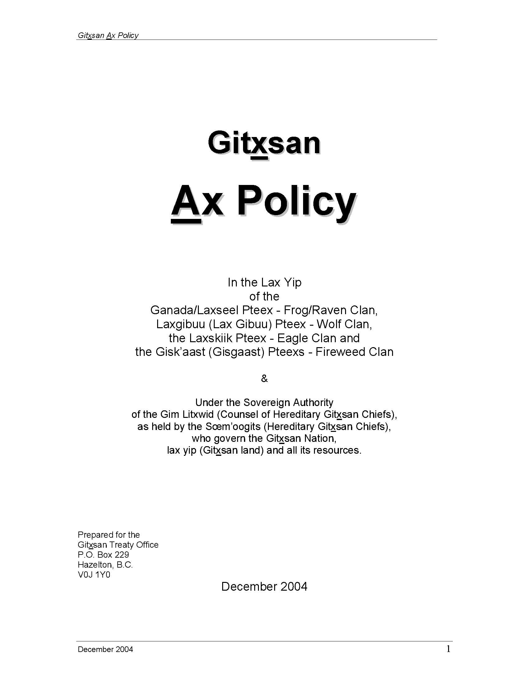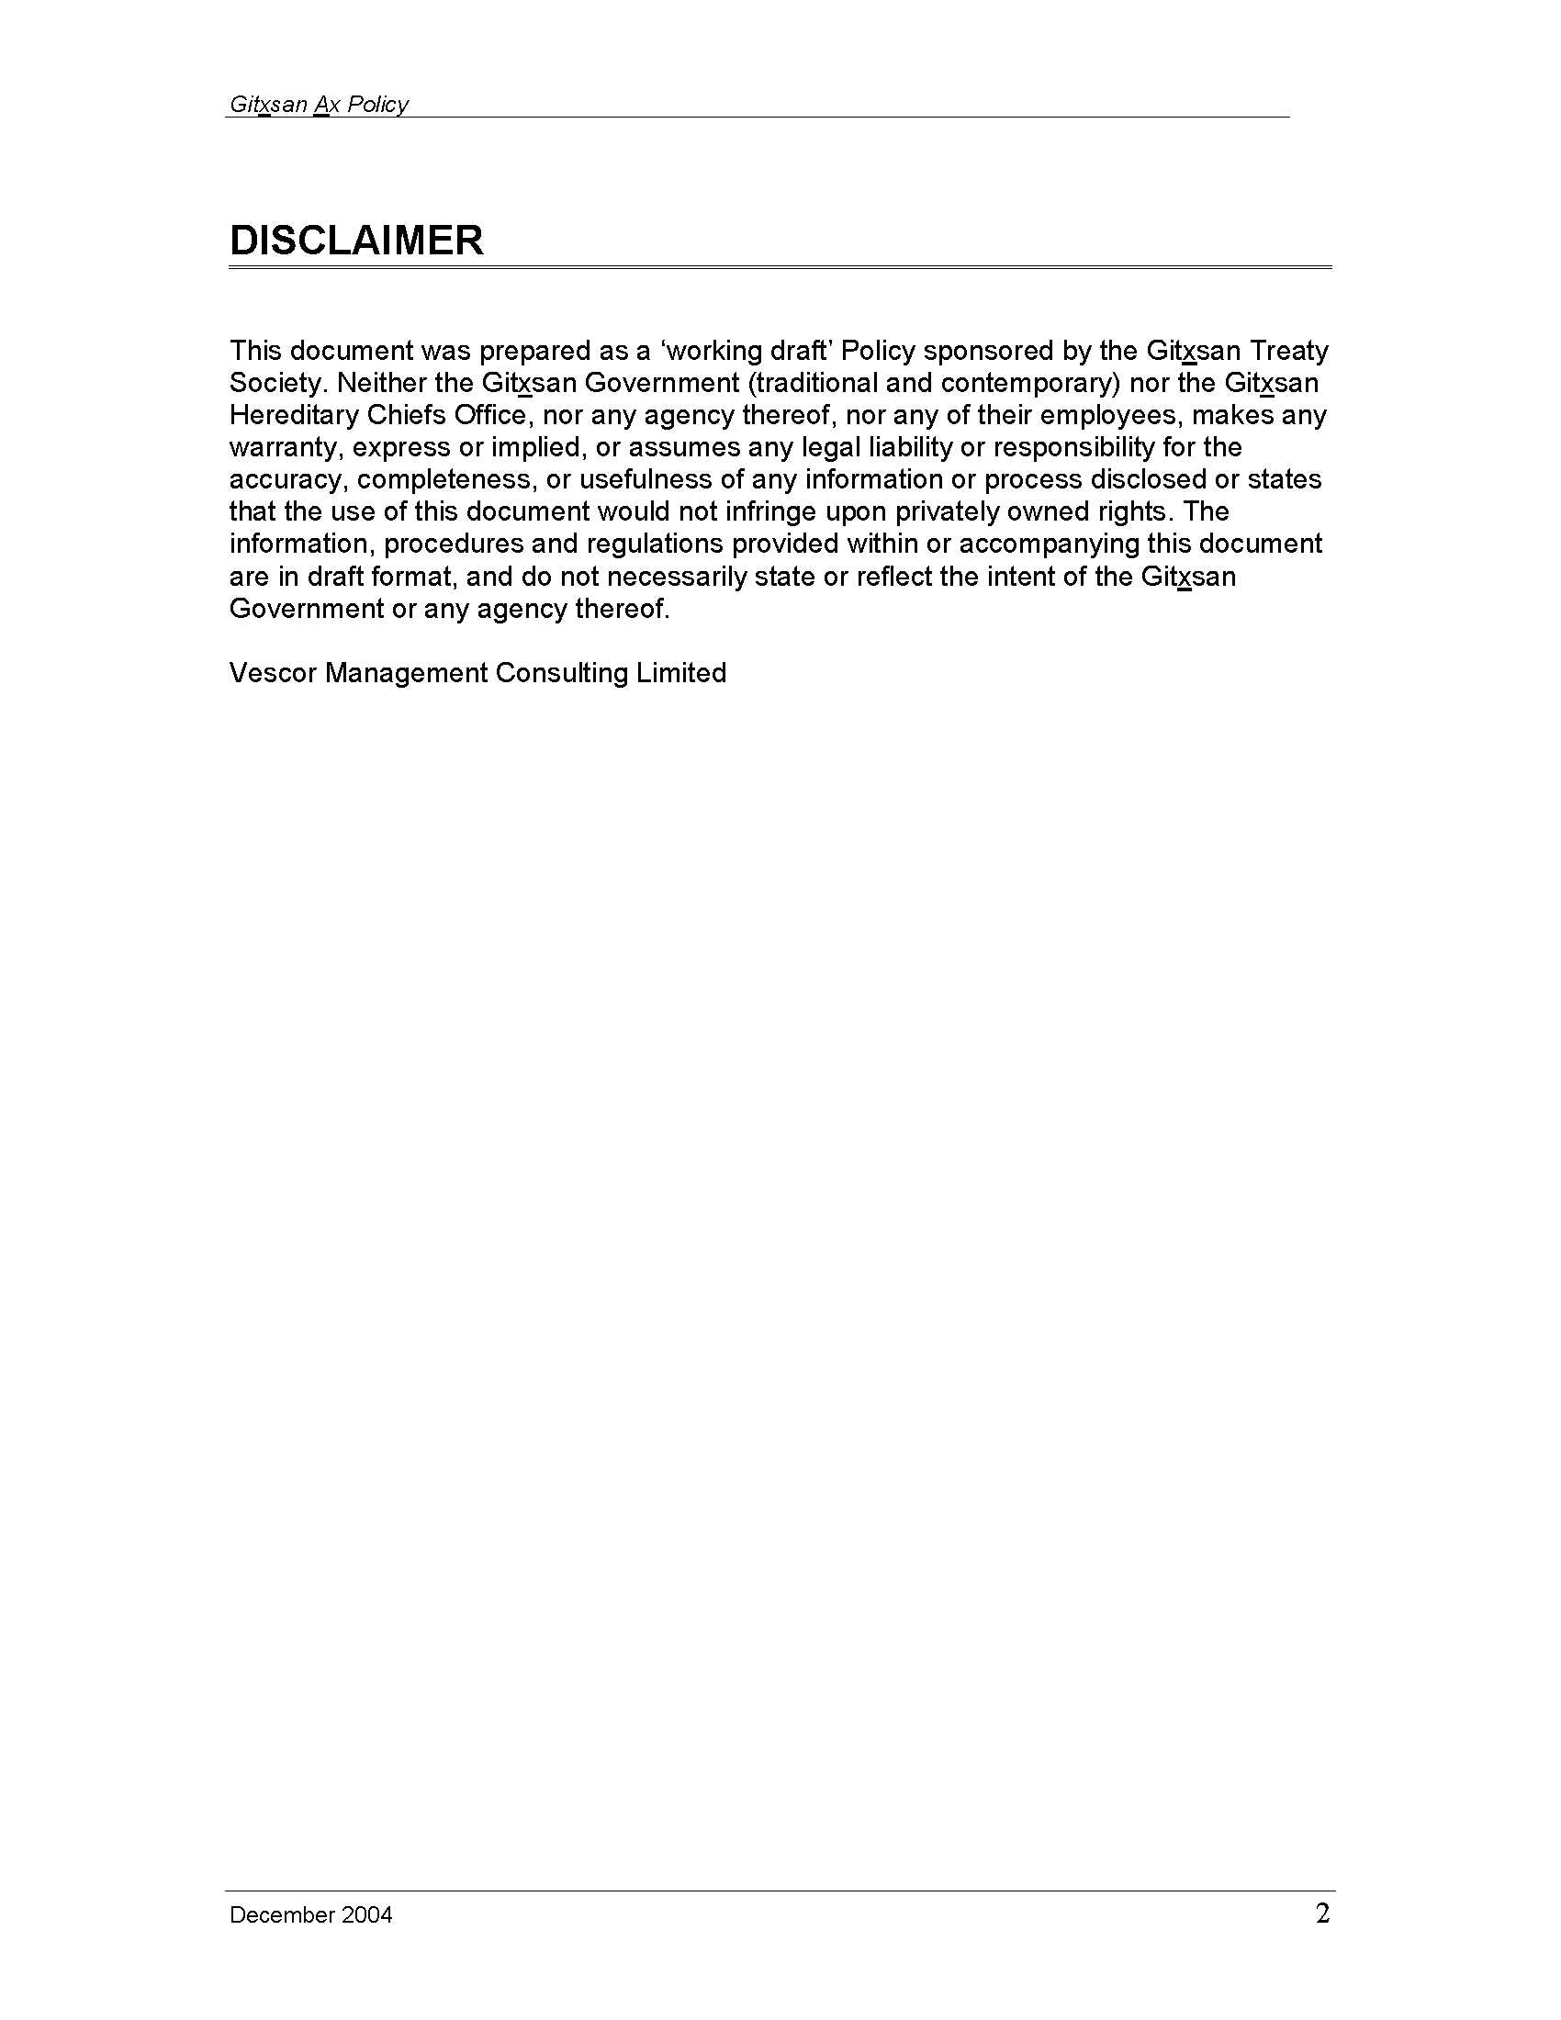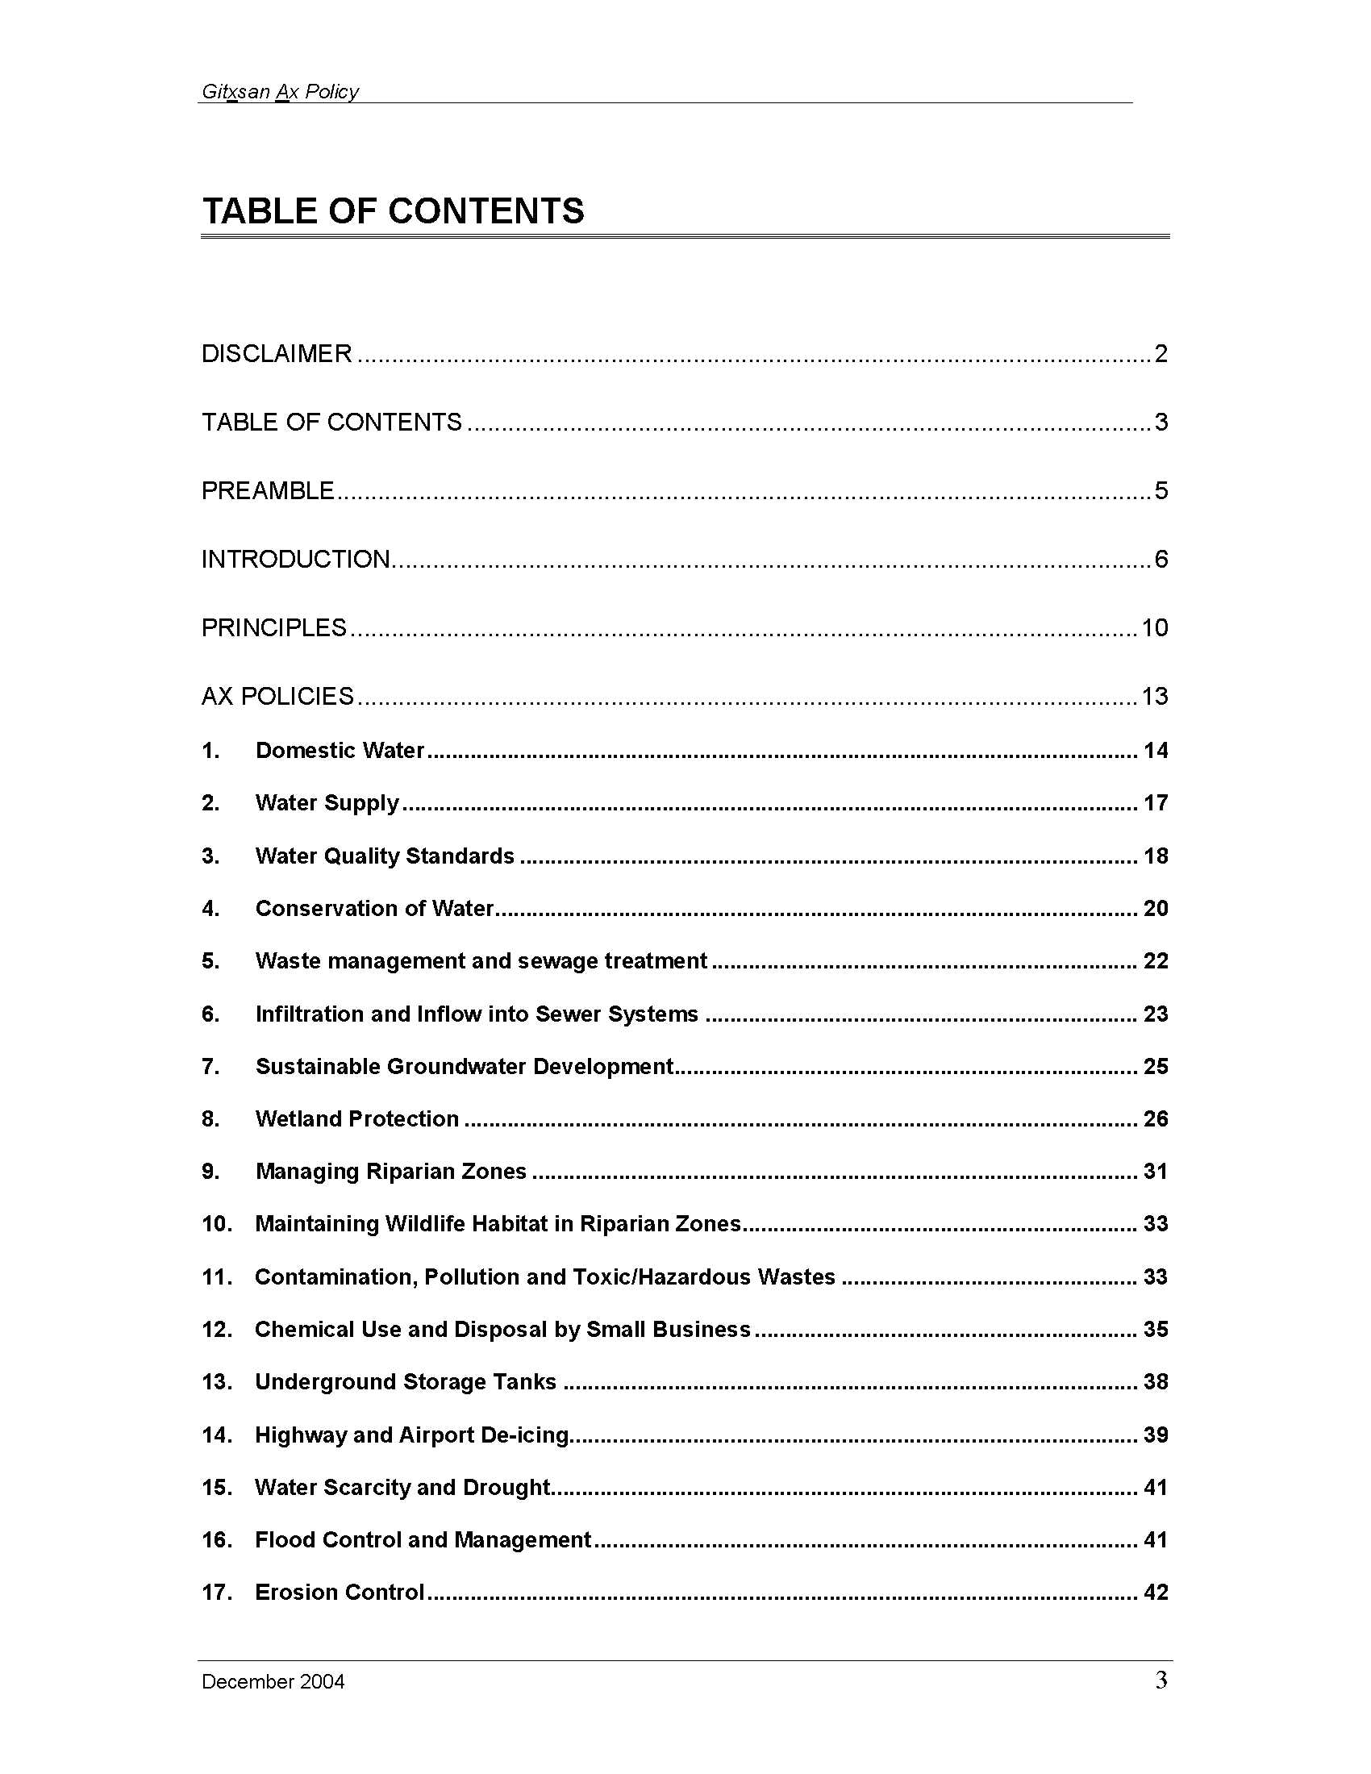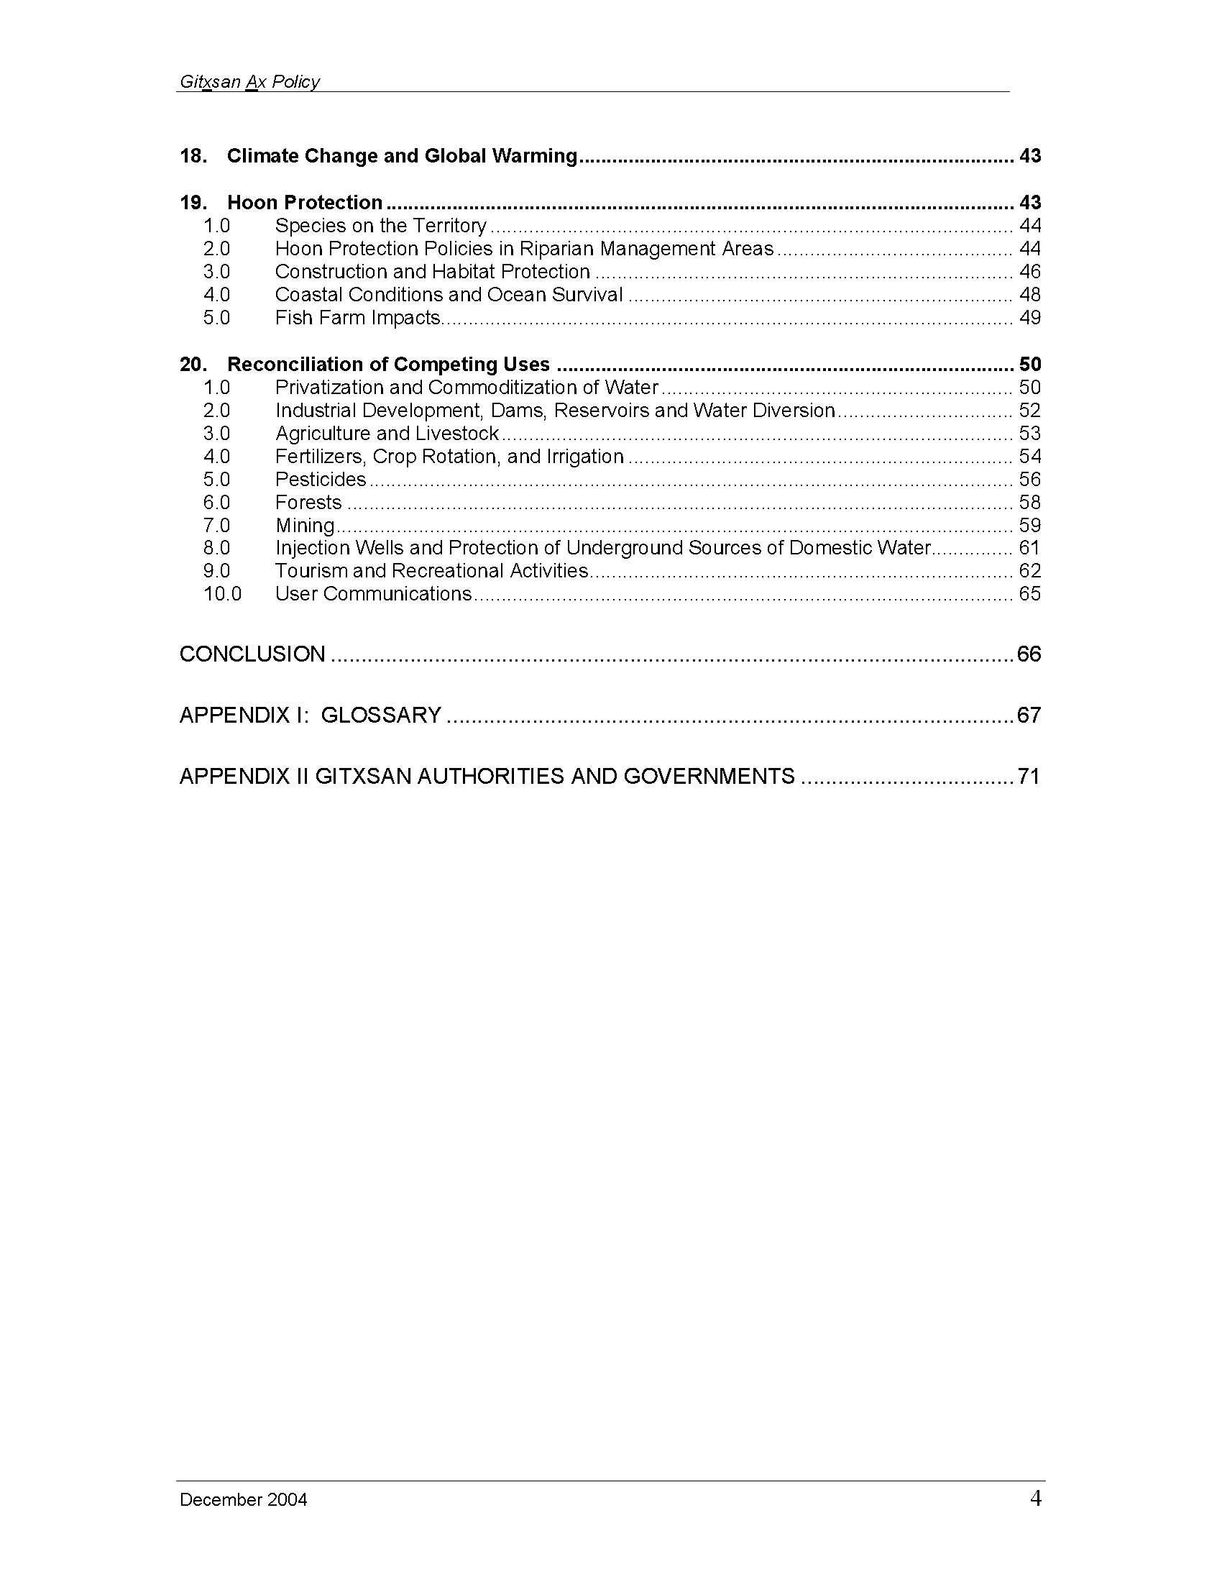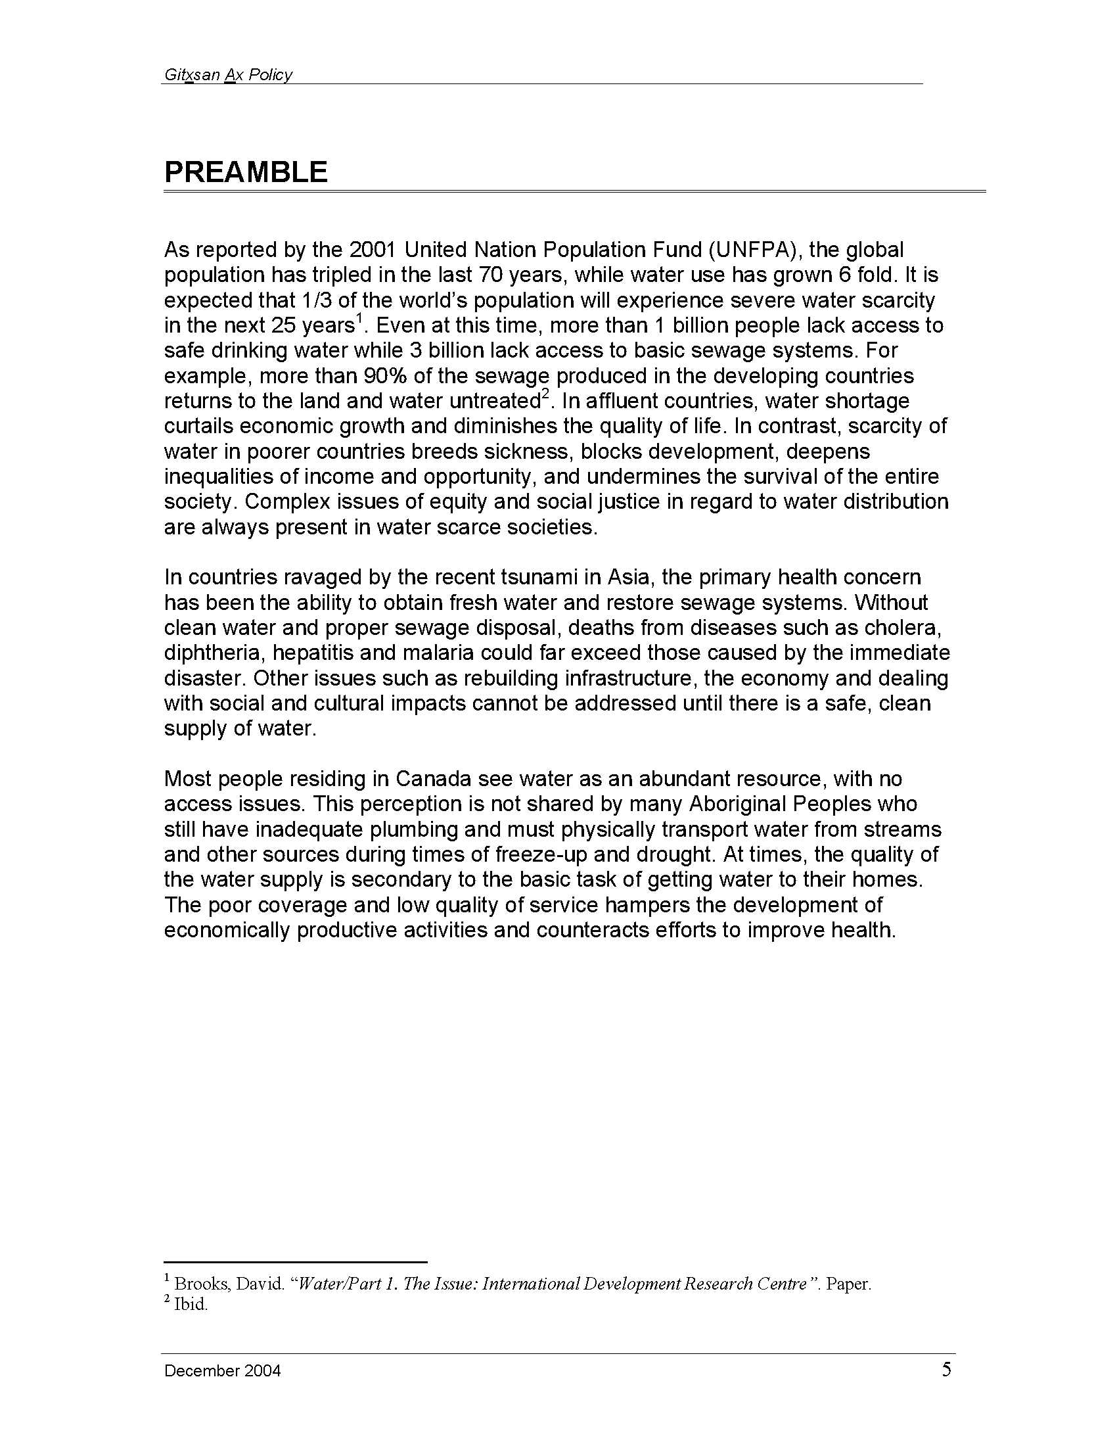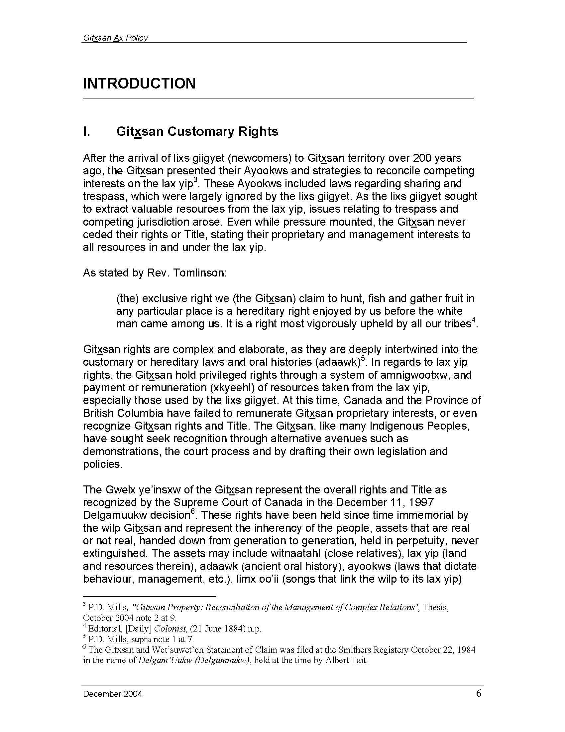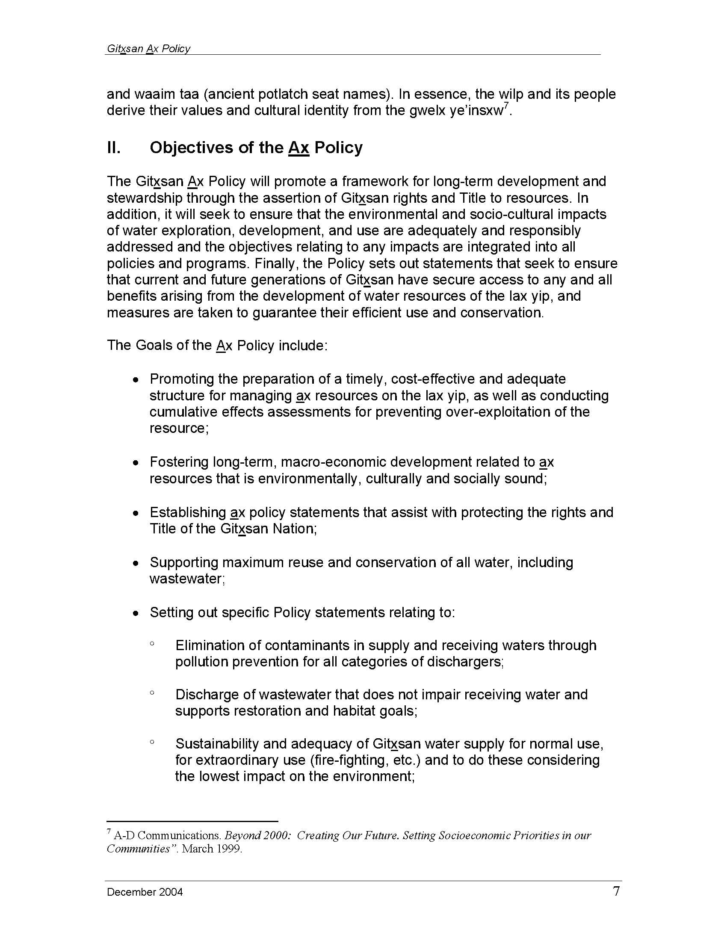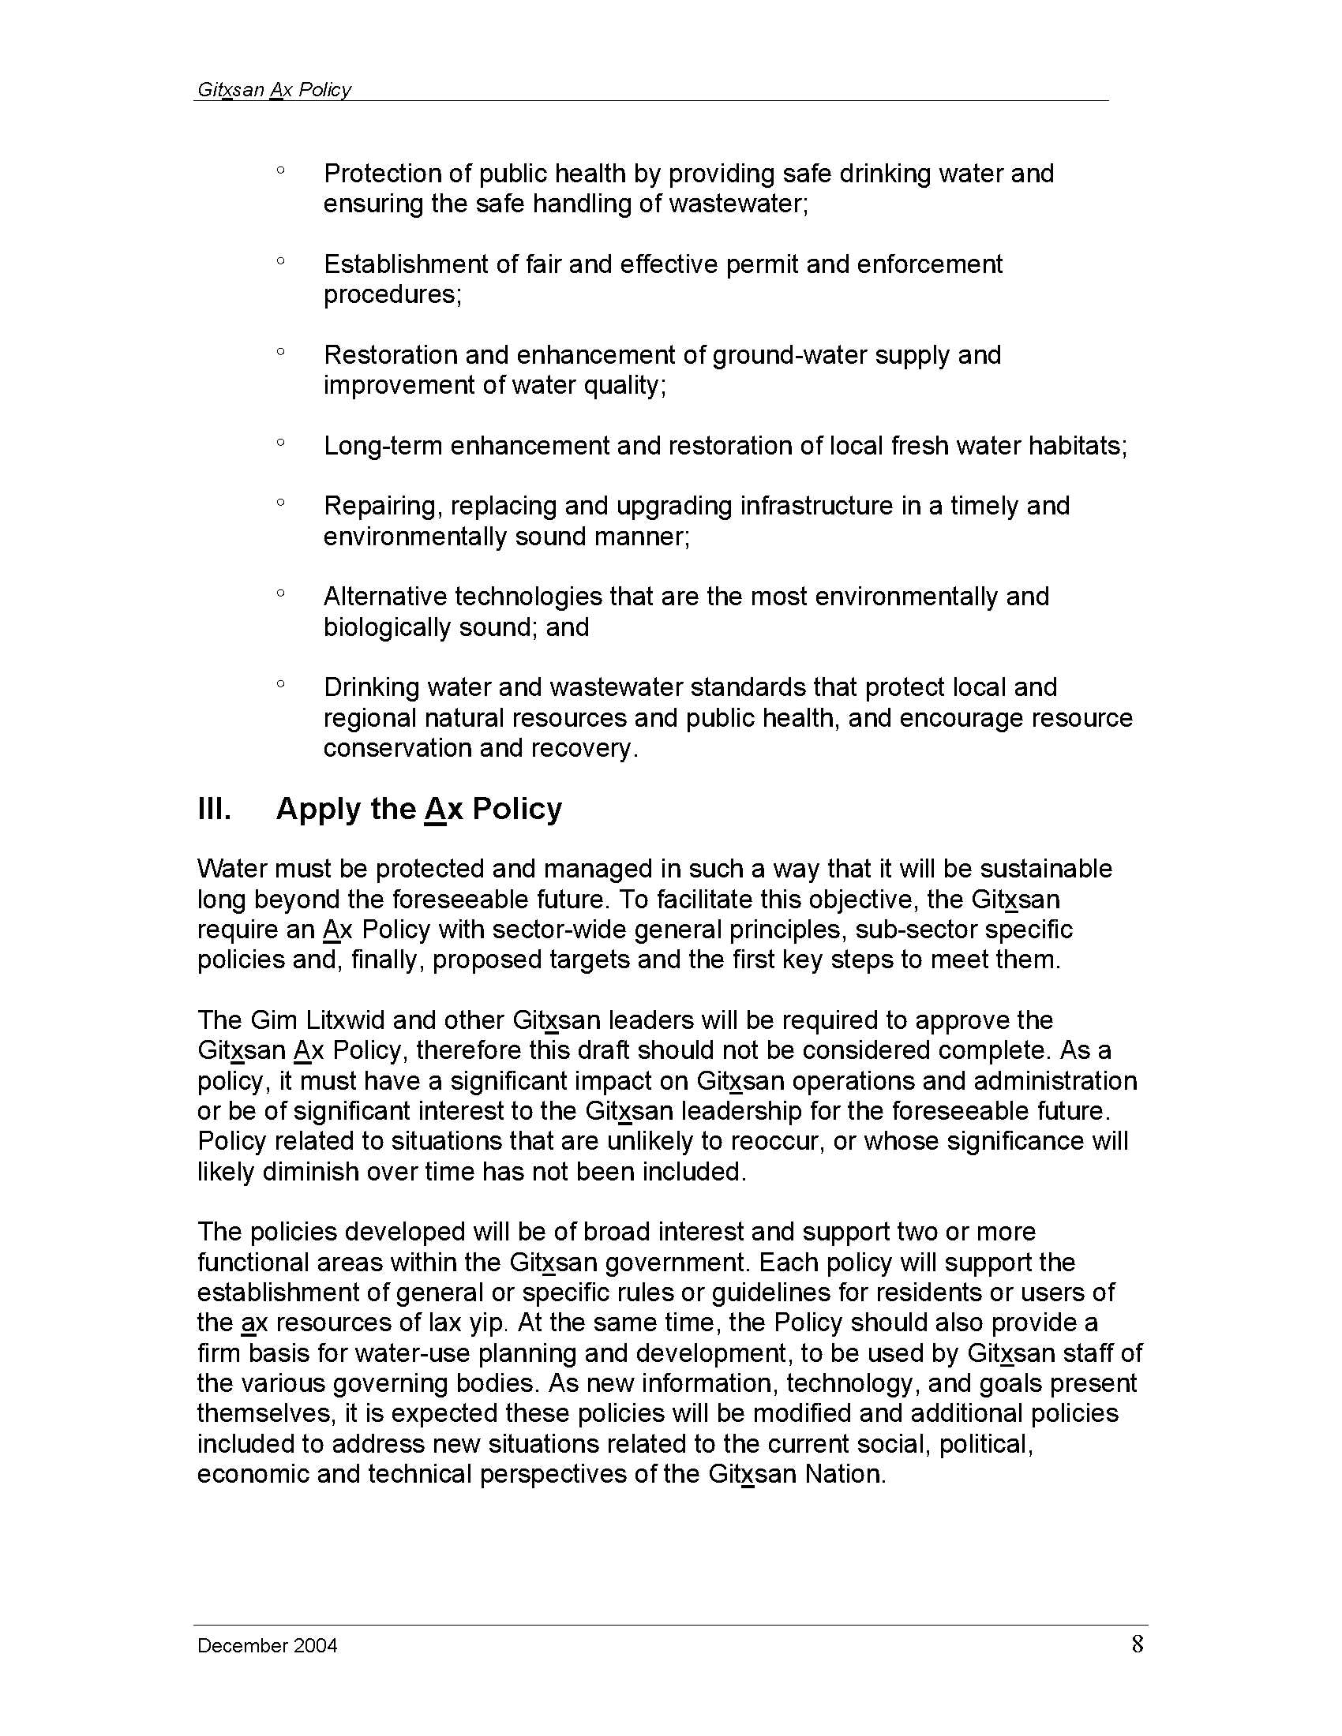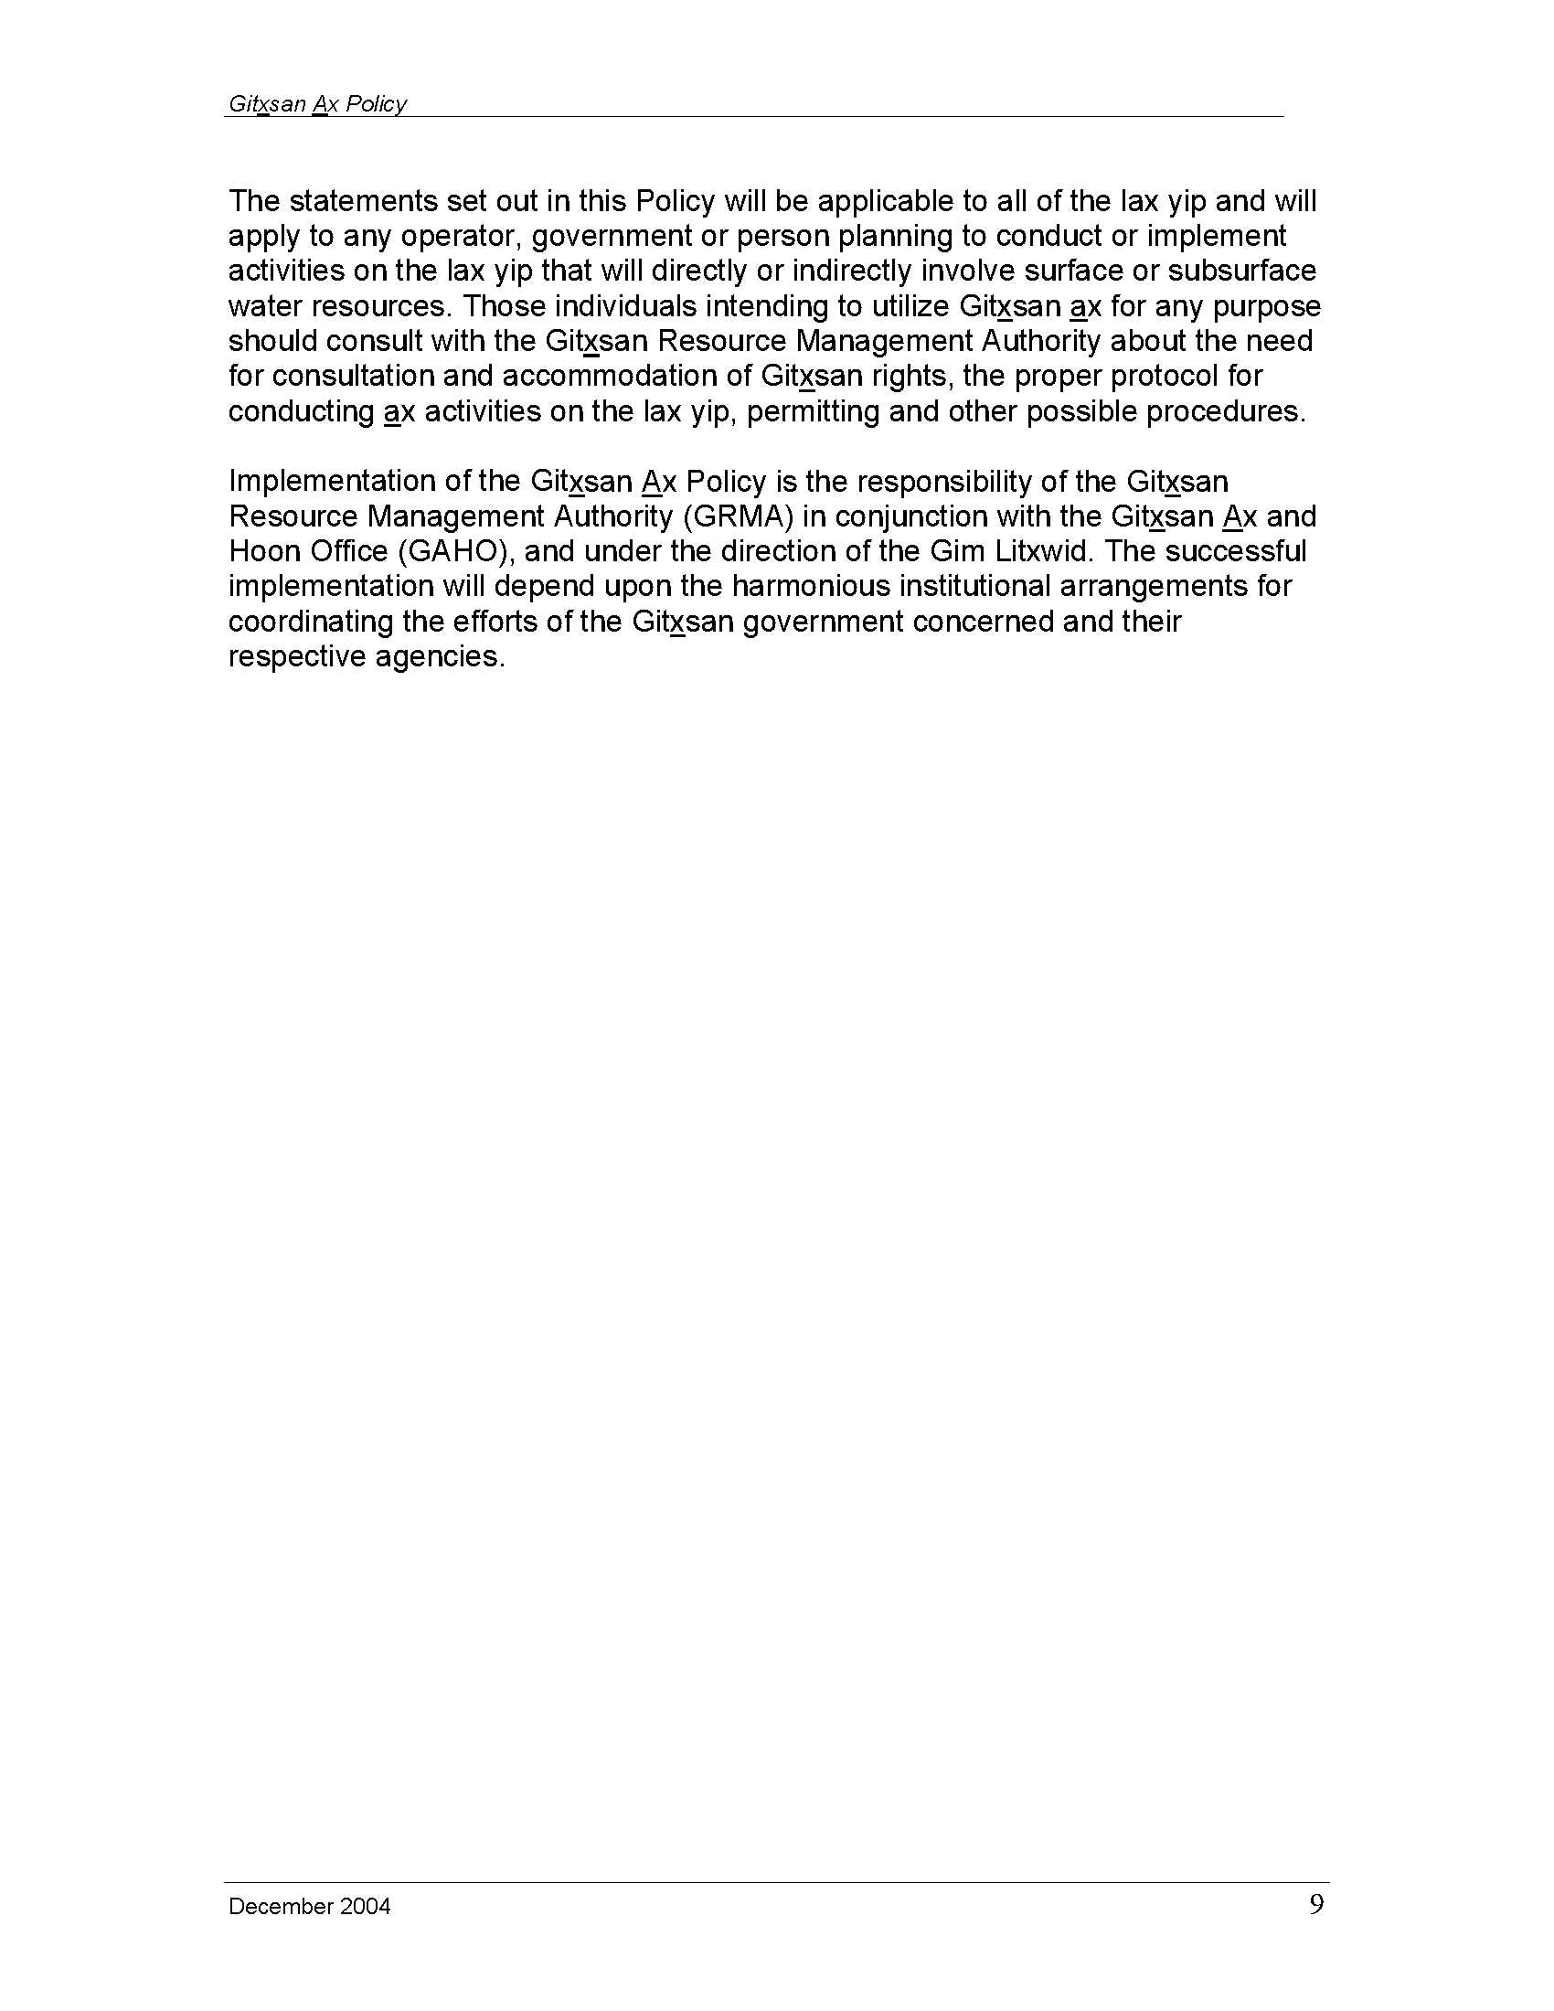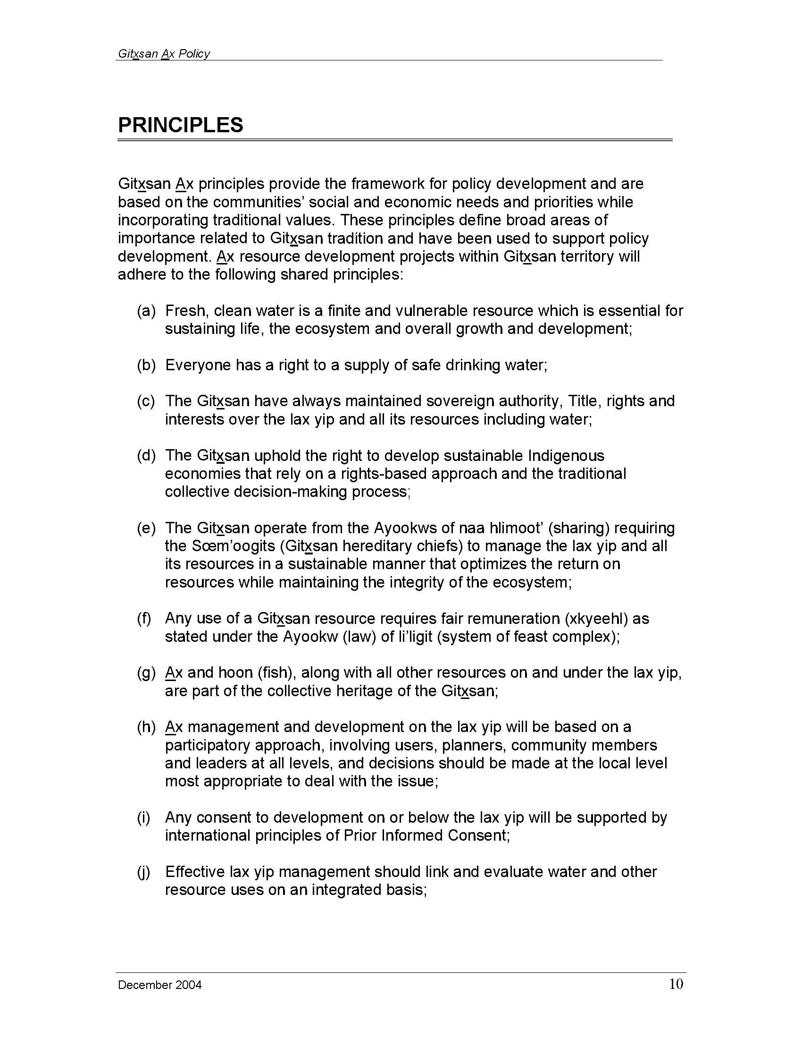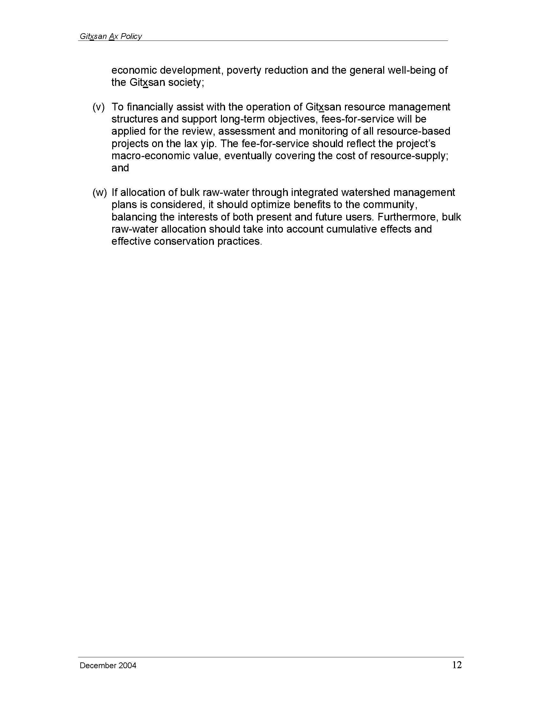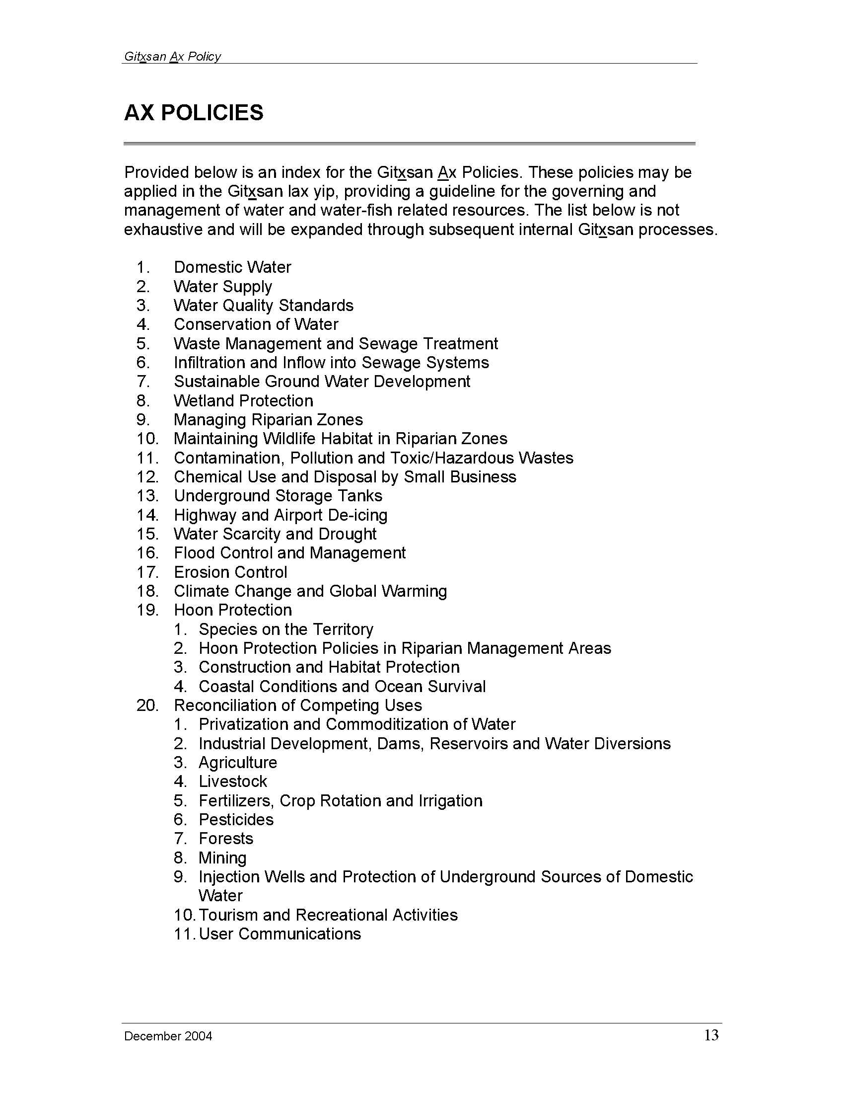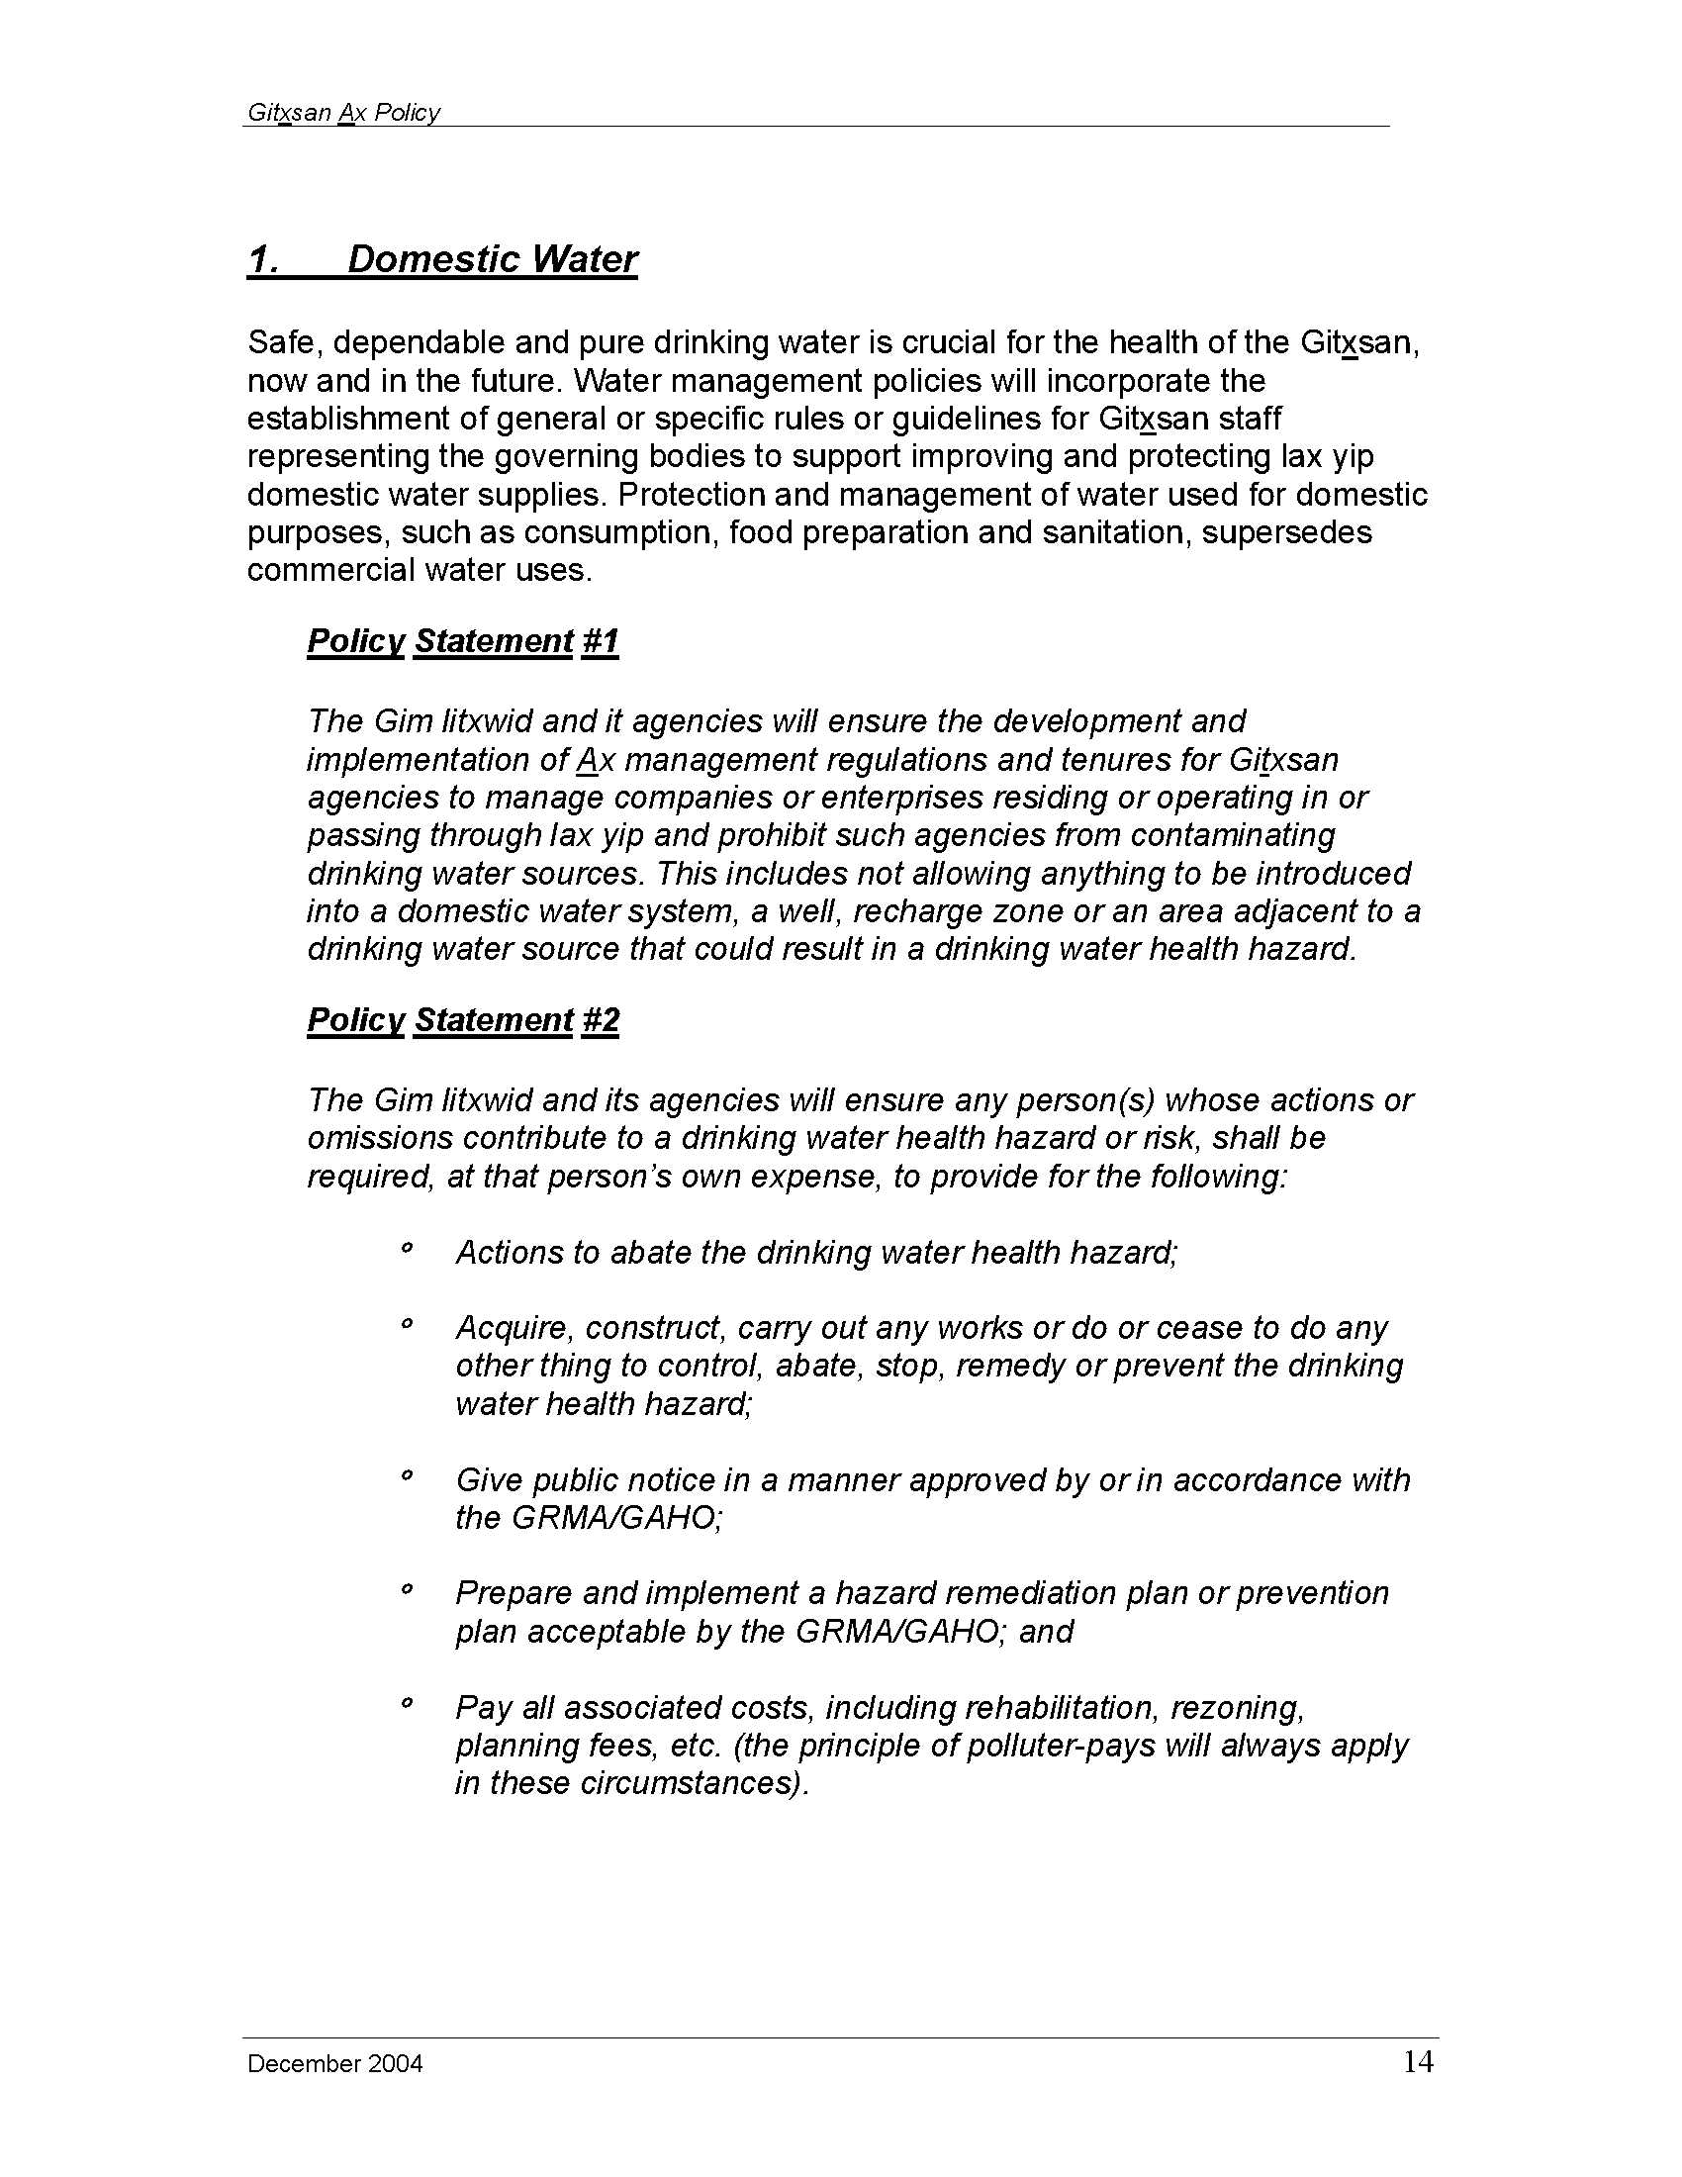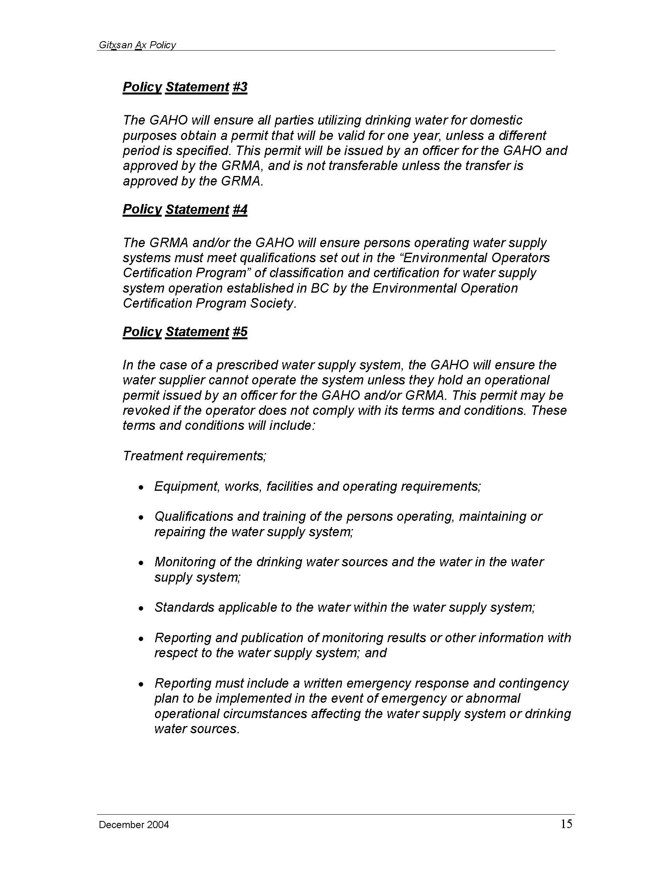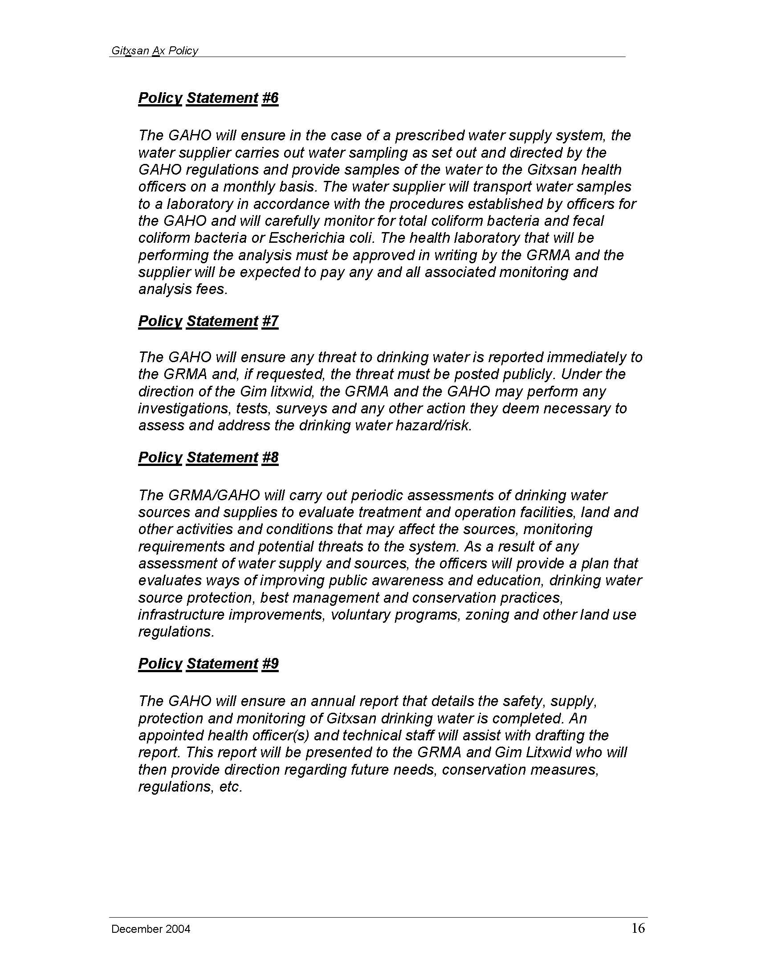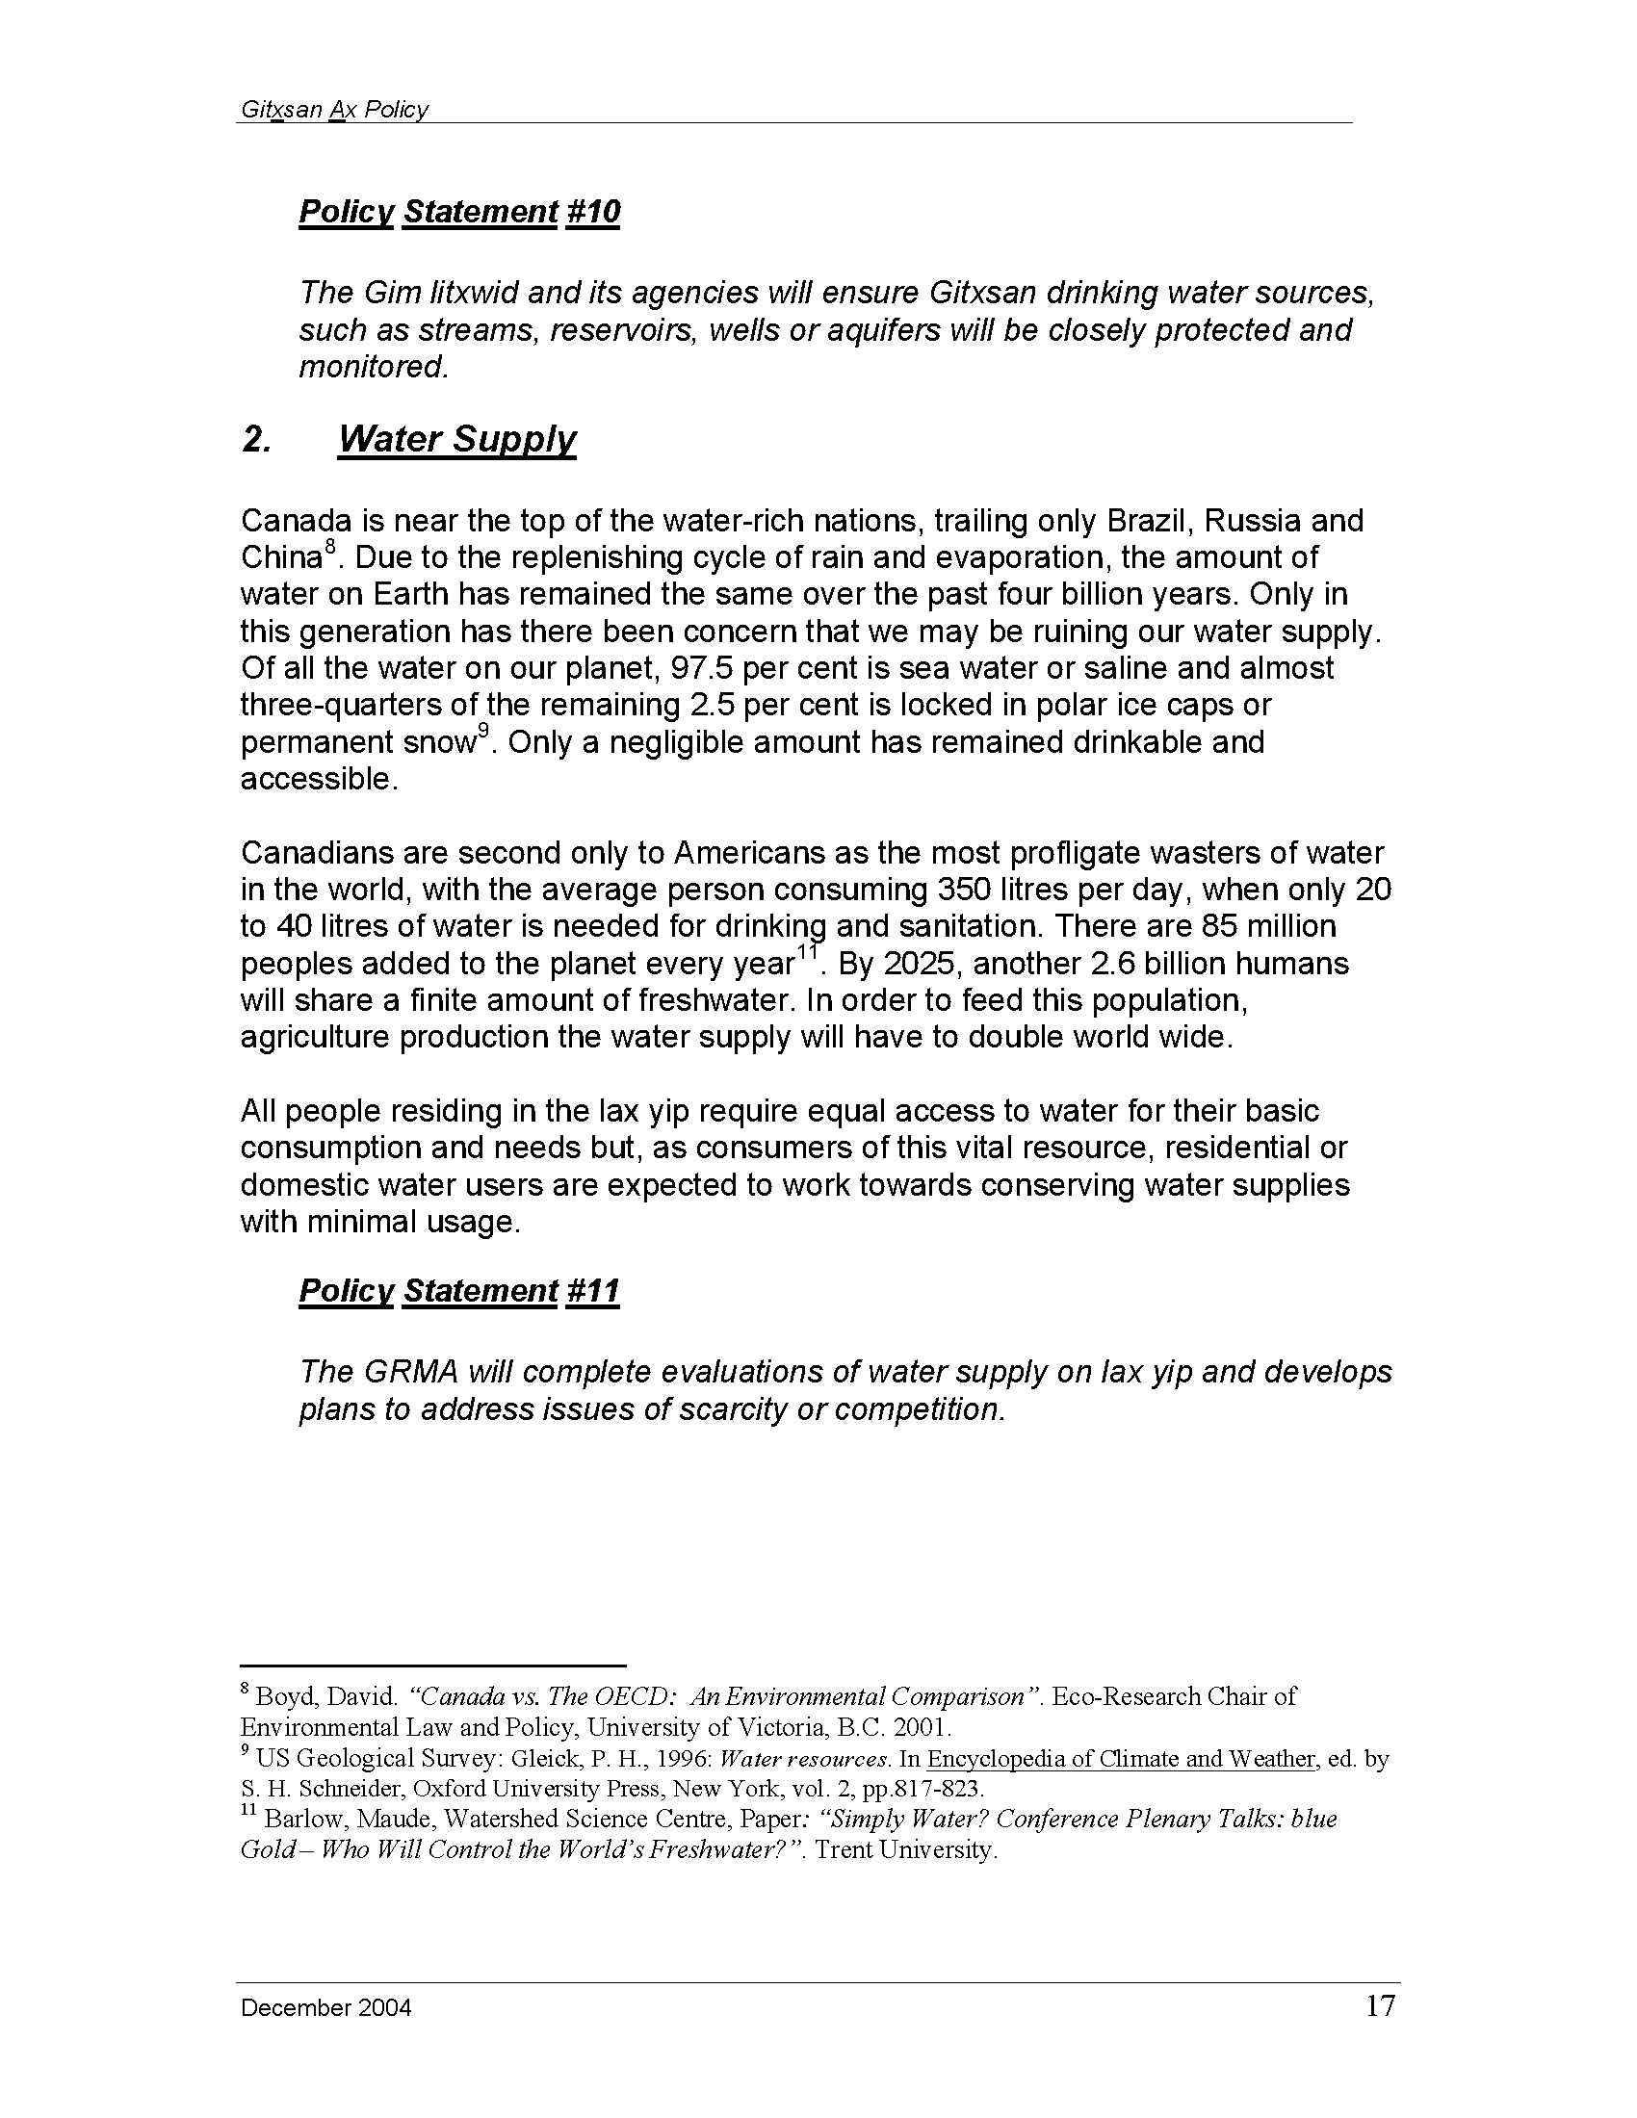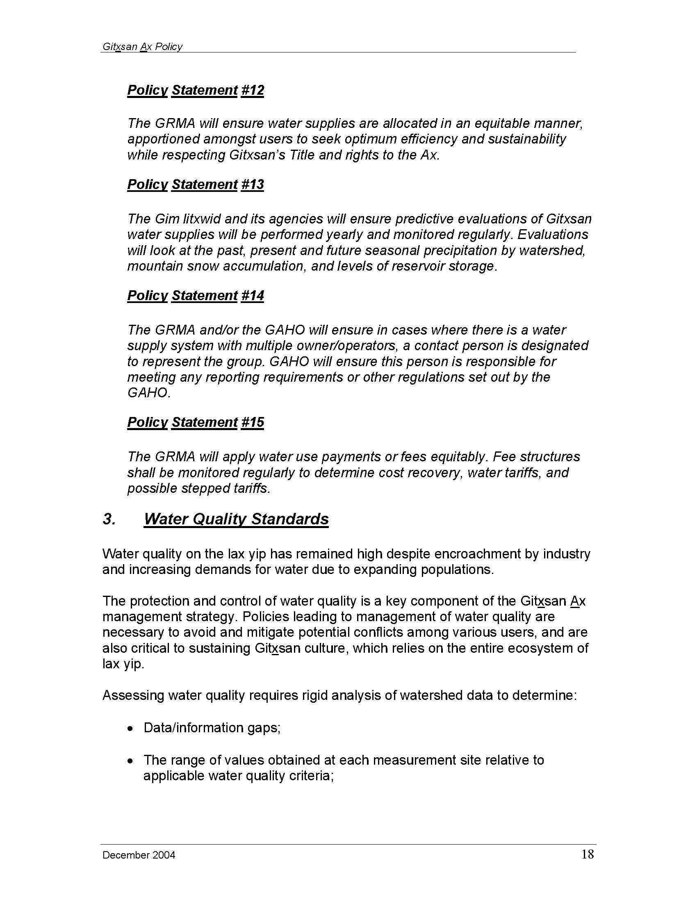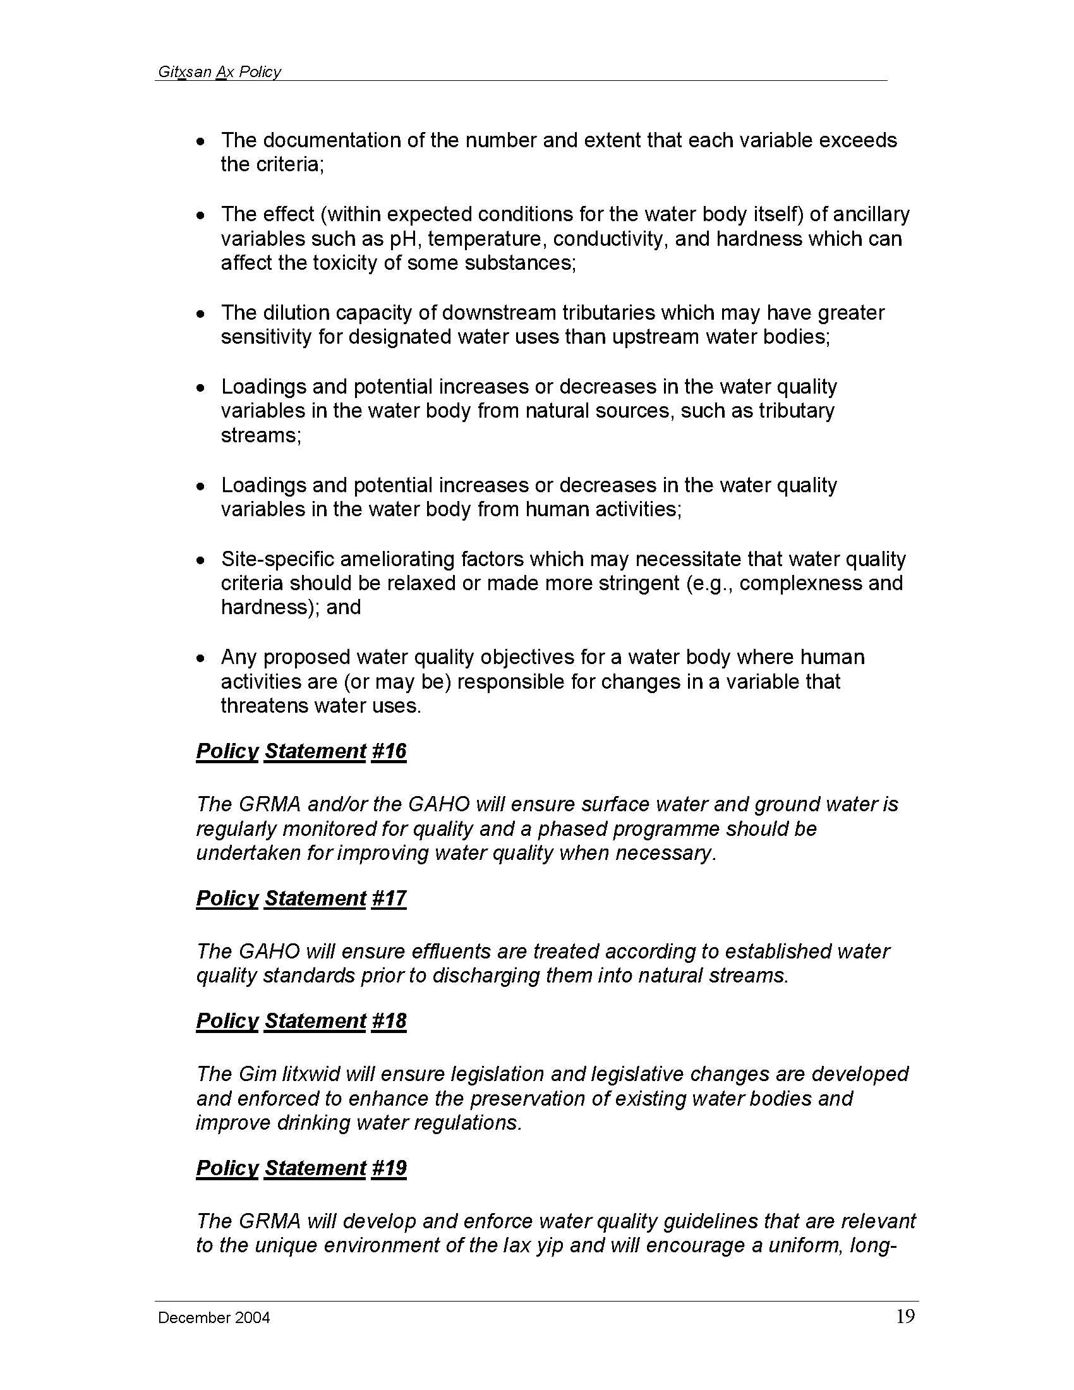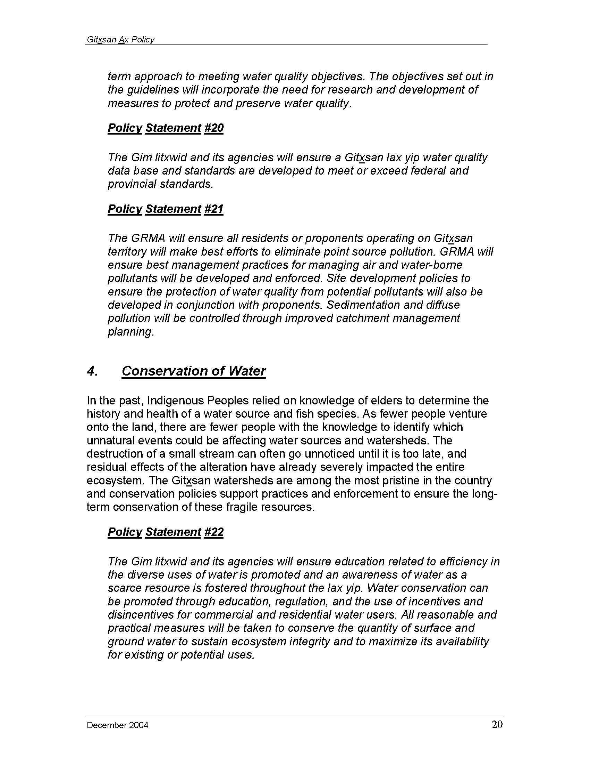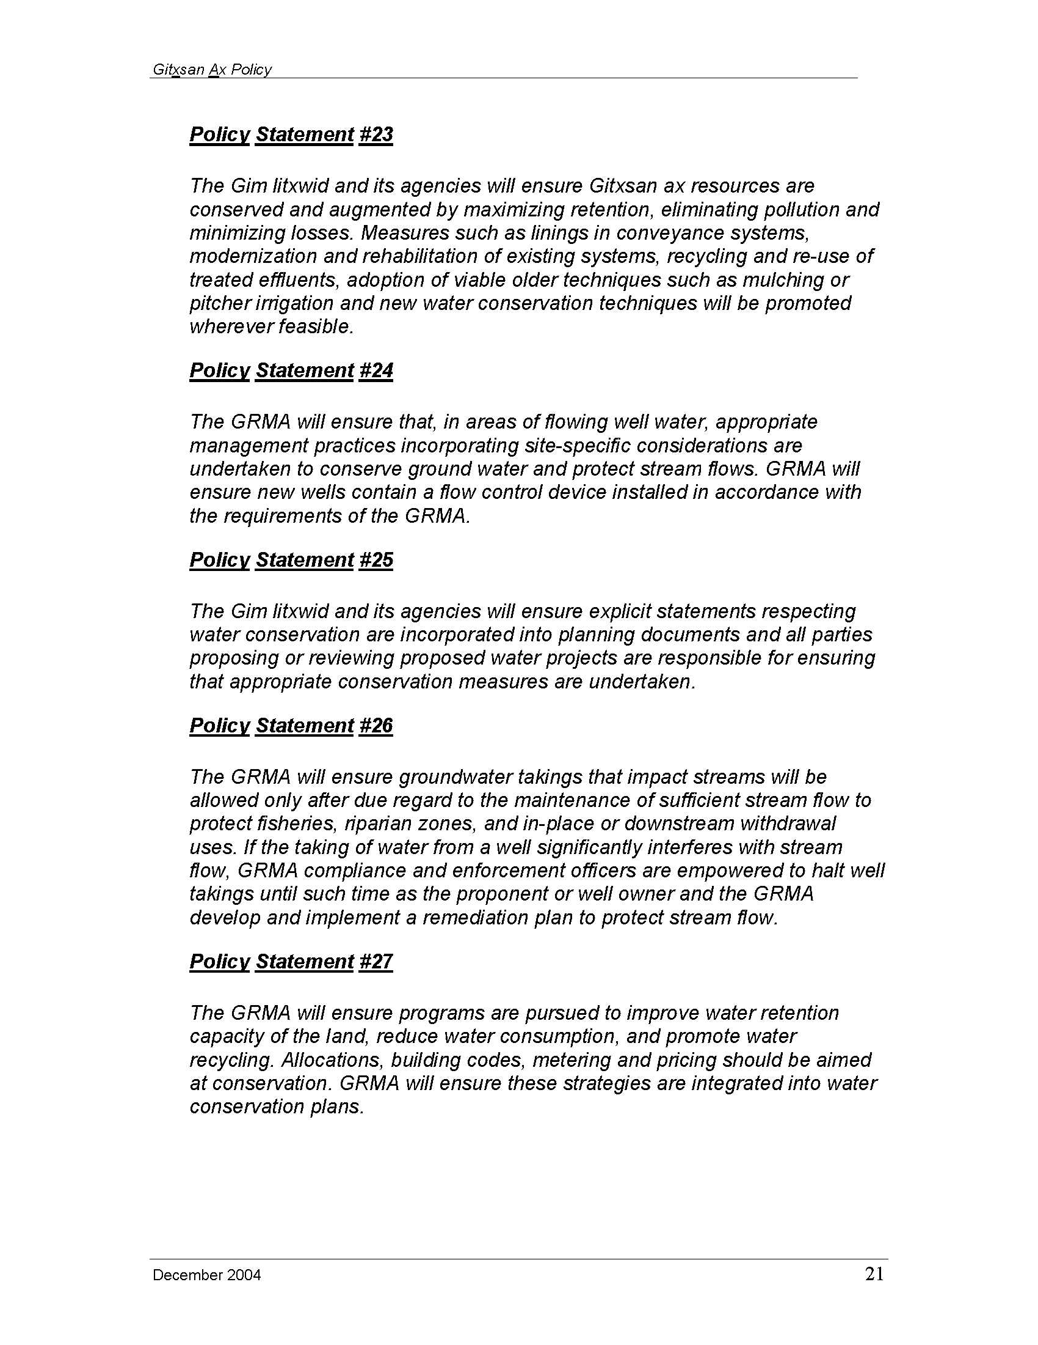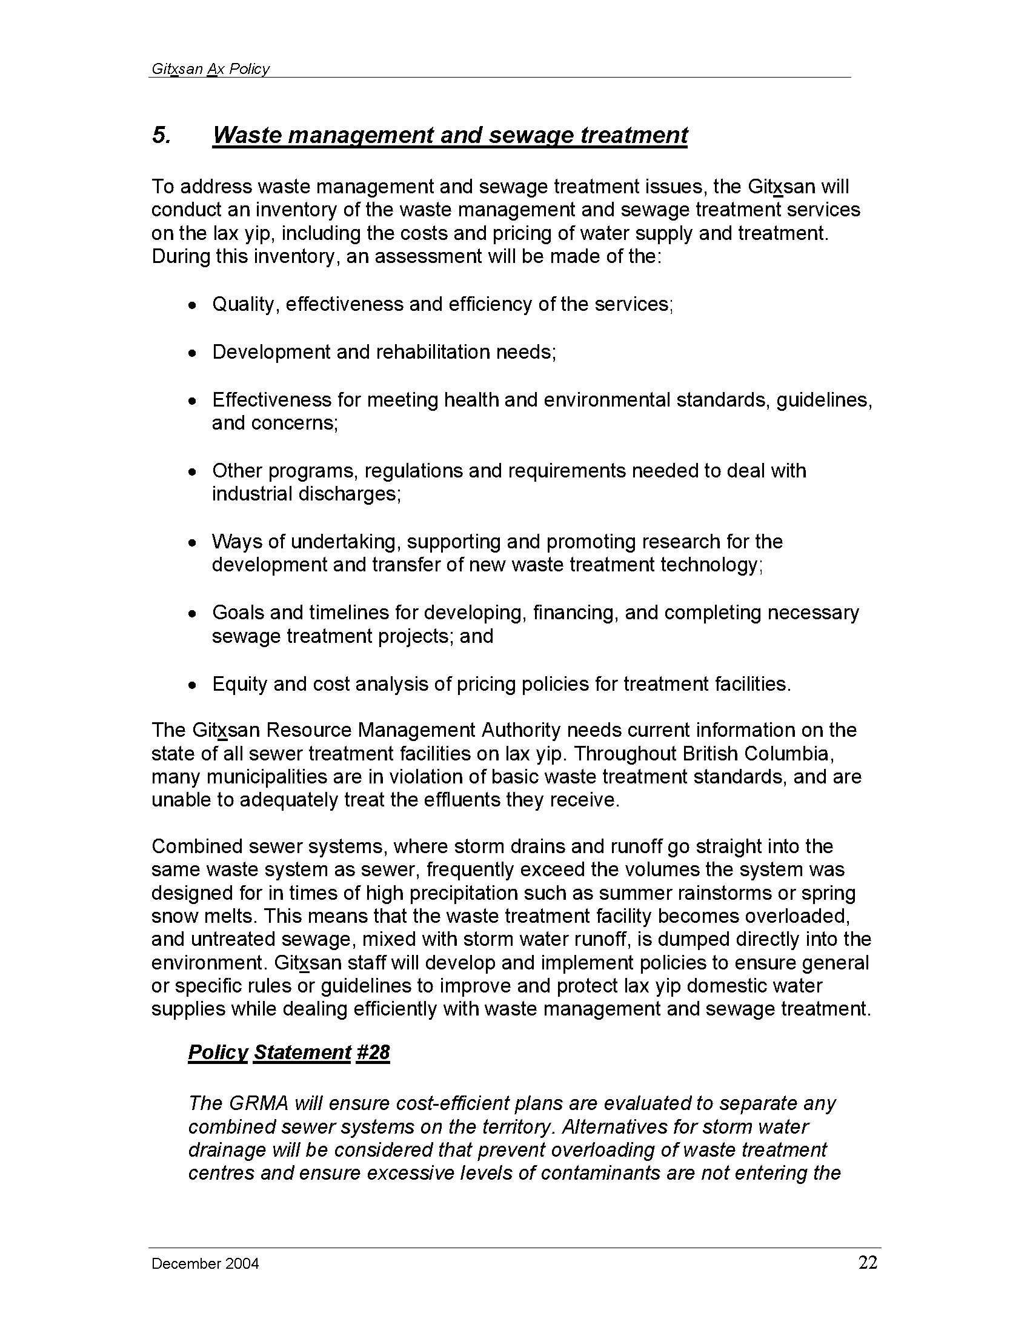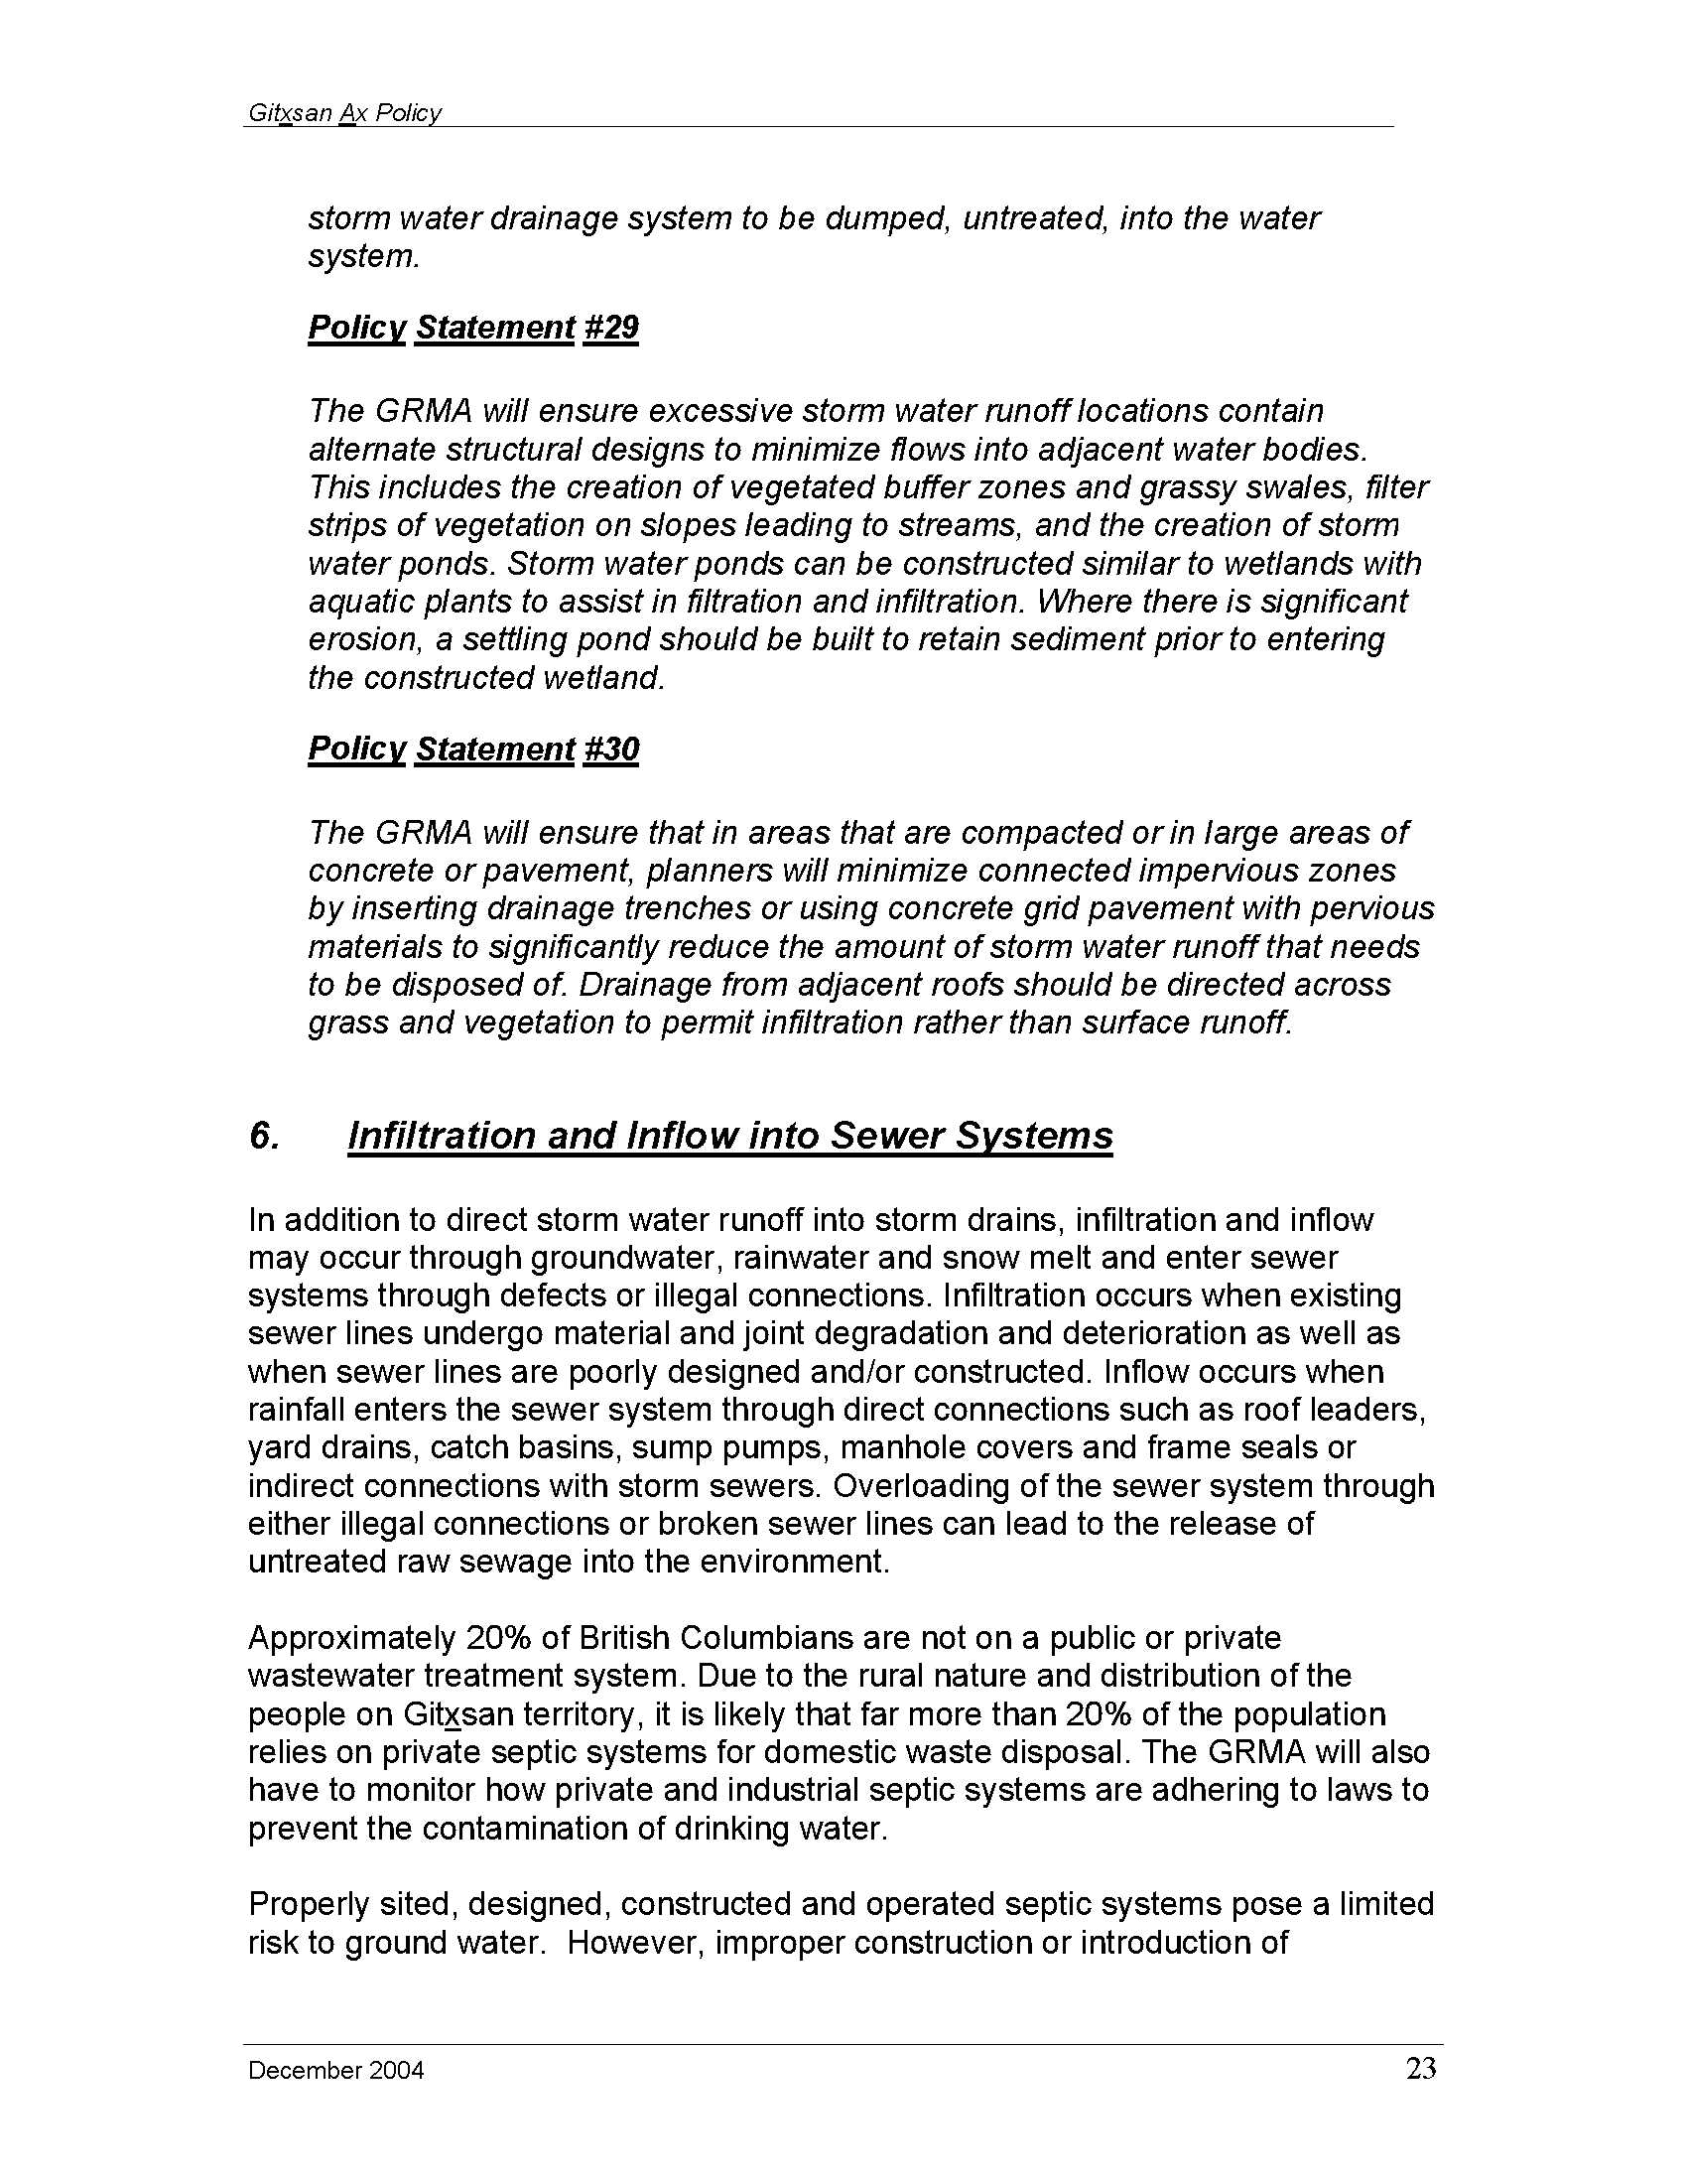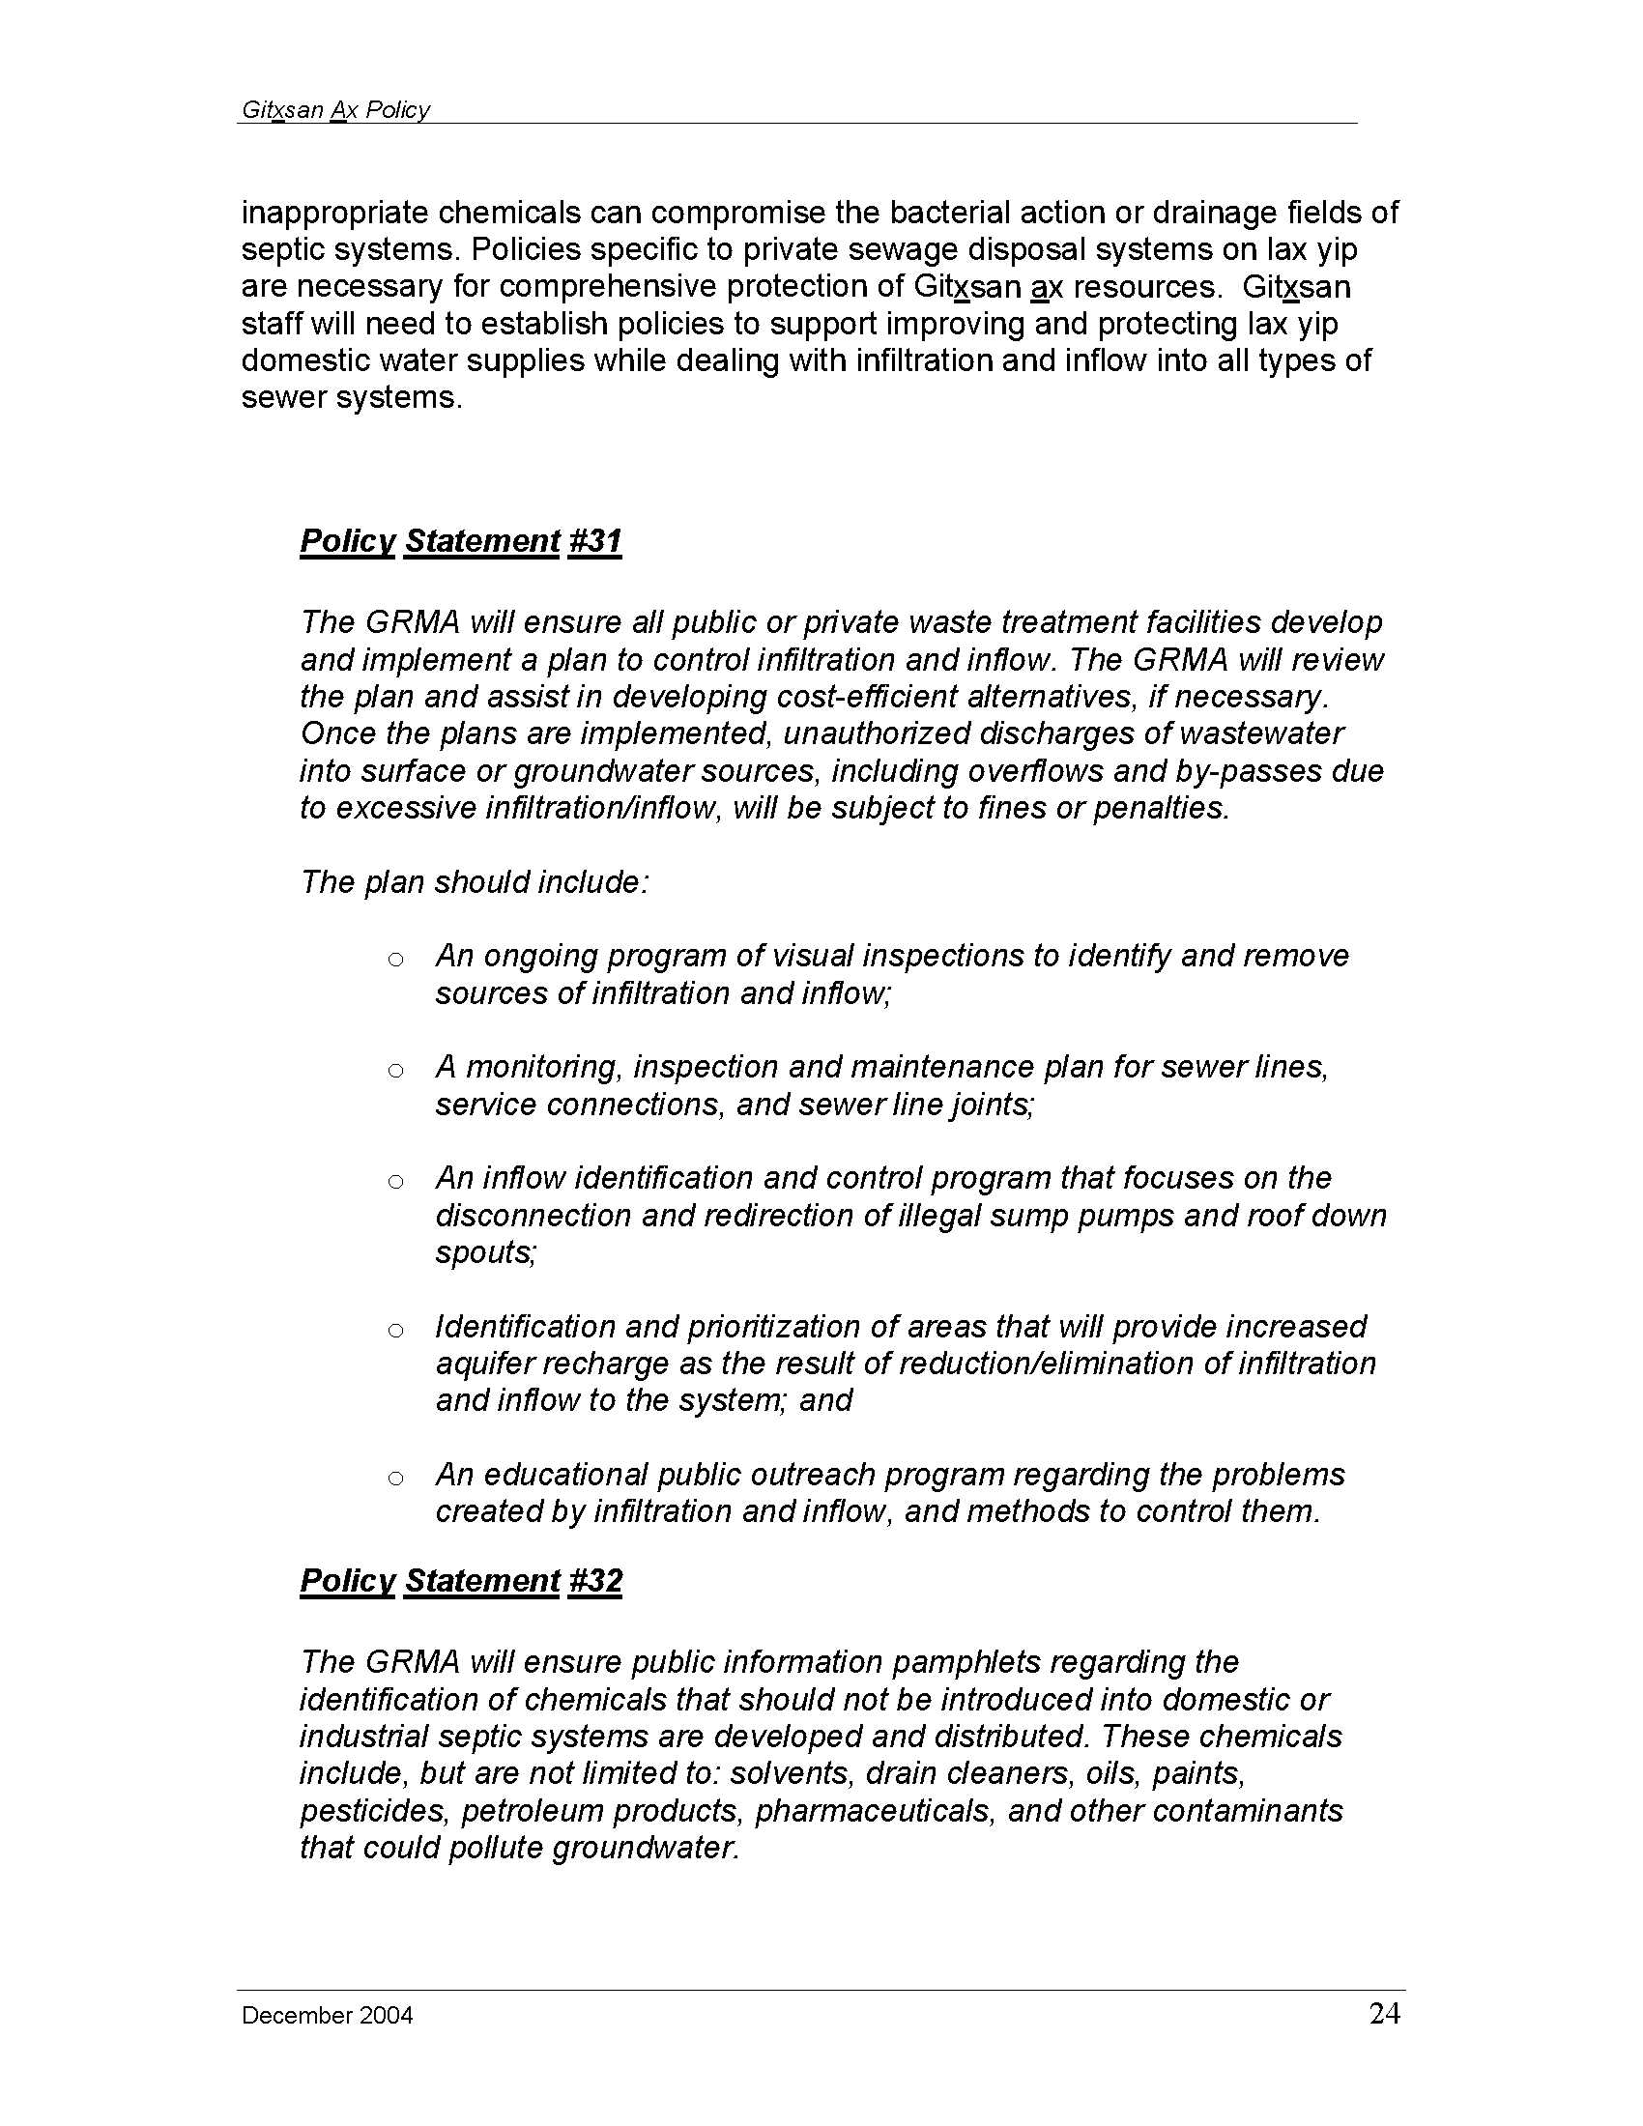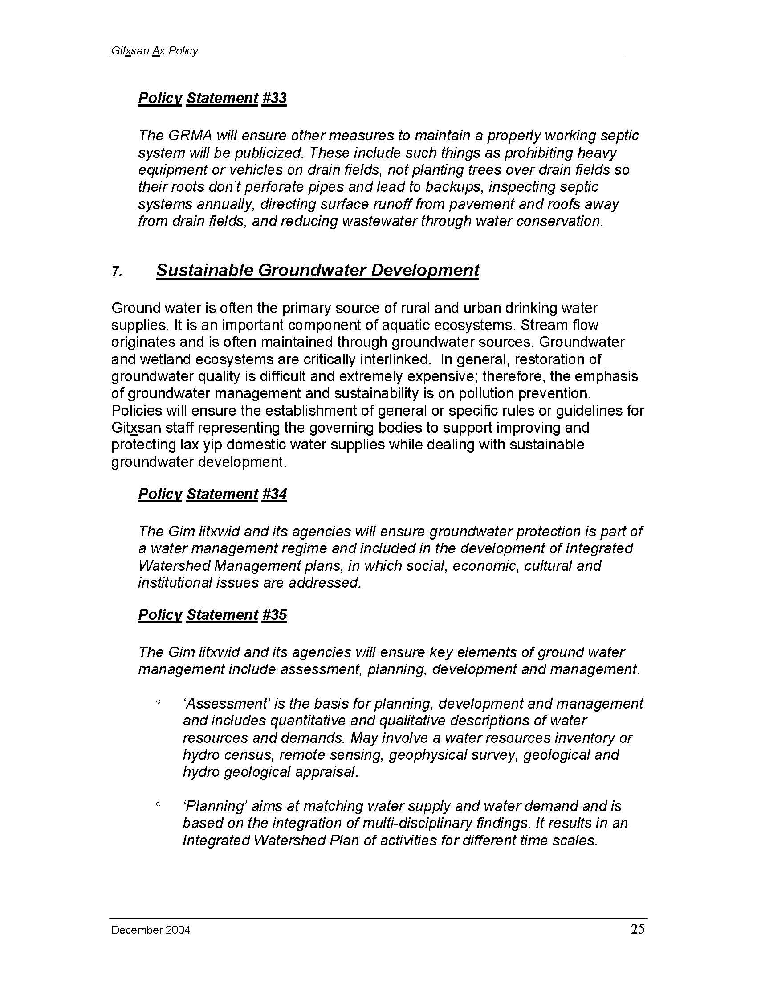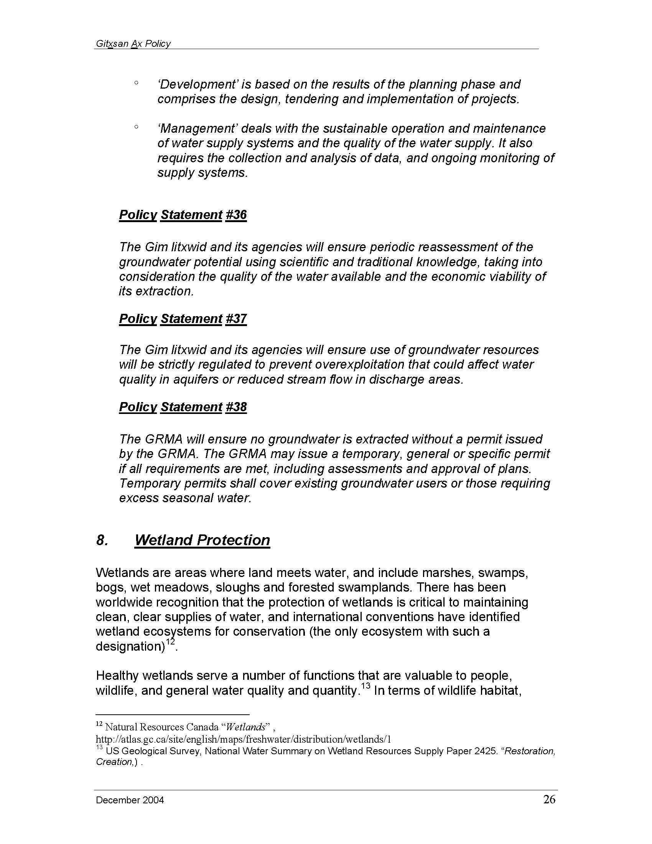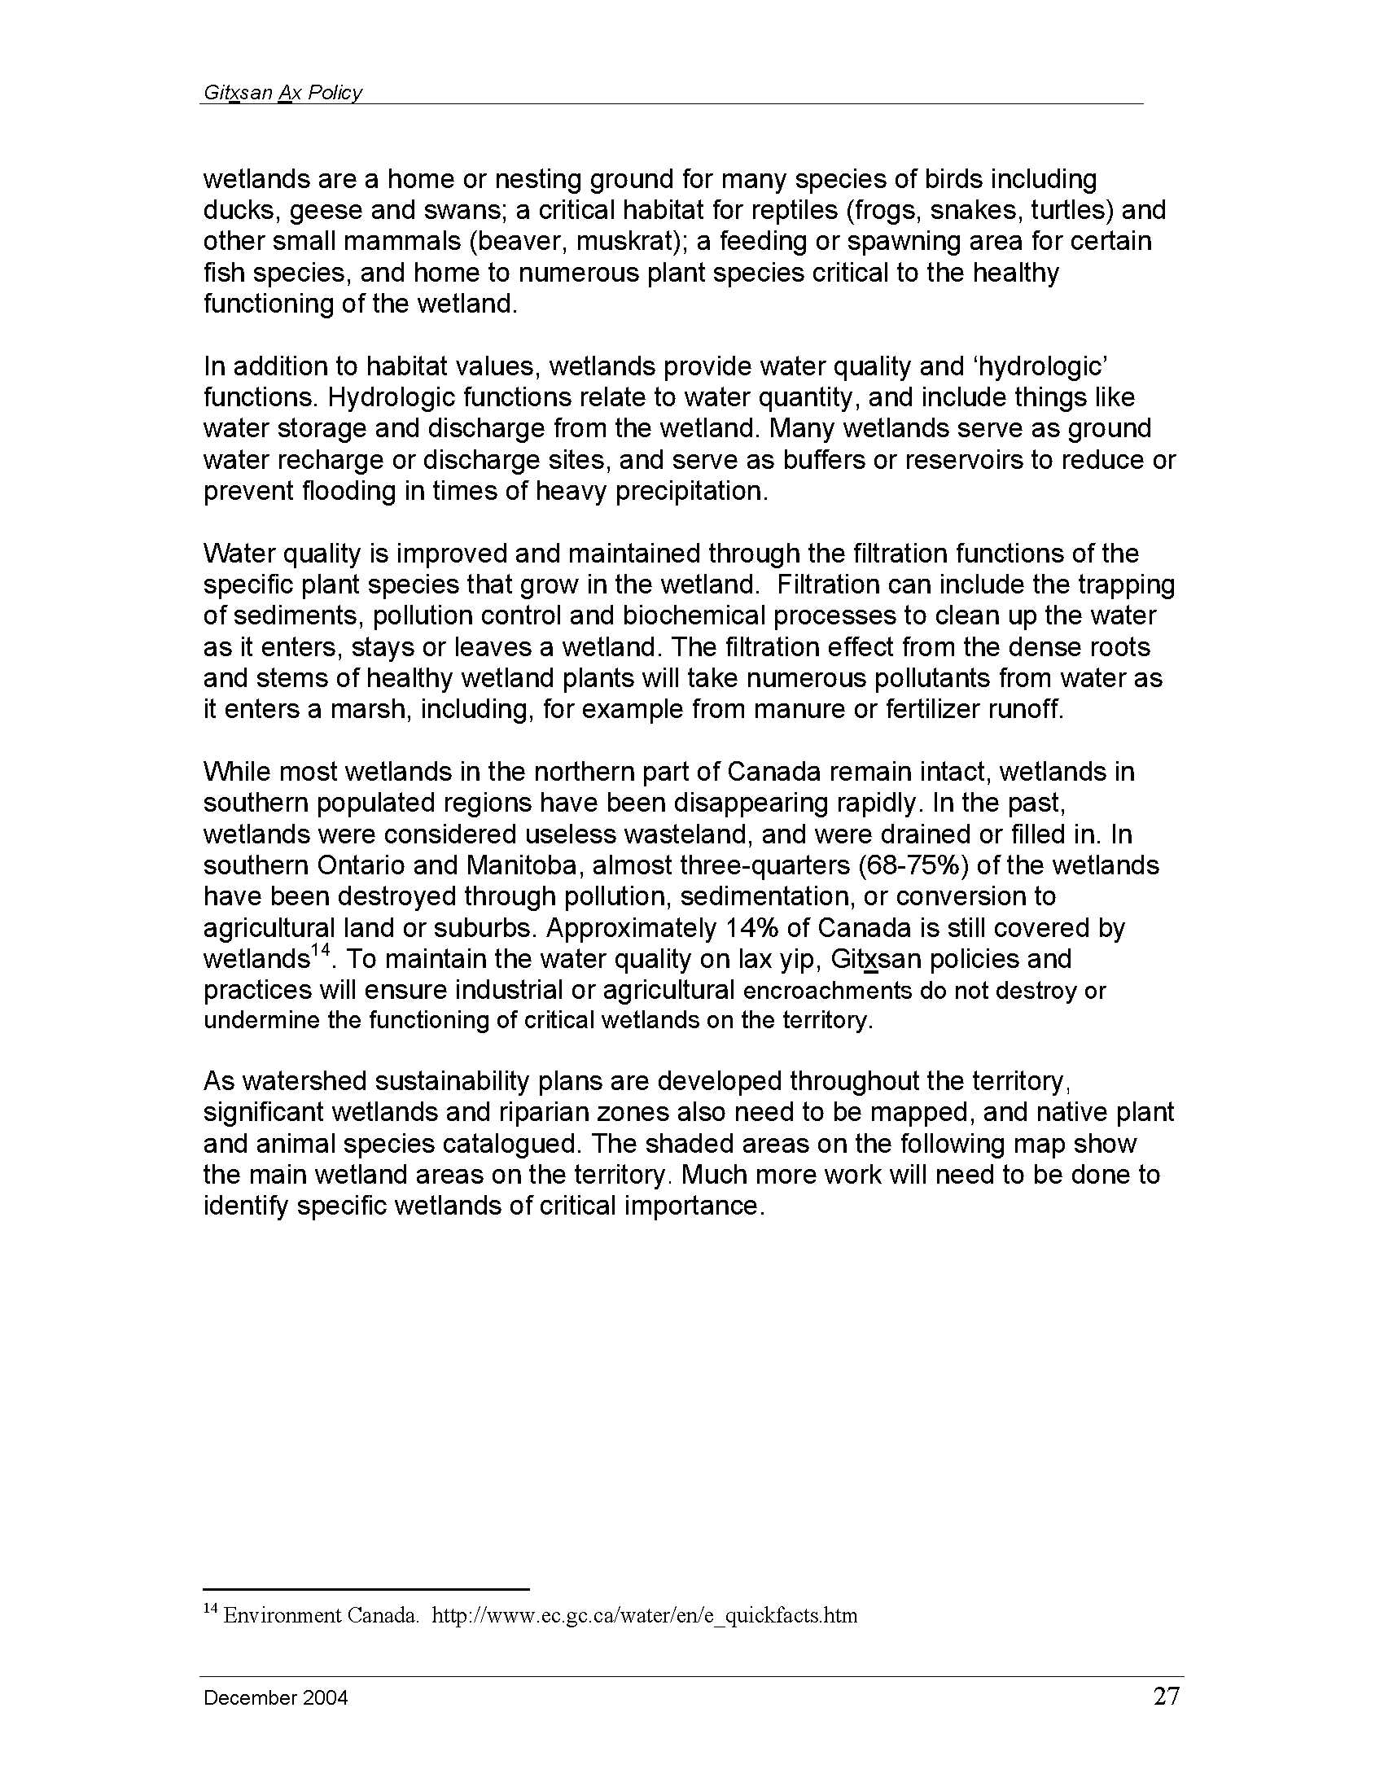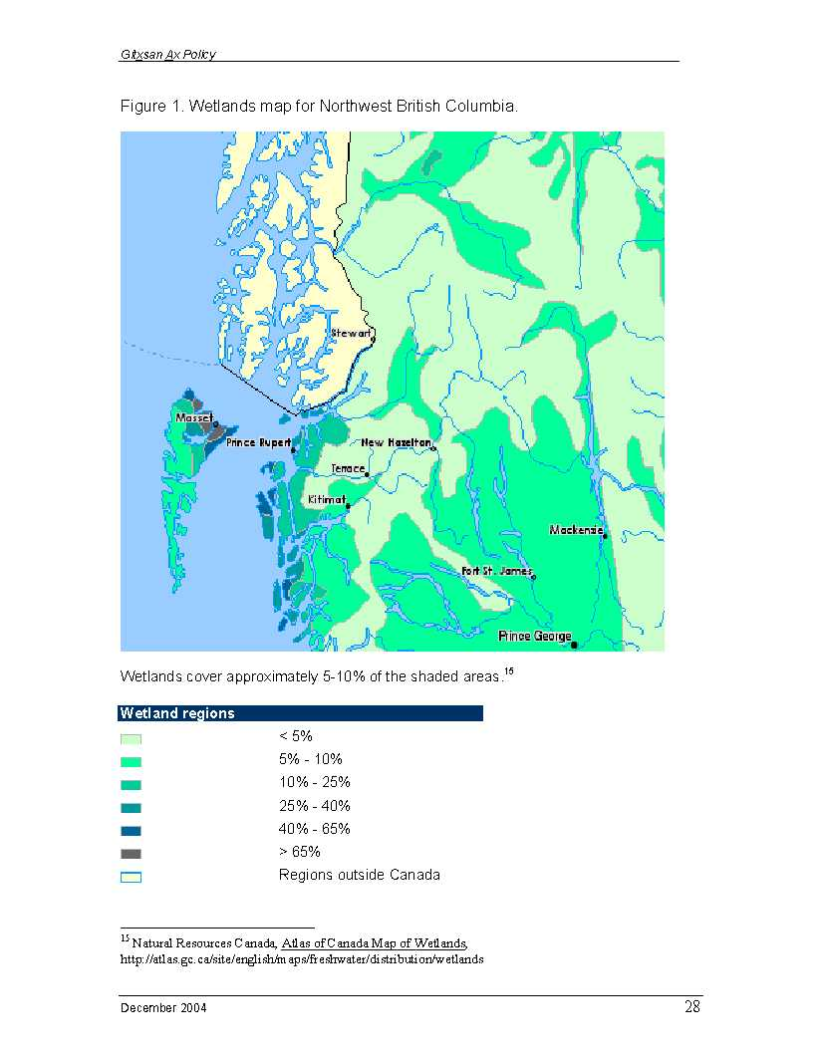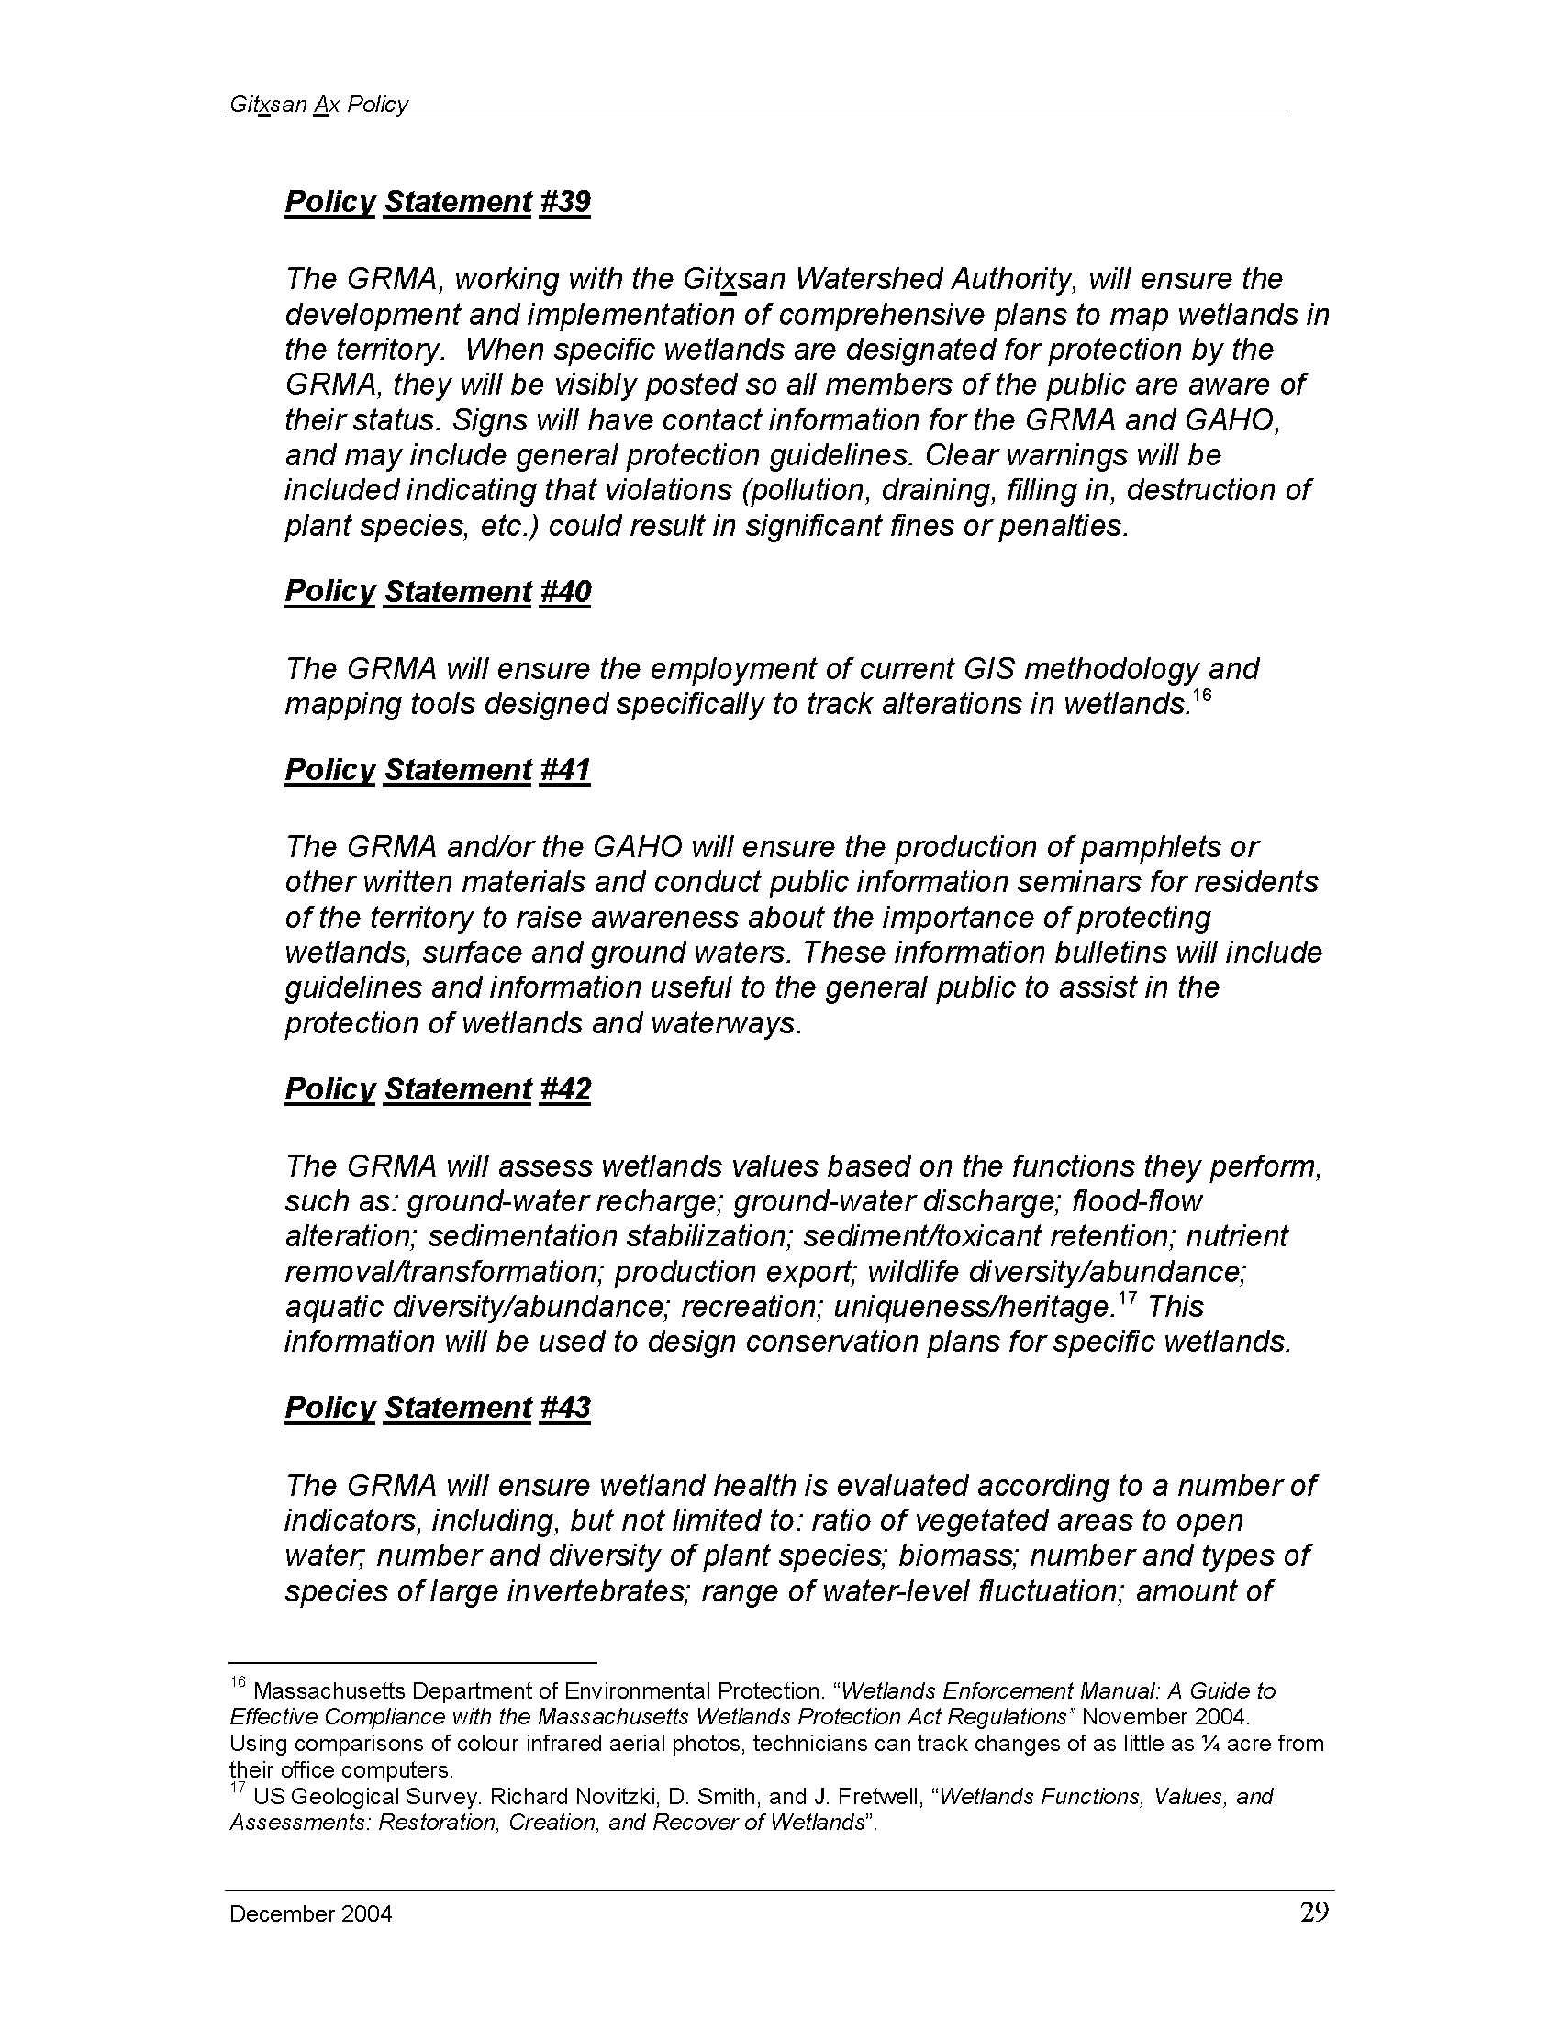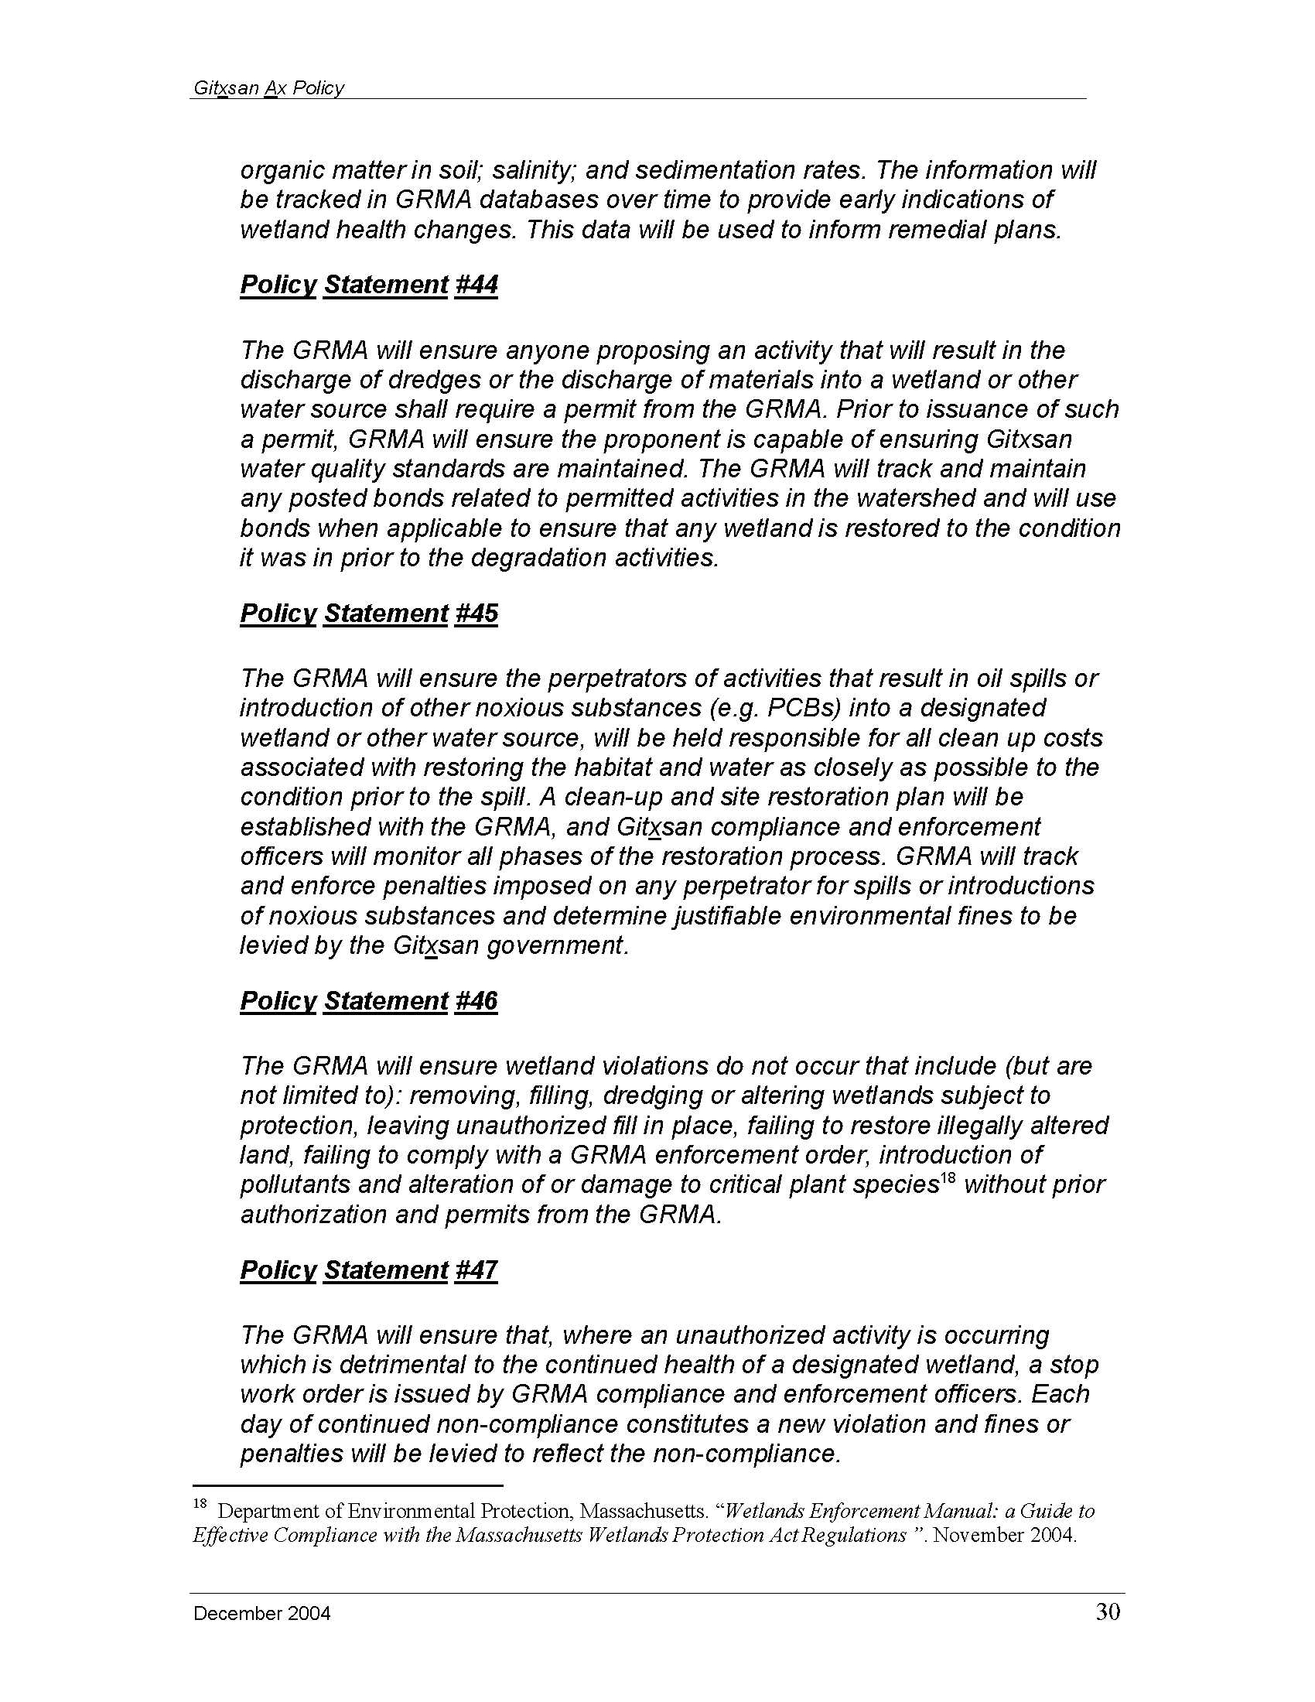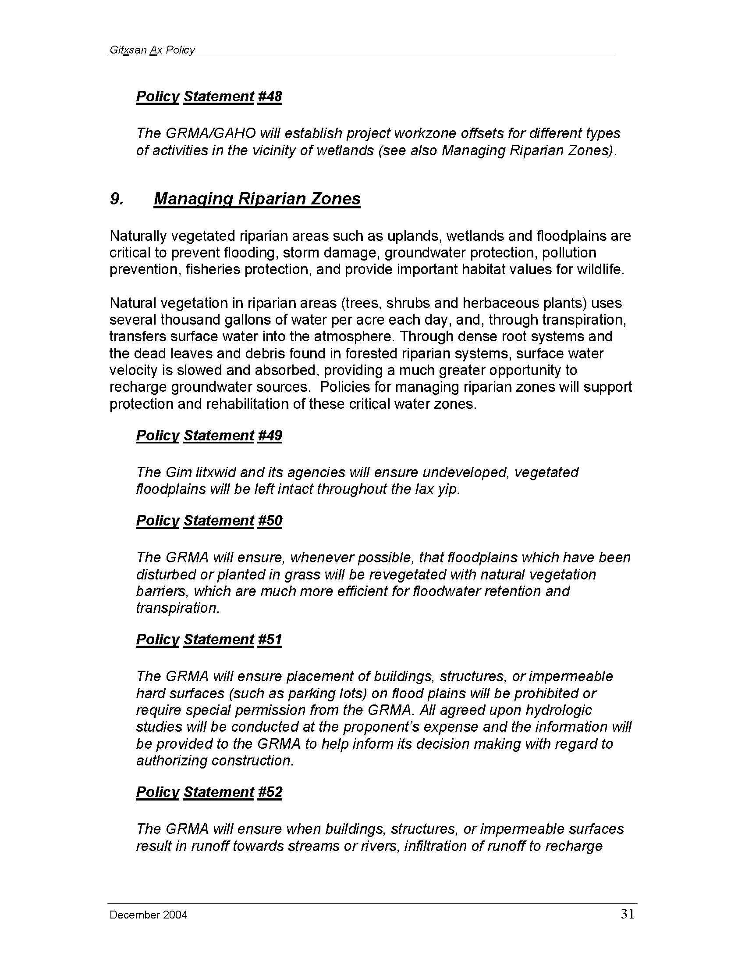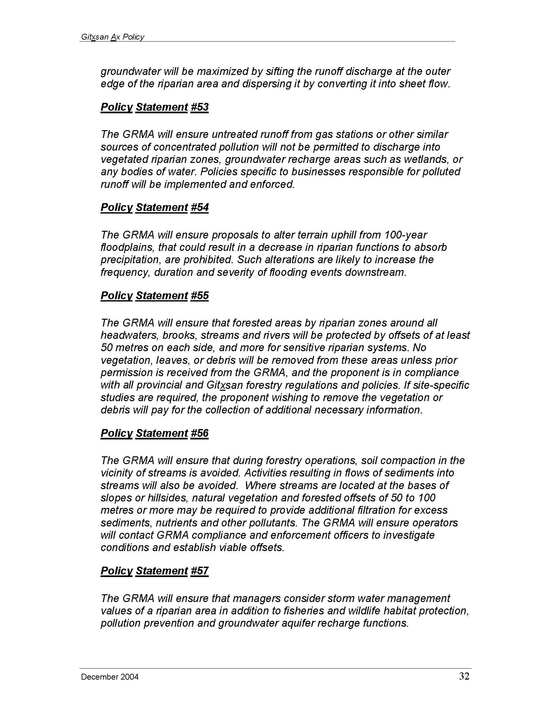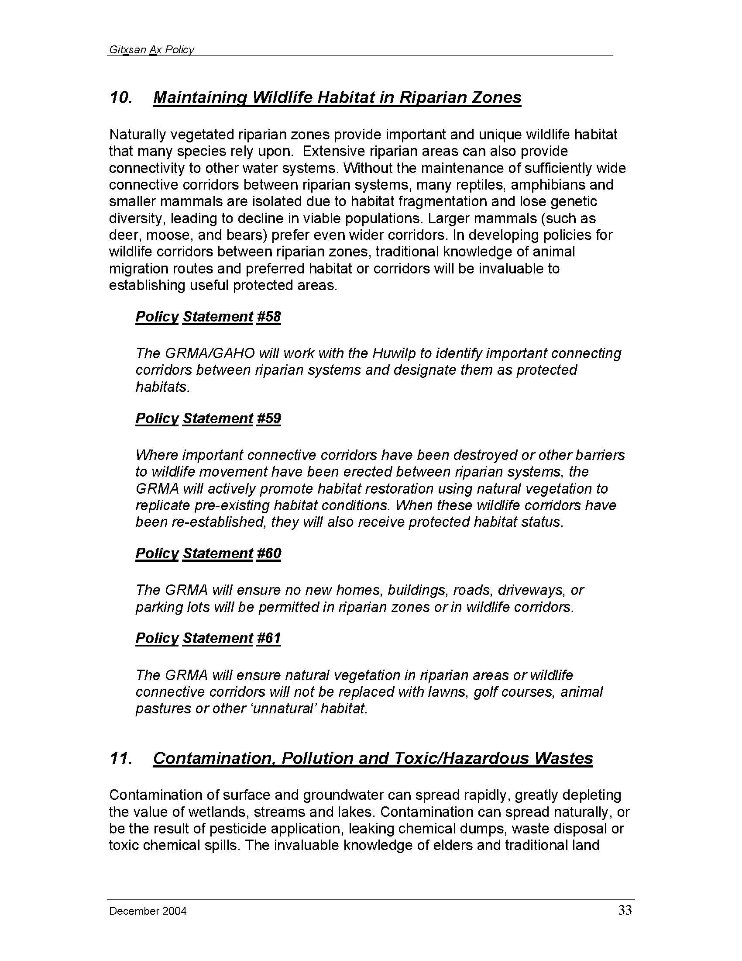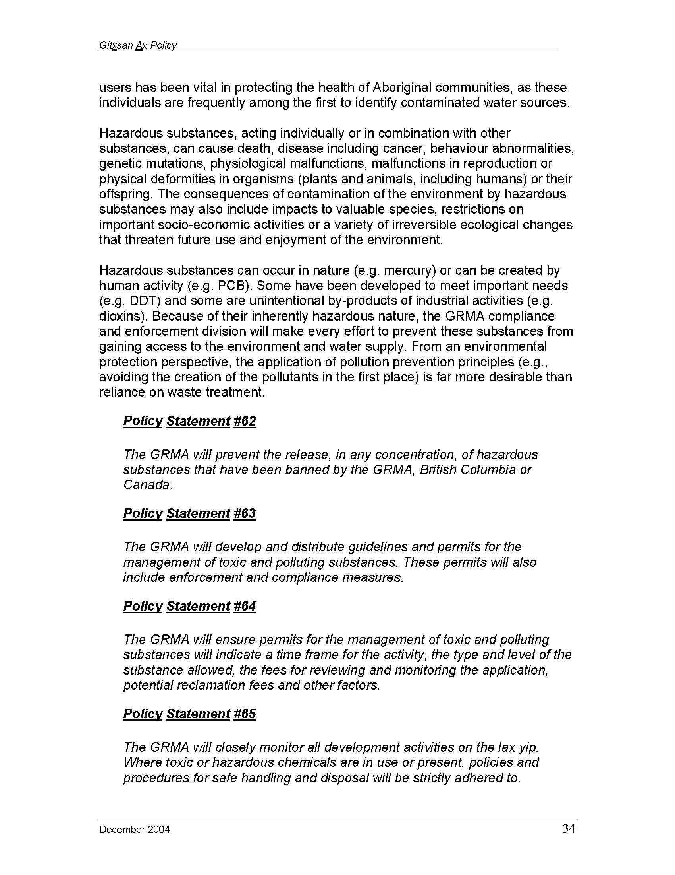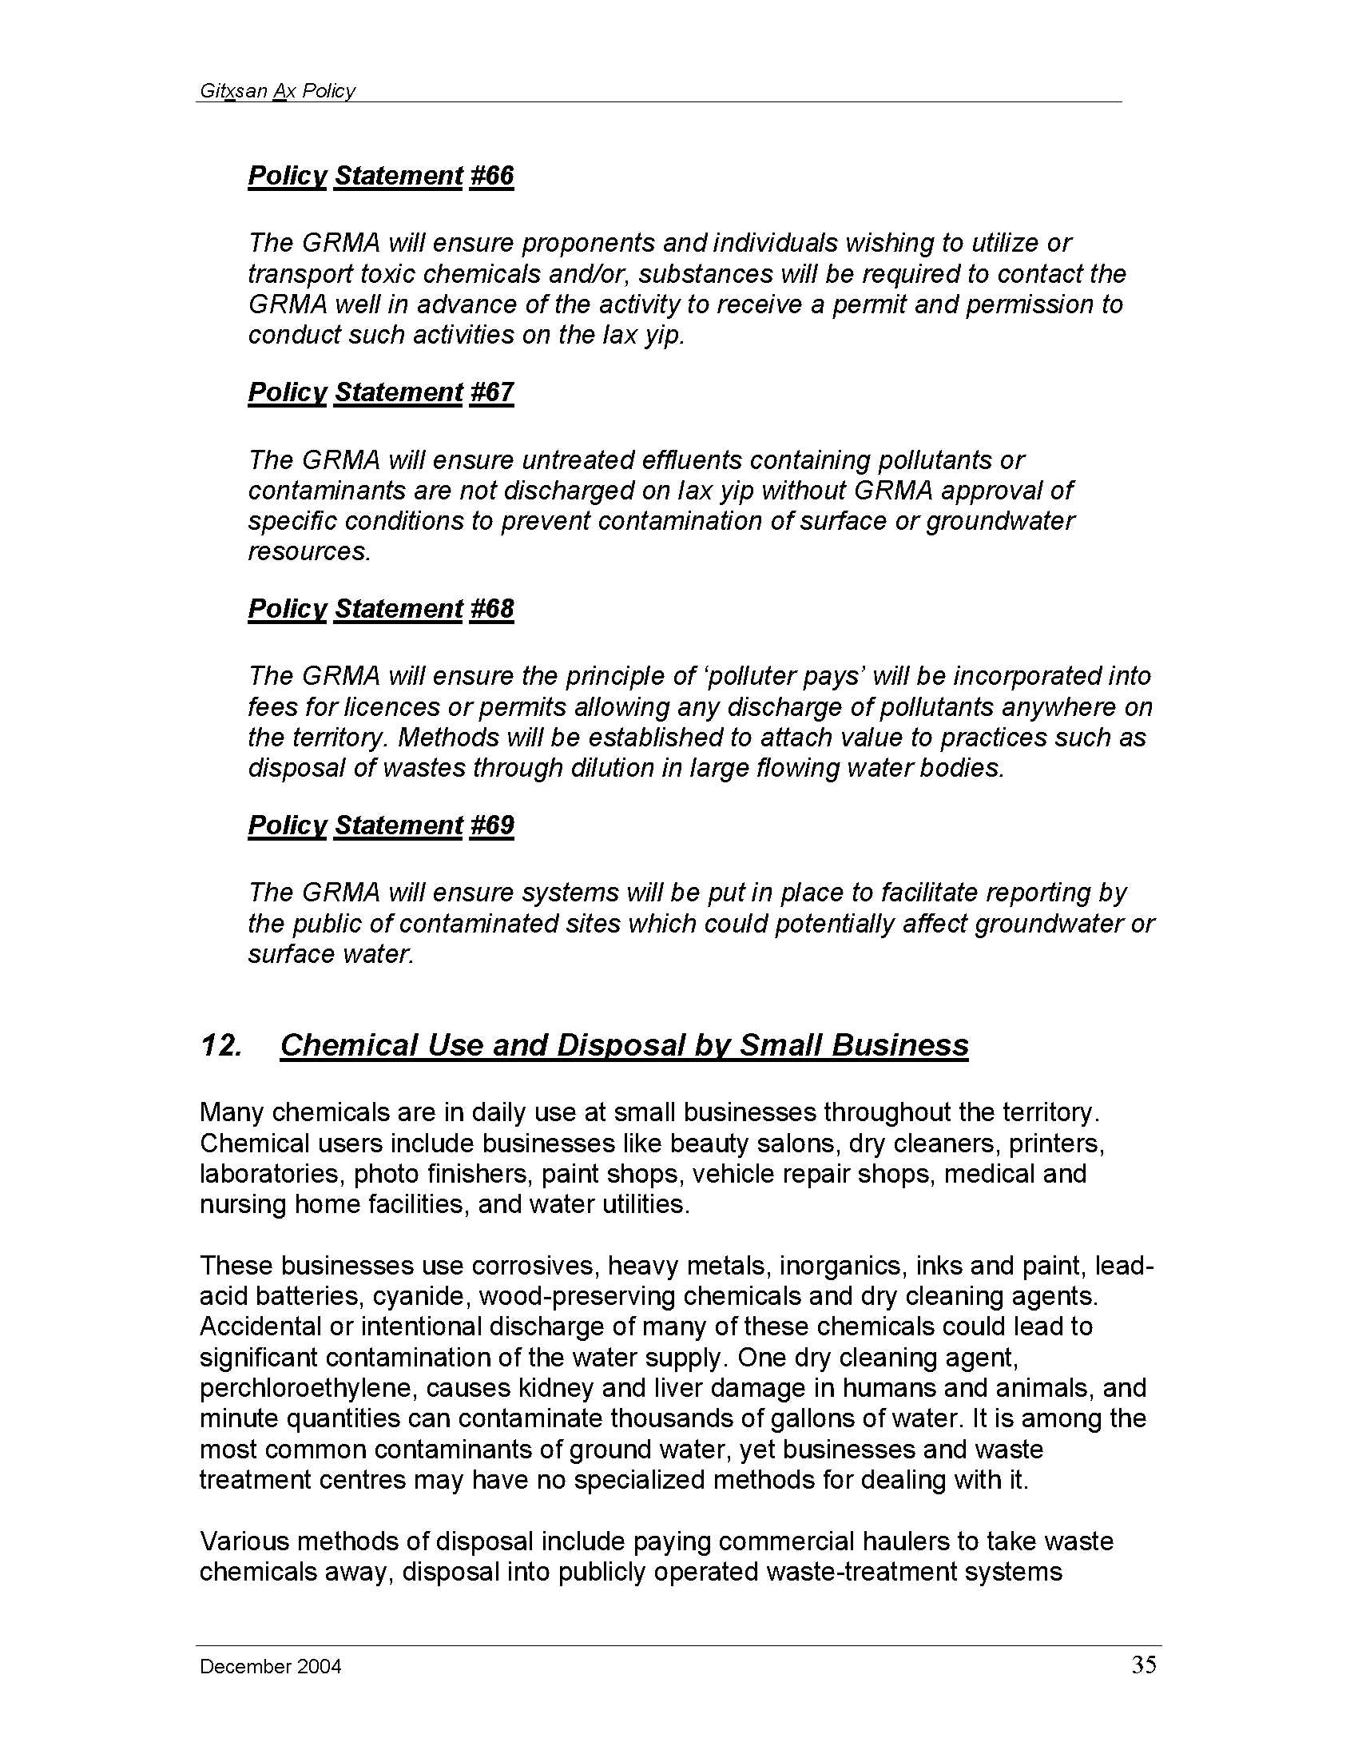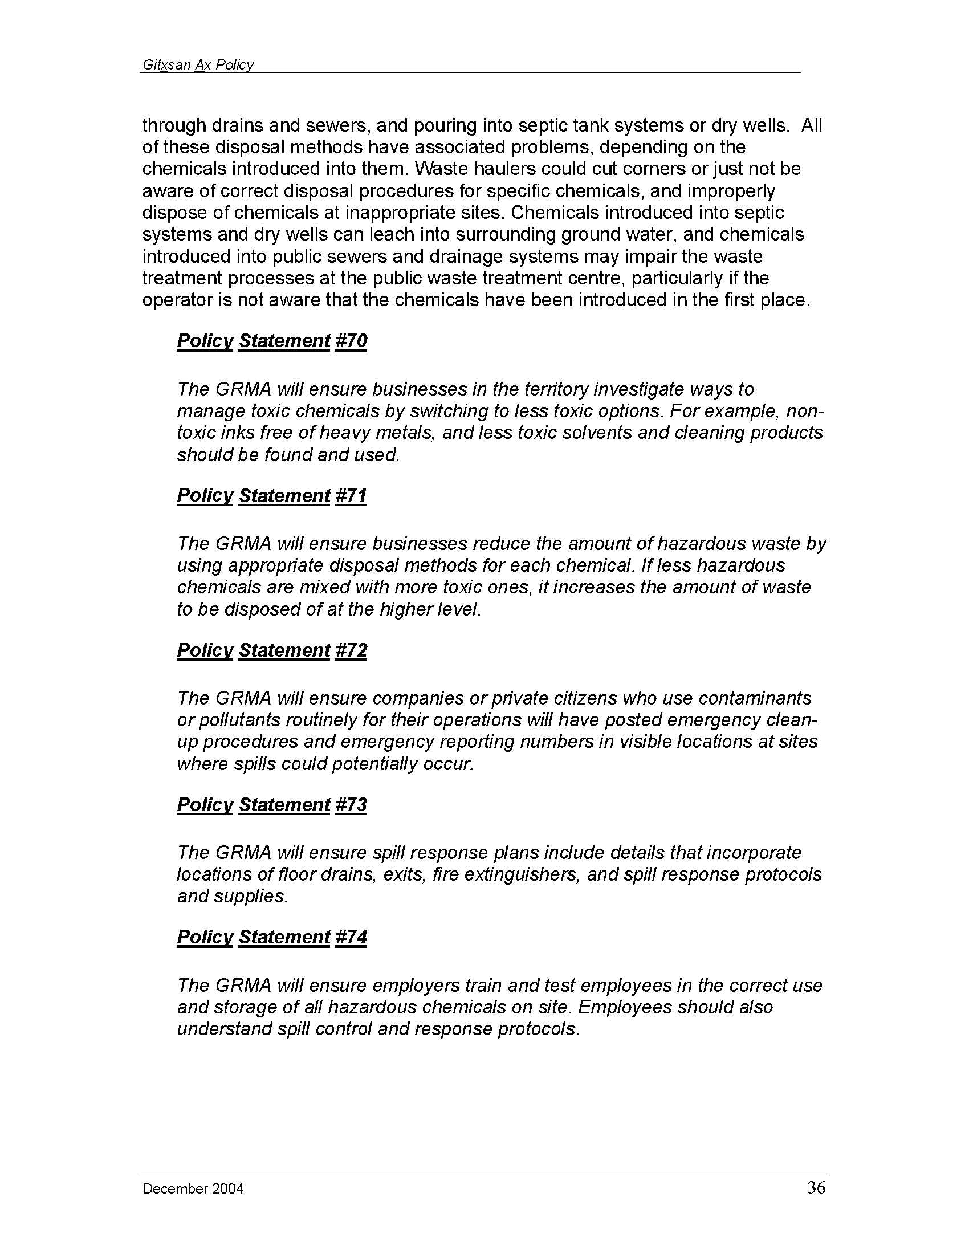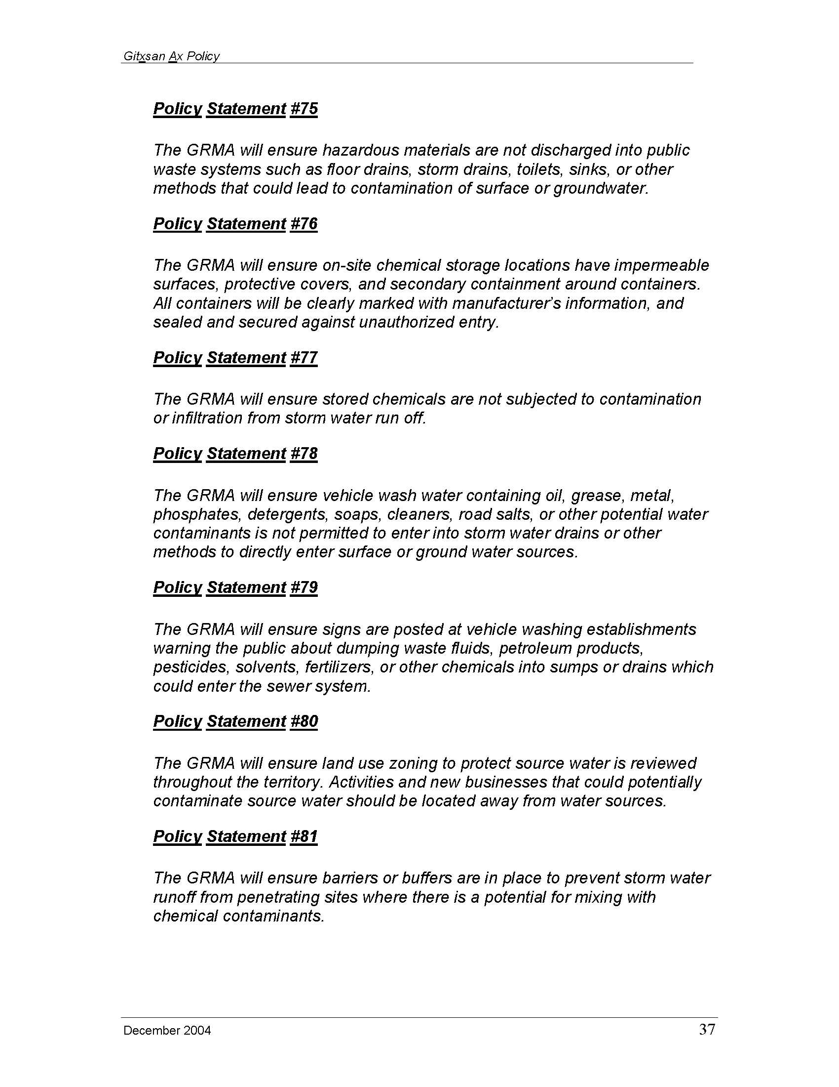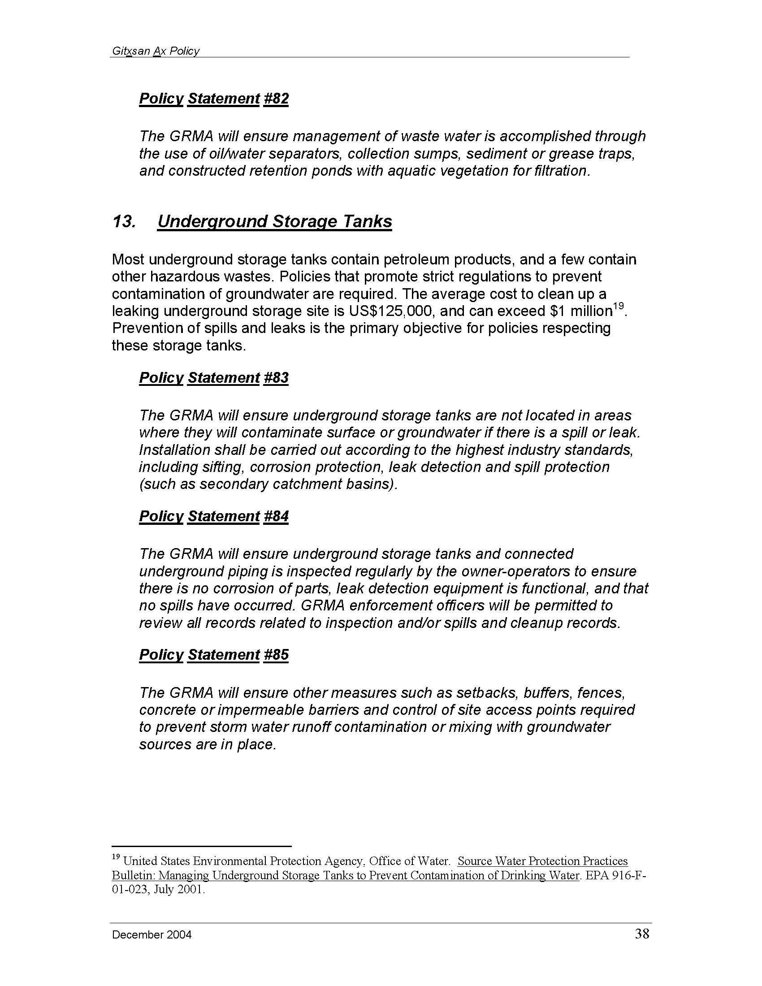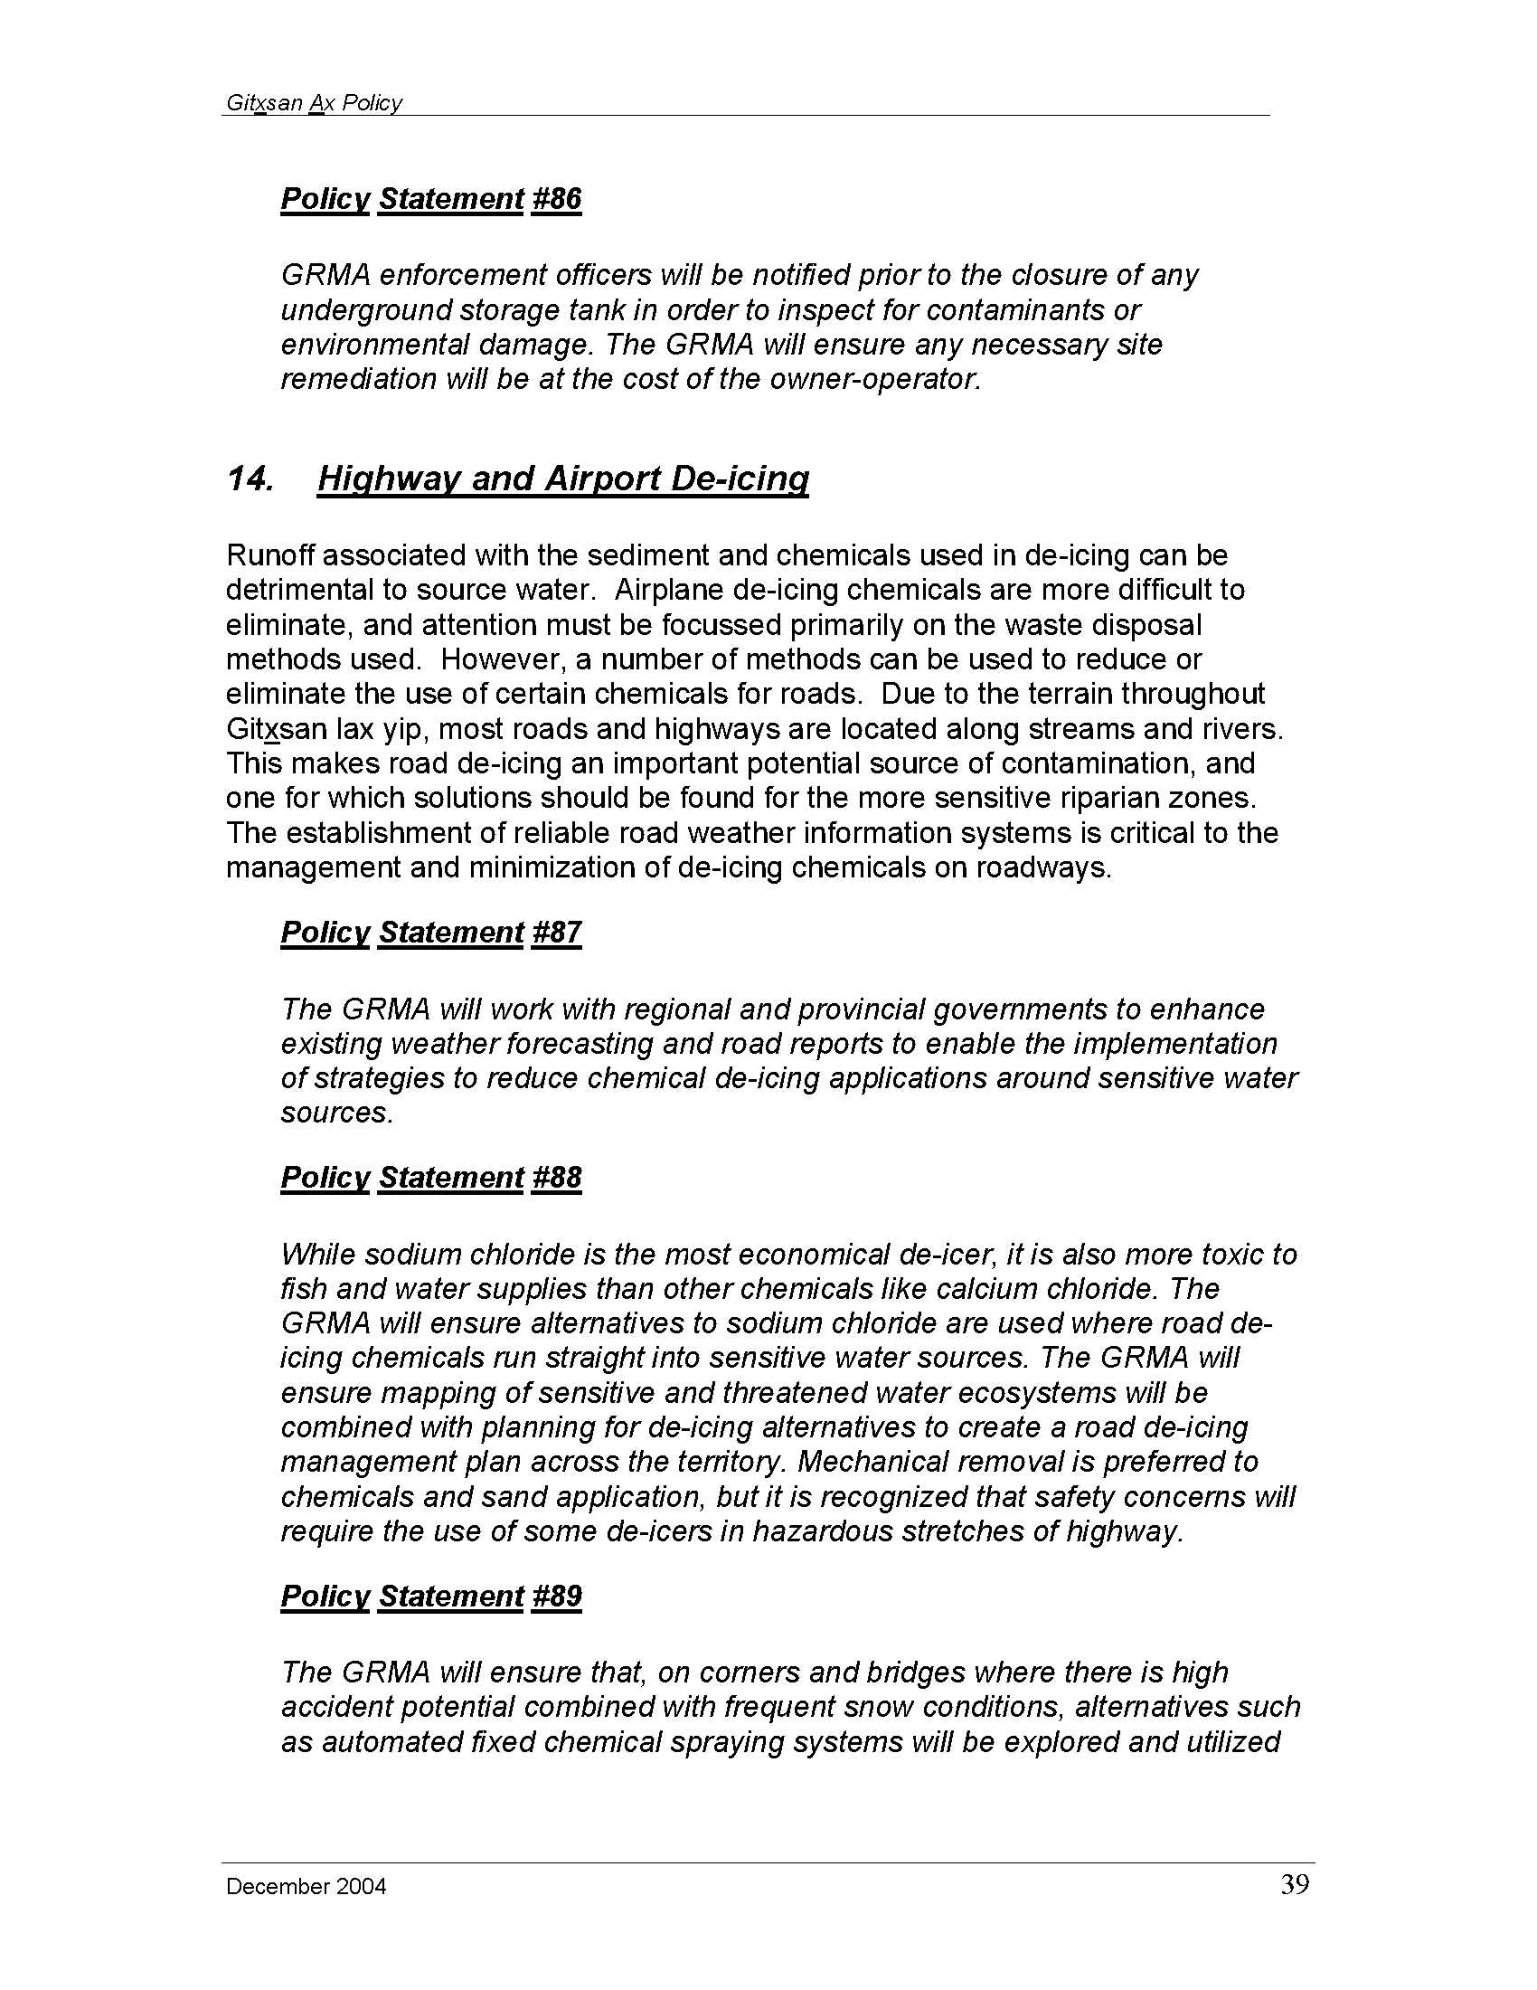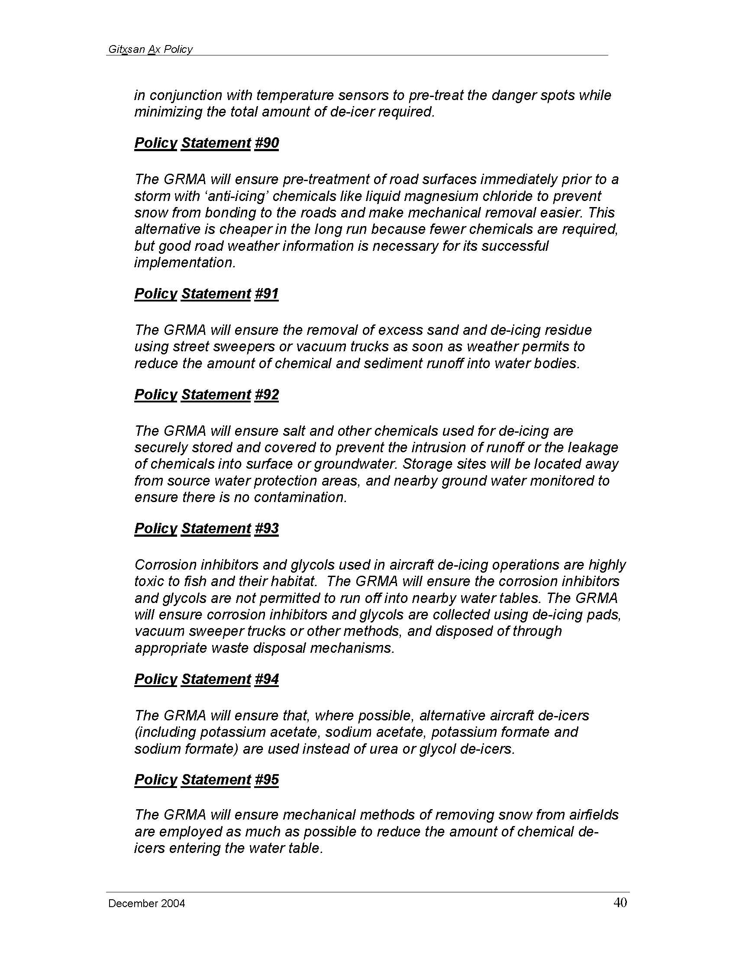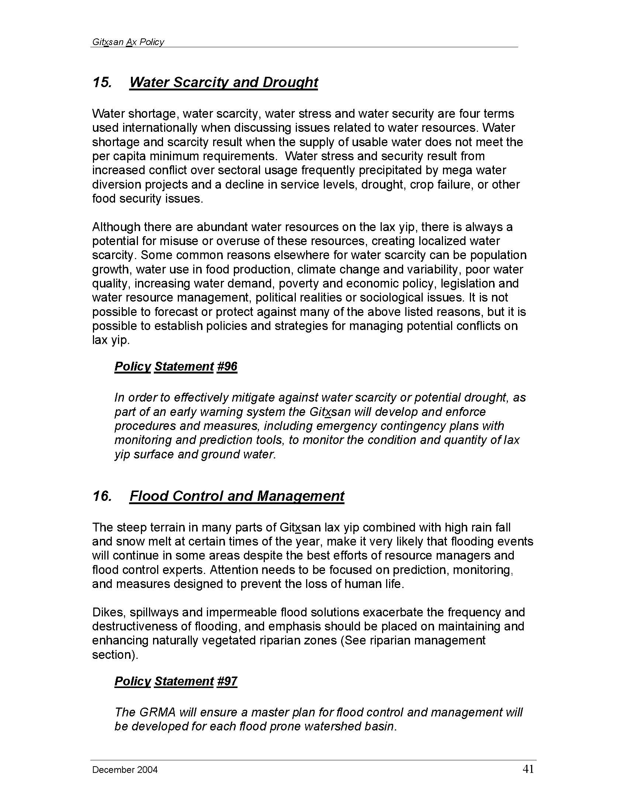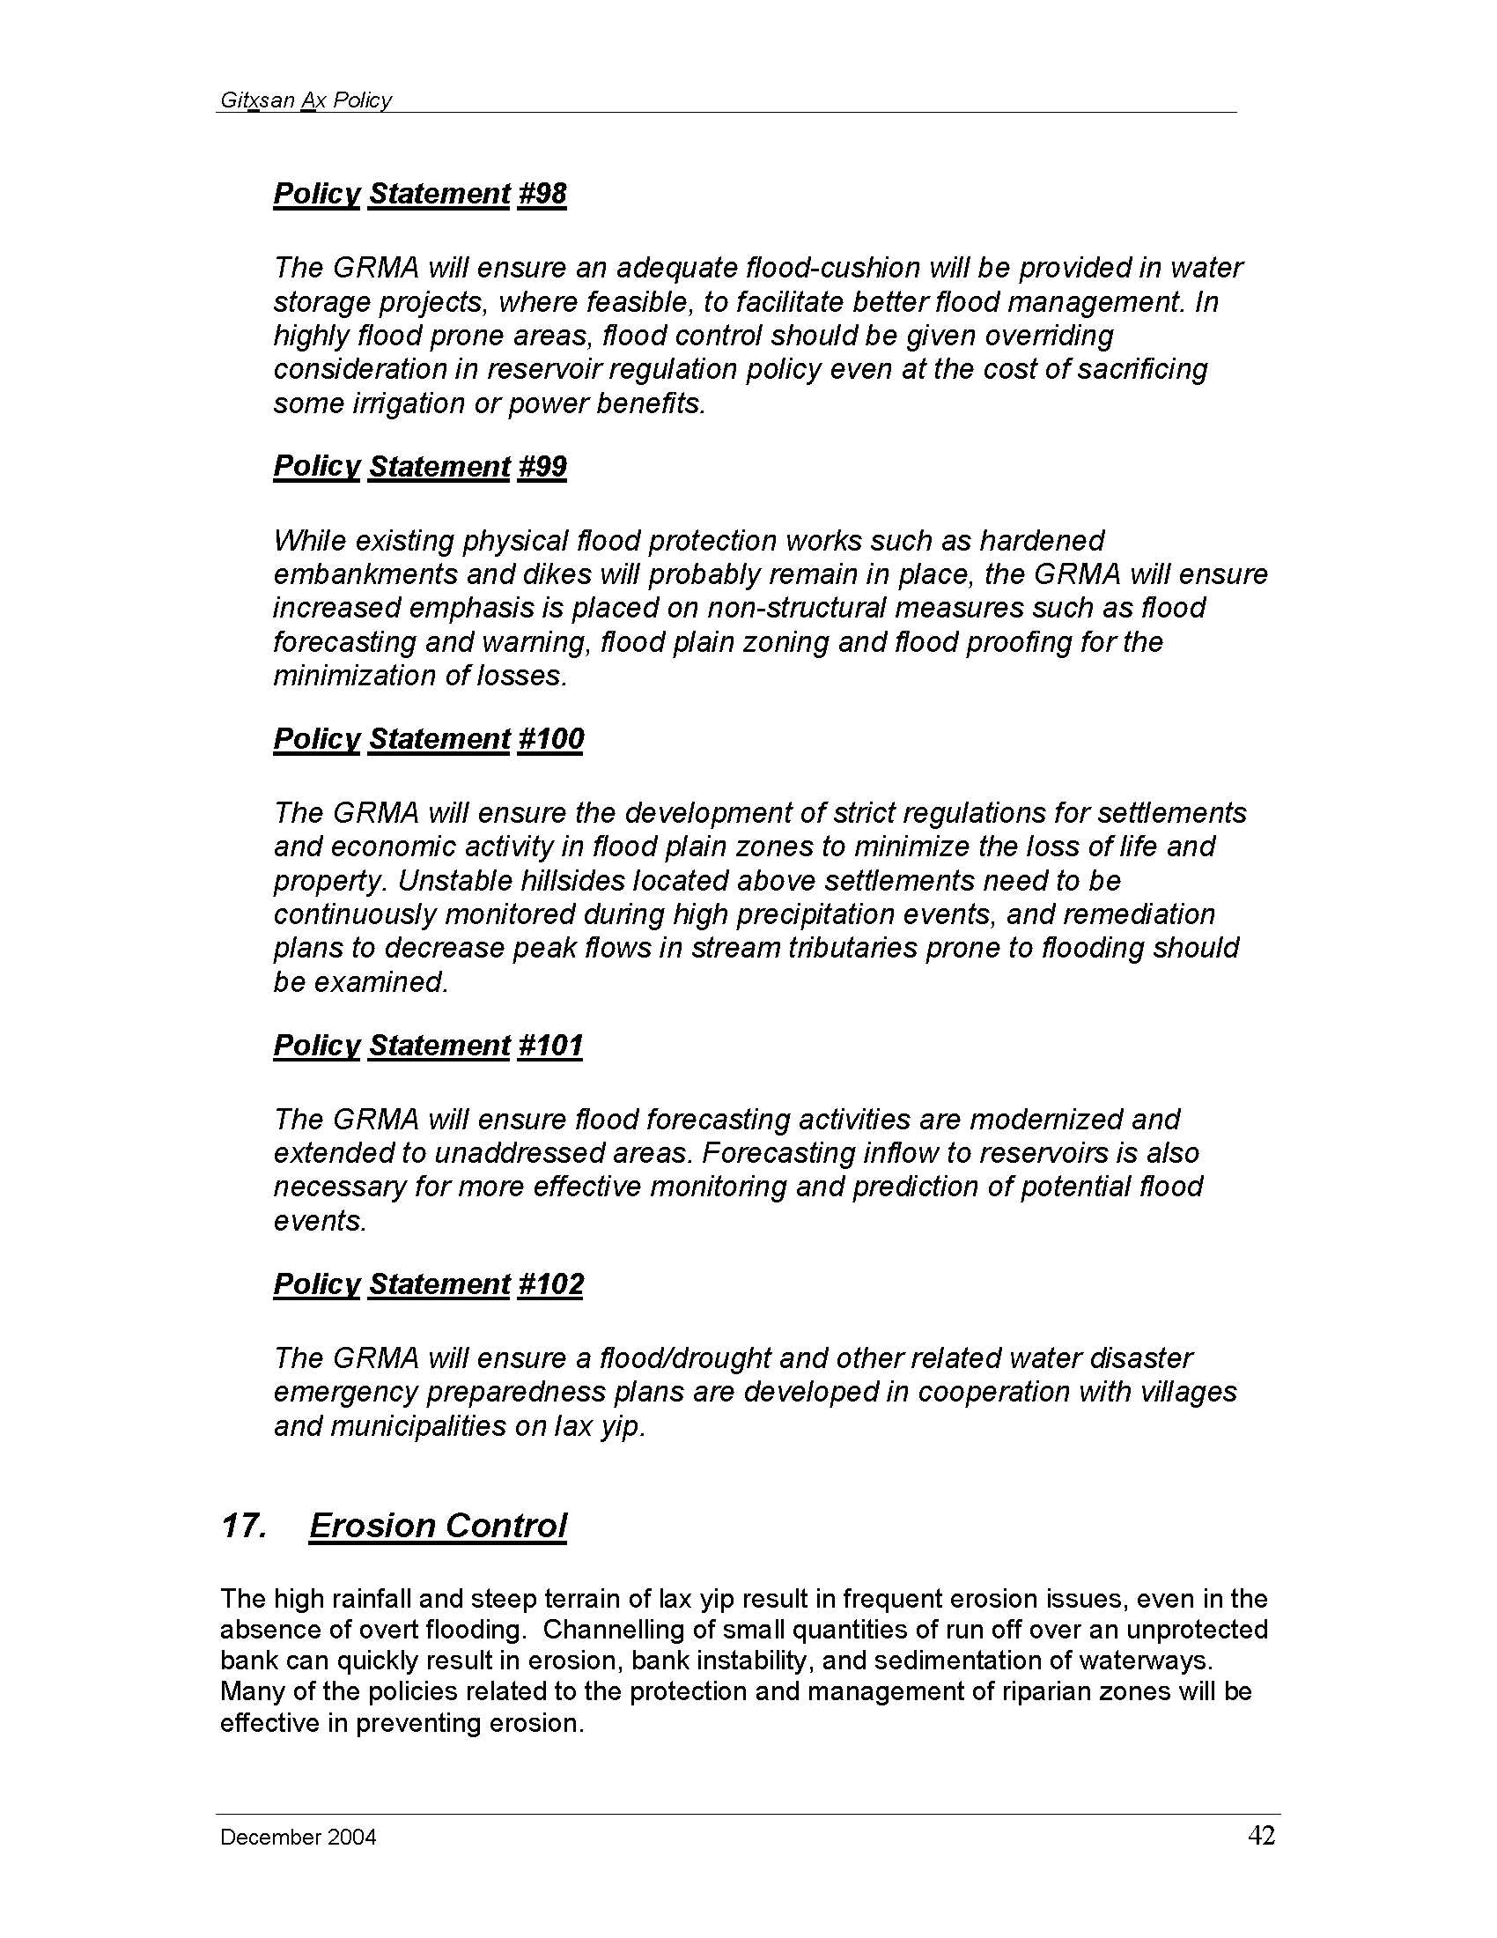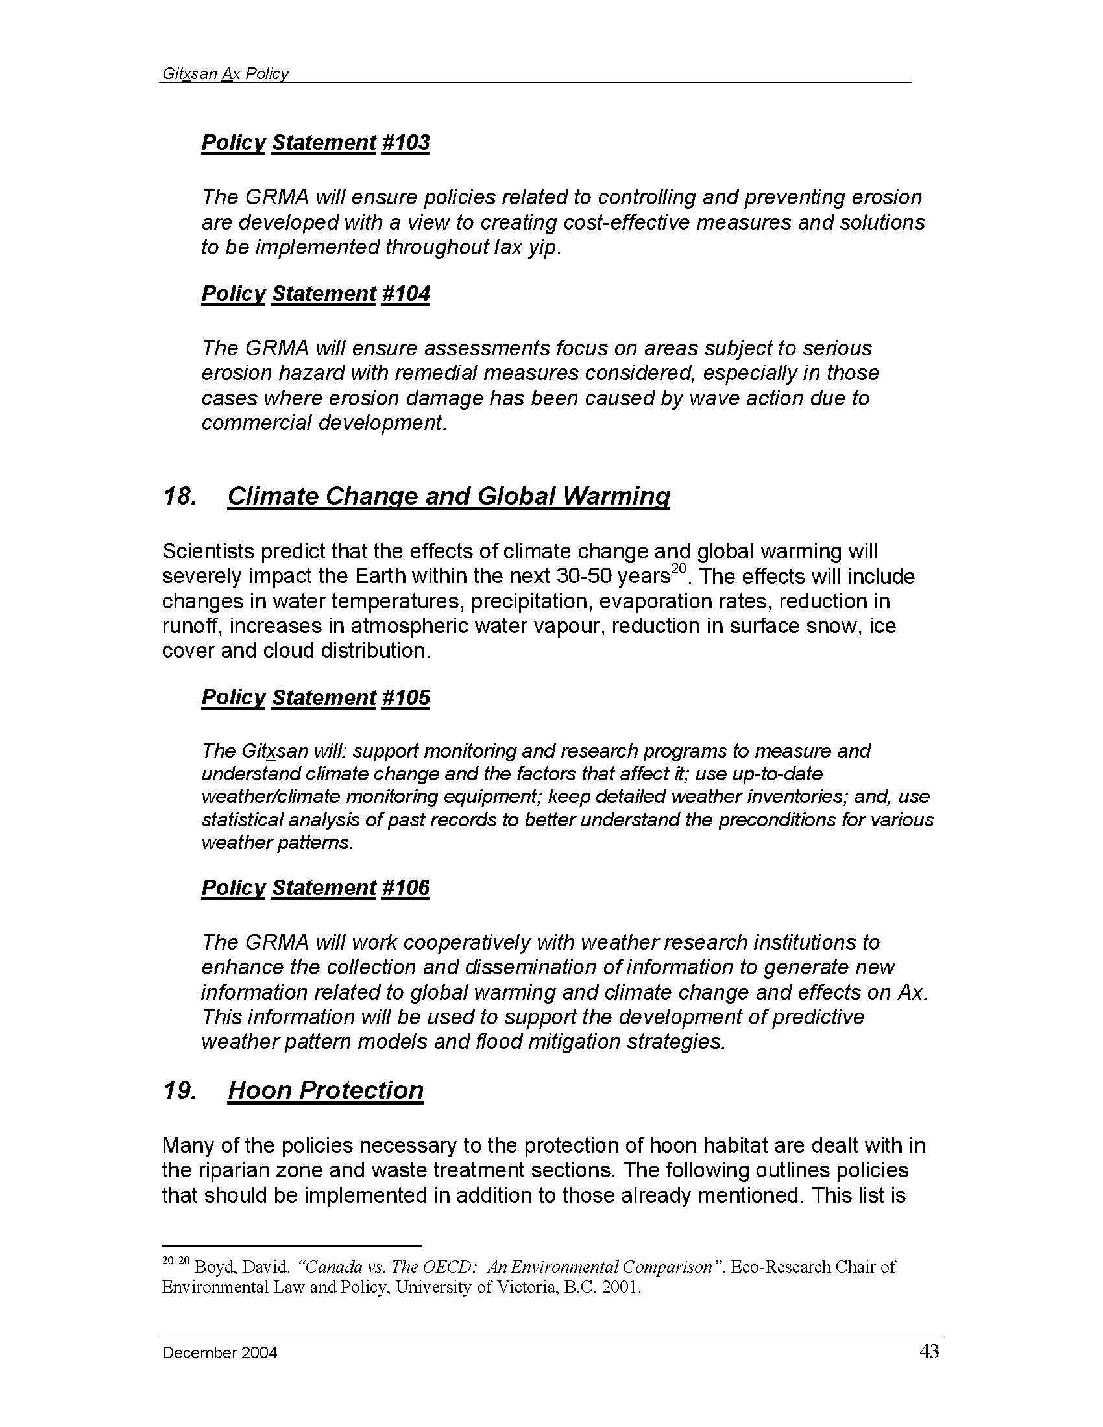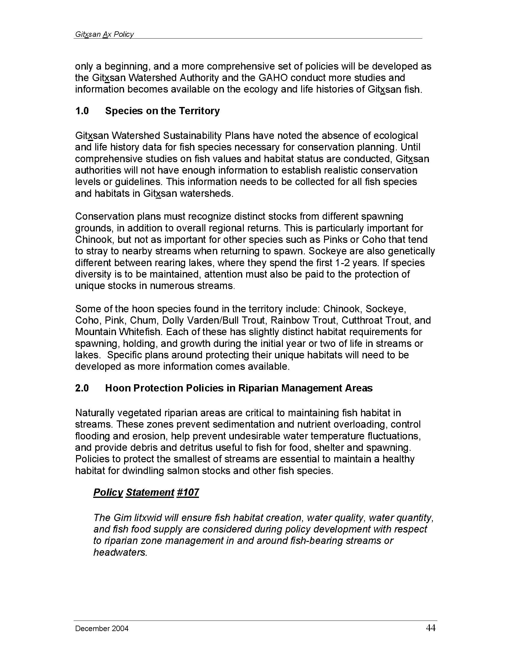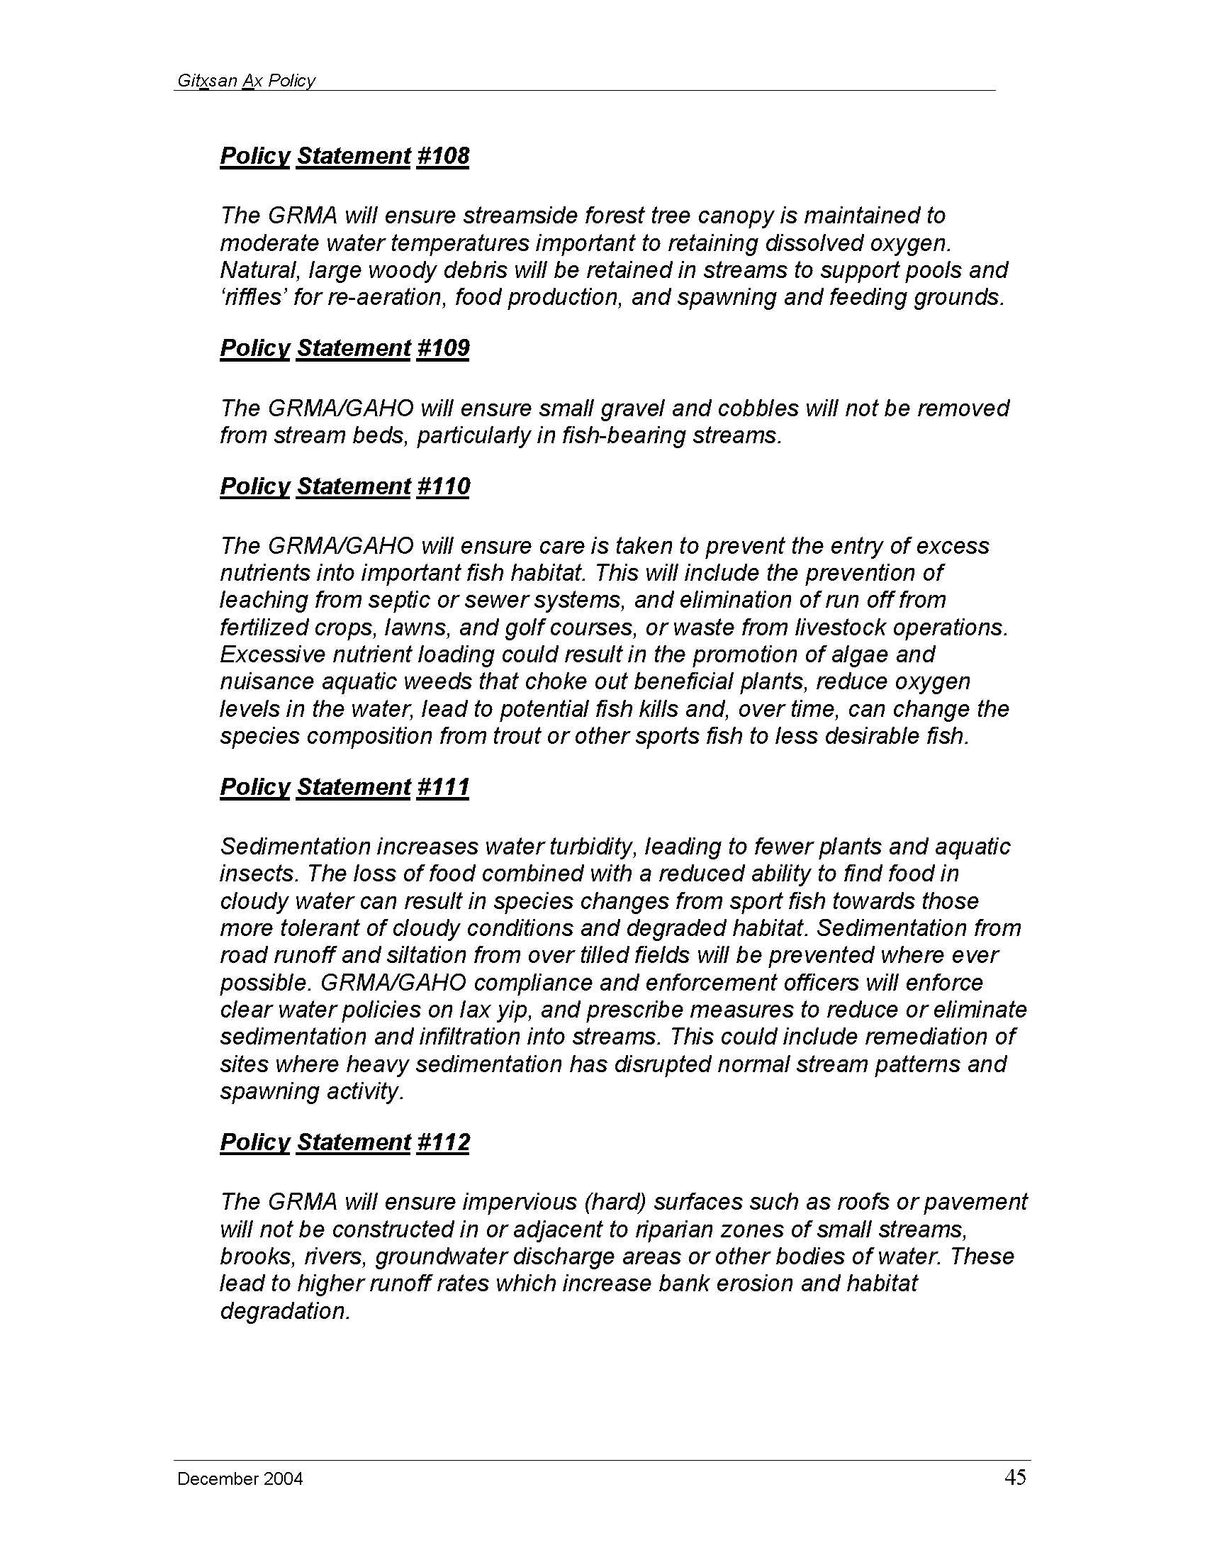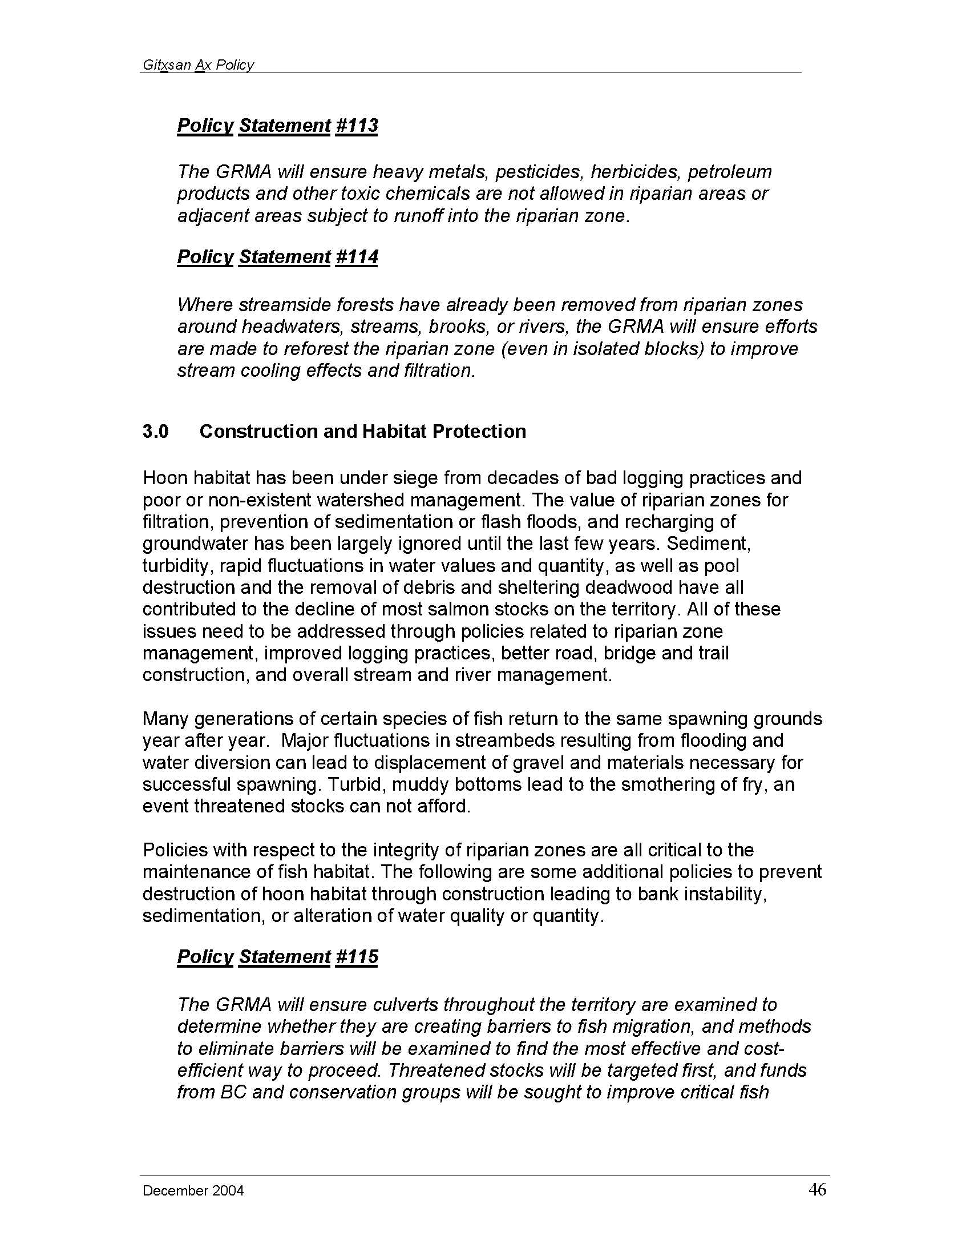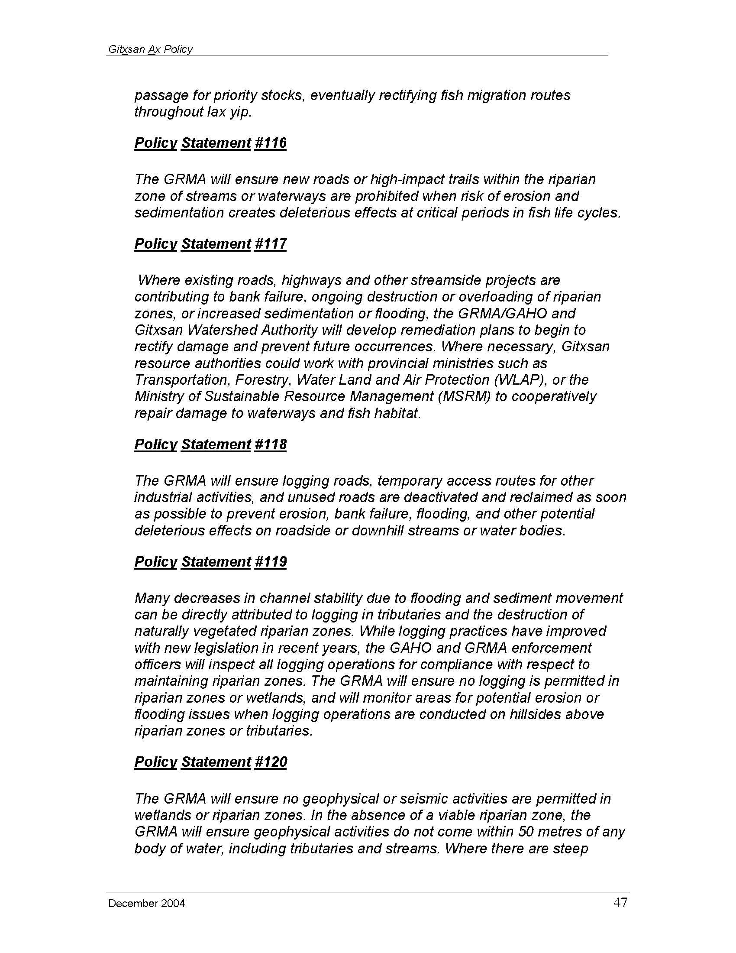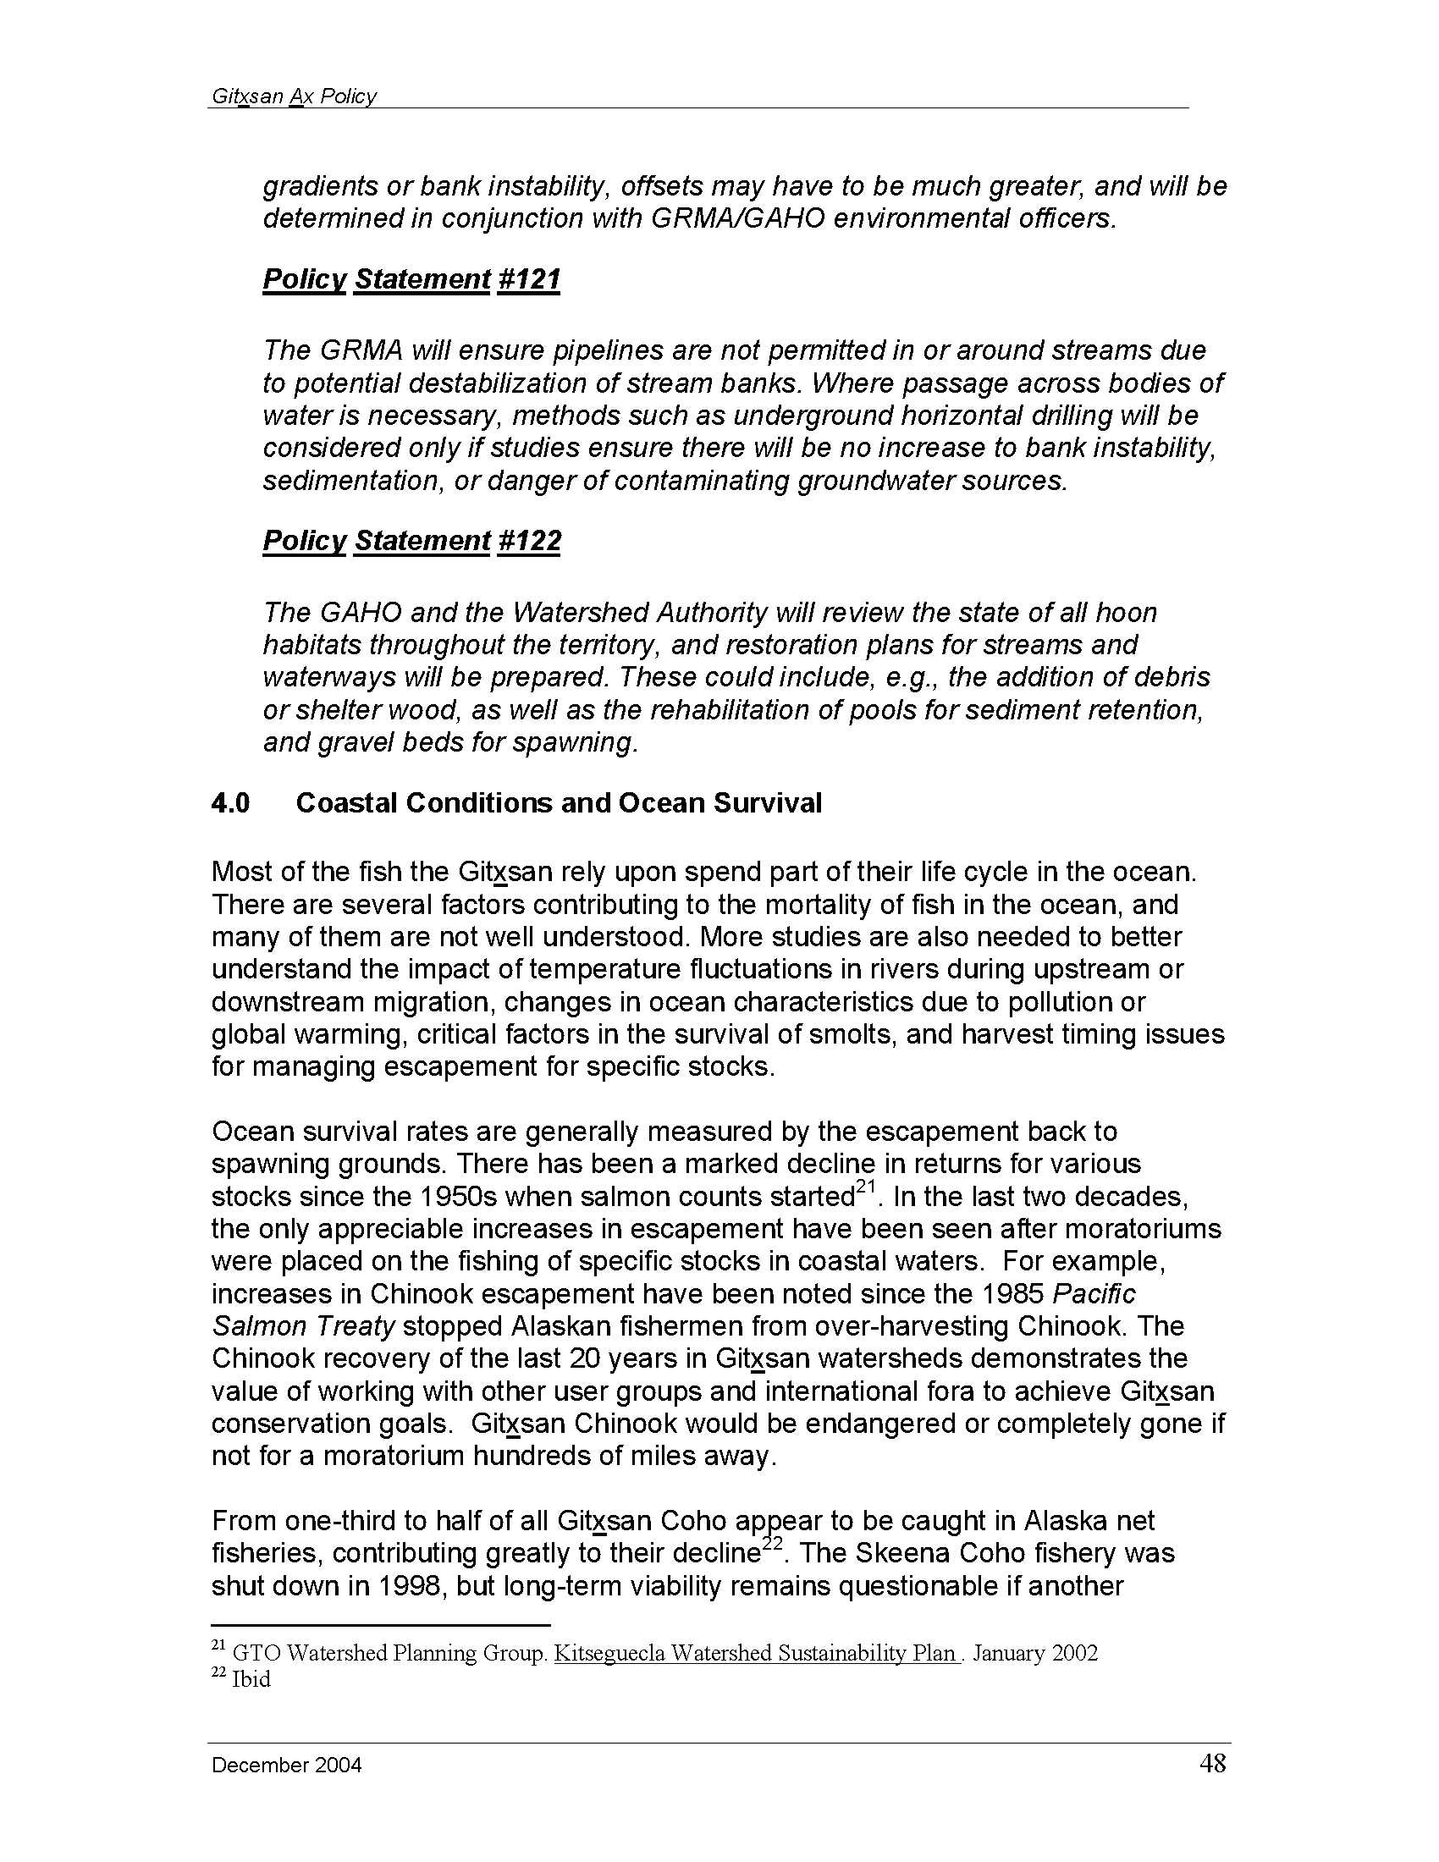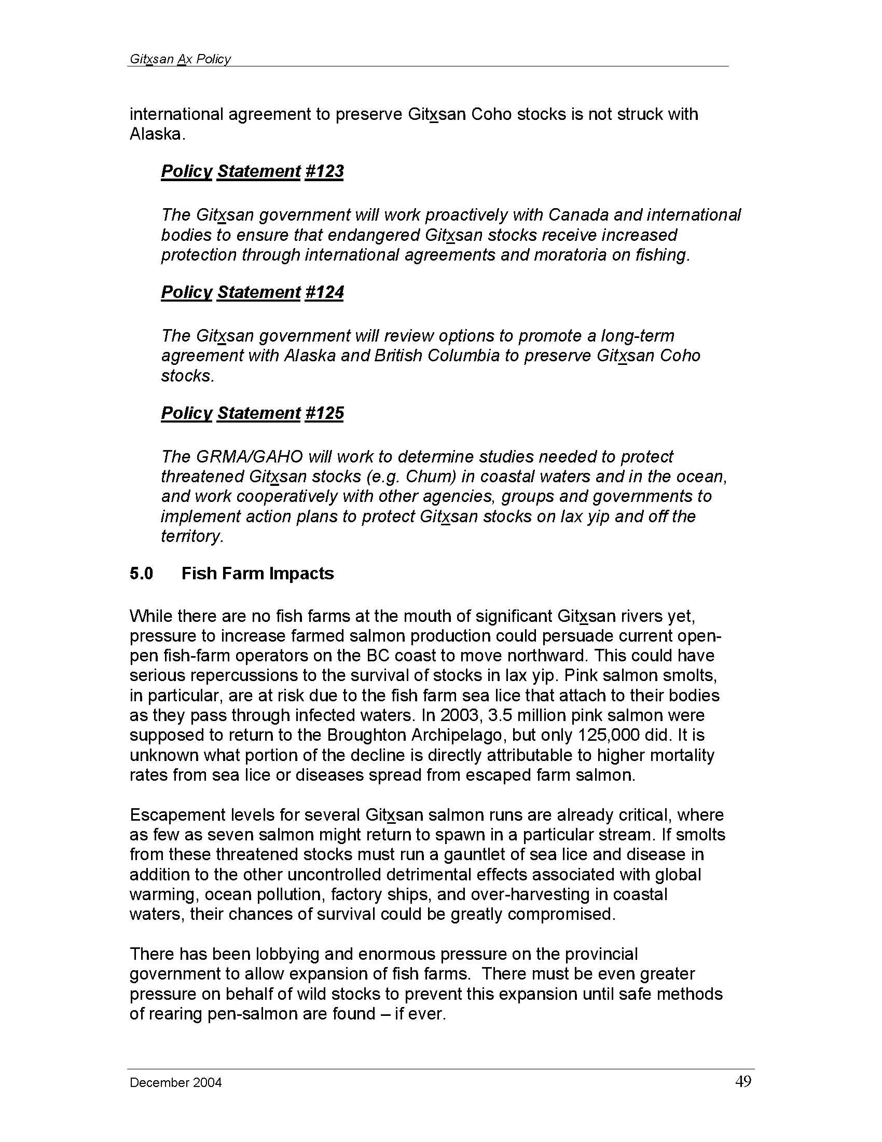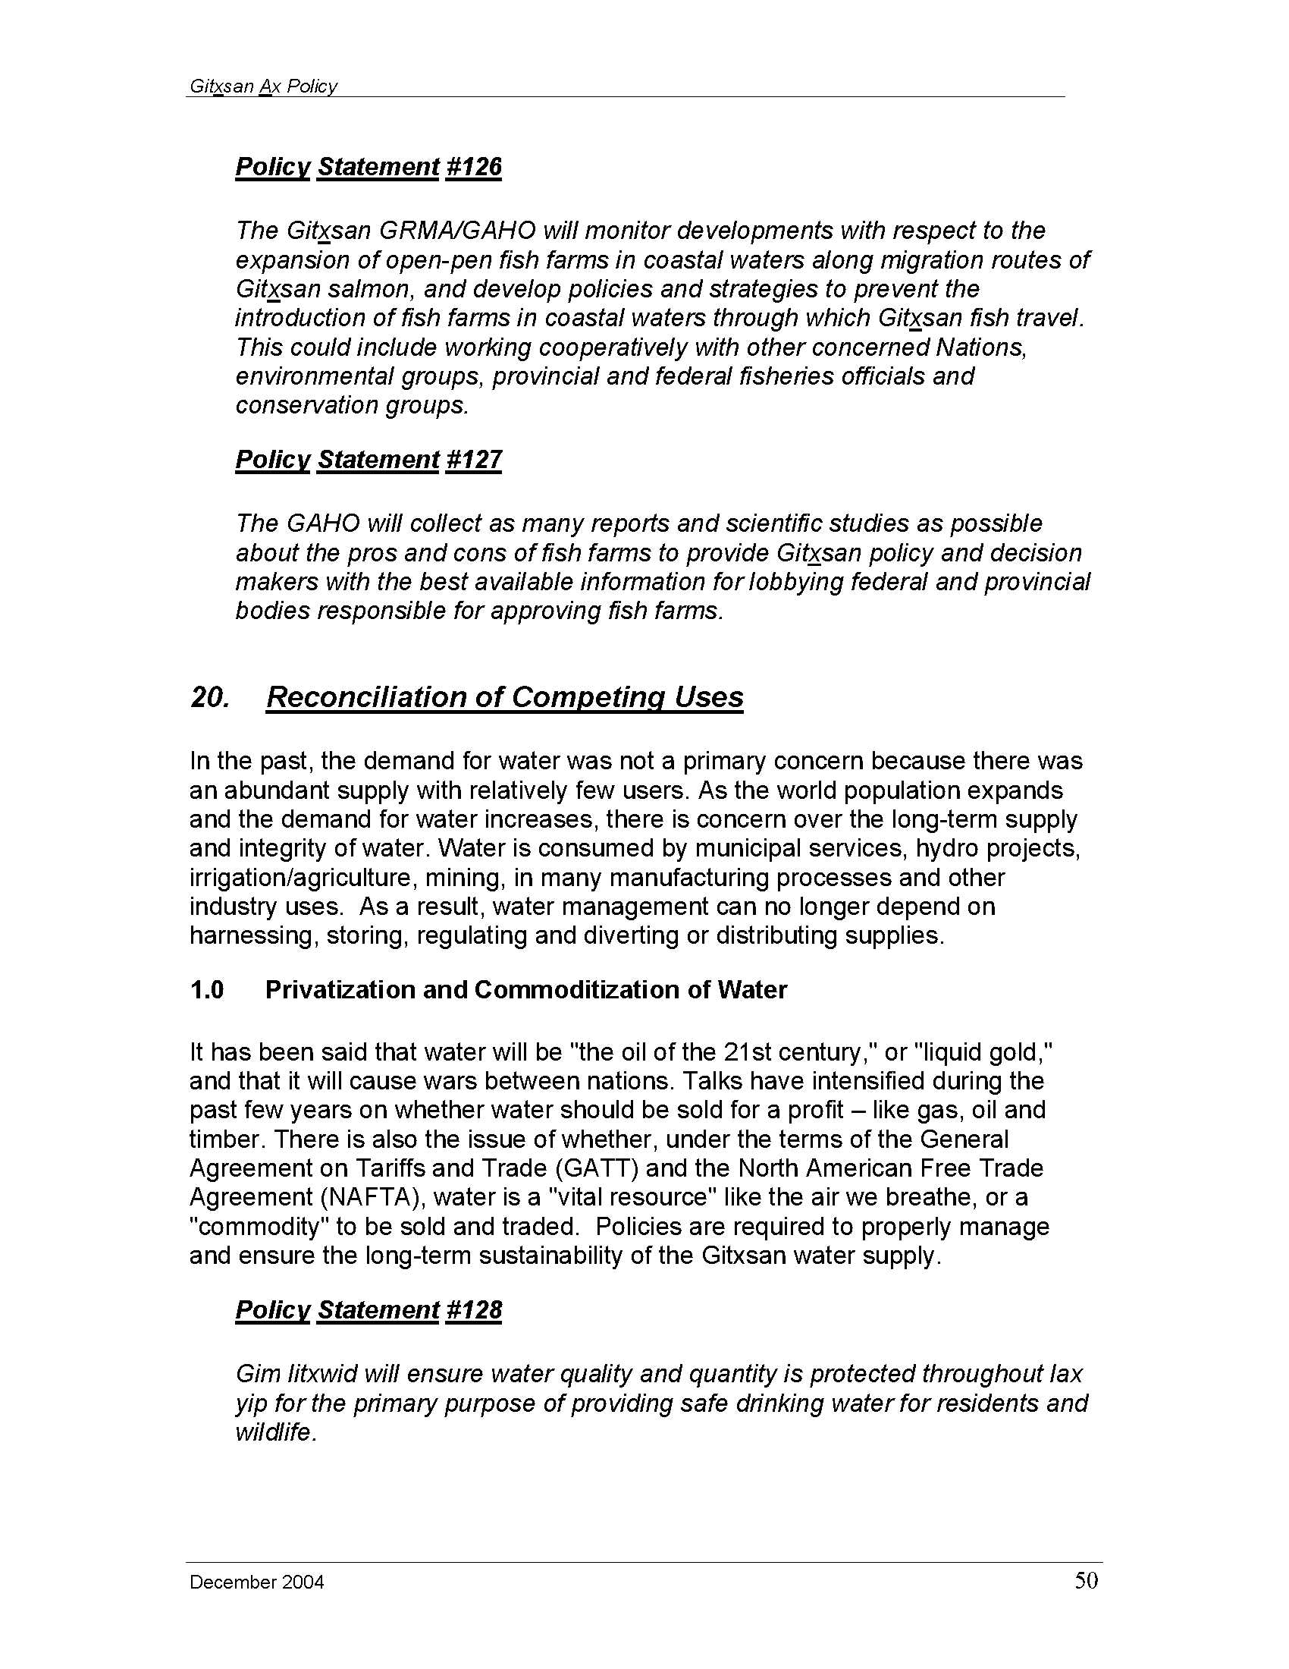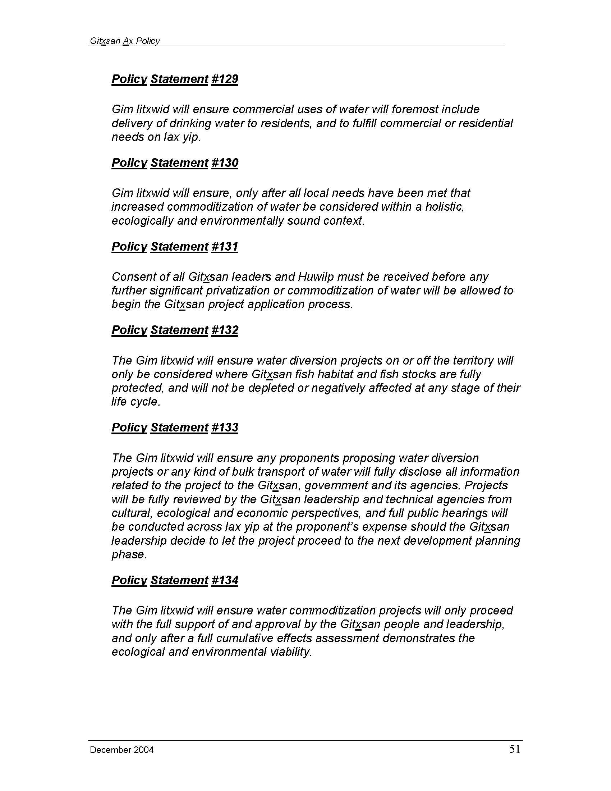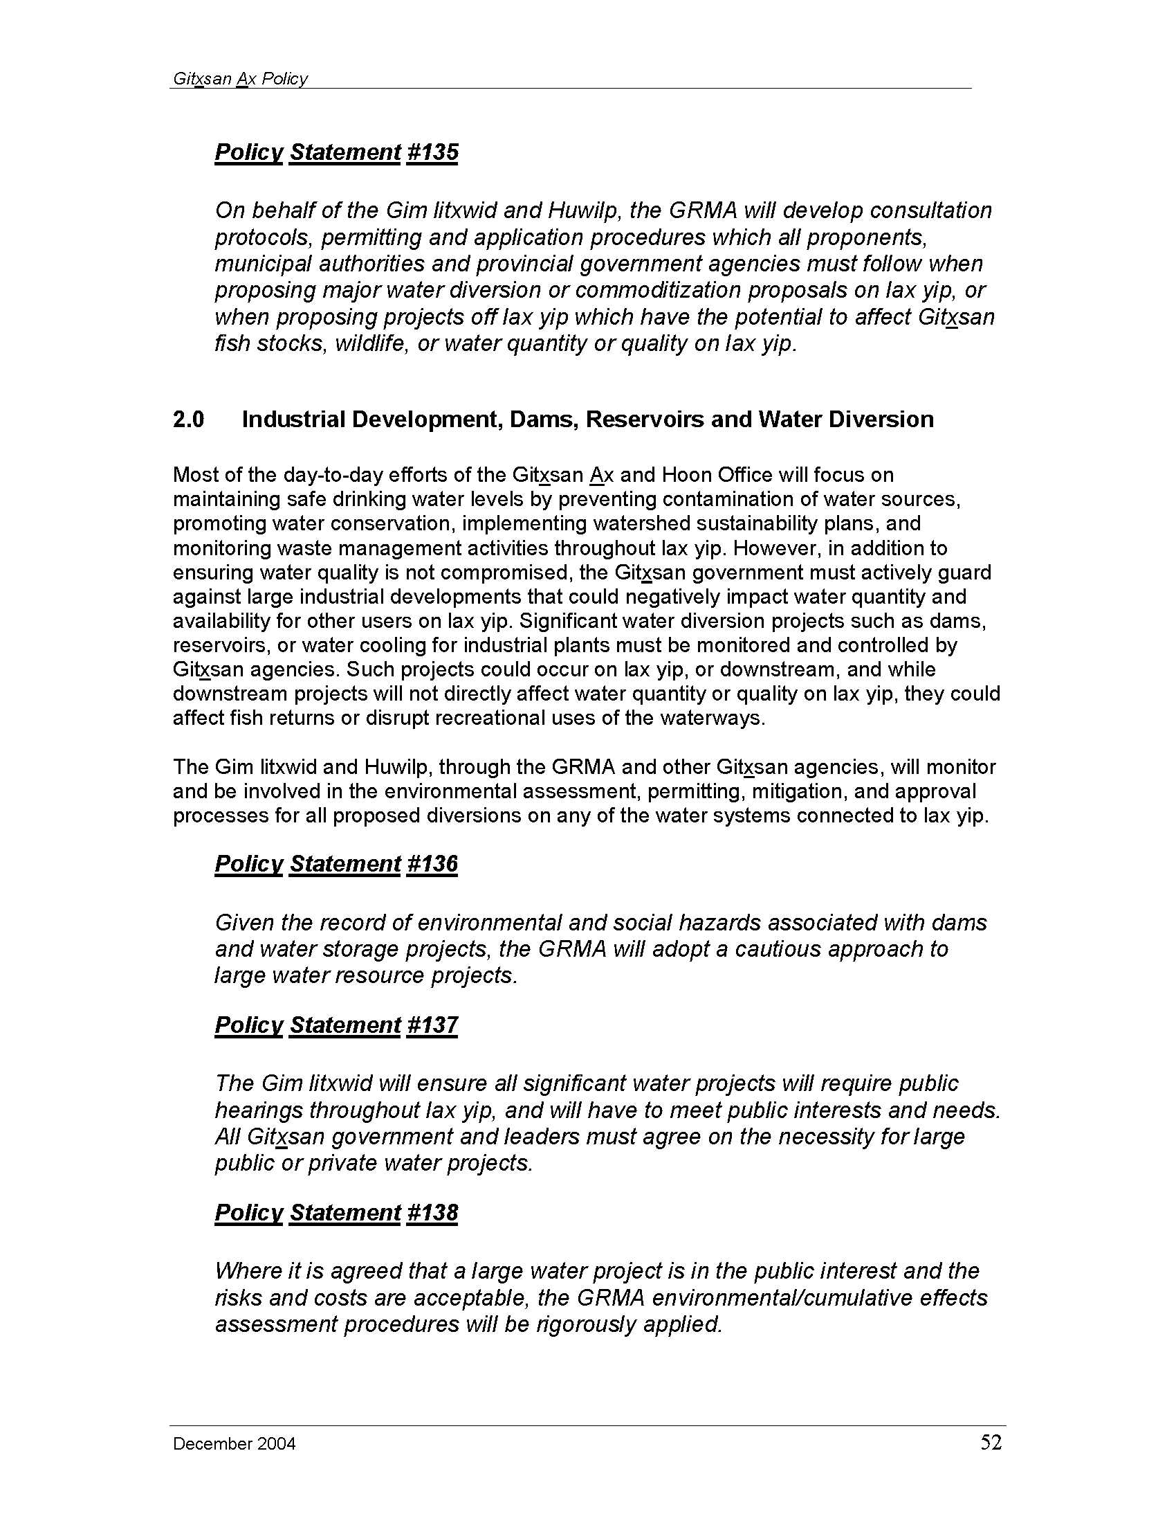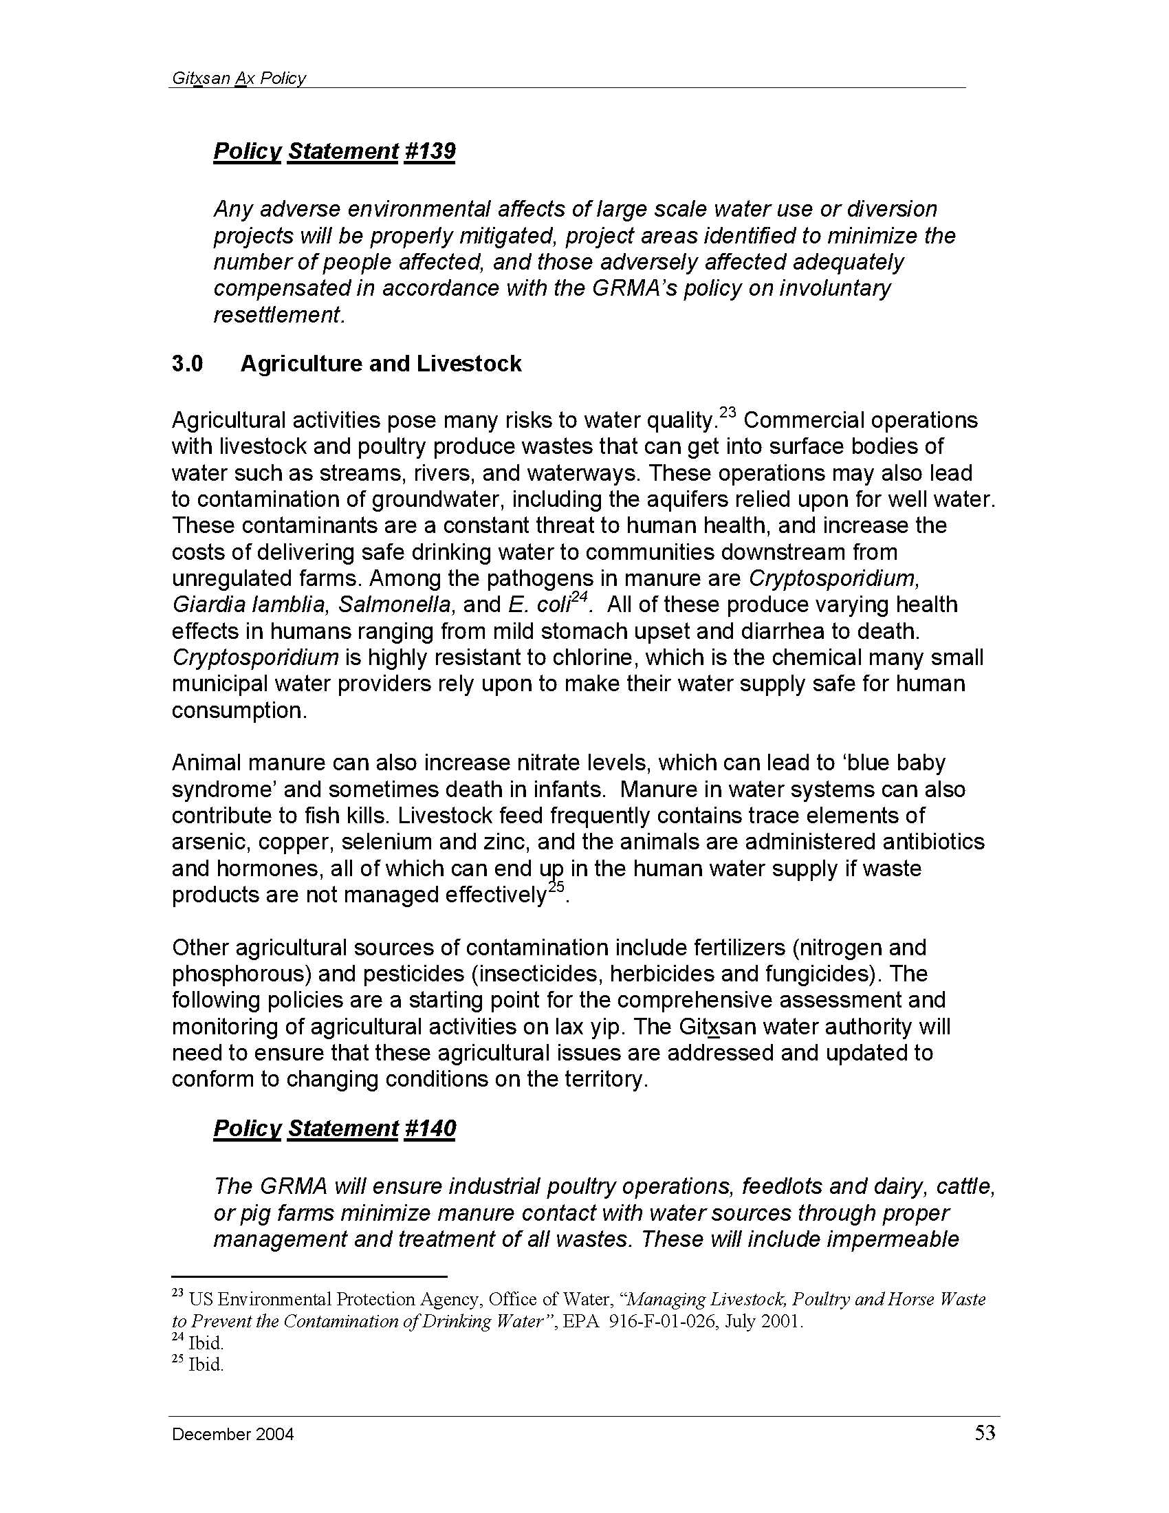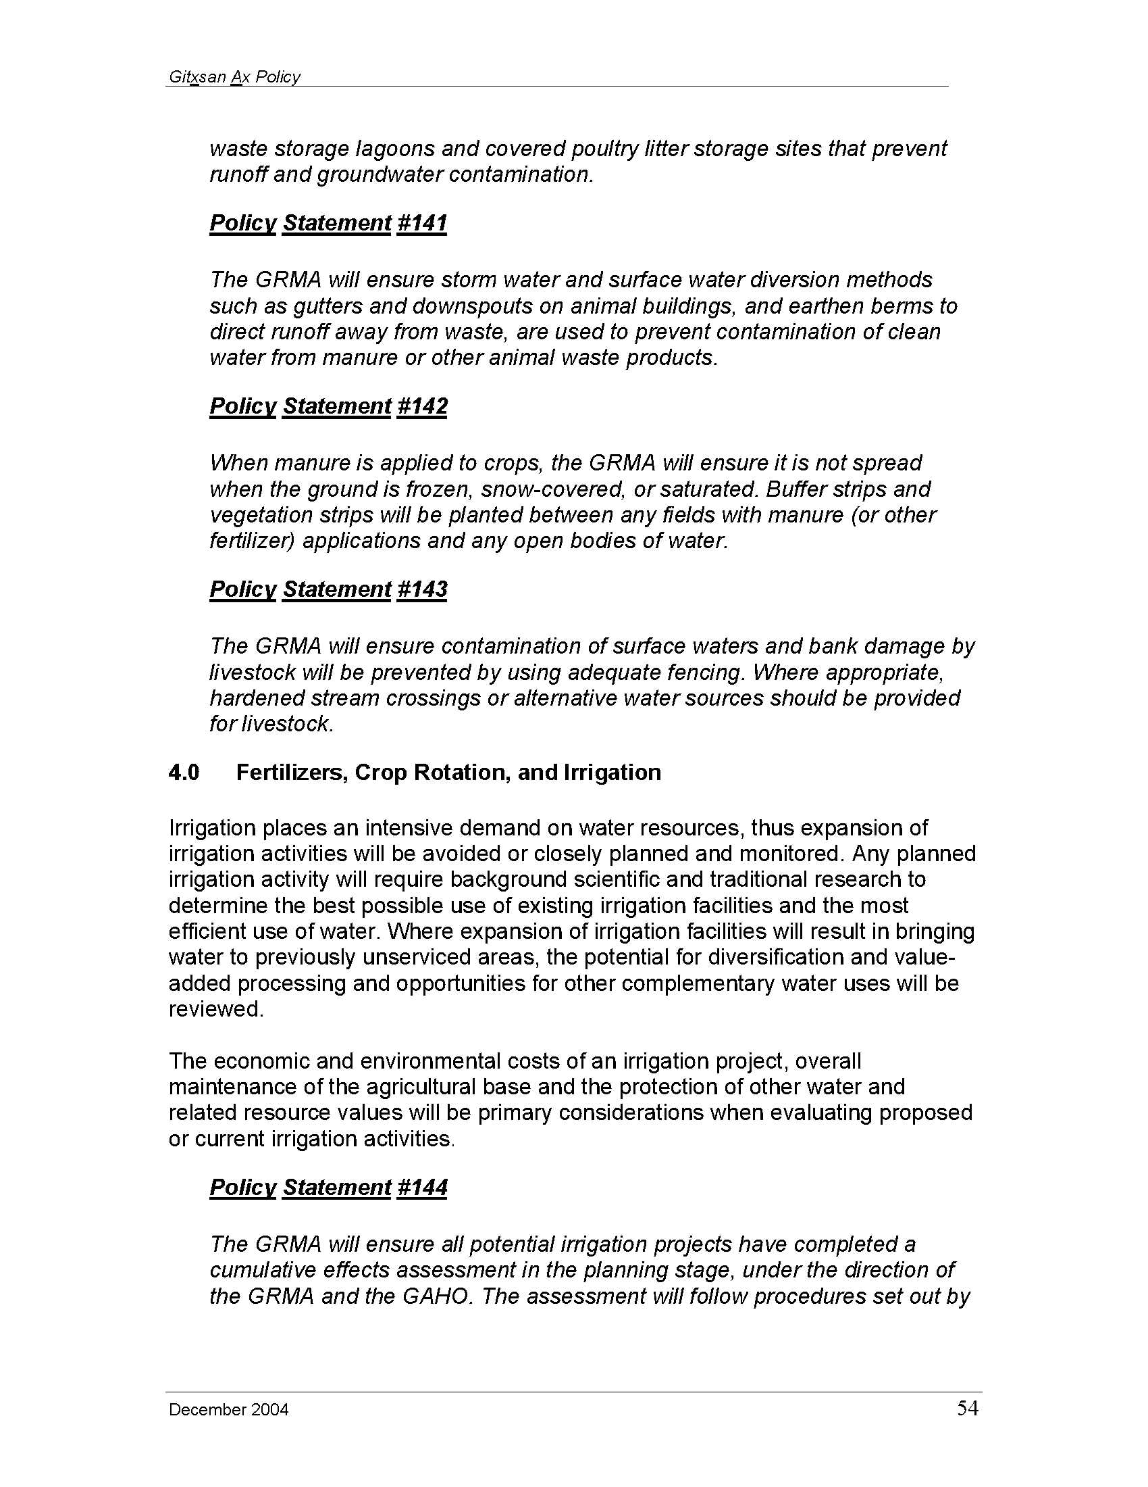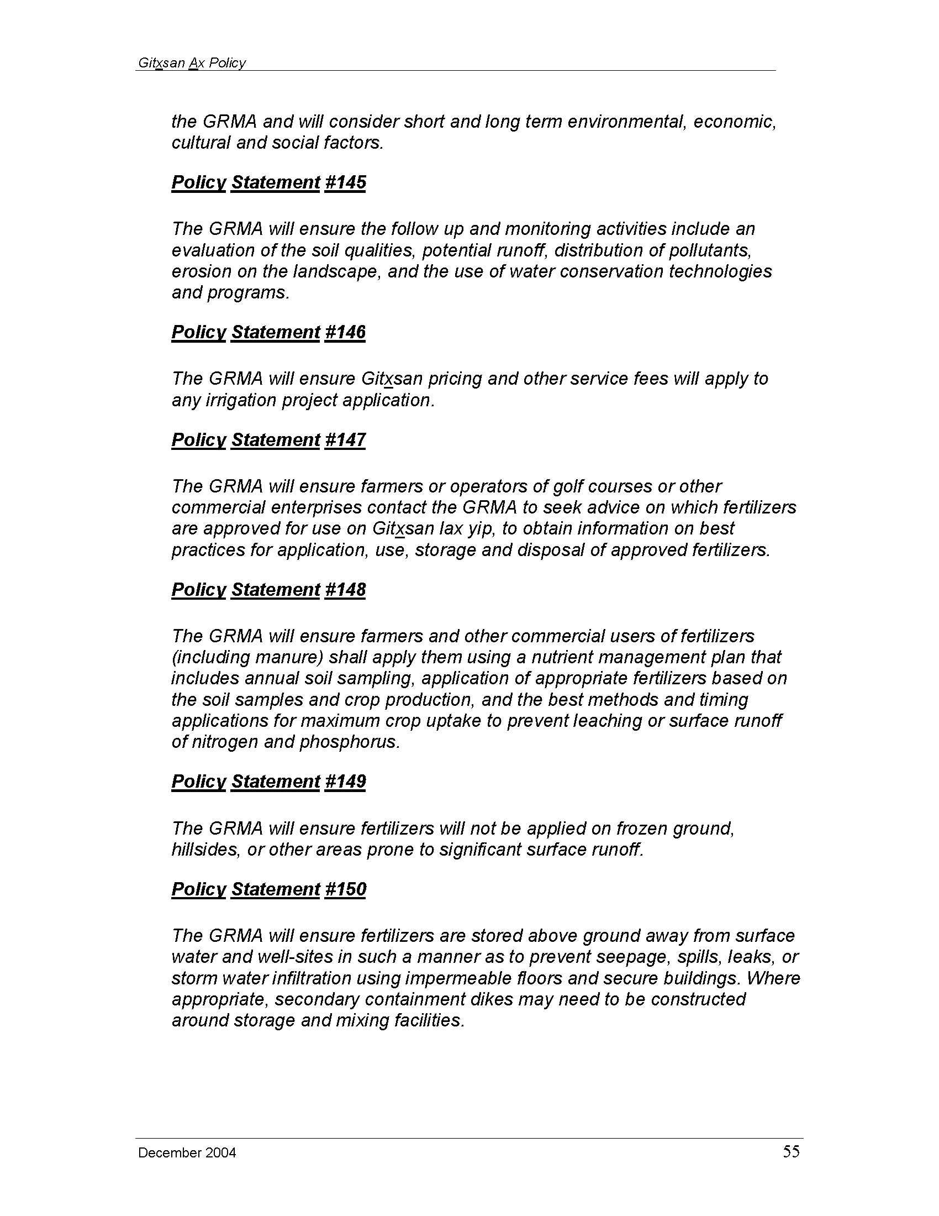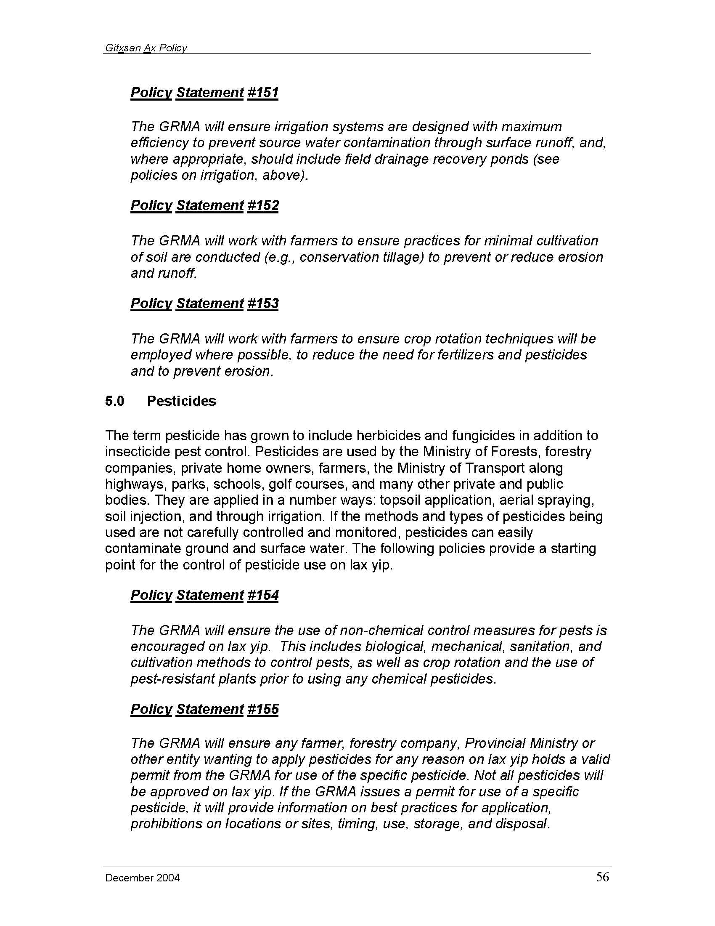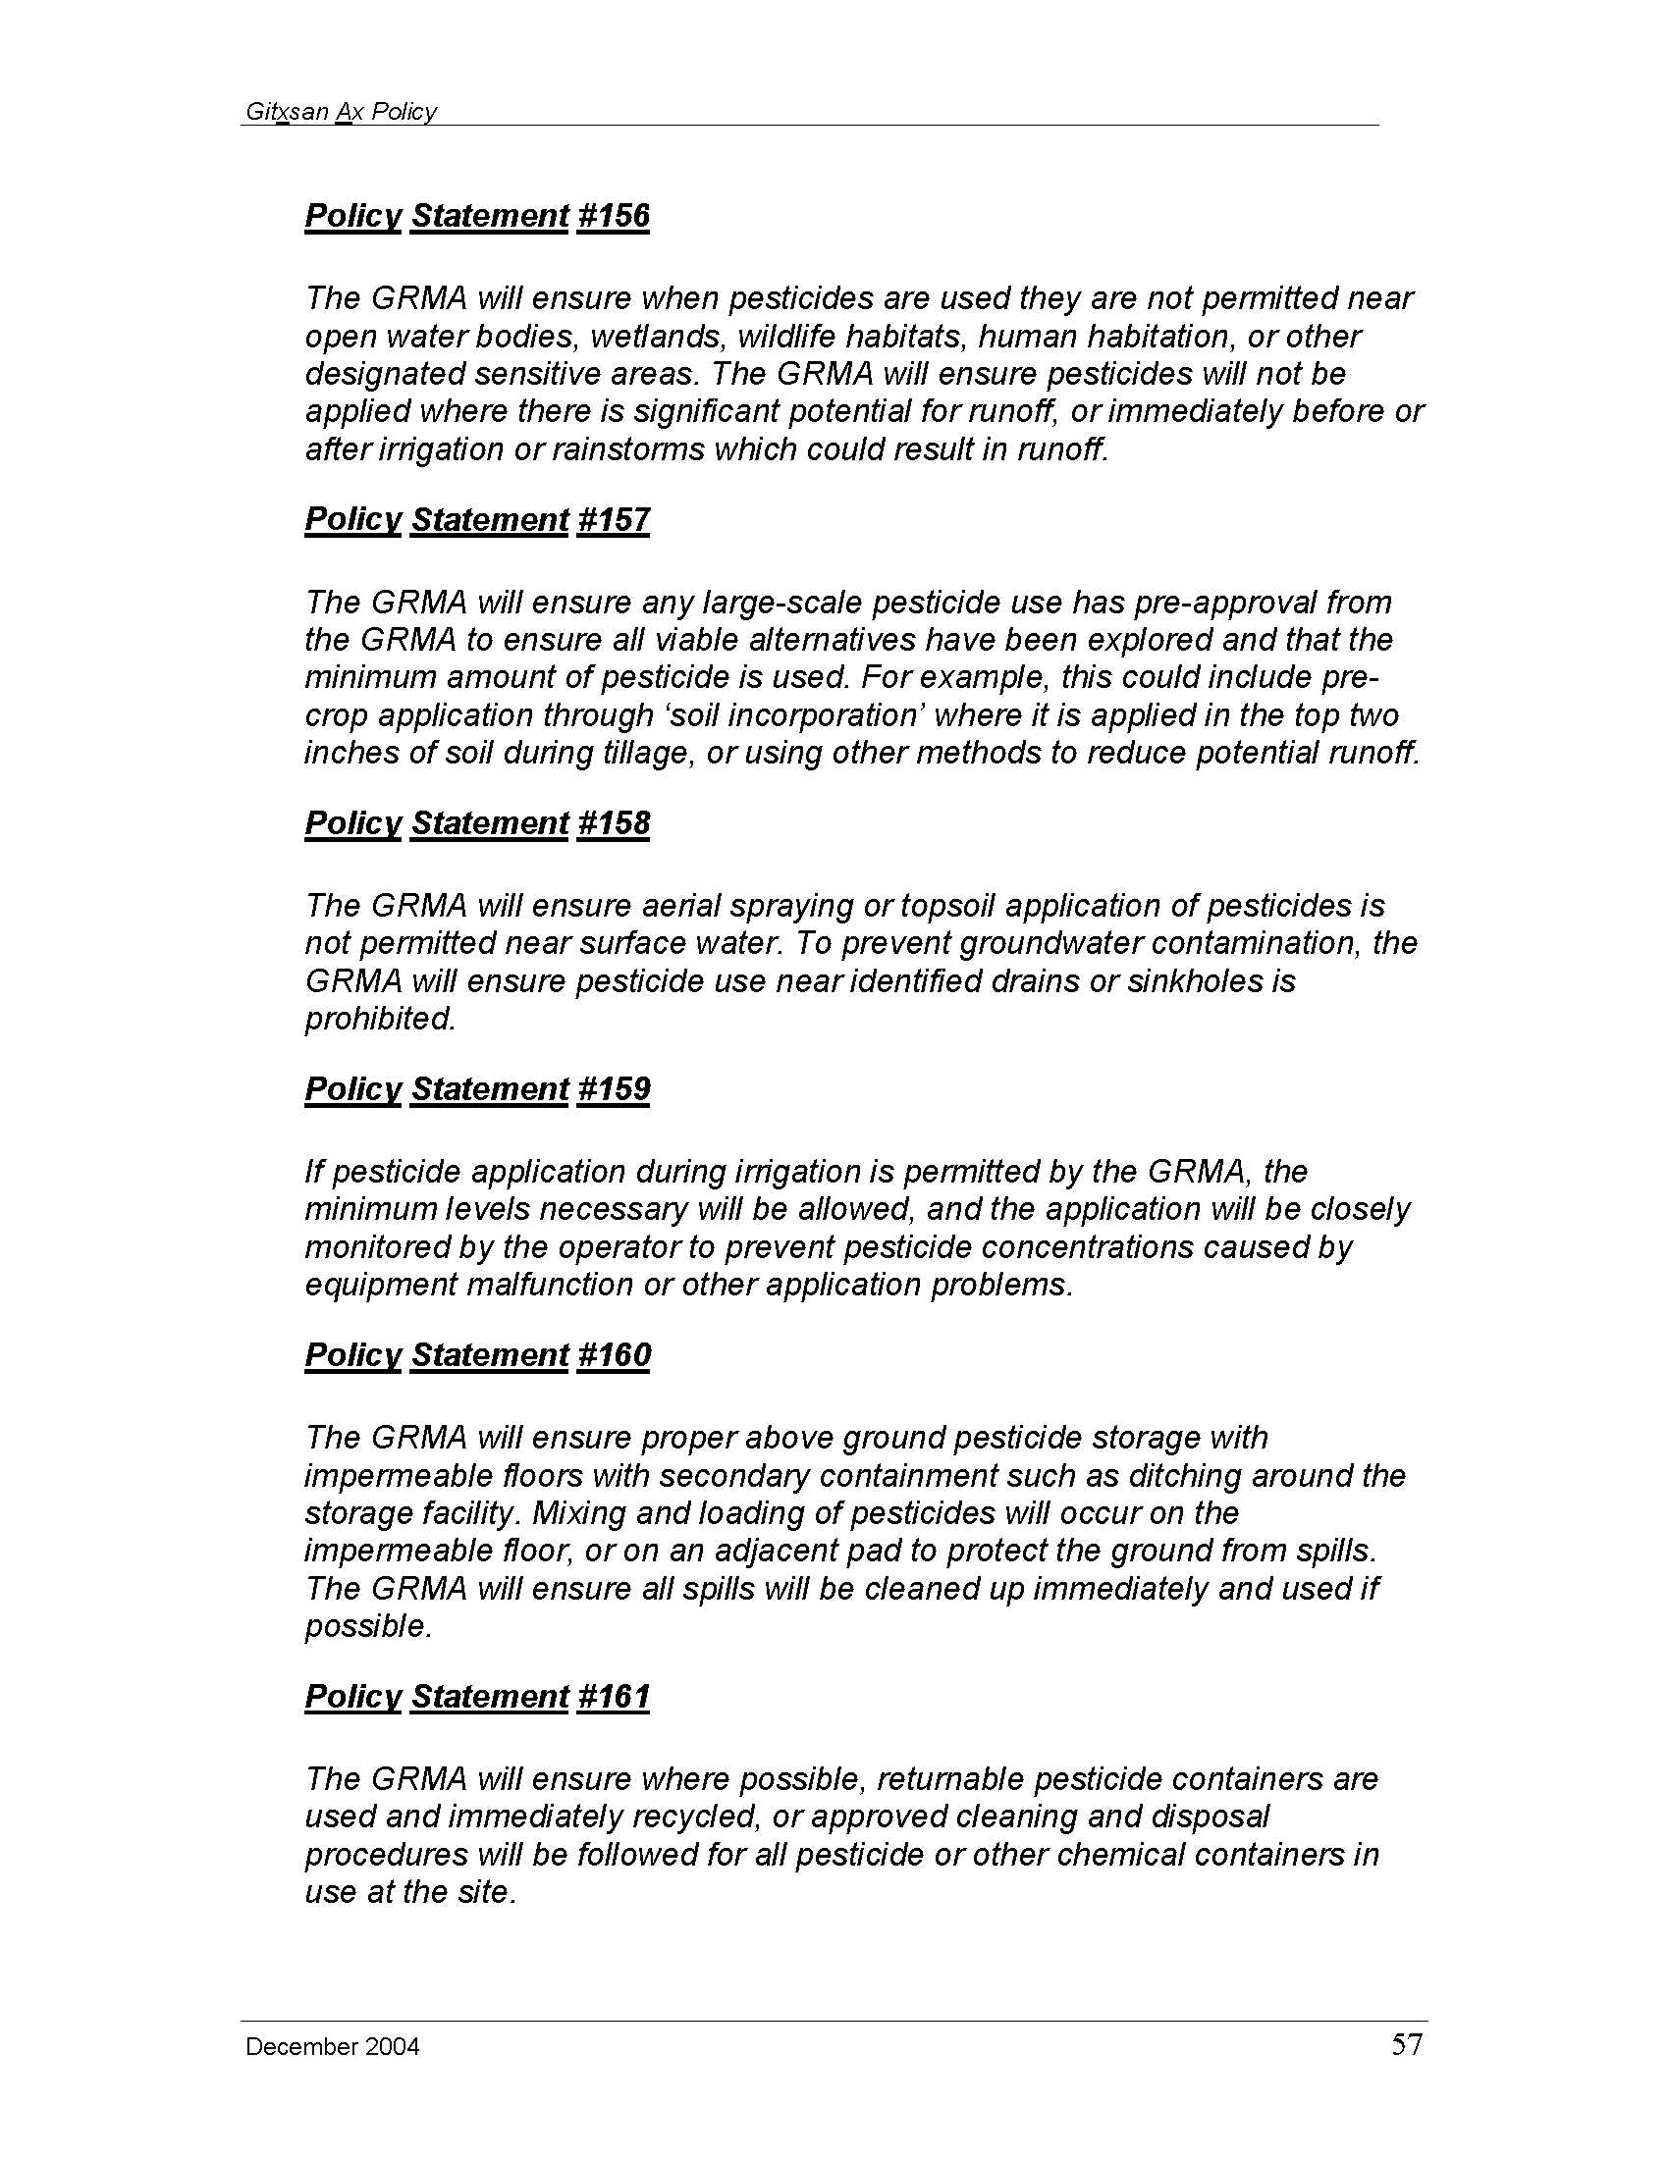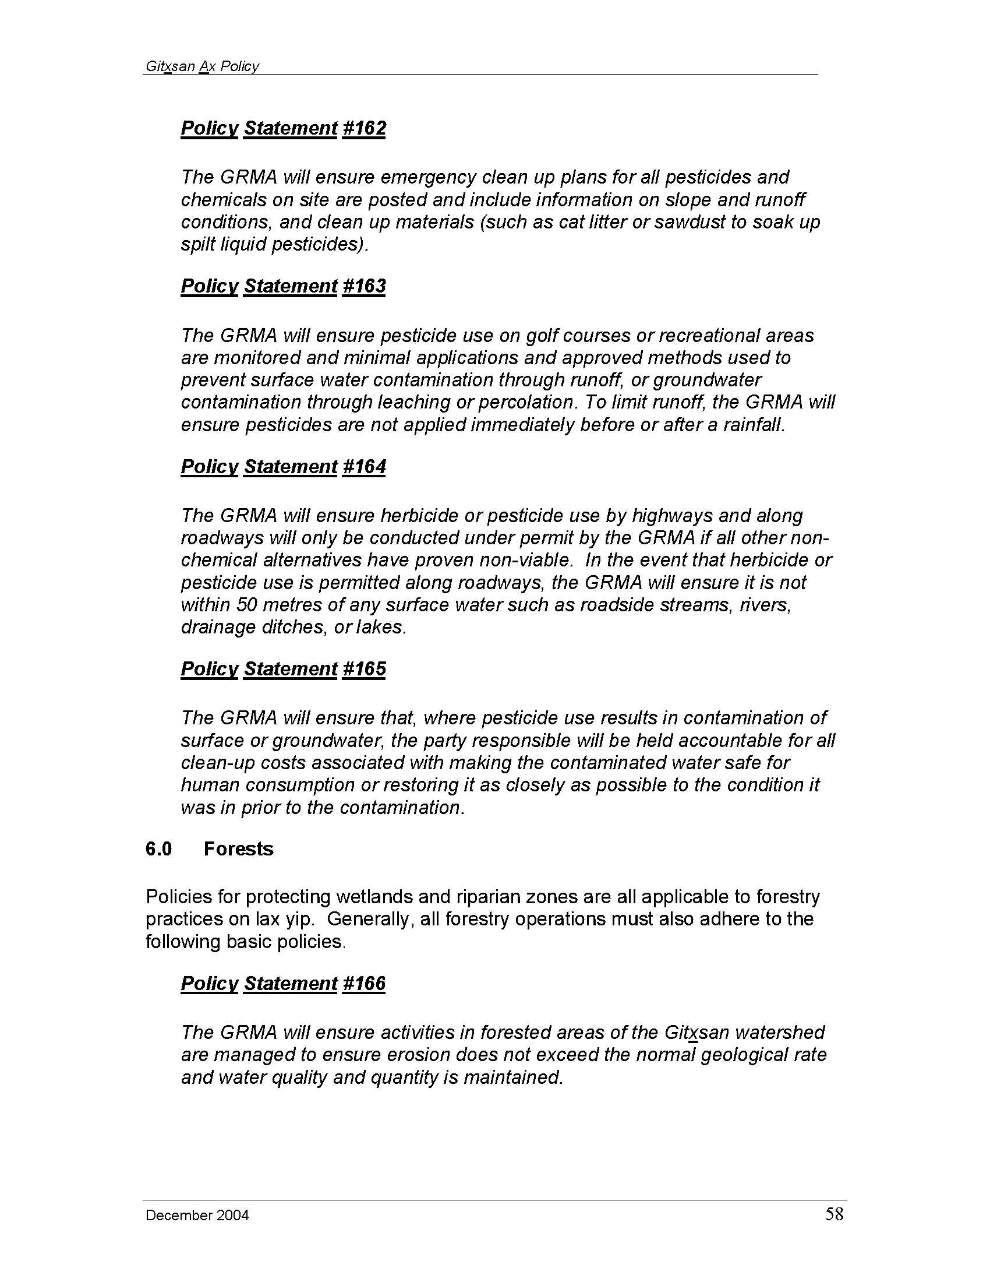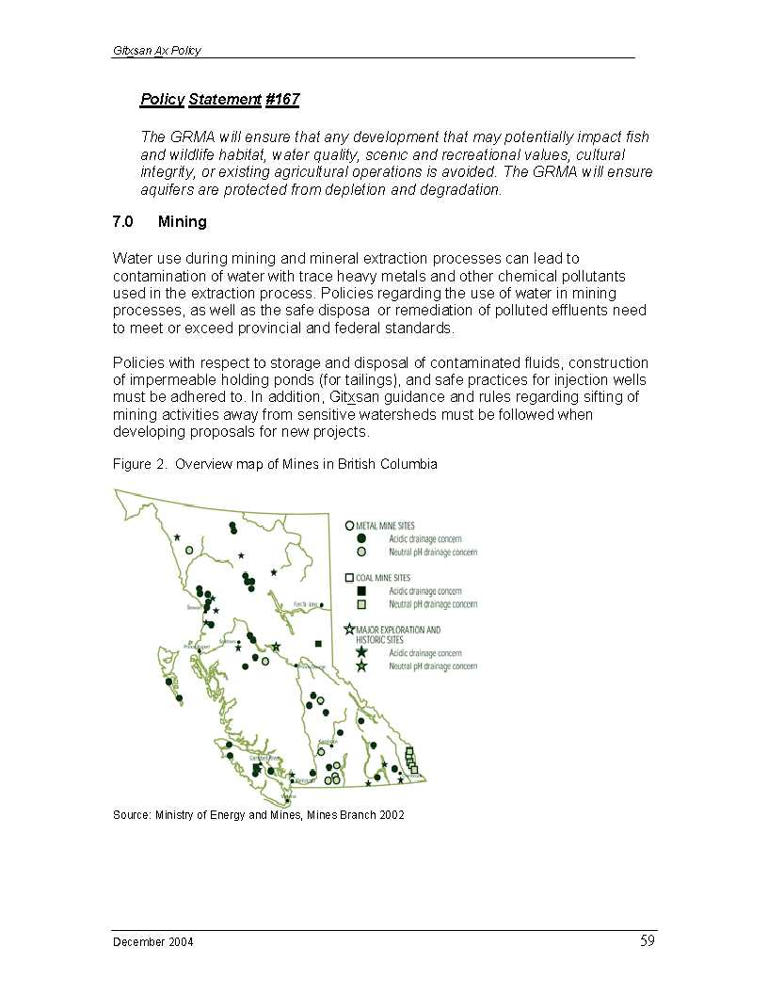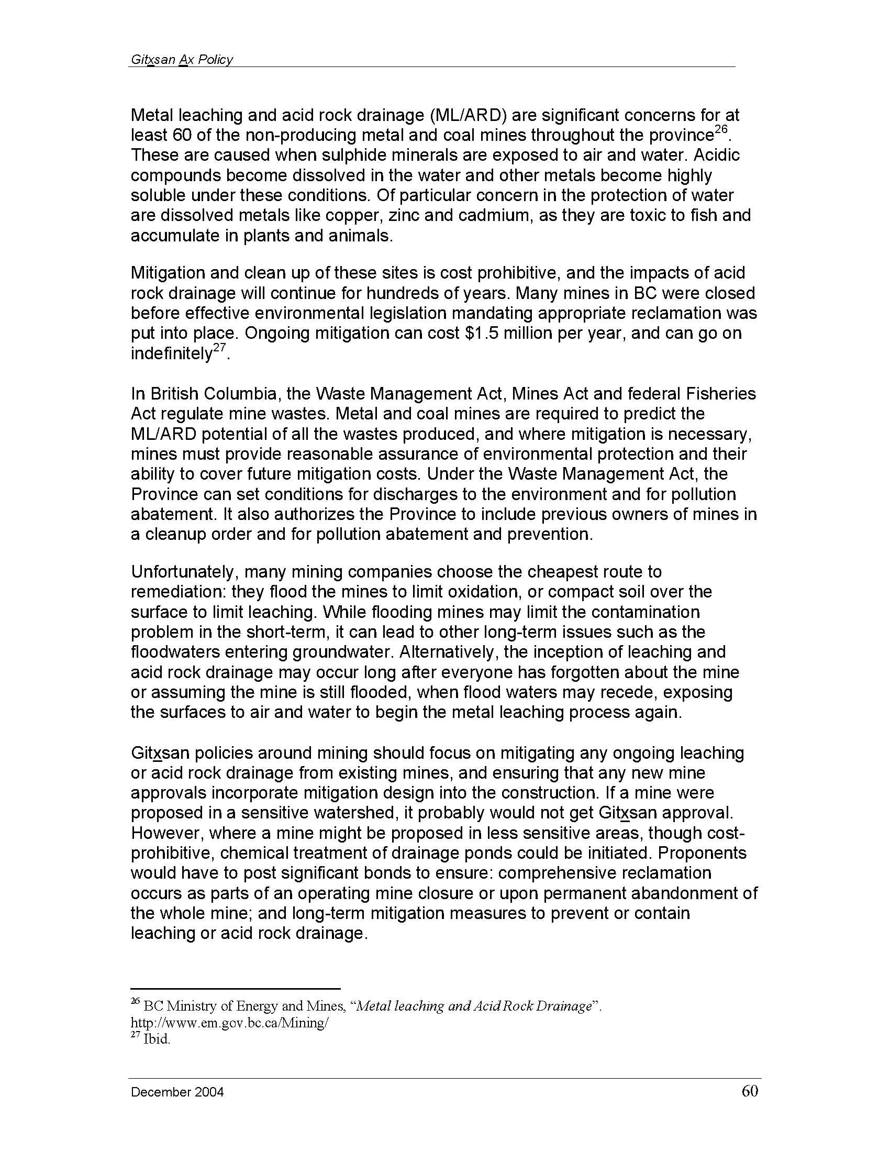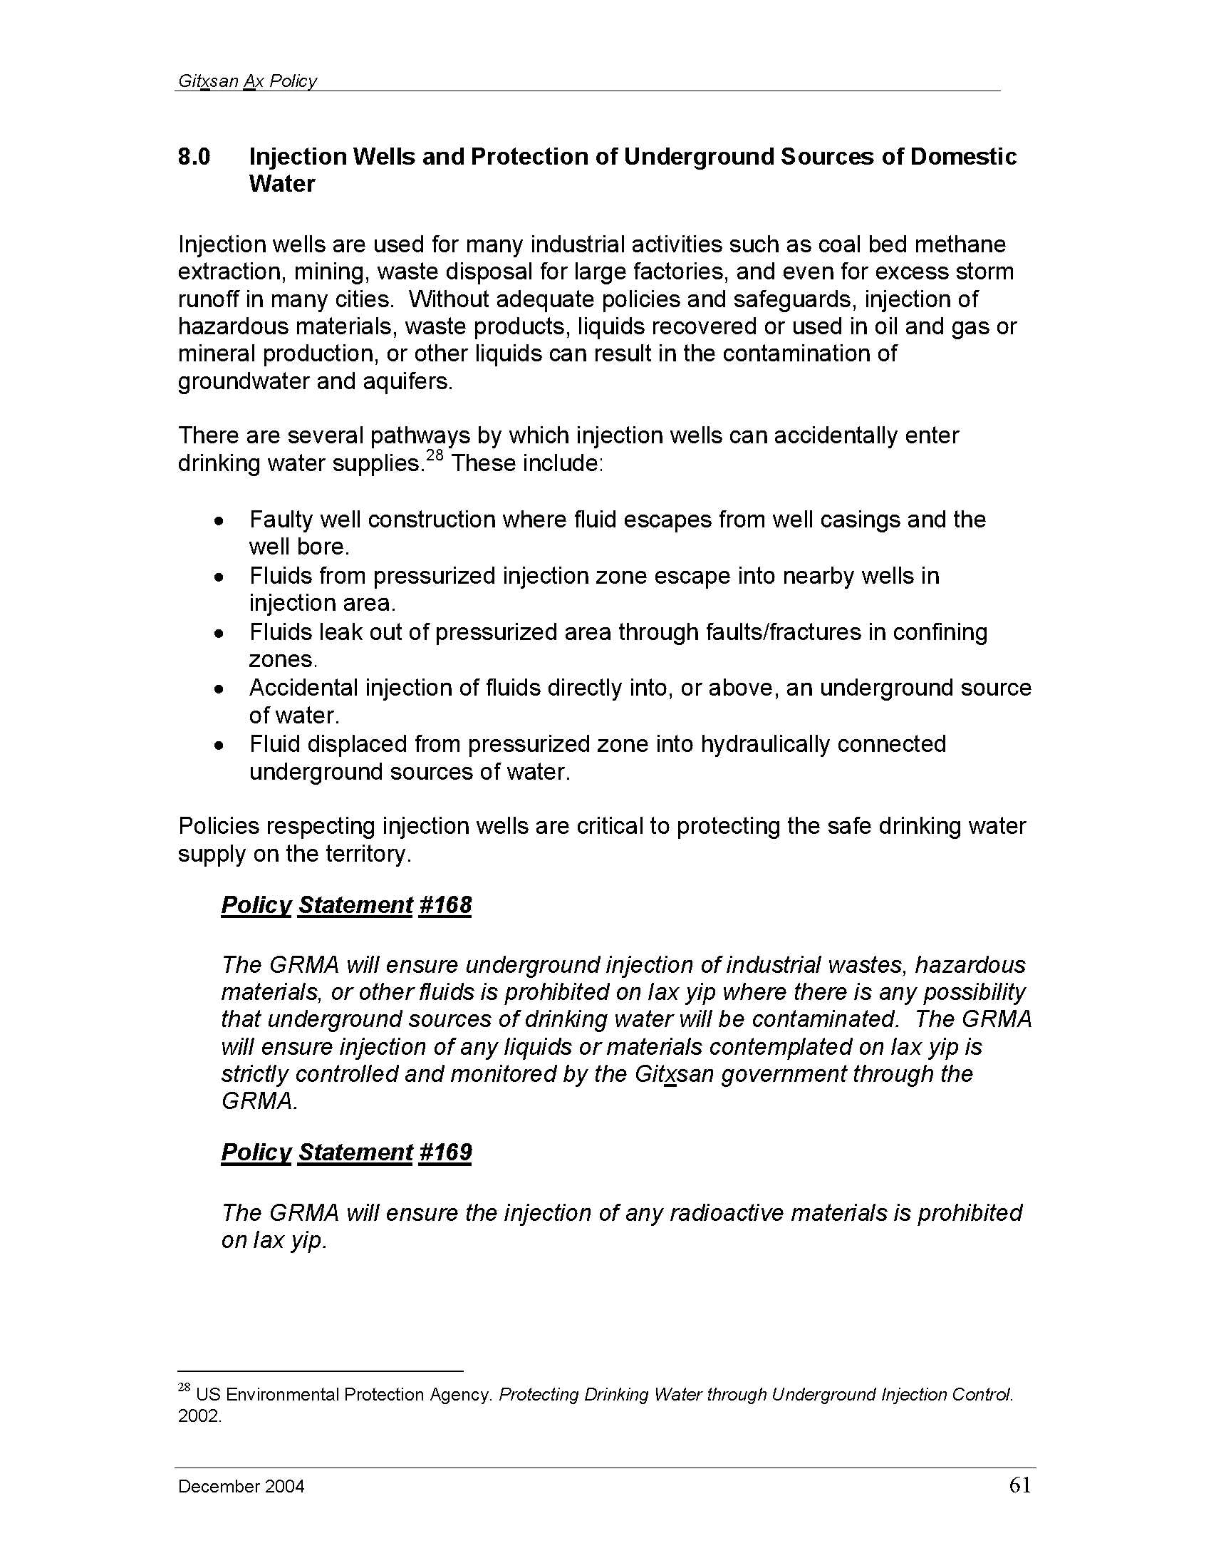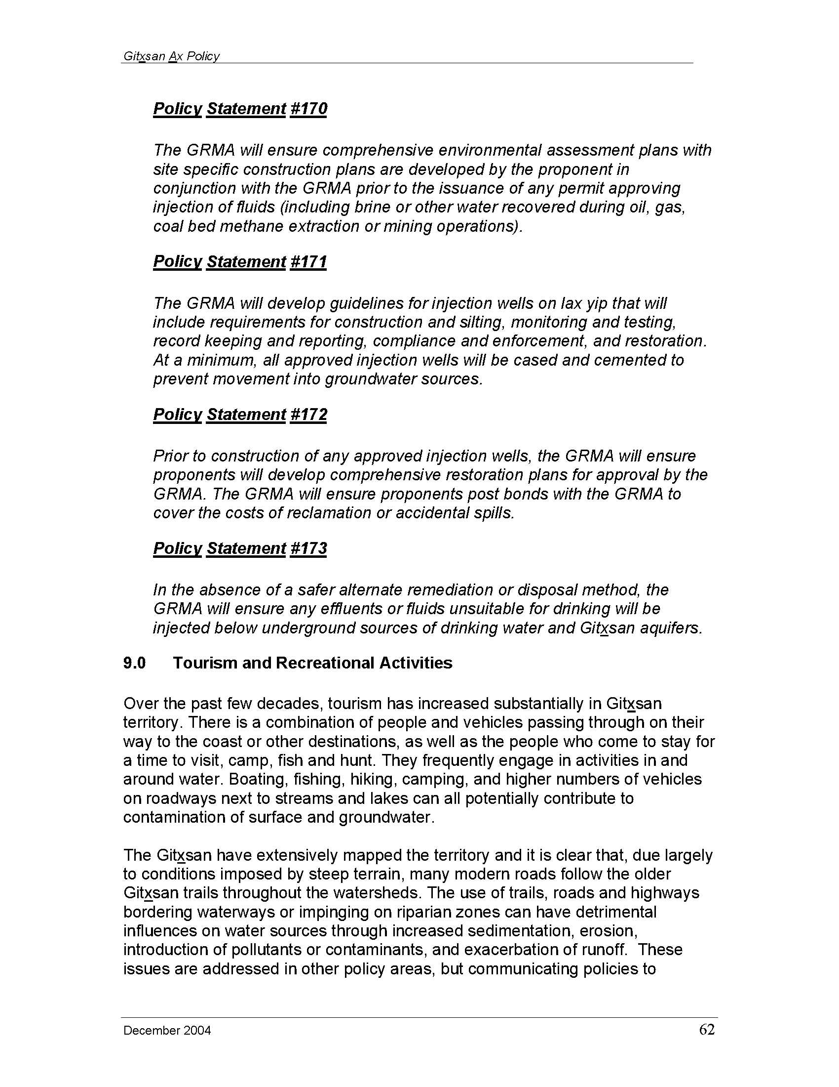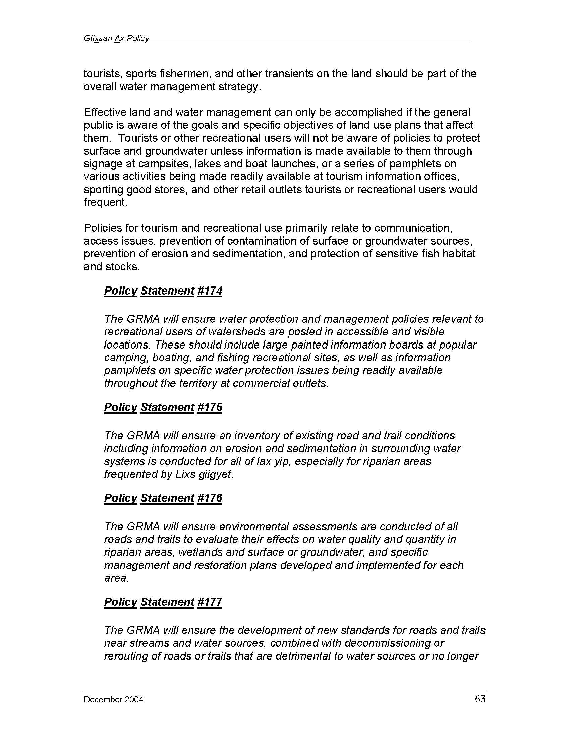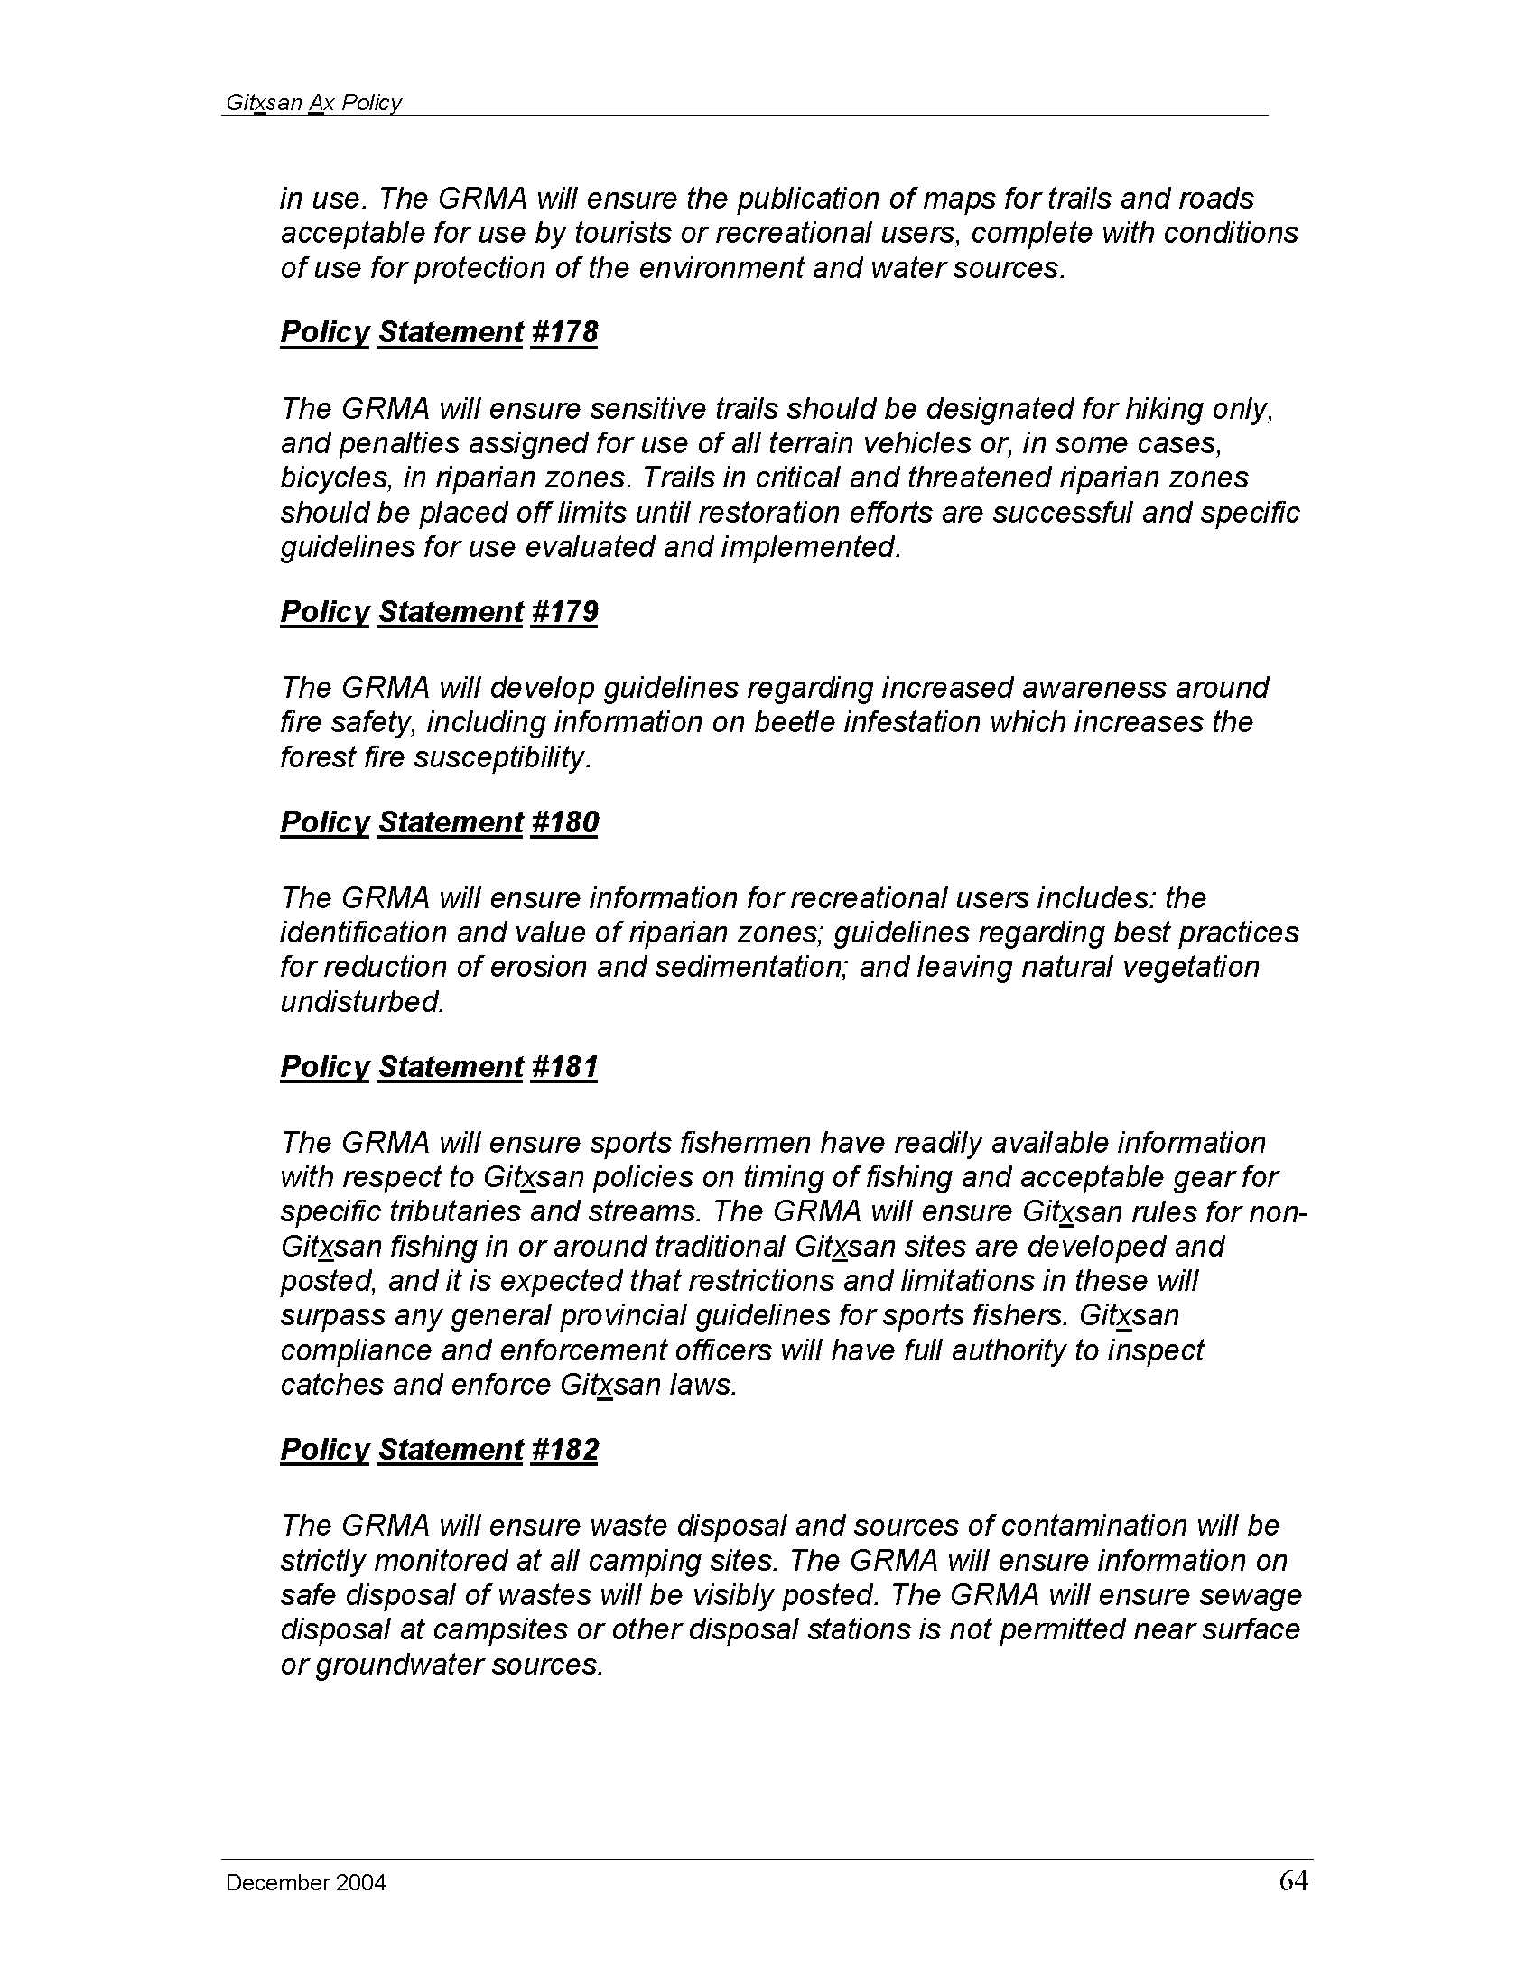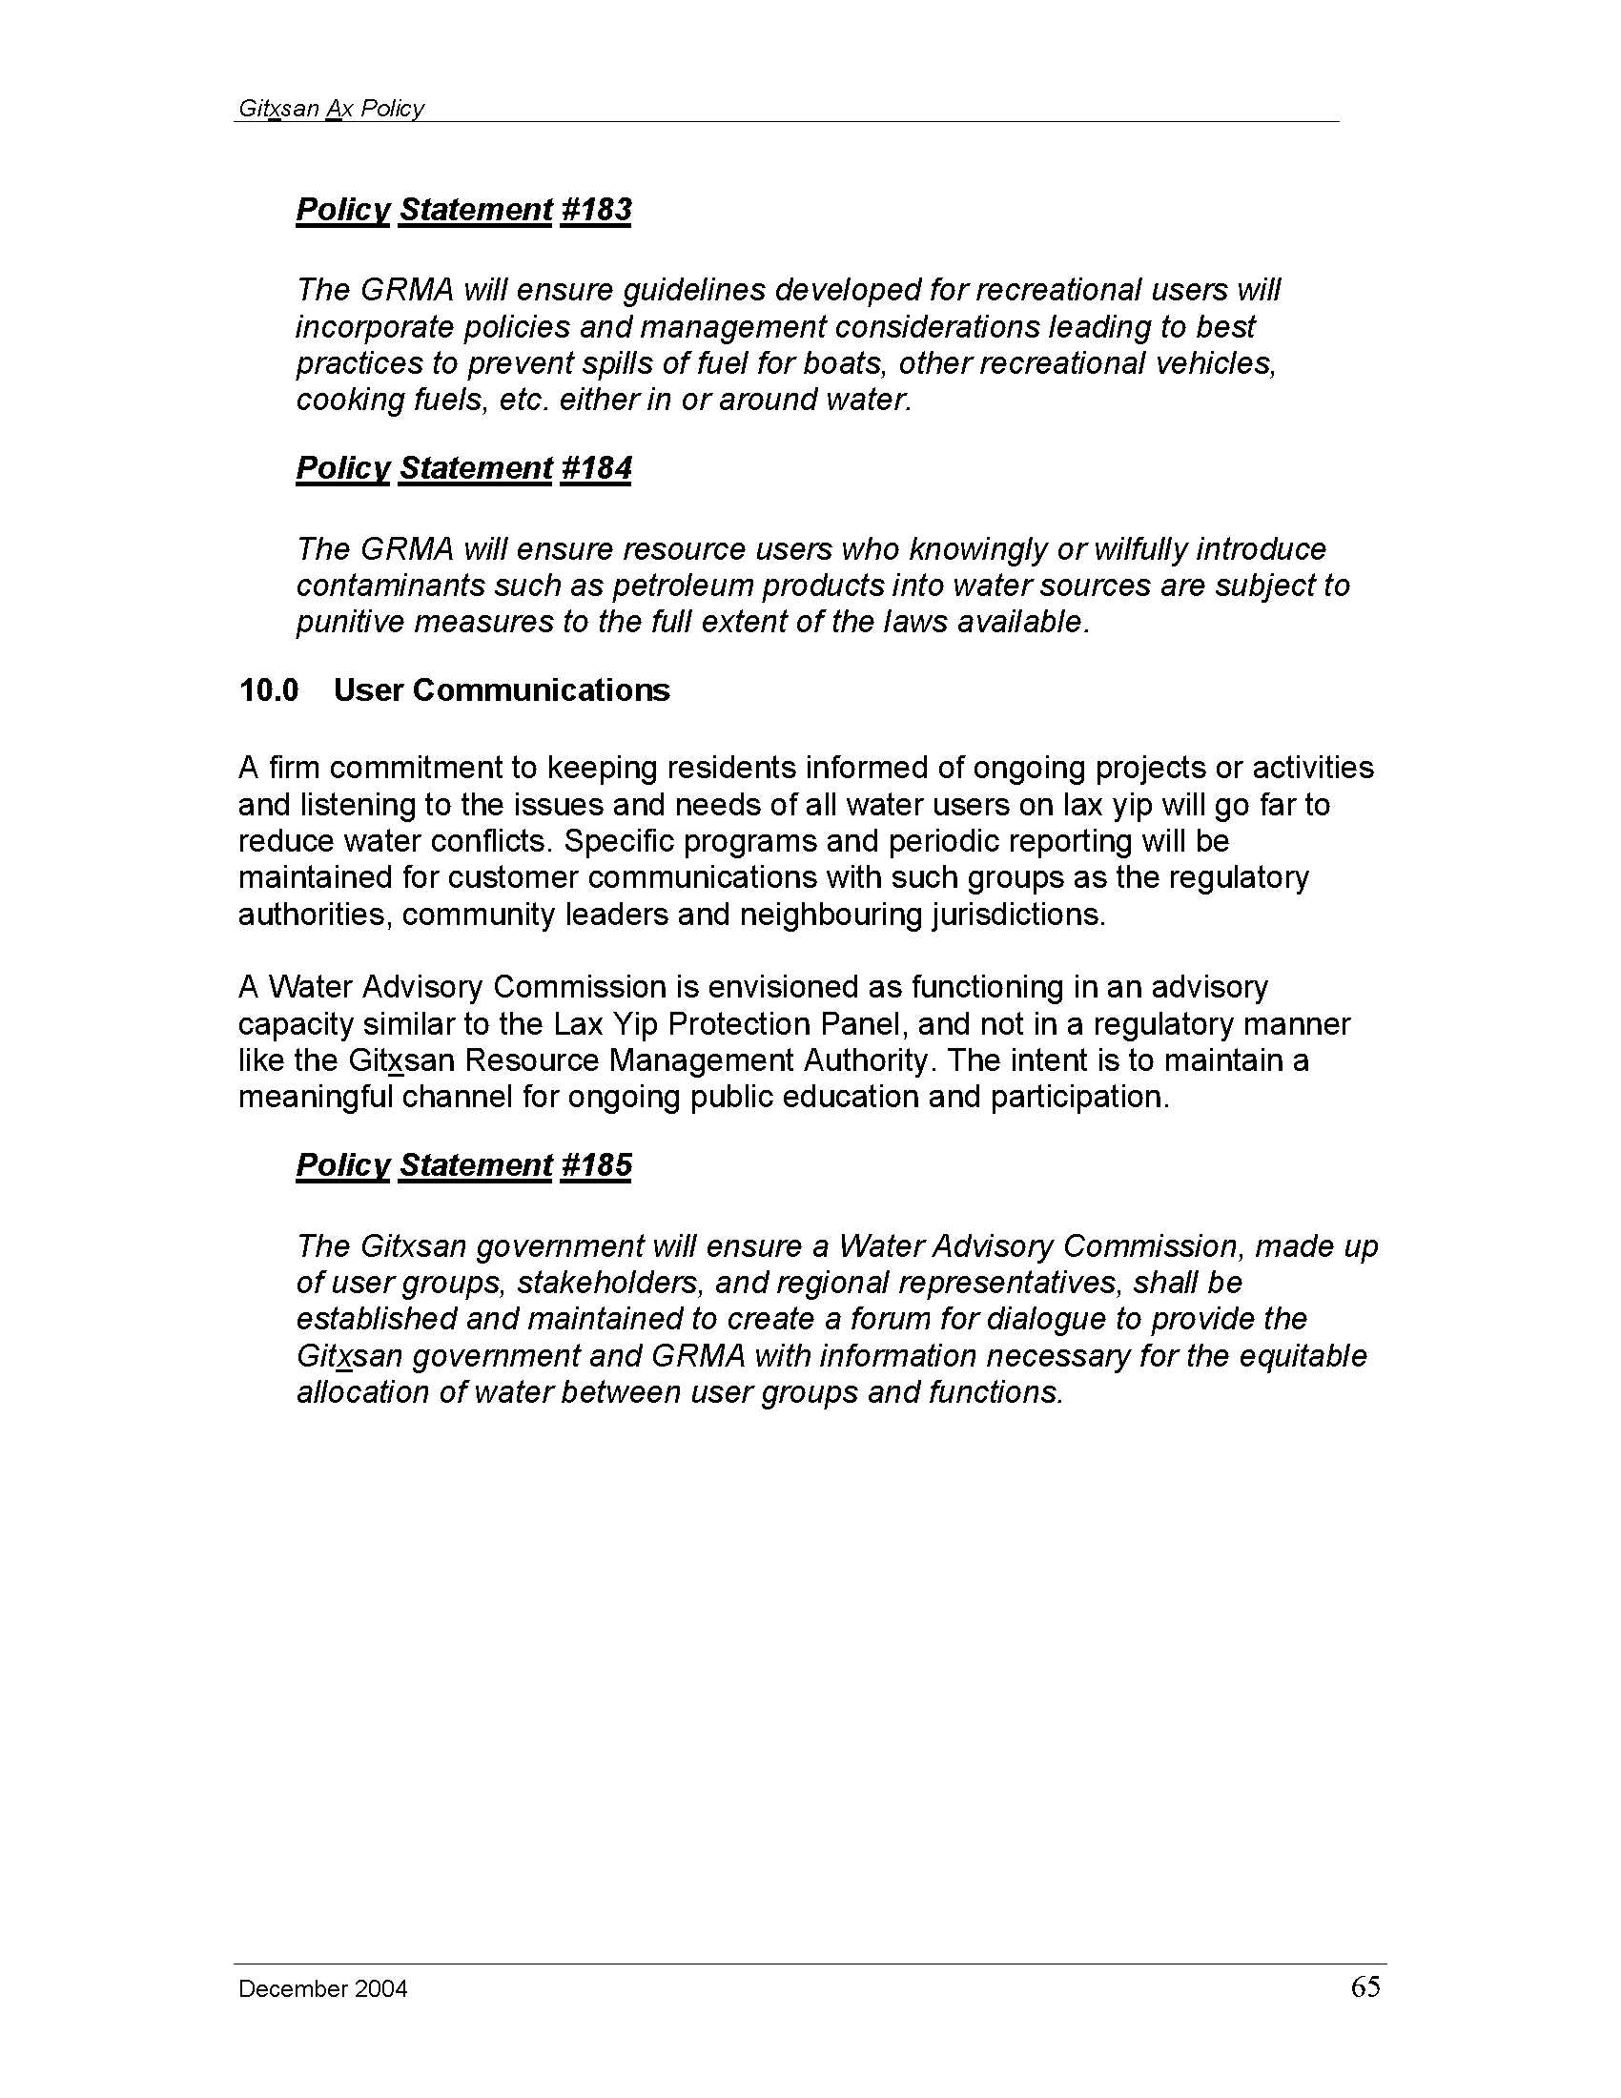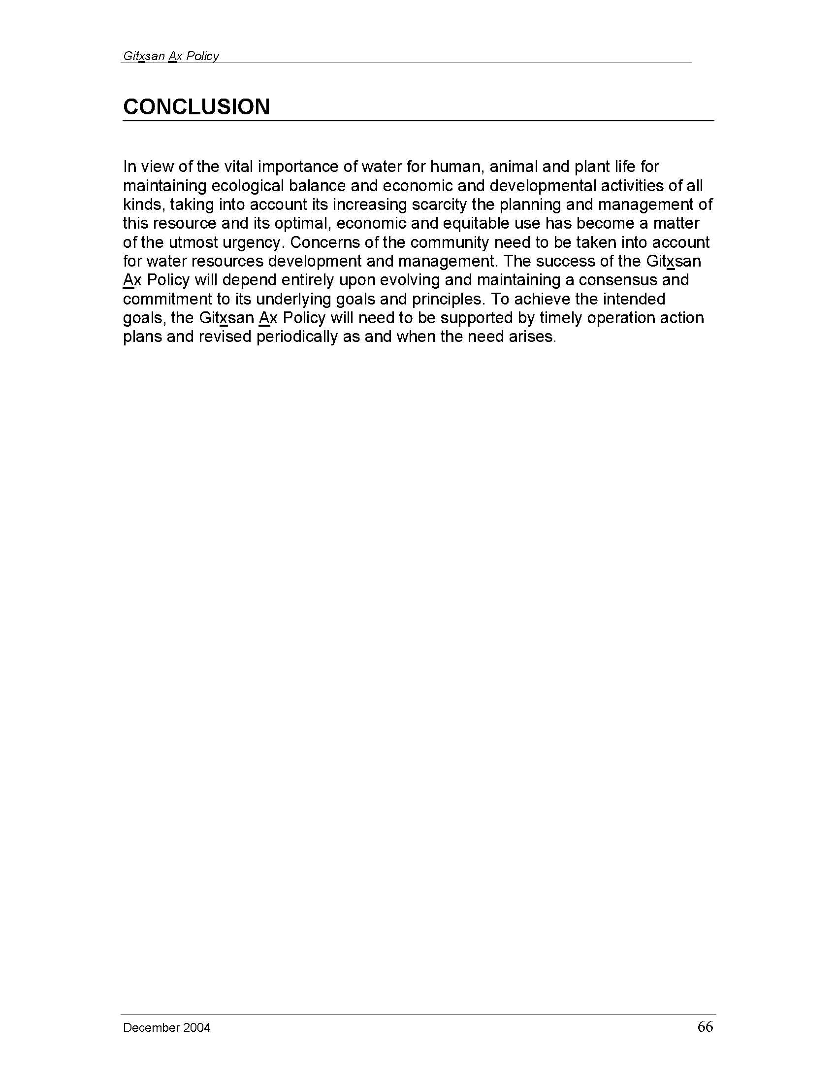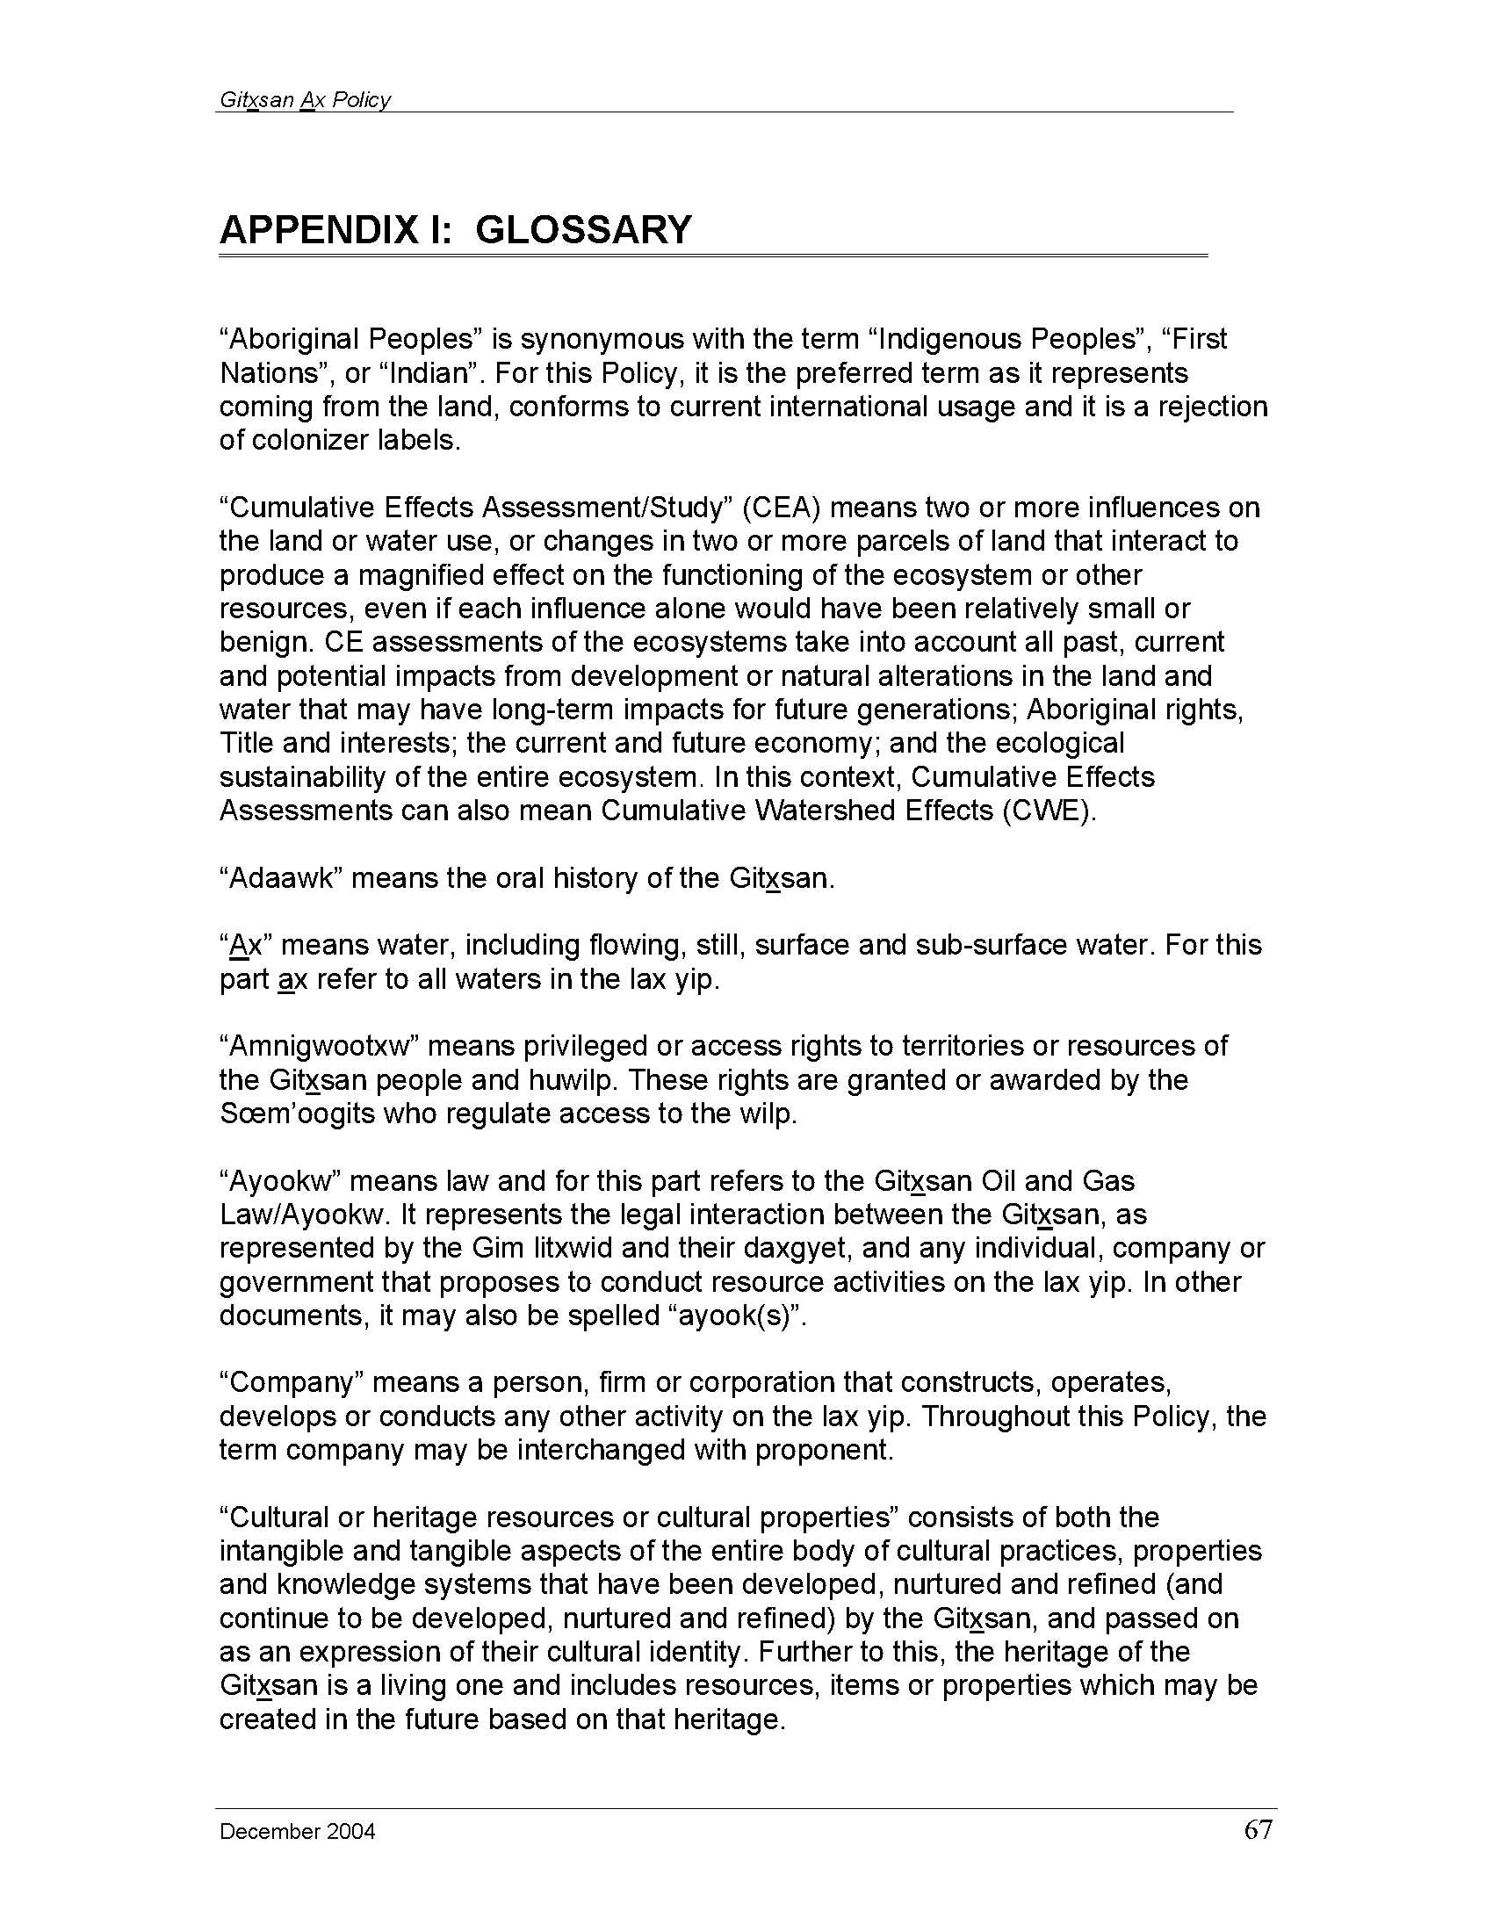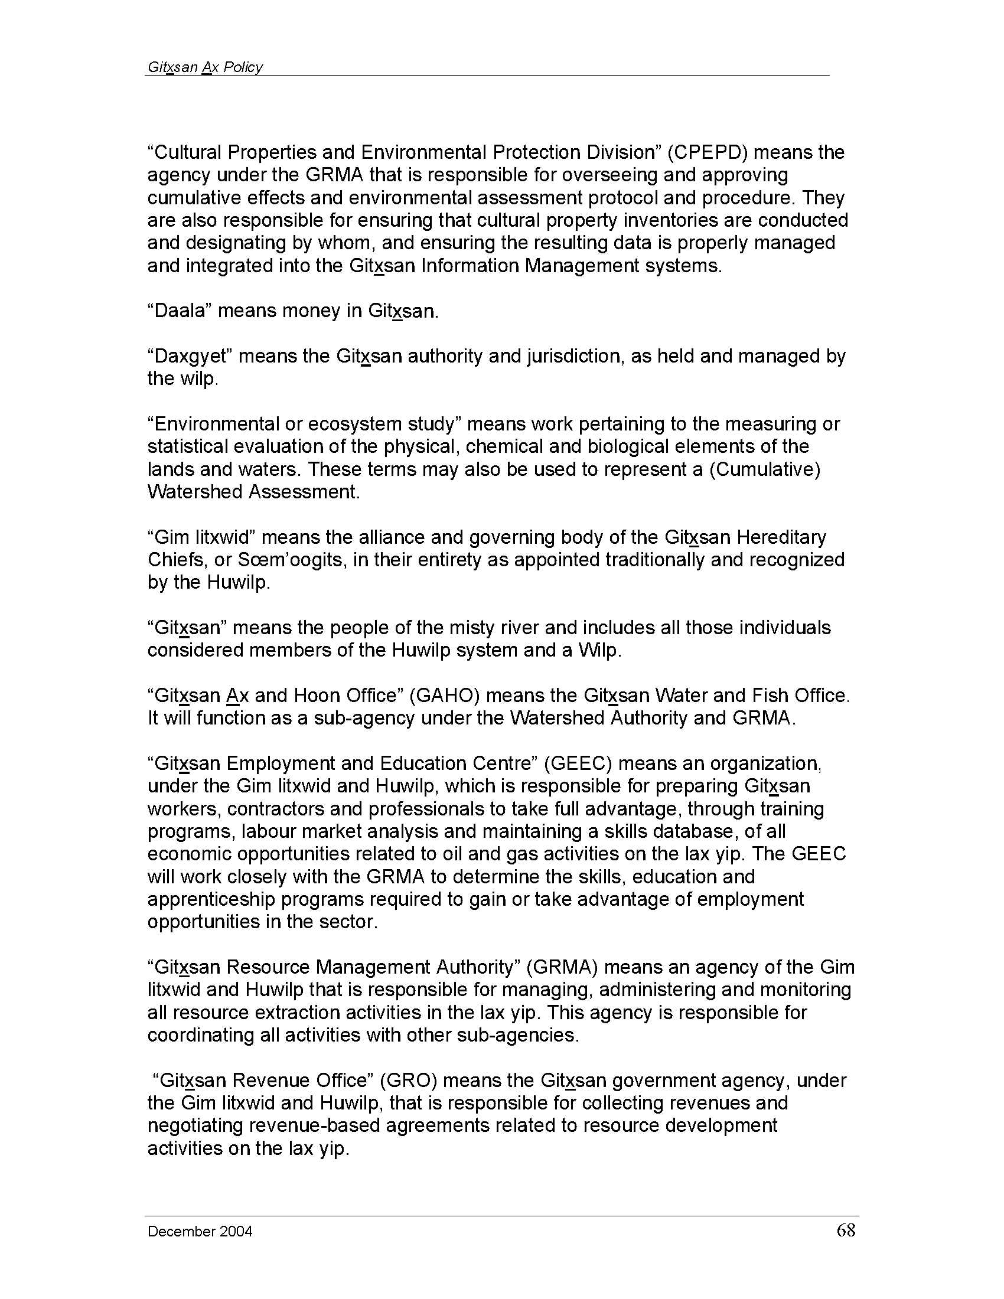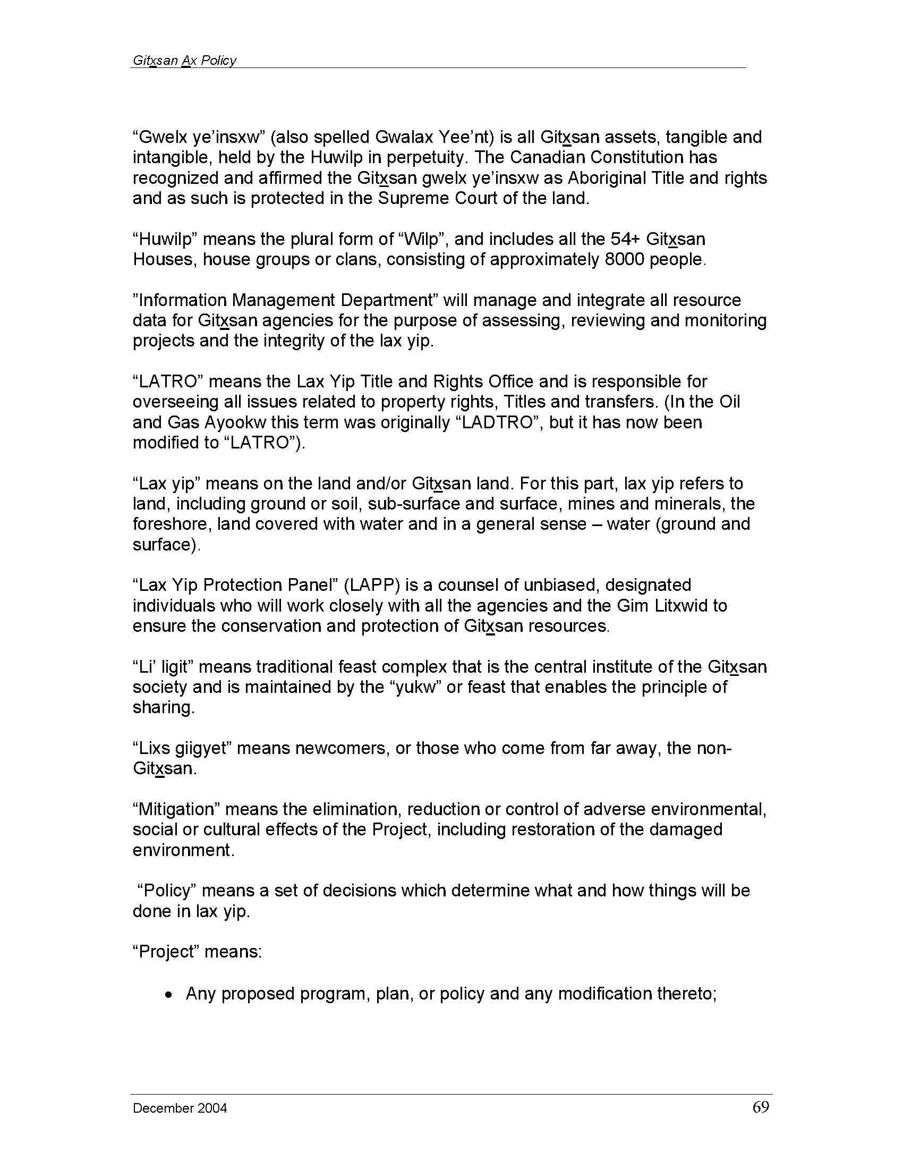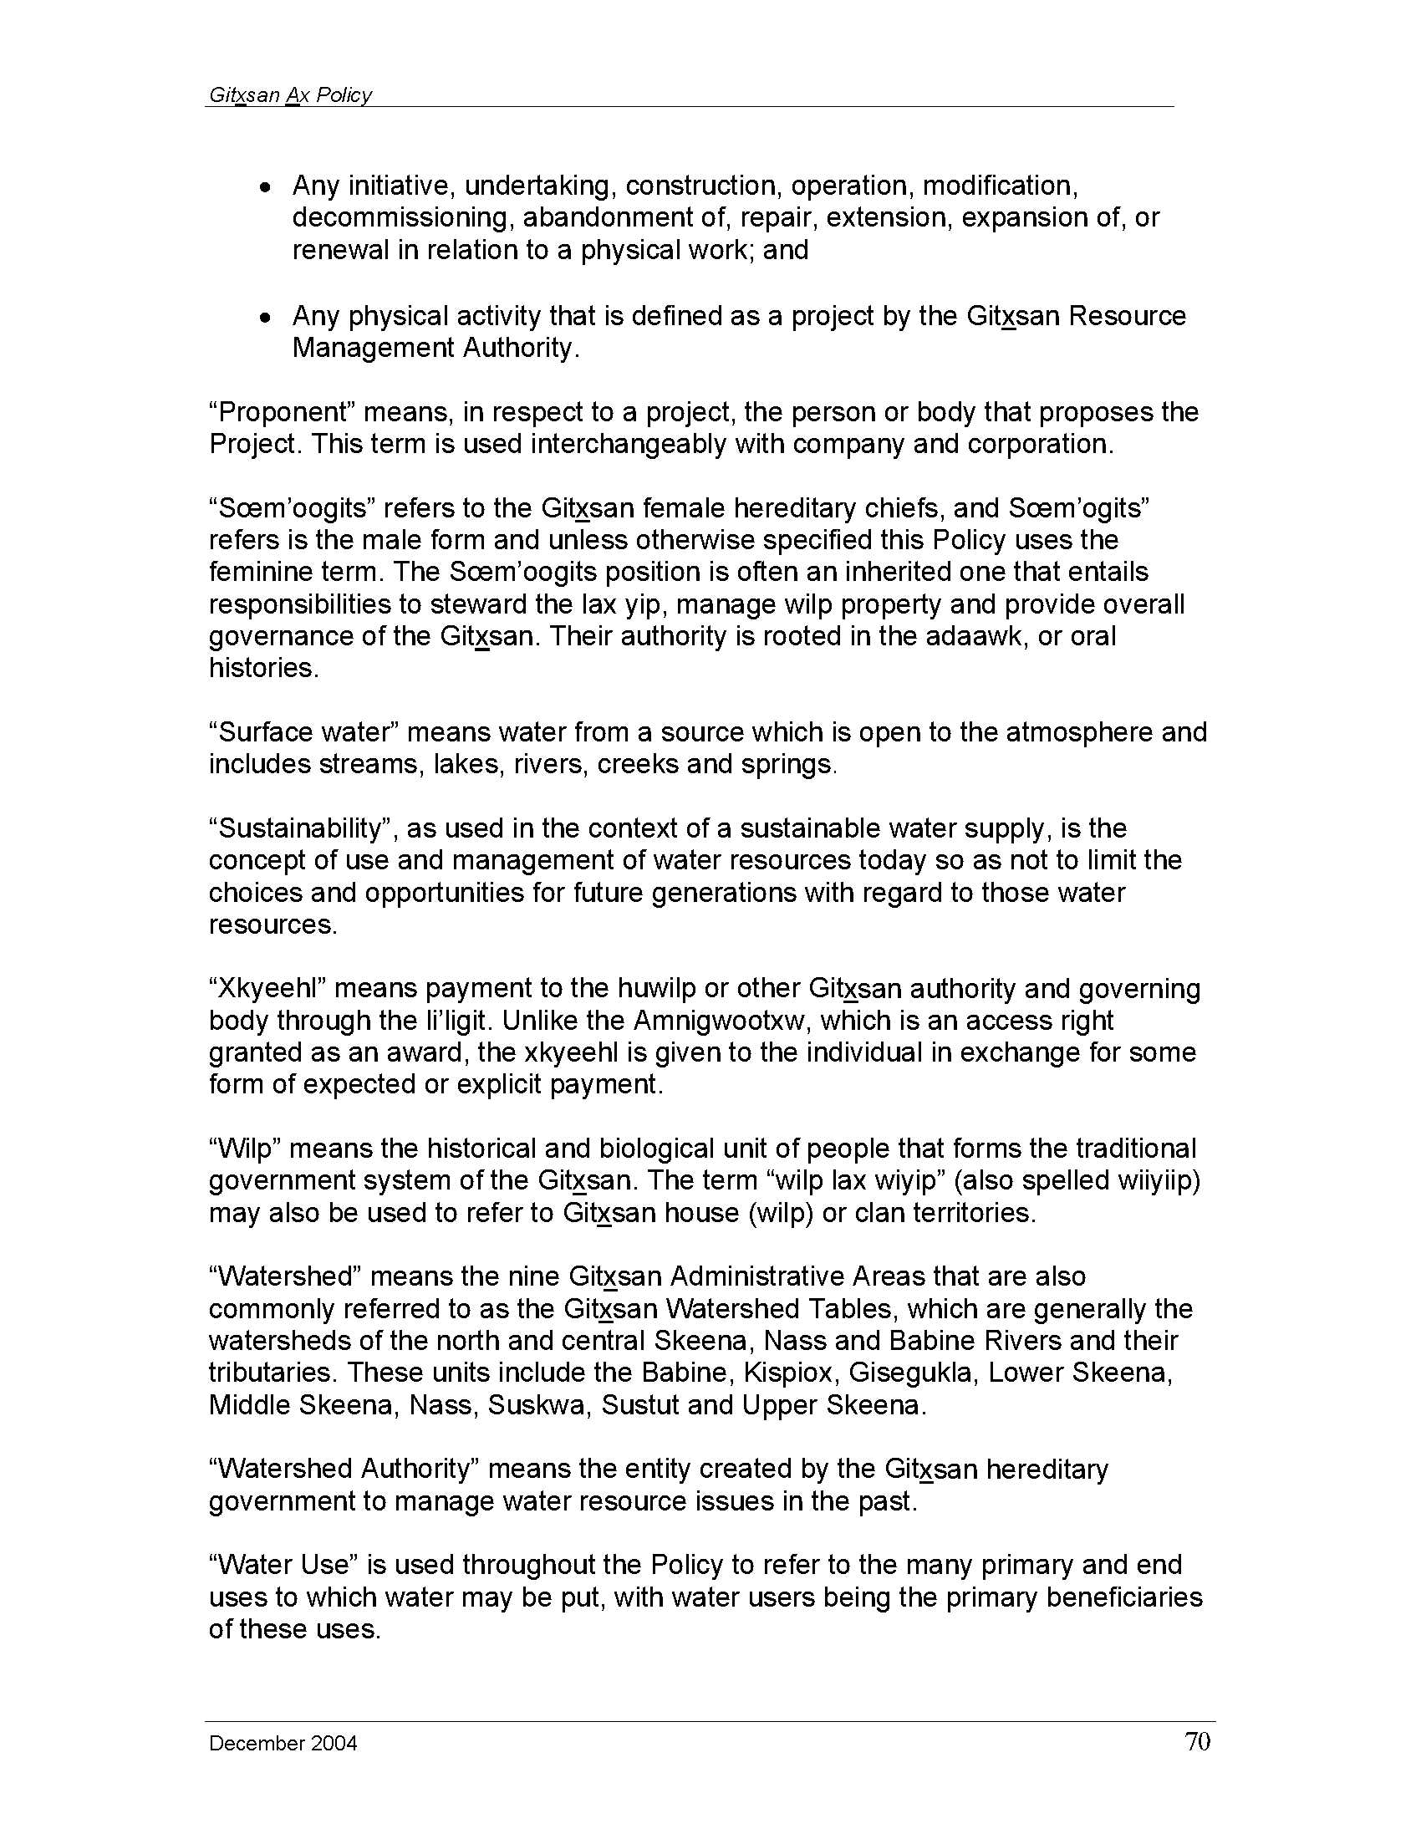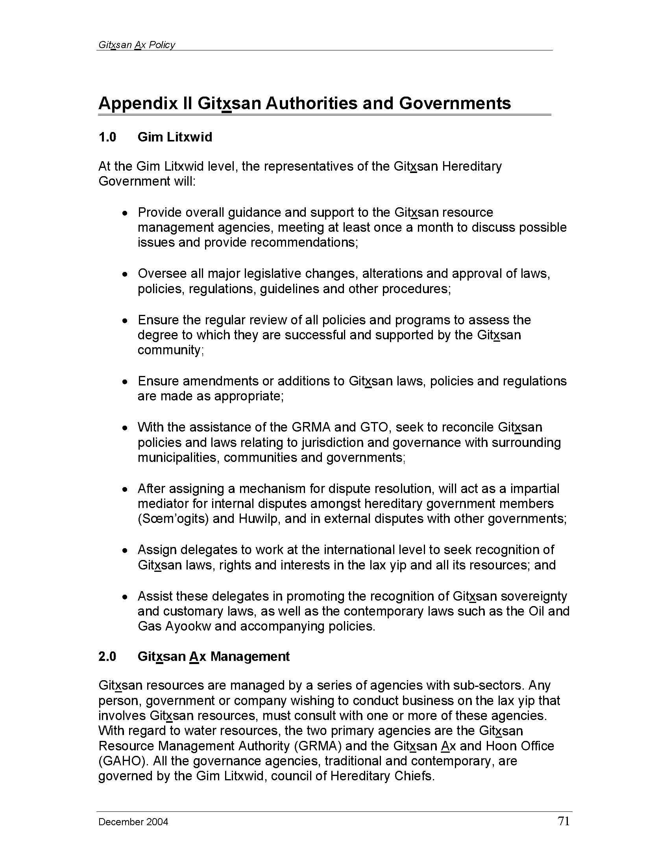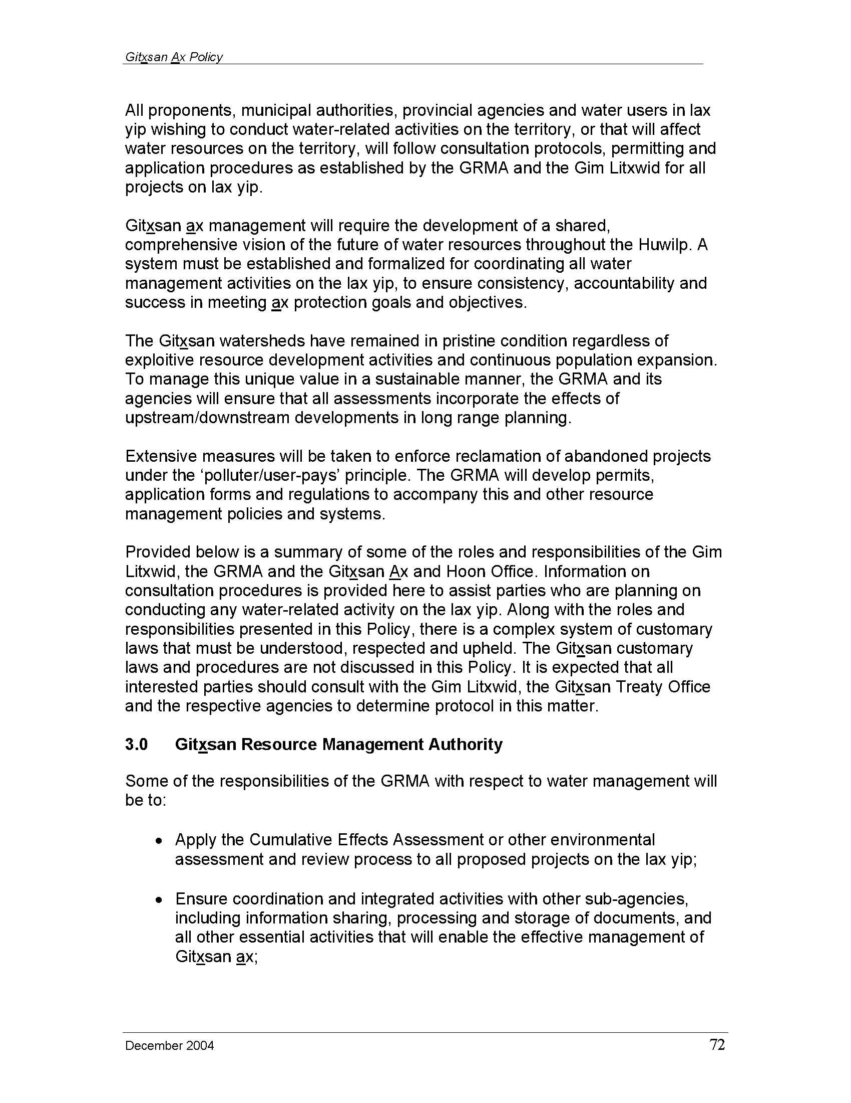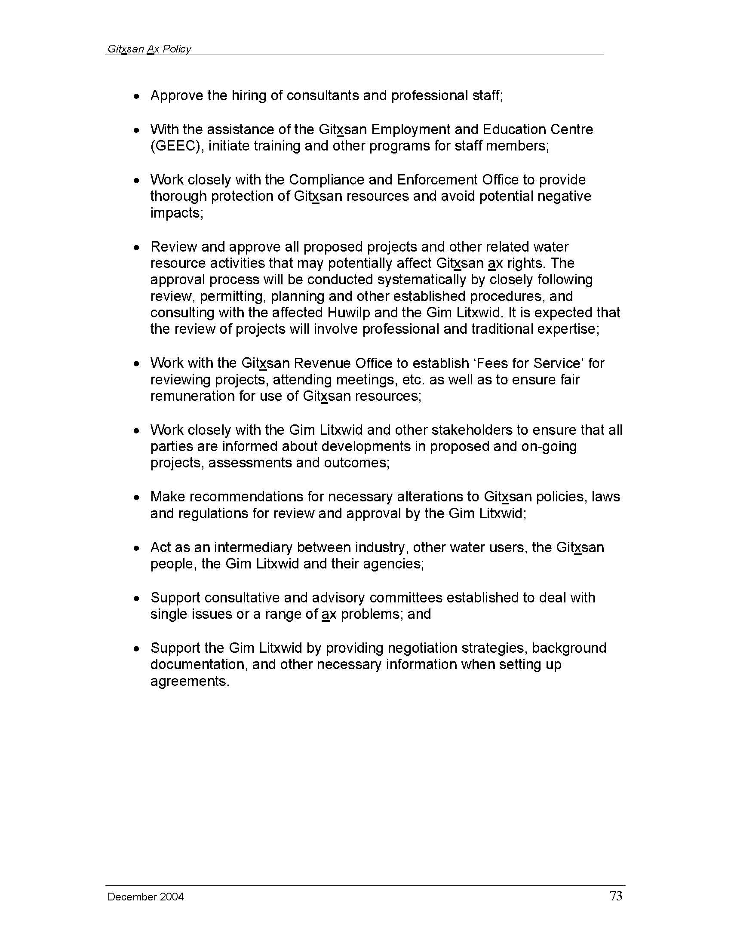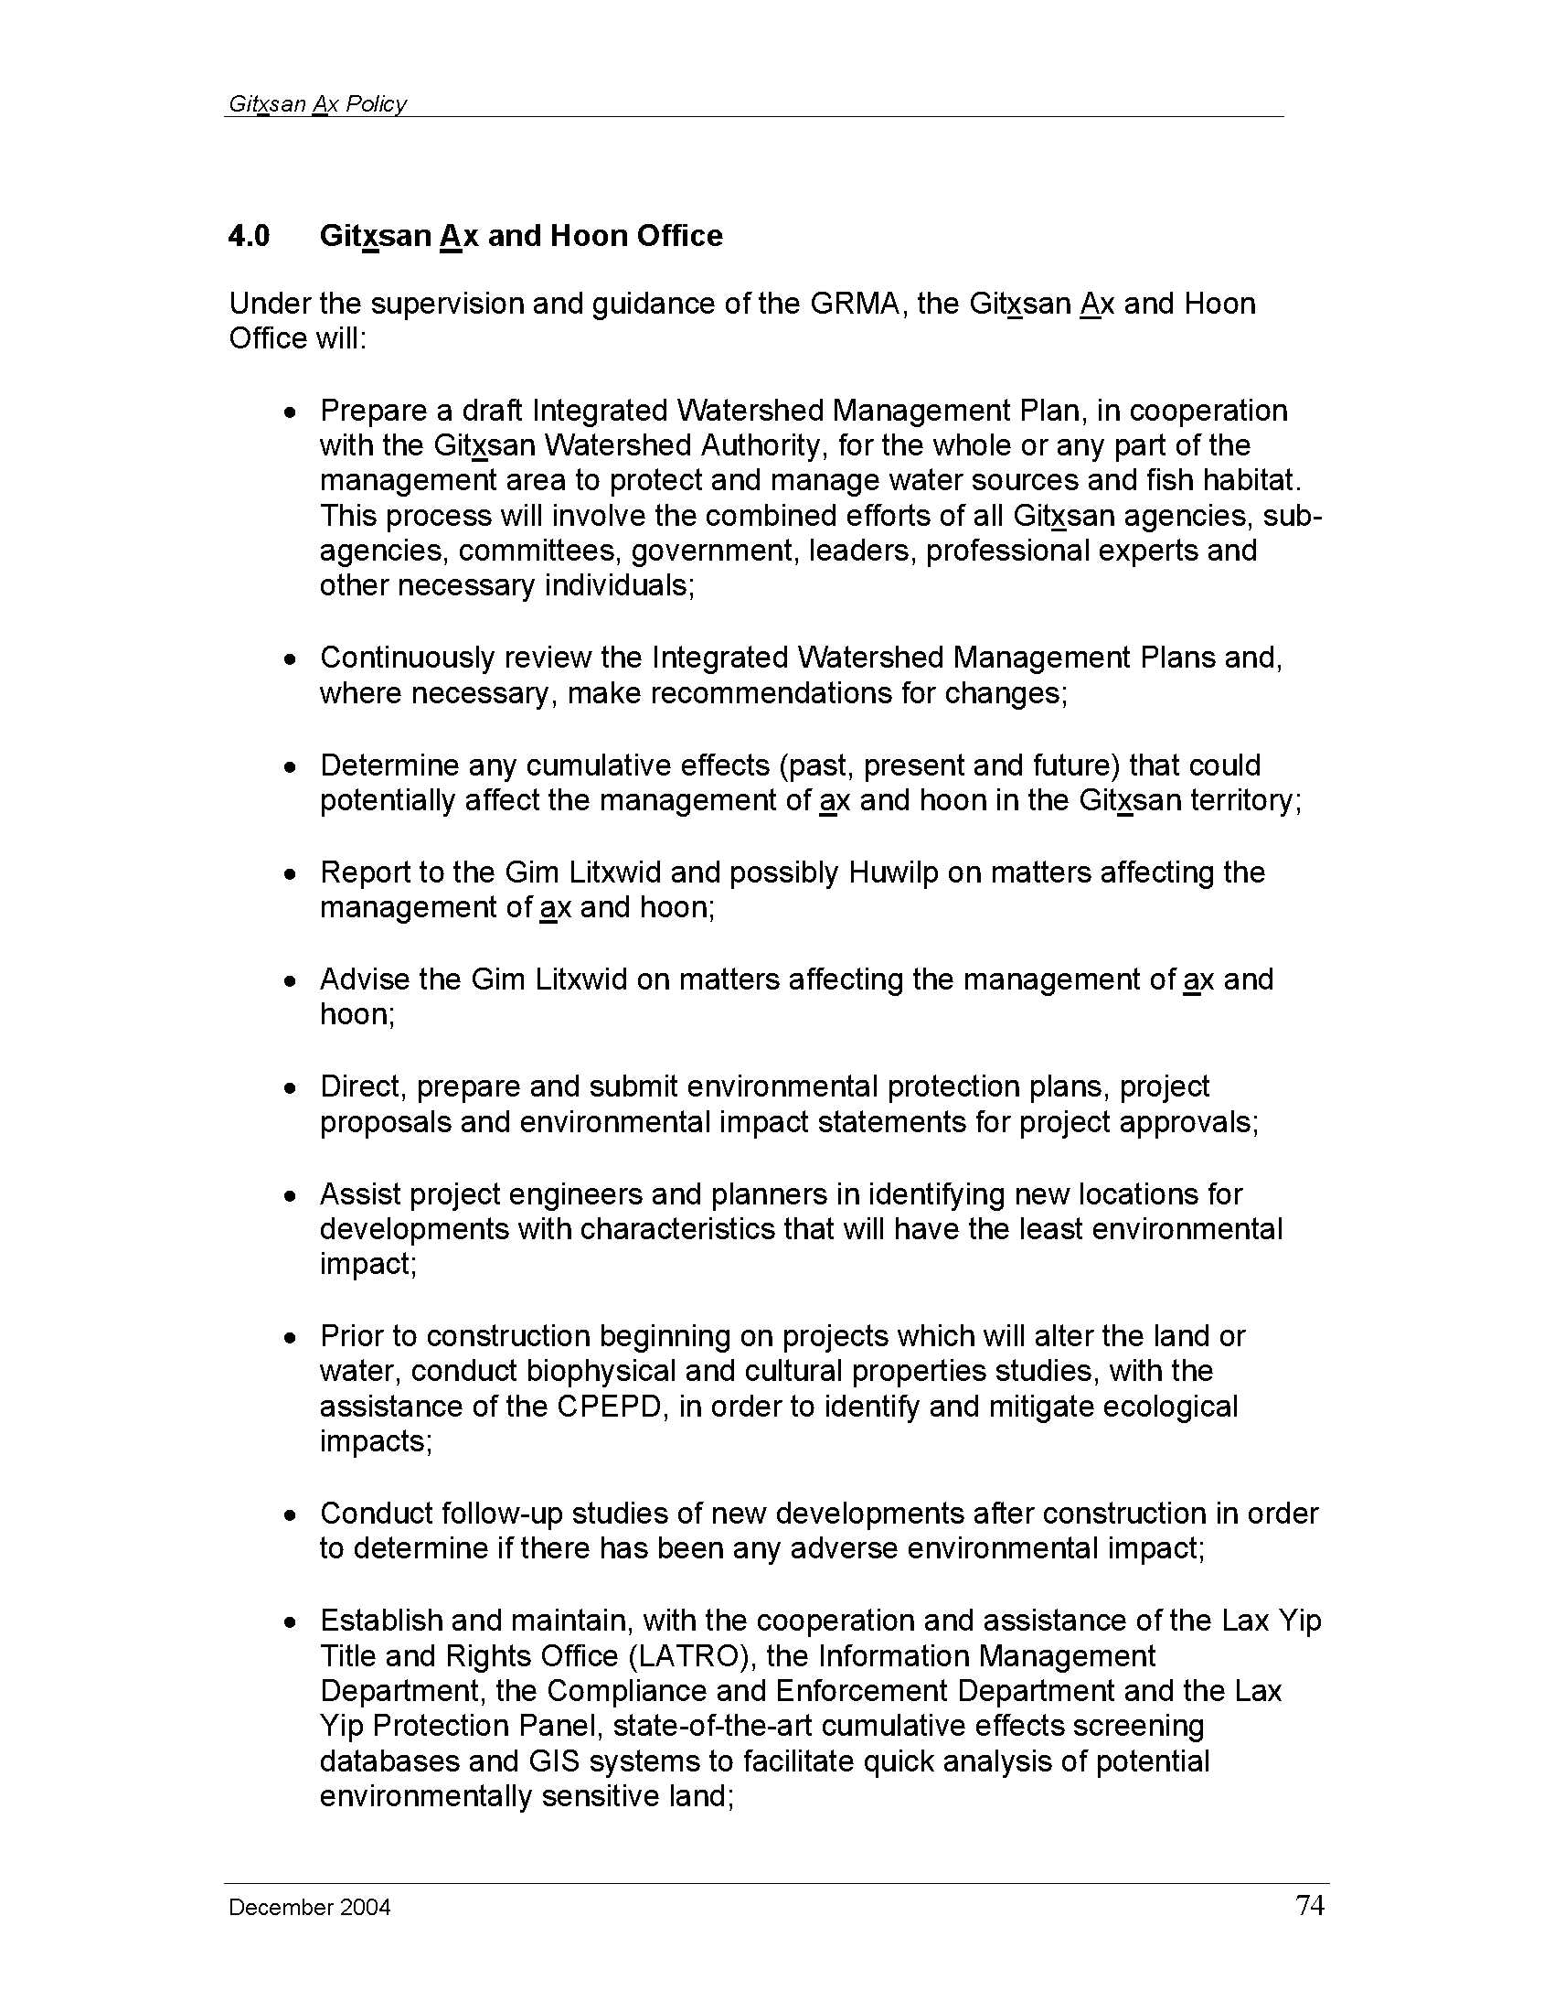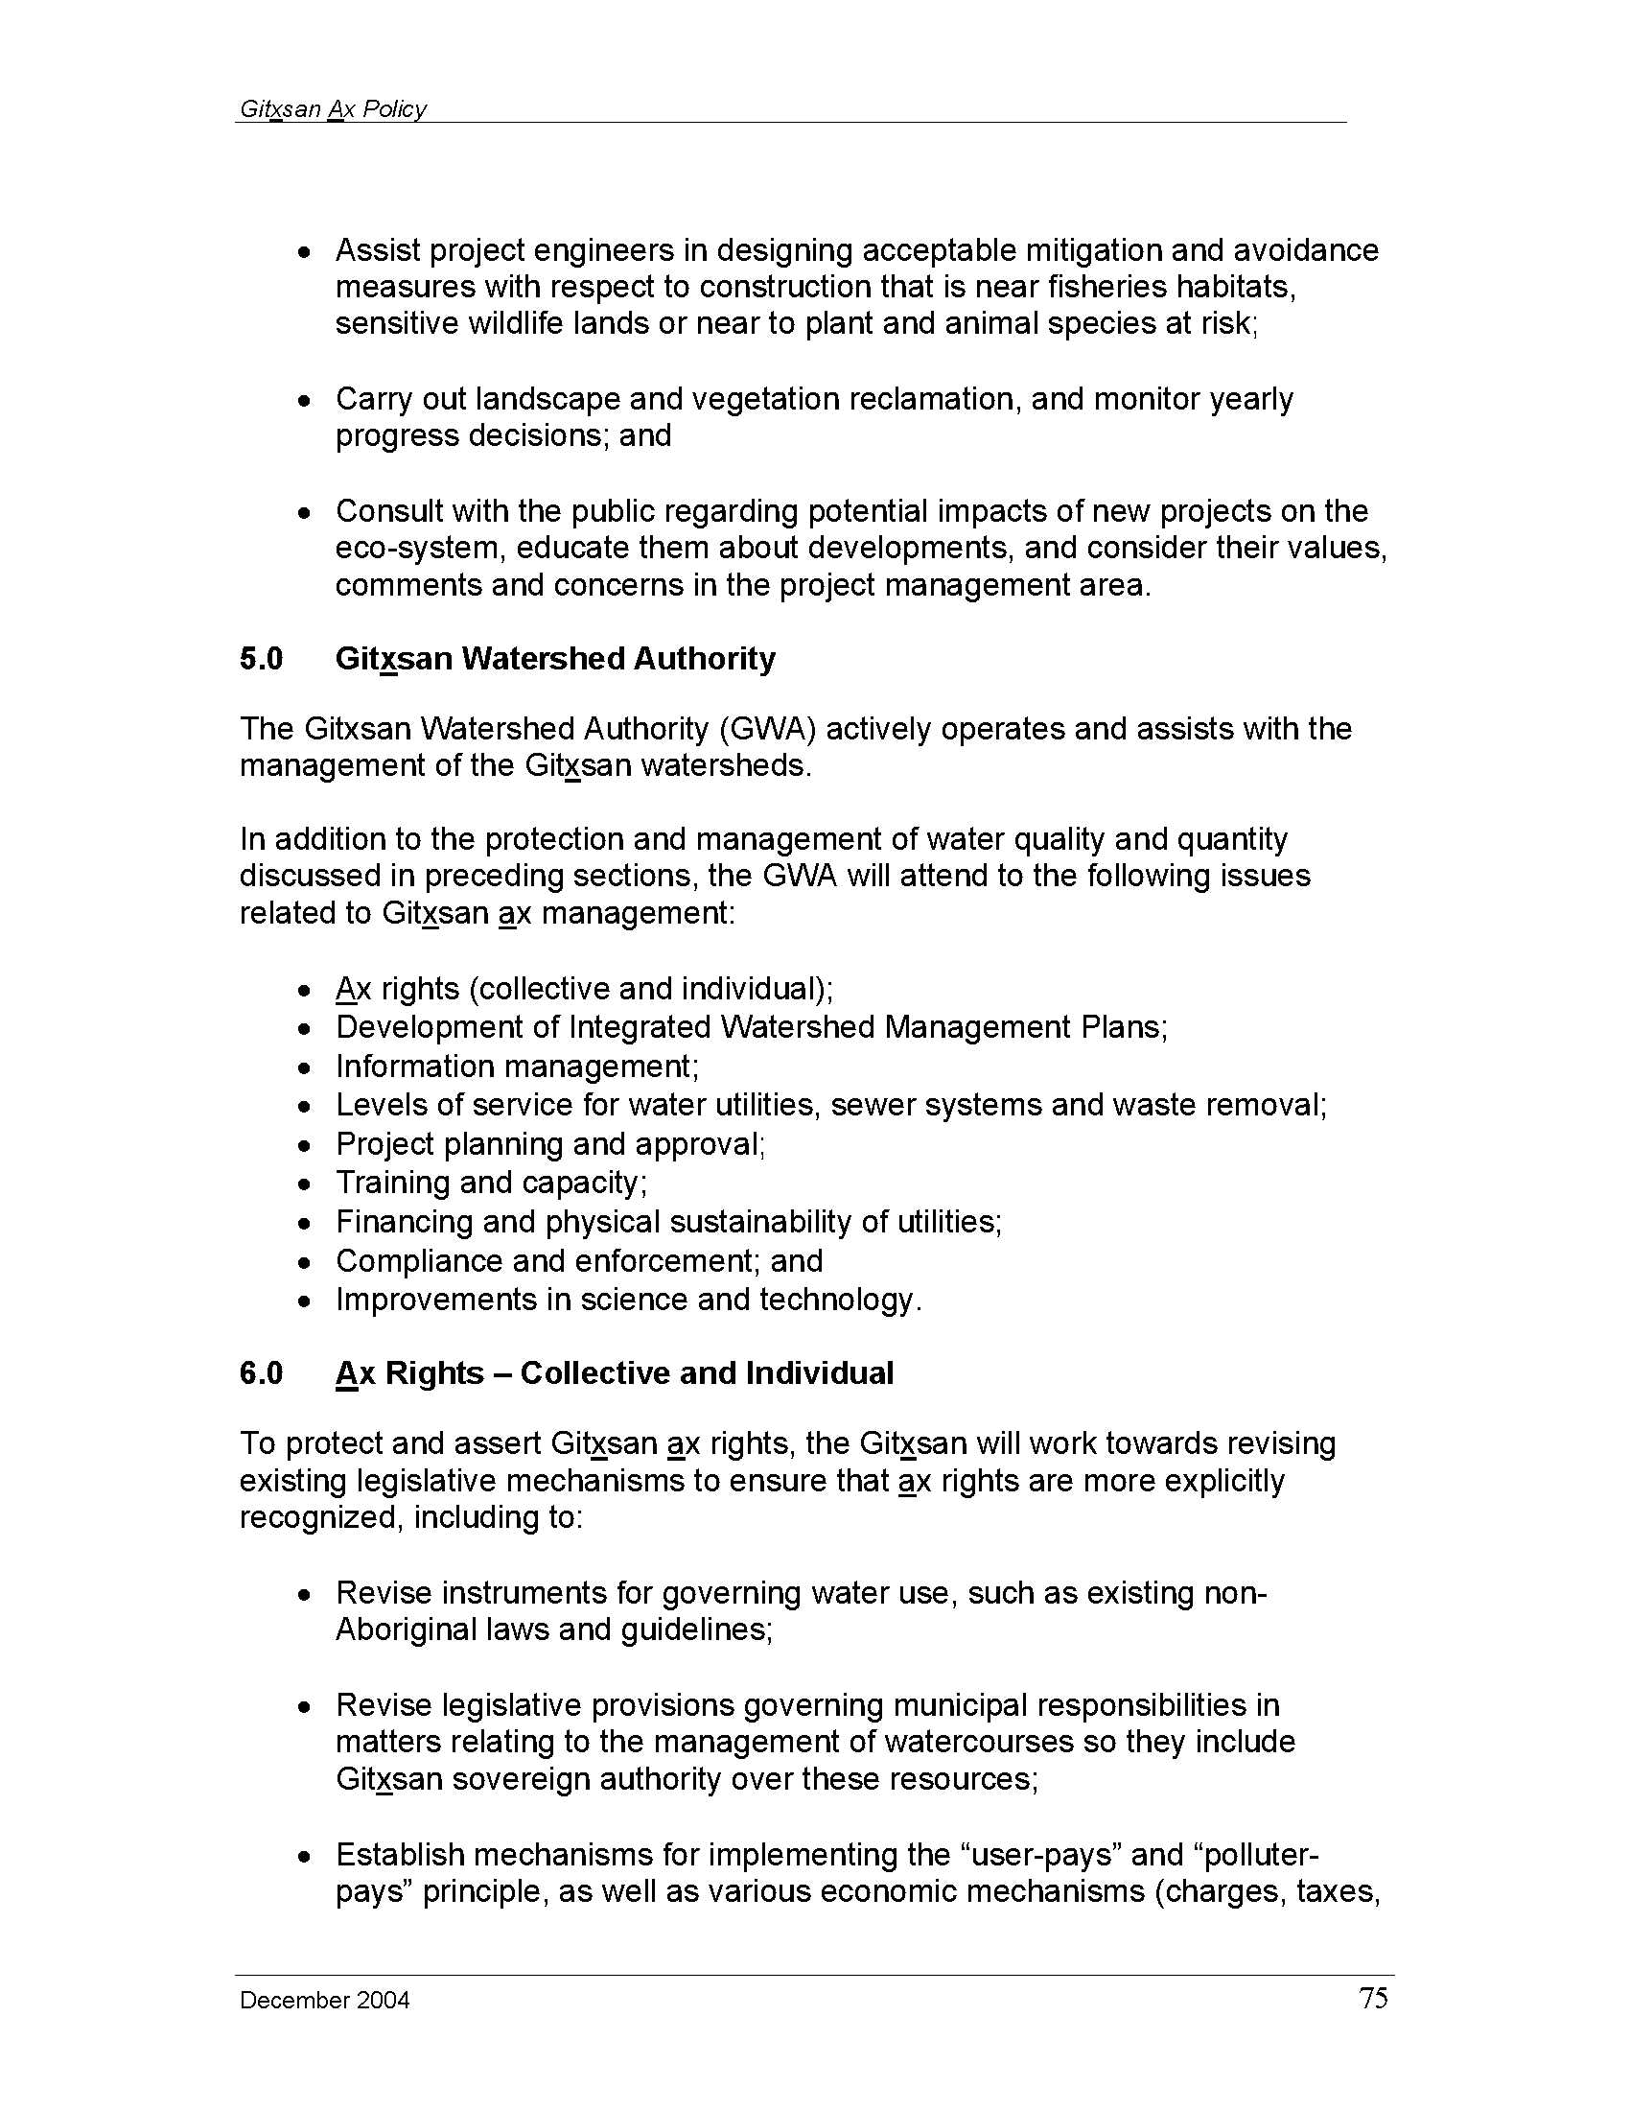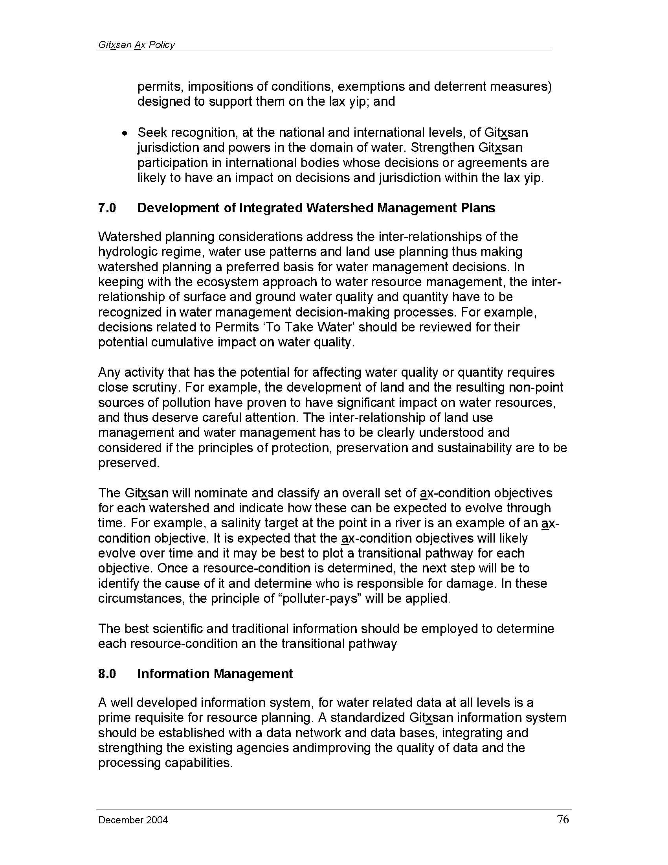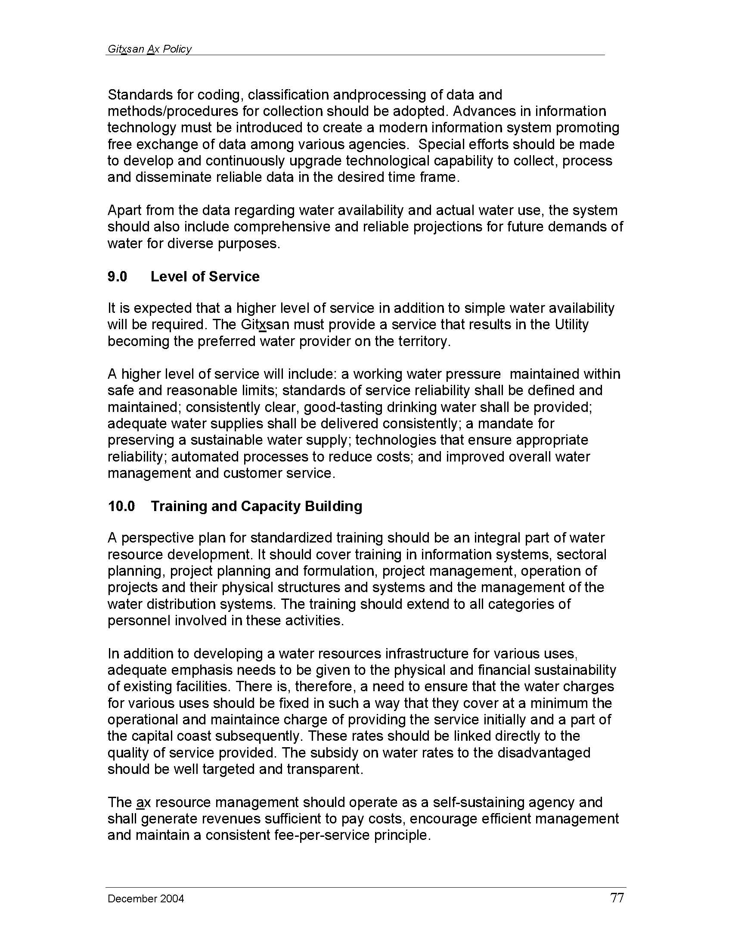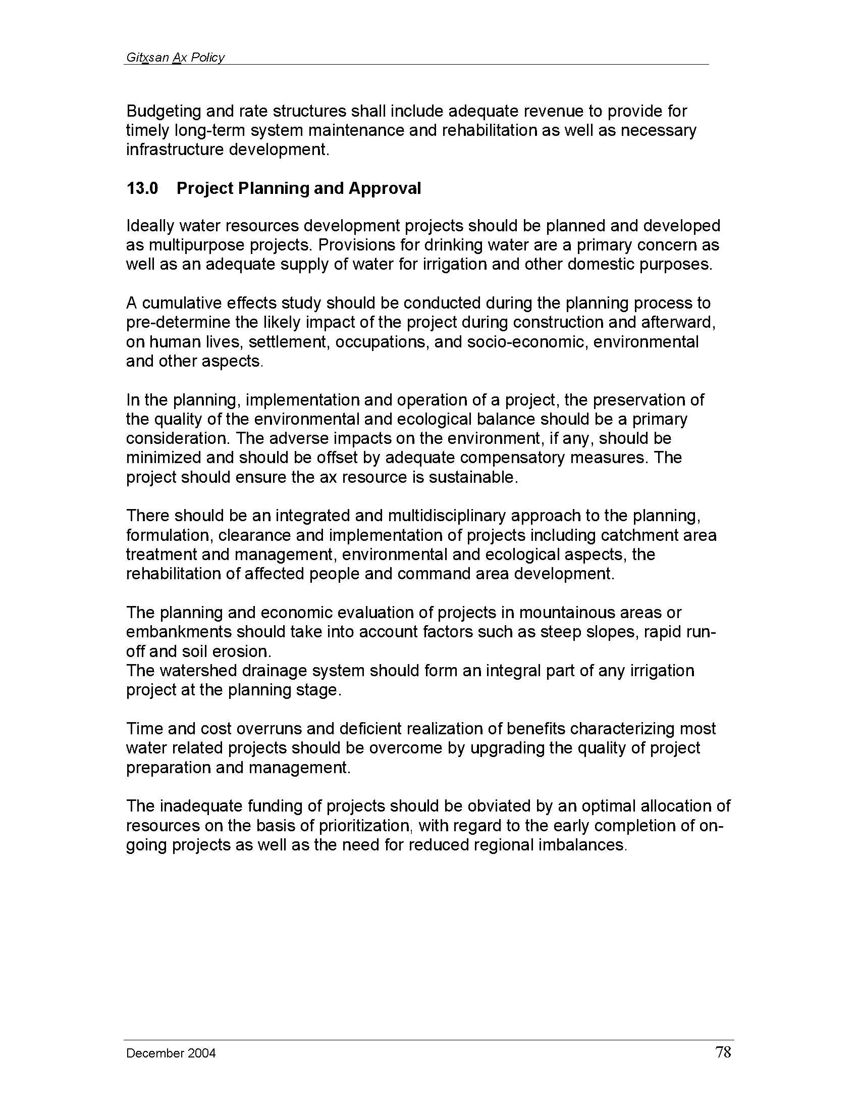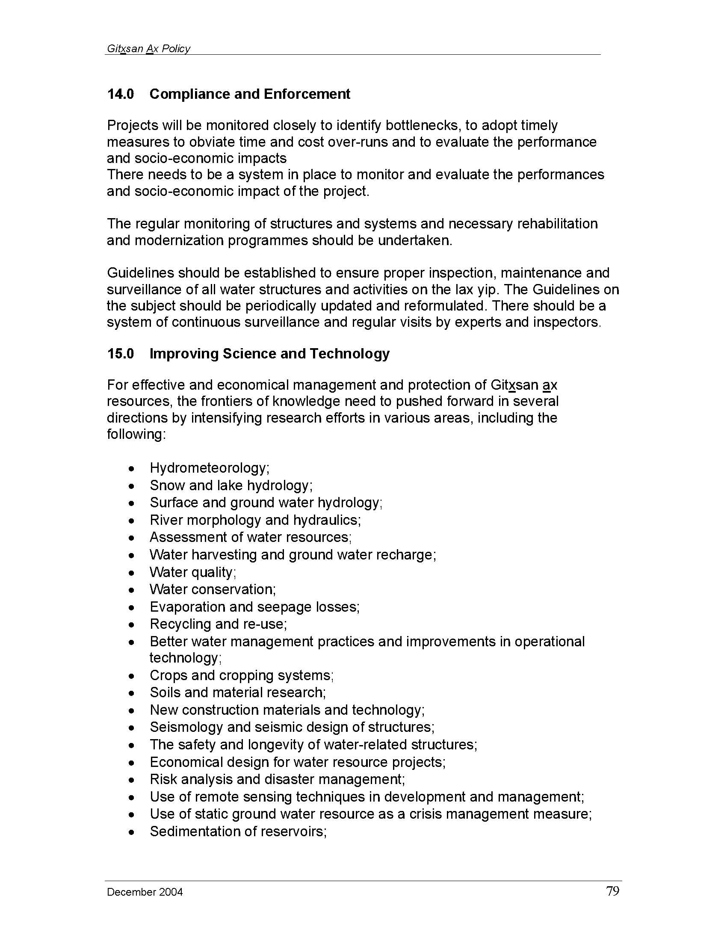

Morgan, Ruby (Luu Giss Yee). Dim Wila Dil Dils’m; the way we live; Gitwangax Traditional Health Governance (prevention). 2013.
Johnston, M. (2009). Vulnerability of Canada’s tree species to climate change and management options for adaptation: an overview for policy makers and practitioners. Canadian Council of Forest Ministers.
The definition/description of Gitsegukla Traditional Cultural Expression is adapted from The World Intellectual Property Organization, Intergovernmental Committee on Intellectual Property and Genetic Resources, Traditional Knowledge and Folklore, Tenth Session, 2006; The Protection of Traditional Cultural Expressions/Expressions of Folklore; Draft Objectives and Principles: WIPO/GRTKF/IC/10/4 (2006).
Development proponents include, but is not limited to, Forest Licensees, mining, oil and gas, and energy companies, commercial recreational development proponents; i.e. all activities that require physical developments on Gitwangak Territories.
Culturally Modified Trees of British Columbia: A Handbook for the Identification and Recording of Culturally Modified Trees. Archaeology Branch, BC Ministry of Small Business, Tourism, and Culture. March 2001. Version 2.0
VICAIRE: Virtual Campus in Hydrology and Water Resources, available at http://echo2.epfl.ch/VICAIRE/
The hydroriparian zone is defined as the area that extends to the edge of the influence of water on land, or land on water, as defined by plant communities (including high bench or dry flood plain communities) or landforms, plus one and one-half site specific tree heights horizontal distance (Hydroriparian Planning Guide, Coast Information Team, , Jan. 30, 2004). Landforms include: - The stream channel, lake, or wetland and adjacent riparian ecosystem, where no floodplain exists - The full width of the floodplain for streams - Adjacent active fluvial units (alluvial fans) - Up to the top of the inner gorge or where slopes become less than 50% for reaches of streams that are gullied, or are in a ravine or canyon - Immediately adjacent unstable slopes (class IV and V terrain) where it is located such that a surcharge of sediment may be delivered to the stream, lake, or wetland.
“Properly Functioning” for a stream, river, wetland or lake and its riparian area means: - the ability to withstand normal peak flood events without experiencing accelerated soil loss, channel movement or bank movement; - the ability to filter runoff; - the ability to store and safely release water; - ability of riparian habitat to maintain an adequate root network or large woody debris supply; - ability of riparian habitat to provide shade and reduce bank microclimate change; and, - fish habitat in streams and riparian areas are fully connected so that fish habitat is not lost or isolated as a result of some management activity.
“Hydroriparian zone” means the area that extends to the edge of the influence of water on land, or land on water, as defined by plant communities (including high bench or dry floodplain communities) or landforms, plus one and one-half site specific tree heights horizontal distance (Hydroriparian Planning Guide, Coast Information Team, Jan. 30, 2004). Landforms include: - The stream channel, lake or wetland and adjacent riparian ecosystem, where no floodplain exists. - The full width of the floodplain for streams - Adjacent active fluvial units - Up to the top of the inner gorge or where slopes become less than 50% for reaches of streams that are gullied, or are in a ravine or canyon - Immediately adjacent unstable slopes (class IV and V terrain) where it is located such that a surcharge of sediment may be delivered to the stream, lake or wetland.
“Properly functioning” for a stream, river, wetland or lake and its riparian area means: - the ability to withstand normal peak flood events without experiencing accelerated soil loss, channel movement or bank movement; - the ability to filter runoff; - the ability to store and safely release water; - ability of riparian habitat to maintain an adequate root network or large woody debris supply; - ability of riparian habitat to provide shade and reduce bank microclimate change; and, - fish habitat in streams and riparian areas are fully connected so that fish habitat is not lost or isolated as a result of some management activity.
The three studies are: - The Bowron River Watershed Project: A landscape level assessment of the post-salvage change on streams and riparian function (2007); Available at: www.for.gov.bc.ca/bre/ffip/Bowron.htm - Prince George Small Streams Project (2002-2006); Accessed at www.for.gov.bc.ca/hre/ffip/PGSSP.htm. - Vanderhoof Riparian Project; Accessed at www.for.gov.bc.ca/hfd/pubs/docs/Eng/En90.htm.
The three studies are: 1.The Bowron River Watershed Project: A landscape level assessment of the post-salvage change on streams and riparian function (2007); at www.for.gov.bc.ca/hre/ffip/Bowron.htm. 2. Prince George Small Streams Project (2002-2006); At http://www.for.gov.bc.ca/hre/ffip/PGSSP.htm 3.Vanderhoof Riparian Project; At www.for.gov.bc.ca/hfd/pubs/docs/Eng/En90.htm.
“Properly Functioning” for a stream, river, wetland or lake and its riparian area means: - the ability to withstand normal peak flood events without experiencing accelerated soil loss, channel movement or bank movement; - the ability to filter runoff; - the ability to store and safely release water; - ability of riparian habitat to maintain an adequate root network or large woody debris supply; - ability of riparian habitat to provide shade and reduce bank microclimate change; and, - fish habitat in streams and riparian areas are fully connected so that fish habitat is not lost or isolated as a result of some management activity.
H 60 elevation is the contour elevation at which 60% of the sub-basin area is above that elevation and 40% is below that elevation.
An exposed erodable soil is a fine textured soil (fine sand, silt, and clay) or erodable mineral deposit that water can readily wash into the adjacent stream.
Hydrologically connected means any bare, erodible soil that can reasonably be expected to reach the riparian area if exposed to rainfall or stream flows. This includes: - bare soil on non-vegetated slopes immediately adjacent to the 10 m riparian zone - bare soil on vegetated slopes of 10% gradient or steeper that are immediately adjacent to the riparian area, up to the first topographic break. - bare soil past the topographic break if there is a channel showing a clear connection to the first 10 m area - bare soil on active road surfaces within the 10 m riparian area, including the crossing, if there is evidence that fines eroded (siltation) off the road surface can reach the stream. This includes the road surface, plus all cut-and-fill slopes associated with the road, within the first 10 m of the riparian area - bare soil on active road surfaces beyond the first 10 m of the riparian area if there is evidence that fines eroding off these road surfaces will reach the stream. Evidence of hydrologic linkage should be conspicuous, such as ruts or eroding tracks down the road to a spot at the crossing where water spills directly off the edge of the road into the stream or a ditch that is clearly connected to the riparian feature. (FREP Protocol for Evaluating the Condition of Streams and Riparian Management Areas, Version 5.0; March 2009, and, FRCP Field Supplement to Evaluating the condition of Streams and Riparian Management Areas, Version 3.0; March 2009).
An exposed erodable soil is a fine textured soil (fine sand, silt and clay) or erodable mineral deposit that water can readily wash into the adjacent stream.
Hydrologically connected means any bare, erodible soil that can reasonably be expected to reach the riparian area if exposed to rainfall or stream flows. This includes: - bare soil on non-vegetated slopes immediately adjacent to the 10 m riparian zone - bare soil on vegetated slopes of 10% gradient or steeper that are immediately adjacent to the riparian area, up to the first topographic break. - bare soil past the topographic break if there is a channel showing a clear connection to the first 10 m of the riparian area - bare soil on active road surfaces within the 10 m riparian area, including the crossing, if there is evidence that fines eroded off the road surface can reach the stream. This includes the road surface, plus all cut-and-fill slopes associated with the road, within the first 10 m of the riparian area - bare soil on active road surfaces beyond the first 10 m of the riparian area if there is evidence that fines eroding off these road surfaces will reach the stream. Evidence of hydrologic linkage should be conspicuous, such as ruts or eroding tracks down the road to a spot at the crossing where water spills directly off the edge of the road into the stream or a ditch that is clearly connected to the riparian feature. (FREP Protocol for Evaluating the Condition of Streams and Riparian Management Areas, Version 5.0; March 2009, and, FRCP Field Supplement to Evaluating the condition of Streams and Riparian Management Areas, Version 3.0; March 2009).
“Effectiveness” means the continued use of a habitat by the species that historically utilized it.
Hydroriparian zone as defined in item 4 of Table 12.
Very High value habitats correspond to the British Columbia Resource Inventory Committee (BCRIC) Class 1 habitats. High value habitats correspond to the BCRIC Class 2 and 3 habitats.
Very High corresponds to British Columbia Resource Inventory Committee (BCRIC) Class 1 habitats.
High corresponds to British Columbia Resource Inventory Committee (BCRIC) Class 2 and 3 habitats.
For definitions of “subhygric” and “subhydric”, see “moisture regime” in the Cranberry SRMP glossary.
The minimum size for a treatable unit is: - One hectare for pure subhygric to subhydric sites; - Two hectares of noncontiguous subhygric to subhydric sites within ecosystem complexes where the individual sites are greater than 0.25 ha and such sites comprise 20% or more of the ecosystem complex area.
Thermal Cover is defined as canopy cover that moderates atmospheric temperature – thermoregulation resulting in cooling during the summer and reduction of wind chill in the winter.
Security Cover is defined as sufficient vegetation cover and/or terrain features that permit a moose to feel secure, comfortable and not threatened despite adjacent activities or predator movement that would otherwise displace the animal.
Refer to Appendix 4 for descriptions of Very High, High, and Moderate Value Forage shrub species composition.
For a definition of Regeneration Delay, see Cranberry SRMP Glossary.
Stewart-Smith, A.K., W. L. Harrower, T. Mahon, E.L. McLaren, and F.I Doyle, 2012. A Scientific basis for managing northern goshawk breeding areas in the interior of British Columbia: Best management practices. Forrex Forum for Research and Extension in Natural Resources, Kamloops, BC; Forrex Series 29: Downloaded from: http://www.forrex.org/forrex_series/forrex-series-29
Mechanized activity is road construction and timber harvesting/mechanized silviculture activities.
Human activity includes log hauling, and those activities not identified as mechanized activity.
Goshawk forage habitat is defined as the hunting territory typically used by a pair of goshawks.
“Productive pine mushroom” sites mean those sites that can best produce pine mushrooms. i.e., sites that currently produce pine mushrooms and those sites undisturbed, previously logged or burned that can produce pine mushrooms. These sites are generally pine or hemlock leading stands below 800 m elevation in the following ecological site series: ICMmc1/01b, ICHmc2/01b, and CWHws2/03. The minimum size of area to be considered is 0.3 ha for homogenous site series and 1 ha for site series complexes.
If research shows that silviculture systems (other than clearcut harvesting) can perpetuate pine mushroom production, the areas having these silviculture systems will contribute to meeting the target.
Information provided in the preamble, objectives, and strategies regarding climate change has been adapted from the following sources: Hansen, J. (2009). Storms of my grandchildren. Bloomsbury USA: New York. Parfitt, B. (2010). Managing BCs forests for a cooler planet. Canadian Centre for Policy Alternatives: Vancouver. Raymer, B. & Dymond, C. (2009). Carbon source to carbon sink: ways to manage BCs forests for carbon storage in BC Forest Professional Magazine (Nov-Dec 2009). Published online at: www.abcfp.ca
Price, Karen (1010) personal communication.
Targets for very large patches apply only to past managed openings and naturally occurring large disturbances. The targets are only identified for reporting purposes, and do not imply that the very large patch targets are to be achieved in the future.
Daust, D. (2008). Spatial distribution of mature and old forests Phase 1: uncertainty related to pattern. Prepared for The Babine Watershed Monitoring Trust. Available online at www.babinetrust.ca.
Natural disturbances rarely kill all the living trees within the patch that the disturbance affects, and rarely remove trees from the site. Residual and downed trees provide habitat that would otherwise be missing while the young forest regenerates, thus providing connectivity between the old and newly regenerating forests.
Any harvest unit within the buffer portions of the EN will, within the buffer, retain ≥70% of the naturally occurring mature and old forest structure (live trees, range of diameter classes, snags, coarse woody debris, tree species etc.) of the harvest unit measured either as basal area (M²) or forest area (hectares). No further harvesting may occur within the harvest unit (within the EN buffer area) until such time as the harvested portion has returned to a mature or older condition (i.e. ICH 100 years, ESSF and MH 120 years).
Any harvest unit within the buffer portions of the FEN will, within the buffer, retain ≥70% of the naturally occurring mature and old forest structure (live trees, range of diameter classes, snags, coarse woody debris, tree species etc.) of the harvest unit measured either as basal area (M²) or forest area (hectares). No further harvesting may occur within the harvest unit (within the FEN buffer area) until such time as the harvested portion has returned to a mature or older condition (i.e. ICH 100 years, ESSF 120 years).
The hydroriparian zone is defined as the area that extends to the edge of the influence of water on land, or land on water, as defined by plant communities (including high bench or dry floodplain communities) or landforms, plus one and one-half site specific tree heights horizontal distance (Hydroriparian Planning Guide, Coast Information Team, Jan. 30, 2004). Landforms include: - The stream channel, lake or wetland and adjacent riparian ecosystem, where no floodplain exists. - The full width of the floodplain for streams - Adjacent active fluvial units - Up to the top of the inner gorge or where slopes become less than 50% for reaches of streams that are gullied, or are in a ravine or canyon Immediately adjacent unstable slopes (class IV and V terrain) where it is located such that a surcharge of sediment may be delivered to the stream, lake or wetland.
Canadian Council of Forest Ministers 2009. Vulnerability of Canada’s tree species to climate change and management options for adaption: An Overview for policymakers and practitioners. Available at ISBN-1-100-13845-9; Cat. No; F04-28/2009E.pdf.
Total habitat is the total area of any identified ecosystem (e.g. high site growth potential and H leading species). If ≥45% of the ecosystem is retained, natural disturbance regimes (e.g. fire, insects, etc.) will lead to a natural age distribution within this habitat. Over time, the amount of old forest on the landscape would approximate the amount of old forest expected naturally (i.e. range of natural variations).
Kremster, L, et al (2008). Accounting for stand level retention: background material. Prepared for the Ecosystem Based Management Working Group. Available online at: http://archive.ilmb.gov.bc.ca/slrp/lrmp/nanaimo/cencoast/ebmwg_docs/ei01b_stand_level_retention.pdf
Total habitat is: the total area of any identified ecosystem (e.g. H leading species and High site growth potential). If ≥45% of the ecosystem is retained, the natural disturbance regimes (e.g. fire, insects, etc.) will lead to a natural age distribution within this habitat. Age class 9 (≥250 years) is first priority for retention, then age class 8 (140-250 years), then the next highest age class until sufficient retention has been identified. Over time, the amount of old forest on the landscape will approximate the amount of old forest expected naturally (i.e. range of natural variation).
Price, K; Holt, R; Kremsater, L (2007). Representative Forest Targets: Informing threshold refinement with science.
A ≥15% stand level retention for harvested cutblocks is recommended, in order to avoid large changes in community and rapid reductions in species. References are Representative Forest Targets: Informing Threshold Refinement with Science, Karen Price, Rachel Holt, and Laurie Kremsater, June 7, 2007.
The minimum size of red-listed plant community to be preserved is 0.25 ha. Where the red-listed plant community exists as the dominant component of a complex, the minimum size of complex to be preserved is 1 ha.
The minimum size of blue-listed plant community to be preserved is 0.25 ha. Where the blue-listed plant community exists as the dominant component of a complex, the minimum size of complex to be preserved is 1 ha.
Valued Ecosystem Components (VEC): - Elements of the environment that have scientific, economic, or cultural significance. Those elements that may be affected by a project activity. Source: Canadian Nuclear Safety Committee - Fundamental elements of the physical, biological, sociological, environment including air, water, soil, terrain, vegetation, birds, wildlife, fish, land use that may be affected by a proposed project; includes heritage resources. Source: KEEYSH Transmission Project Environmental Assessment, Appendix C
Planning Stages: Recce: Proposed block or road has been walked but no field work has been completed; first referral to Gitwangak Layout Started: Proposed blocks or roads have layout partially completed Layout Complete: All layout and assessments have been completed but not yet tendered or under cutting permit Permitted: Block has had all assessments completed, licence has been tendered and awarded or cutting permit is issued Roads Tendered: FSR roads are built but associated blocks are not yet tendered (BCTS) Roads Permitted: Main roads (outside cut block boundary) are permitted.
Resource Overlaps or Adjacencies: This column is used to identify any overlaps between industrial developments and cultural resources identified in the LUP, or Gitwangak Cultural Resources Database. This includes any proposed developments that are within close proximity (300 meters) of any identified cultural site.

